UNITED STATES
SECURITIES AND EXCHANGE COMMISSION
Washington, D.C. 20549
______________________________________
FORM 10-Q
______________________________________
☒ |  |  | QUARTERLY REPORT PURSUANT TO SECTION 13 OR 15(d) OF THE SECURITIES EXCHANGE ACT OF 1934
For the quarterly period ended June 30, 2026
OR
☐ |  |  | TRANSITION REPORT PURSUANT TO SECTION 13 OR 15(d) OF THE SECURITIES EXCHANGE ACT OF 1934
For the transition period from to

Commission File Number: 000-32191
______________________________________
T. ROWE PRICE GROUP, INC.
(Exact name of registrant as specified in its charter)
Maryland |  |  |  |  |  | 52-2264646
(State of incorporation) |  |  |  |  |  | (I.R.S. Employer Identification No.)
1307 Point Street, Baltimore, Maryland 21231
(Address, including Zip Code, of principal executive offices)
(410) 345-2000
(Registrant’s telephone number, including area code)
________________
Securities registered pursuant to Section 12(b) of the Act:
Title of each class |  |  | Trading Symbol(s) |  |  | Name of each exchange on which registered
Common Stock, $0.20 par value per share |  |  | TROW |  |  | The NASDAQ Stock Market LLC
______________________
Indicate by check mark whether the registrant (1) has filed all reports required to be filed by Section 13 of the Securities Exchange Act of 1934 during the preceding 12 months (or for such shorter period that the registrant was required to file such reports), and (2) has been subject to such filing requirements for the past 90 days. ☒ Yes ☐ No

Indicate by check mark whether the registrant has submitted electronically every Interactive Data File required to be submitted pursuant to Rule 405 of Regulation S-T (§232.405 of this chapter) during the preceding 12 months (or for such shorter period that the registrant was required to submit such files). ☒ Yes ☐ No
Indicate by check mark whether the registrant is a large accelerated filer, an accelerated filer, a non-accelerated filer, smaller reporting company, or an emerging growth company. See the definitions of “large accelerated filer,” “accelerated filer” “smaller reporting company” and “emerging growth company” in Rule 12b-2 of the Exchange Act.
Large accelerated filer |  |  | ☒ |  |  | Accelerated filer |  |  | ☐
Non-accelerated filer |  |  | ☐ |  |  | Smaller reporting company |  |  | ☐
 |  |  |  |  |  | Emerging growth company |  |  | ☐
If an emerging growth company, indicate by check mark if the registrant has elected not to use the extended transition period for complying with any new or revised financial accounting standards provided pursuant to Section 13(a) of the Exchange Act.☐
Indicate by check mark whether the registrant is a shell company (as defined in Rule 12b-2 of the Exchange Act). ☐ Yes ☒ No
The number of shares outstanding of the issuer’s common stock ($0.20 par value), as of the latest practicable date, July 29, 2026, is 213,315,850.
The exhibit index is at Item 6 on page 45.

PART I - FINANCIAL INFORMATION

Item 1.Financial Statements.

UNAUDITED CONSOLIDATED BALANCE SHEETS
(in millions, except share data)
 |  |  | 6/30/2026 |  |  |  |  |  | 12/31/2025
ASSETS
Cash and cash equivalents |  |  | $ | 3,234.3 |  |  |  |  | $ | 3,378.2
Accounts receivable and accrued revenue |  |  | 941.6 |  |  |  |  |  | 931.2
Investments |  |  | 4,090.2 |  |  |  |  |  | 3,325.2
Assets of consolidated investment products ($1,906.6 million at June 30, 2026 and $1,596.1 million at December 31, 2025, related to variable interest entities) |  |  | 2,477.2 |  |  |  |  |  | 1,951.0
Operating lease assets |  |  | 369.8 |  |  |  |  |  | 382.9
Property, equipment and software, net |  |  | 813.5 |  |  |  |  |  | 845.3
Intangible assets, net |  |  | 245.4 |  |  |  |  |  | 274.2
Goodwill |  |  | 2,642.8 |  |  |  |  |  | 2,642.8
Other assets |  |  | 542.4 |  |  |  |  |  | 611.0
Total assets |  |  | $ | 15,357.2 |  |  |  |  | $ | 14,341.8
LIABILITIES
Accounts payable and accrued expenses |  |  | $ | 402.4 |  |  |  |  | $ | 352.7
Debt and liabilities of consolidated investment products ($414.6 million at June 30, 2026 and $14.2 million at December 31, 2025, related to variable interest entities) |  |  | 452.5 |  |  |  |  |  | 21.3
Operating lease liabilities |  |  | 429.4 |  |  |  |  |  | 447.2
Accrued compensation and related costs |  |  | 600.4 |  |  |  |  |  | 235.7
Deferred compensation liabilities |  |  | 1,268.5 |  |  |  |  |  | 1,176.8
Income taxes payable |  |  | 31.2 |  |  |  |  |  | 54.9
Total liabilities |  |  | 3,184.4 |  |  |  |  |  | 2,288.6
Commitments and contingent liabilities
Redeemable non-controlling interests |  |  | 1,009.3 |  |  |  |  |  | 1,036.0
STOCKHOLDERS' EQUITY
Preferred stock, undesignated, $0.20 par value — authorized and unissued 20,000,000 shares |  |  | — |  |  |  |  |  | —
Common stock, $0.20 par value — authorized 750,000,000; issued 213,312,000 shares at June 30, 2026 and 218,565,000 at December 31, 2025 |  |  | 42.7 |  |  |  |  |  | 43.8
Additional capital in excess of par value |  |  | — |  |  |  |  |  | —
Retained earnings |  |  | 11,018.0 |  |  |  |  |  | 10,866.8
Accumulated other comprehensive loss |  |  | (58.2) |  |  |  |  |  | (50.5)
Total stockholders' equity attributable to T. Rowe Price Group |  |  | 11,002.5 |  |  |  |  |  | 10,860.1
Non-controlling interests in consolidated entities |  |  | 161.0 |  |  |  |  |  | 157.1
Total permanent stockholders' equity |  |  | 11,163.5 |  |  |  |  |  | 11,017.2
Total liabilities, redeemable non-controlling interests, and permanent stockholders' equity |  |  | $ | 15,357.2 |  |  |  |  | $ | 14,341.8

The accompanying notes are an integral part of these statements.
Page 2

UNAUDITED CONSOLIDATED STATEMENTS OF INCOME
(in millions, except per-share amounts)
 |  |  | Three months ended |  |  |  |  |  |  |  |  |  |  |  | Six months ended
 |  |  | 6/30/2026 |  |  |  |  |  | 6/30/2025 |  |  |  |  |  | 6/30/2026 |  |  |  |  |  | 6/30/2025
Revenues
Investment advisory fees |  |  | $ | 1,744.8 |  |  |  |  | $ | 1,567.6 |  |  |  |  | $ | 3,427.8 |  |  |  |  | $ | 3,166.0
Performance-based advisory fees |  |  | 6.5 |  |  |  |  |  | 6.4 |  |  |  |  |  | 14.0 |  |  |  |  |  | 16.8
Capital allocation-based income |  |  | 11.9 |  |  |  |  |  | (0.4) |  |  |  |  |  | 40.0 |  |  |  |  |  | (1.6)
Administrative, distribution, servicing, and other fees |  |  | 144.2 |  |  |  |  |  | 149.7 |  |  |  |  |  | 282.6 |  |  |  |  |  | 306.0
Net revenues |  |  | 1,907.4 |  |  |  |  |  | 1,723.3 |  |  |  |  |  | 3,764.4 |  |  |  |  |  | 3,487.2
Operating expenses
Compensation and related costs |  |  | 823.4 |  |  |  |  |  | 727.7 |  |  |  |  |  | 1,483.1 |  |  |  |  |  | 1,392.2
Distribution and servicing costs |  |  | 106.1 |  |  |  |  |  | 92.5 |  |  |  |  |  | 205.4 |  |  |  |  |  | 186.1
Advertising and promotion costs |  |  | 20.3 |  |  |  |  |  | 29.9 |  |  |  |  |  | 38.7 |  |  |  |  |  | 56.0
Product and recordkeeping related costs |  |  | 83.1 |  |  |  |  |  | 74.8 |  |  |  |  |  | 157.4 |  |  |  |  |  | 158.6
Technology, occupancy, and facility costs |  |  | 205.9 |  |  |  |  |  | 195.0 |  |  |  |  |  | 410.3 |  |  |  |  |  | 376.2
General, administrative, and other costs |  |  | 104.9 |  |  |  |  |  | 93.9 |  |  |  |  |  | 197.3 |  |  |  |  |  | 183.6
Acquisition-related amortization and impairment costs |  |  | 16.5 |  |  |  |  |  | 31.2 |  |  |  |  |  | 34.5 |  |  |  |  |  | 59.9
Restructuring charge |  |  | 6.7 |  |  |  |  |  | — |  |  |  |  |  | 16.7 |  |  |  |  |  | —
Total operating expenses |  |  | 1,366.9 |  |  |  |  |  | 1,245.0 |  |  |  |  |  | 2,543.4 |  |  |  |  |  | 2,412.6
Net operating income |  |  | 540.5 |  |  |  |  |  | 478.3 |  |  |  |  |  | 1,221.0 |  |  |  |  |  | 1,074.6
Non-operating income
Net gains on investments |  |  | 237.4 |  |  |  |  |  | 165.9 |  |  |  |  |  | 231.3 |  |  |  |  |  | 197.8
Net gains on consolidated investment products |  |  | 132.6 |  |  |  |  |  | 78.6 |  |  |  |  |  | 91.2 |  |  |  |  |  | 110.5
Other losses, including foreign currency losses |  |  | (0.9) |  |  |  |  |  | (9.0) |  |  |  |  |  | (1.7) |  |  |  |  |  | (2.1)
Total non-operating income |  |  | 369.1 |  |  |  |  |  | 235.5 |  |  |  |  |  | 320.8 |  |  |  |  |  | 306.2
Income before income taxes |  |  | 909.6 |  |  |  |  |  | 713.8 |  |  |  |  |  | 1,541.8 |  |  |  |  |  | 1,380.8
Provision for income taxes |  |  | 214.2 |  |  |  |  |  | 157.7 |  |  |  |  |  | 362.3 |  |  |  |  |  | 319.6
Net income |  |  | 695.4 |  |  |  |  |  | 556.1 |  |  |  |  |  | 1,179.5 |  |  |  |  |  | 1,061.2
Less: net income attributable to redeemable non-controlling interests |  |  | 63.4 |  |  |  |  |  | 50.9 |  |  |  |  |  | 49.3 |  |  |  |  |  | 65.5
Net income attributable to T. Rowe Price Group, Inc. |  |  | $ | 632.0 |  |  |  |  | $ | 505.2 |  |  |  |  | $ | 1,130.2 |  |  |  |  | $ | 995.7
Earnings per share on common stock of T. Rowe Price Group, Inc.
Basic |  |  | $ | 2.88 |  |  |  |  | $ | 2.24 |  |  |  |  | $ | 5.11 |  |  |  |  | $ | 4.39
Diluted |  |  | $ | 2.88 |  |  |  |  | $ | 2.24 |  |  |  |  | $ | 5.10 |  |  |  |  | $ | 4.38

The accompanying notes are an integral part of these statements.
Page 3

UNAUDITED CONSOLIDATED STATEMENTS OF COMPREHENSIVE INCOME
(in millions)
 |  |  | Three months ended |  |  |  |  |  |  |  |  |  |  |  | Six months ended
 |  |  | 6/30/2026 |  |  |  |  |  | 6/30/2025 |  |  |  |  |  | 6/30/2026 |  |  |  |  |  | 6/30/2025
Net income |  |  | $ | 695.4 |  |  |  |  | $ | 556.1 |  |  |  |  | $ | 1,179.5 |  |  |  |  | $ | 1,061.2
Other comprehensive income (loss)
Currency translation adjustments
Consolidated investment products—variable interest entities |  |  | (0.8) |  |  |  |  |  | 19.8 |  |  |  |  |  | (2.2) |  |  |  |  |  | 27.5
Reclassification (gains) losses recognized in non-operating income upon deconsolidation of certain investment products |  |  | — |  |  |  |  |  | (3.1) |  |  |  |  |  | (0.2) |  |  |  |  |  | (3.1)
Total currency translation adjustments of consolidated investment products—variable interest entities |  |  | (0.8) |  |  |  |  |  | 16.7 |  |  |  |  |  | (2.4) |  |  |  |  |  | 24.4
Equity method investments |  |  | (7.8) |  |  |  |  |  | 0.8 |  |  |  |  |  | (8.4) |  |  |  |  |  | (3.5)
Other comprehensive income (loss) before income taxes |  |  | (8.6) |  |  |  |  |  | 17.5 |  |  |  |  |  | (10.8) |  |  |  |  |  | 20.9
Net deferred tax (expense) benefit |  |  | 1.1 |  |  |  |  |  | (2.3) |  |  |  |  |  | 1.5 |  |  |  |  |  | (2.8)
Total other comprehensive income (loss) |  |  | (7.5) |  |  |  |  |  | 15.2 |  |  |  |  |  | (9.3) |  |  |  |  |  | 18.1
Total comprehensive income |  |  | 687.9 |  |  |  |  |  | 571.3 |  |  |  |  |  | 1,170.2 |  |  |  |  |  | 1,079.3
Less: comprehensive income (loss) attributable to redeemable non-controlling interests |  |  | 62.5 |  |  |  |  |  | 58.8 |  |  |  |  |  | 47.7 |  |  |  |  |  | 76.5
Comprehensive income attributable to T. Rowe Price Group |  |  | $ | 625.4 |  |  |  |  | $ | 512.5 |  |  |  |  | $ | 1,122.5 |  |  |  |  | $ | 1,002.8

The accompanying notes are an integral part of these statements.
Page 4

UNAUDITED CONSOLIDATED STATEMENTS OF CASH FLOWS
(in millions)
 |  |  | Six months ended
 |  |  | 6/30/2026 |  |  |  |  |  | 6/30/2025
Cash flows from operating activities
Net income |  |  | $ | 1,179.5 |  |  |  |  | $ | 1,061.2
Adjustments to reconcile net income to net cash provided by operating activities
Depreciation, amortization and impairment of property, equipment and software |  |  | 139.3 |  |  |  |  |  | 132.9
Amortization and impairment of acquisition-related assets and retention arrangements |  |  | 66.4 |  |  |  |  |  | 116.4
Stock-based compensation expense |  |  | 89.8 |  |  |  |  |  | 96.9
Net gains recognized on investments |  |  | (196.7) |  |  |  |  |  | (173.8)
Net redemptions in investment products used to economically hedge deferred compensation liabilities |  |  | 54.8 |  |  |  |  |  | 71.3
Net change in securities held by consolidated investment products |  |  | (547.4) |  |  |  |  |  | (409.5)
Other changes in assets and liabilities |  |  | 555.9 |  |  |  |  |  | 267.4
Net cash provided by operating activities |  |  | 1,341.6 |  |  |  |  |  | 1,162.8
Cash flows from investing activities
Purchases of sponsored investment products |  |  | (728.4) |  |  |  |  |  | (114.0)
Dispositions of sponsored investment products |  |  | 169.5 |  |  |  |  |  | 223.5
Net cash of investment products upon deconsolidation |  |  | (0.7) |  |  |  |  |  | (1.1)
Additions to property, equipment and software |  |  | (128.4) |  |  |  |  |  | (144.2)
Other investing activity |  |  | (29.4) |  |  |  |  |  | (21.0)
Net cash used in investing activities |  |  | (717.4) |  |  |  |  |  | (56.8)
Cash flows from financing activities
Repurchases of common stock |  |  | (500.8) |  |  |  |  |  | (328.3)
Common share issuances under stock-based compensation plans |  |  | (0.1) |  |  |  |  |  | 16.5
Dividends paid to common stockholders and equity-unit holders |  |  | (571.2) |  |  |  |  |  | (575.1)
Borrowings of debt of consolidated products |  |  | 217.8 |  |  |  |  |  | —
Net distributions to non-controlling interests in consolidated entities |  |  | (14.3) |  |  |  |  |  | (5.5)
Net subscriptions from redeemable non-controlling interest holders |  |  | 138.0 |  |  |  |  |  | 205.1
Net cash used in financing activities |  |  | (730.6) |  |  |  |  |  | (687.3)
Effect of exchange rate changes on cash and cash equivalents of consolidated investment products |  |  | (1.3) |  |  |  |  |  | (1.1)
Net change in cash and cash equivalents during period |  |  | (107.7) |  |  |  |  |  | 417.6
Cash and cash equivalents at beginning of period, including $39.1 million at December 31, 2025, and $63.1 million at December 31, 2024, held by consolidated investment products |  |  | 3,417.3 |  |  |  |  |  | 2,712.9
Cash and cash equivalents at end of period, including $75.3 million at June 30, 2026, and $71.6 million at June 30, 2025, held by consolidated investment products |  |  | $ | 3,309.6 |  |  |  |  | $ | 3,130.5

The accompanying notes are an integral part of these statements.
Page 5

UNAUDITED CONSOLIDATED STATEMENTS OF STOCKHOLDERS’ EQUITY
(shares in thousands; dollars in millions)

 |  |  | Three months ended 6/30/2026
 |  |  | Common shares outstanding |  |  |  |  |  | Common stock |  |  |  |  |  | Additional capital in excess of par value |  |  |  |  |  | Retained earnings |  |  |  |  |  | AOCI(1) |  |  |  |  |  | Total stockholders’ equity attributable to T. Rowe Price Group |  |  |  |  |  | Non-controlling interests in consolidated entities |  |  |  |  |  | Total permanent stockholders' equity |  |  |  |  |  | Redeemable non-controlling interests
Balances at March 31, 2026 |  |  | 214,880 |  |  |  |  |  | $ | 43.1 |  |  |  |  | $ | — |  |  |  |  | $ | 10,786.1 |  |  |  |  | $ | (51.6) |  |  |  |  | $ | 10,777.6 |  |  |  |  | $ | 157.6 |  |  |  |  | $ | 10,935.2 |  |  |  |  | $ | 940.2
Net income |  |  | — |  |  |  |  |  | — |  |  |  |  |  | — |  |  |  |  |  | 632.0 |  |  |  |  |  | — |  |  |  |  |  | 632.0 |  |  |  |  |  | 6.8 |  |  |  |  |  | 638.8 |  |  |  |  |  | 63.4
Other comprehensive loss, net of tax |  |  | — |  |  |  |  |  | — |  |  |  |  |  | — |  |  |  |  |  | — |  |  |  |  |  | (6.6) |  |  |  |  |  | (6.6) |  |  |  |  |  | — |  |  |  |  |  | (6.6) |  |  |  |  |  | (0.9)
Dividends declared ($1.30 per share) |  |  | — |  |  |  |  |  | — |  |  |  |  |  | — |  |  |  |  |  | (283.9) |  |  |  |  |  | — |  |  |  |  |  | (283.9) |  |  |  |  |  | — |  |  |  |  |  | (283.9) |  |  |  |  |  | —
Common stock-based compensation plans activity:
Shares issued upon option exercises |  |  | 9 |  |  |  |  |  | — |  |  |  |  |  | 0.6 |  |  |  |  |  | — |  |  |  |  |  | — |  |  |  |  |  | 0.6 |  |  |  |  |  | — |  |  |  |  |  | 0.6 |  |  |  |  |  | —
Restricted shares issued, net of shares withheld for taxes |  |  | 5 |  |  |  |  |  | — |  |  |  |  |  | (0.3) |  |  |  |  |  | — |  |  |  |  |  | — |  |  |  |  |  | (0.3) |  |  |  |  |  | — |  |  |  |  |  | (0.3) |  |  |  |  |  | —
Net shares issued upon vesting of restricted stock units |  |  | 9 |  |  |  |  |  | — |  |  |  |  |  | (0.5) |  |  |  |  |  | — |  |  |  |  |  | — |  |  |  |  |  | (0.5) |  |  |  |  |  | — |  |  |  |  |  | (0.5) |  |  |  |  |  | —
Forfeiture of restricted awards |  |  | (18) |  |  |  |  |  | — |  |  |  |  |  | — |  |  |  |  |  | — |  |  |  |  |  | — |  |  |  |  |  | — |  |  |  |  |  | — |  |  |  |  |  | — |  |  |  |  |  | —
Stock-based compensation expense |  |  | — |  |  |  |  |  | — |  |  |  |  |  | 40.7 |  |  |  |  |  | — |  |  |  |  |  | — |  |  |  |  |  | 40.7 |  |  |  |  |  | — |  |  |  |  |  | 40.7 |  |  |  |  |  | —
Restricted stock units issued as dividend equivalents |  |  | — |  |  |  |  |  | — |  |  |  |  |  | 0.1 |  |  |  |  |  | (0.1) |  |  |  |  |  | — |  |  |  |  |  | — |  |  |  |  |  | — |  |  |  |  |  | — |  |  |  |  |  | —
Common shares repurchased |  |  | (1,573) |  |  |  |  |  | (0.4) |  |  |  |  |  | (40.6) |  |  |  |  |  | (116.1) |  |  |  |  |  | — |  |  |  |  |  | (157.1) |  |  |  |  |  | — |  |  |  |  |  | (157.1) |  |  |  |  |  | —
Net distributions to non-controlling interests in consolidated entities |  |  | — |  |  |  |  |  | — |  |  |  |  |  | — |  |  |  |  |  | — |  |  |  |  |  | — |  |  |  |  |  | — |  |  |  |  |  | (3.4) |  |  |  |  |  | (3.4) |  |  |  |  |  | —
Net subscriptions into T. Rowe Price investment products |  |  | — |  |  |  |  |  | — |  |  |  |  |  | — |  |  |  |  |  | — |  |  |  |  |  | — |  |  |  |  |  | — |  |  |  |  |  | — |  |  |  |  |  | — |  |  |  |  |  | 11.4
Net deconsolidations of T. Rowe Price investment products |  |  | — |  |  |  |  |  | — |  |  |  |  |  | — |  |  |  |  |  | — |  |  |  |  |  | — |  |  |  |  |  | — |  |  |  |  |  | — |  |  |  |  |  | — |  |  |  |  |  | (4.8)
Balances at June 30, 2026 |  |  | 213,312 |  |  |  |  |  | $ | 42.7 |  |  |  |  | $ | — |  |  |  |  | $ | 11,018.0 |  |  |  |  | $ | (58.2) |  |  |  |  | $ | 11,002.5 |  |  |  |  | $ | 161.0 |  |  |  |  | $ | 11,163.5 |  |  |  |  | $ | 1,009.3
 |  |  | Three months ended 6/30/2025
 |  |  | Common shares outstanding |  |  |  |  |  | Common stock |  |  |  |  |  | Additional capital in excess of par value |  |  |  |  |  | Retained earnings |  |  |  |  |  | AOCI(1) |  |  |  |  |  | Total stockholders’ equity attributable to T. Rowe Price Group |  |  |  |  |  | Non-controlling interests in consolidated entities |  |  |  |  |  | Total permanent stockholders' equity |  |  |  |  |  | Redeemable non-controlling interests
Balances at March 31, 2025 |  |  | 221,061 |  |  |  |  |  | $ | 44.2 |  |  |  |  | $ | 160.2 |  |  |  |  | $ | 10,242.2 |  |  |  |  | $ | (51.9) |  |  |  |  | $ | 10,394.7 |  |  |  |  | $ | 160.4 |  |  |  |  | $ | 10,555.1 |  |  |  |  | $ | 977.2
Net income (loss) |  |  | — |  |  |  |  |  | — |  |  |  |  |  | — |  |  |  |  |  | 505.2 |  |  |  |  |  | — |  |  |  |  |  | 505.2 |  |  |  |  |  | (1.5) |  |  |  |  |  | 503.7 |  |  |  |  |  | 50.9
Other comprehensive income, net of tax |  |  | — |  |  |  |  |  | — |  |  |  |  |  | — |  |  |  |  |  | — |  |  |  |  |  | 7.3 |  |  |  |  |  | 7.3 |  |  |  |  |  | — |  |  |  |  |  | 7.3 |  |  |  |  |  | 7.9
Dividends declared ($1.27 per share) |  |  | — |  |  |  |  |  | — |  |  |  |  |  | — |  |  |  |  |  | (286.1) |  |  |  |  |  | — |  |  |  |  |  | (286.1) |  |  |  |  |  | — |  |  |  |  |  | (286.1) |  |  |  |  |  | —
Common stock-based compensation plans activity:
Shares issued upon option exercises |  |  | 33 |  |  |  |  |  | 0.1 |  |  |  |  |  | 1.9 |  |  |  |  |  | — |  |  |  |  |  | — |  |  |  |  |  | 2.0 |  |  |  |  |  | — |  |  |  |  |  | 2.0 |  |  |  |  |  | —
Restricted shares issued, net of shares withheld for taxes |  |  | 8 |  |  |  |  |  | — |  |  |  |  |  | (0.2) |  |  |  |  |  | — |  |  |  |  |  | — |  |  |  |  |  | (0.2) |  |  |  |  |  | — |  |  |  |  |  | (0.2) |  |  |  |  |  | —
Net shares issued upon vesting of restricted stock units |  |  | 10 |  |  |  |  |  | — |  |  |  |  |  | (0.4) |  |  |  |  |  | — |  |  |  |  |  | — |  |  |  |  |  | (0.4) |  |  |  |  |  | — |  |  |  |  |  | (0.4) |  |  |  |  |  | —
Stock-based compensation expense |  |  | — |  |  |  |  |  | — |  |  |  |  |  | 46.6 |  |  |  |  |  | — |  |  |  |  |  | — |  |  |  |  |  | 46.6 |  |  |  |  |  | — |  |  |  |  |  | 46.6 |  |  |  |  |  | —
Common shares repurchased |  |  | (1,210) |  |  |  |  |  | (0.3) |  |  |  |  |  | (108.3) |  |  |  |  |  | — |  |  |  |  |  | — |  |  |  |  |  | (108.6) |  |  |  |  |  | — |  |  |  |  |  | (108.6) |  |  |  |  |  | —
Net distributions to non-controlling interests in consolidated entities |  |  | — |  |  |  |  |  | — |  |  |  |  |  | — |  |  |  |  |  | — |  |  |  |  |  | — |  |  |  |  |  | — |  |  |  |  |  | (5.6) |  |  |  |  |  | (5.6) |  |  |  |  |  | —
Net subscriptions into T. Rowe Price investment products |  |  | — |  |  |  |  |  | — |  |  |  |  |  | — |  |  |  |  |  | — |  |  |  |  |  | — |  |  |  |  |  | — |  |  |  |  |  | — |  |  |  |  |  | — |  |  |  |  |  | 169.1
Net deconsolidations of T. Rowe Price investment products |  |  | — |  |  |  |  |  | — |  |  |  |  |  | — |  |  |  |  |  | — |  |  |  |  |  | — |  |  |  |  |  | — |  |  |  |  |  | — |  |  |  |  |  | — |  |  |  |  |  | (106.0)
Balances at June 30, 2025 |  |  | 219,902 |  |  |  |  |  | $ | 44.0 |  |  |  |  | $ | 99.8 |  |  |  |  | $ | 10,461.3 |  |  |  |  | $ | (44.6) |  |  |  |  | $ | 10,560.5 |  |  |  |  | $ | 153.3 |  |  |  |  | $ | 10,713.8 |  |  |  |  | $ | 1,099.1

The accompanying notes are an integral part of these statements.
Page 6

UNAUDITED CONDENSED CONSOLIDATED STATEMENTS OF STOCKHOLDERS’ EQUITY
(shares in thousands; dollars in millions)
 |  |  | Six months ended 6/30/2026
 |  |  | Common shares outstanding |  |  |  |  |  | Common stock |  |  |  |  |  | Additional capital in excess of par value |  |  |  |  |  | Retained earnings |  |  |  |  |  | AOCI(1) |  |  |  |  |  | Total stockholders’ equity attributable to T. Rowe Price Group |  |  |  |  |  | Non-controlling interests in consolidated entities |  |  |  |  |  | Total permanent stockholders' equity |  |  |  |  |  | Redeemable non-controlling interests
Balances at December 31, 2025 |  |  | 218,565 |  |  |  |  |  | $ | 43.8 |  |  |  |  | $ | — |  |  |  |  | $ | 10,866.8 |  |  |  |  | $ | (50.5) |  |  |  |  | $ | 10,860.1 |  |  |  |  | $ | 157.1 |  |  |  |  | $ | 11,017.2 |  |  |  |  | $ | 1,036.0
Net income |  |  | — |  |  |  |  |  | — |  |  |  |  |  | — |  |  |  |  |  | 1,130.2 |  |  |  |  |  | — |  |  |  |  |  | 1,130.2 |  |  |  |  |  | 18.2 |  |  |  |  |  | 1,148.4 |  |  |  |  |  | 49.3
Other comprehensive loss, net of tax |  |  | — |  |  |  |  |  | — |  |  |  |  |  | — |  |  |  |  |  | — |  |  |  |  |  | (7.7) |  |  |  |  |  | (7.7) |  |  |  |  |  | — |  |  |  |  |  | (7.7) |  |  |  |  |  | (1.6)
Dividends declared ($2.60 per share) |  |  | — |  |  |  |  |  | — |  |  |  |  |  | — |  |  |  |  |  | (572.3) |  |  |  |  |  | — |  |  |  |  |  | (572.3) |  |  |  |  |  | — |  |  |  |  |  | (572.3) |  |  |  |  |  | —
Common stock-based compensation plans activity:
Shares issued upon option exercises |  |  | 13 |  |  |  |  |  | — |  |  |  |  |  | 0.9 |  |  |  |  |  | — |  |  |  |  |  | — |  |  |  |  |  | 0.9 |  |  |  |  |  | — |  |  |  |  |  | 0.9 |  |  |  |  |  | —
Restricted shares issued, net of shares withheld for taxes |  |  | 5 |  |  |  |  |  | — |  |  |  |  |  | (0.3) |  |  |  |  |  | — |  |  |  |  |  | — |  |  |  |  |  | (0.3) |  |  |  |  |  | — |  |  |  |  |  | (0.3) |  |  |  |  |  | —
Net shares issued upon vesting of restricted stock units |  |  | 14 |  |  |  |  |  | — |  |  |  |  |  | (0.7) |  |  |  |  |  | — |  |  |  |  |  | — |  |  |  |  |  | (0.7) |  |  |  |  |  | — |  |  |  |  |  | (0.7) |  |  |  |  |  | —
Forfeiture of restricted awards |  |  | (18) |  |  |  |  |  | — |  |  |  |  |  | — |  |  |  |  |  | — |  |  |  |  |  | — |  |  |  |  |  | — |  |  |  |  |  | — |  |  |  |  |  | —
Stock-based compensation expense |  |  | — |  |  |  |  |  | — |  |  |  |  |  | 89.8 |  |  |  |  |  | — |  |  |  |  |  | — |  |  |  |  |  | 89.8 |  |  |  |  |  | — |  |  |  |  |  | 89.8 |  |  |  |  |  | —
Restricted stock units issued as dividend equivalents |  |  | — |  |  |  |  |  | — |  |  |  |  |  | 0.3 |  |  |  |  |  | (0.3) |  |  |  |  |  | — |  |  |  |  |  | — |  |  |  |  |  | — |  |  |  |  |  | — |  |  |  |  |  | —
Common shares repurchased |  |  | (5,267) |  |  |  |  |  | (1.1) |  |  |  |  |  | (90.0) |  |  |  |  |  | (406.4) |  |  |  |  |  | — |  |  |  |  |  | (497.5) |  |  |  |  |  | — |  |  |  |  |  | (497.5) |  |  |  |  |  | —
Net distributions to non-controlling interests in consolidated entities |  |  | — |  |  |  |  |  | — |  |  |  |  |  | — |  |  |  |  |  | — |  |  |  |  |  | — |  |  |  |  |  | — |  |  |  |  |  | (14.3) |  |  |  |  |  | (14.3) |  |  |  |  |  | —
Net subscriptions into T. Rowe Price investment products |  |  | — |  |  |  |  |  | — |  |  |  |  |  | — |  |  |  |  |  | — |  |  |  |  |  | — |  |  |  |  |  | — |  |  |  |  |  | — |  |  |  |  |  | — |  |  |  |  |  | 128.5
Net deconsolidations of T. Rowe Price investment products |  |  | — |  |  |  |  |  | — |  |  |  |  |  | — |  |  |  |  |  | — |  |  |  |  |  | — |  |  |  |  |  | — |  |  |  |  |  | — |  |  |  |  |  | — |  |  |  |  |  | (202.9)
Balances at June 30, 2026 |  |  | 213,312 |  |  |  |  |  | $ | 42.7 |  |  |  |  | $ | — |  |  |  |  | $ | 11,018.0 |  |  |  |  | $ | (58.2) |  |  |  |  | $ | 11,002.5 |  |  |  |  | $ | 161.0 |  |  |  |  | $ | 11,163.5 |  |  |  |  | $ | 1,009.3
 |  |  | Six months ended 6/30/2025
 |  |  | Common shares outstanding |  |  |  |  |  | Common stock |  |  |  |  |  | Additional capital in excess of par value |  |  |  |  |  | Retained earnings |  |  |  |  |  | AOCI(1) |  |  |  |  |  | Total stockholders’ equity attributable to T. Rowe Price Group |  |  |  |  |  | Non-controlling interests in consolidated entities |  |  |  |  |  | Total permanent stockholders' equity |  |  |  |  |  | Redeemable non-controlling interests
Balances at December 31, 2024 |  |  | 222,966 |  |  |  |  |  | $ | 44.6 |  |  |  |  | $ | 311.9 |  |  |  |  | $ | 10,040.6 |  |  |  |  | $ | (51.7) |  |  |  |  | $ | 10,345.4 |  |  |  |  | $ | 160.7 |  |  |  |  | $ | 10,506.1 |  |  |  |  | $ | 944.0
Net income (loss) |  |  | — |  |  |  |  |  | — |  |  |  |  |  | — |  |  |  |  |  | 995.7 |  |  |  |  |  | — |  |  |  |  |  | 995.7 |  |  |  |  |  | (1.9) |  |  |  |  |  | 993.8 |  |  |  |  |  | 65.5
Other comprehensive income, net of tax |  |  | — |  |  |  |  |  | — |  |  |  |  |  | — |  |  |  |  |  | — |  |  |  |  |  | 7.1 |  |  |  |  |  | 7.1 |  |  |  |  |  | — |  |  |  |  |  | 7.1 |  |  |  |  |  | 11.0
Dividends declared ($2.54 per share) |  |  | — |  |  |  |  |  | — |  |  |  |  |  | — |  |  |  |  |  | (574.9) |  |  |  |  |  | — |  |  |  |  |  | (574.9) |  |  |  |  |  | — |  |  |  |  |  | (574.9) |  |  |  |  |  | —
Common stock-based compensation plans activity:
Shares issued upon option exercises |  |  | 264 |  |  |  |  |  | 0.1 |  |  |  |  |  | 17.1 |  |  |  |  |  | — |  |  |  |  |  | — |  |  |  |  |  | 17.2 |  |  |  |  |  | — |  |  |  |  |  | 17.2 |  |  |  |  |  | —
Restricted shares issued, net of shares withheld for taxes |  |  | 8 |  |  |  |  |  | — |  |  |  |  |  | (0.2) |  |  |  |  |  | — |  |  |  |  |  | — |  |  |  |  |  | (0.2) |  |  |  |  |  | — |  |  |  |  |  | (0.2) |  |  |  |  |  | —
Net shares issued upon vesting of restricted stock units |  |  | 15 |  |  |  |  |  | — |  |  |  |  |  | (0.6) |  |  |  |  |  | — |  |  |  |  |  | — |  |  |  |  |  | (0.6) |  |  |  |  |  | — |  |  |  |  |  | (0.6) |  |  |  |  |  | —
Stock-based compensation expense |  |  | — |  |  |  |  |  | — |  |  |  |  |  | 96.9 |  |  |  |  |  | — |  |  |  |  |  | — |  |  |  |  |  | 96.9 |  |  |  |  |  | — |  |  |  |  |  | 96.9 |  |  |  |  |  | —
Restricted stock units issued as dividend equivalents |  |  | — |  |  |  |  |  | — |  |  |  |  |  | 0.1 |  |  |  |  |  | (0.1) |  |  |  |  |  | — |  |  |  |  |  | — |  |  |  |  |  | — |  |  |  |  |  | — |  |  |  |  |  | —
Common shares repurchased |  |  | (3,351) |  |  |  |  |  | (0.7) |  |  |  |  |  | (325.4) |  |  |  |  |  | — |  |  |  |  |  | — |  |  |  |  |  | (326.1) |  |  |  |  |  | — |  |  |  |  |  | (326.1) |  |  |  |  |  | —
Net distributions to non-controlling interests in consolidated entities |  |  | — |  |  |  |  |  | — |  |  |  |  |  | — |  |  |  |  |  | — |  |  |  |  |  | — |  |  |  |  |  | — |  |  |  |  |  | (5.5) |  |  |  |  |  | (5.5) |  |  |  |  |  | —
Net subscriptions into T. Rowe Price investment products |  |  | — |  |  |  |  |  | — |  |  |  |  |  | — |  |  |  |  |  | — |  |  |  |  |  | — |  |  |  |  |  | — |  |  |  |  |  | — |  |  |  |  |  | — |  |  |  |  |  | 259.7
Net deconsolidations of T. Rowe Price investment products |  |  | — |  |  |  |  |  | — |  |  |  |  |  | — |  |  |  |  |  | — |  |  |  |  |  | — |  |  |  |  |  | — |  |  |  |  |  | — |  |  |  |  |  | — |  |  |  |  |  | (181.1)
Balances at June 30, 2025 |  |  | 219,902 |  |  |  |  |  | $ | 44.0 |  |  |  |  | $ | 99.8 |  |  |  |  | $ | 10,461.3 |  |  |  |  | $ | (44.6) |  |  |  |  | $ | 10,560.5 |  |  |  |  | $ | 153.3 |  |  |  |  | $ | 10,713.8 |  |  |  |  | $ | 1,099.1
(1) Accumulated other comprehensive income

The accompanying notes are an integral part of these statements.
Page 7

NOTES TO UNAUDITED CONSOLIDATED FINANCIAL STATEMENTS

NOTE 1 – BASIS OF PREPARATION AND SUMMARY OF SIGNIFICANT ACCOUNTING POLICIES.

T. Rowe Price Group derives its consolidated revenues and net income primarily from investment advisory services that its subsidiaries provide globally to individual and institutional investors that invest in a broad range of investment solutions across equity, fixed income, multi-asset, and alternatives capabilities. We also provide certain investment advisory clients with related administrative services, including distribution, mutual fund transfer agent, accounting, and shareholder services; participant recordkeeping and transfer agent services for defined contribution retirement plans; brokerage; trust services; and other advisory services.

The investment solutions are provided in a number of vehicles including the T. Rowe Price U.S. mutual funds (U.S. mutual funds), subadvised funds, separately managed accounts, collective investment trusts, exchange-traded funds, and other sponsored products. The other sponsored products include: open-ended investment products offered to investors outside the U.S., products offered through variable annuity life insurance plans in the U.S., affiliated private investment funds, business development companies, an interval fund, and collateralized loan obligations.

Investment advisory fees depend largely on the total value and composition of assets under our management. Accordingly, fluctuations in financial markets and in the composition of assets under management impact our revenues and results of operations.

BASIS OF PREPARATION.

These unaudited consolidated financial statements have been prepared by management in accordance with accounting principles generally accepted in the United States and include the accounts of the Company and its controlled subsidiaries. These principles require the use of estimates and reflect all adjustments that are, in the opinion of management, necessary for a fair statement of our results for the interim periods presented. All such adjustments are of a normal recurring nature. Actual results may vary from our estimates.

Certain prior-period technology-related professional fees and servicing costs have been reclassified from general, administrative, and other costs to technology, occupancy, and facilities costs to conform with current year presentation. The new presentation better aligns the nature of the expenses following our decision to outsource and expand certain technology capabilities through trusted vendor partnerships. The amounts reclassified for the three- and six- months ended June 30, 2025 were $15.5 million and $29.1 million. While the presentation of certain expense categories changed, the reclassifications did not impact previously reported total operating expenses, operating income, net income, or cash flows.

The unaudited financial information contained in these consolidated financial statements should be read in conjunction with the consolidated financial statements contained in our 2025 Annual Report.

CONSOLIDATION.

Our consolidated financial statements include the accounts of all wholly-owned subsidiaries, majority-owned entities that are entitled to a disproportionate allocation of income, or carried interest, and investment products in which we have a controlling interest.

During the three months ended June 30, 2026, we closed a collateralized loan obligation (CLO) offering. Prior to closing, the CLO issuer acquired debt investments that became collateral for the CLO at closing. These debt investments were financed primarily using a warehouse credit facility and were repaid using proceeds from notes the CLO issued to third-party investors at close. We retain a controlling economic interest in the CLO issuer through our ownership of subordinated notes and provide investment management services. We evaluated the CLO under the consolidation guidance of ASC 810, Consolidation, and determined that the CLO is a variable interest entity for which we are the primary beneficiary. Accordingly, the CLO is being consolidated in our financial statements and reported with our other consolidated investment products. We recognize and report the CLO’s financial information in our consolidated financial statements on a three-month reporting lag as the information is not available in a timely manner. As such, our financial statements and related footnotes as of June 30, 2026, reflect the assets, liabilities and related activities of the CLO issuer as of March 31, 2026.

20
Page 8

We have determined that the consolidated CLO meets the definition of an investment company under ASC 946, Financial Services—Investment Companies. We have also elected the fair value option pursuant to ASC 825, Financial Instruments, for measuring the warehouse facility and the notes issued by the CLO to eliminate inconsistencies that would otherwise arise from using different accounting bases. To determine fair value, we elected the collateralized financing entity measurement alternative, under which both the assets and liabilities of the CLO would be measured based on the fair value of the CLO’s assets, since they have the more observable fair value. Gains and losses related to changes in the fair value of the assets and liabilities of the consolidated CLOs are recognized in net gains (losses) on consolidated investment products in the consolidated statements of Income and are largely offset within that line item. Additionally, net income (loss) attributable to T. Rowe Price Group, Inc. reflects only changes in the fair value of its retained economic interests in the consolidated CLOs due to the elimination of income (loss) attributable to noncontrolling interests.

NEWLY ISSUED BUT NOT YET ADOPTED ACCOUNTING GUIDANCE.

In November 2024, the FASB issued Accounting Standards Update No. 2024-03 - Income Statement—Reporting Comprehensive Income—Expense Disaggregation Disclosures (Subtopic 220-4): Disaggregation of Income Statement Expenses, which requires disclosures of additional information and disaggregation of certain expenses included in the income statement. The guidance is effective for the firm on January 1, 2027, and allows for either a prospective or retrospective approach on adoption. We are currently evaluating the impact the adoption will have on our financial statements and have not yet determined our transition approach.

In September 2025, the FASB issued Accounting Standards Update No. 2025-06 - Intangibles—Goodwill and Other—Internal-Use Software (Subtopic 350-40): Targeted Improvements to the Accounting for Internal-Use Software, which amends the existing internal-use software guidance. The amendment eliminates the project stage model and clarifies that capitalization of internal-use software costs commences when management has authorized and committed funding for the project and it is probable that software will be completed and used for its intended function. The amendment allows for varying transition approaches and is effective for the firm on January 1, 2028, with early adoption permitted. We are currently evaluating the impact the adoption will have on our financial statements and have not yet determined our transition approach.

We have considered all other newly issued accounting guidance that is applicable to our operations and the preparation of our unaudited consolidated financial statements, including those we have not yet adopted. We do not believe that any such guidance has or will have a material effect on our financial position or results of operations.

NOTE 2 – INFORMATION ABOUT RECEIVABLES, REVENUES, AND SERVICES.

Net revenues earned in the three- and six-month periods ended June 30, 2026 and 2025 are included in the table below along with details of investment advisory revenues by underlying asset class. We also included average assets under management by asset class, on which we earn investment advisory fees.

20
Page 9

 |  |  | Three months ended |  |  |  |  |  |  |  |  |  |  |  | Six months ended
(in millions) |  |  | 6/30/2026 |  |  |  |  |  | 6/30/2025 |  |  |  |  |  | 6/30/2026 |  |  |  |  |  | 6/30/2025
Investment advisory fees
Equity |  |  | $ | 1,011.9 |  |  |  |  | $ | 923.6 |  |  |  |  | $ | 1,986.6 |  |  |  |  | $ | 1,882.8
Fixed income, including money market |  |  | 113.5 |  |  |  |  |  | 105.5 |  |  |  |  |  | 225.3 |  |  |  |  |  | 209.1
Multi-asset |  |  | 529.5 |  |  |  |  |  | 455.9 |  |  |  |  |  | 1,038.6 |  |  |  |  |  | 910.6
Alternatives |  |  | 89.9 |  |  |  |  |  | 82.6 |  |  |  |  |  | 177.3 |  |  |  |  |  | 163.5
Total investment advisory fees |  |  | $ | 1,744.8 |  |  |  |  | $ | 1,567.6 |  |  |  |  | $ | 3,427.8 |  |  |  |  | $ | 3,166.0
Performance-based advisory fees |  |  | 6.5 |  |  |  |  |  | 6.4 |  |  |  |  |  | 14.0 |  |  |  |  |  | 16.8
Capital allocation-based income |  |  | 11.9 |  |  |  |  |  | (0.4) |  |  |  |  |  | 40.0 |  |  |  |  |  | (1.6)
Administrative, distribution, servicing, and other fees |  |  | 144.2 |  |  |  |  |  | 149.7 |  |  |  |  |  | 282.6 |  |  |  |  |  | 306.0
Net revenues |  |  | $ | 1,907.4 |  |  |  |  | $ | 1,723.3 |  |  |  |  | $ | 3,764.4 |  |  |  |  | $ | 3,487.2
Average AUM (in billions):
Equity |  |  | $ | 886.6 |  |  |  |  | $ | 784.4 |  |  |  |  | $ | 873.9 |  |  |  |  | $ | 805.3
Fixed income, including money market |  |  | 219.0 |  |  |  |  |  | 198.0 |  |  |  |  |  | 216.4 |  |  |  |  |  | 194.8
Multi-asset |  |  | 671.2 |  |  |  |  |  | 552.5 |  |  |  |  |  | 656.6 |  |  |  |  |  | 551.1
Alternatives |  |  | 60.9 |  |  |  |  |  | 53.9 |  |  |  |  |  | 60.0 |  |  |  |  |  | 53.3
Average AUM |  |  | $ | 1,837.7 |  |  |  |  | $ | 1,588.8 |  |  |  |  | $ | 1,806.9 |  |  |  |  | $ | 1,604.5

Total net revenues earned from sponsored investment products totaled $1,619.6 million and $1,435.2 million for the three months ended June 30, 2026 and 2025, respectively. Total net revenues earned during the six months ended June 30, 2026 and 2025 aggregate to $3,194.1 million and $2,906.5 million, respectively. Accounts receivable from these products aggregate to $702.3 million at June 30, 2026 and $664.2 million at December 31, 2025.

Investors we serve are primarily domiciled in the U.S.; investors domiciled outside the United States account for 9.1% at June 30, 2026, 8.6% at March 31, 2026, and 8.8% at December 31, 2025 of our assets under management.

20
Page 10

NOTE 3 – INVESTMENTS.

The carrying values of our investments that are not consolidated investment products are as follows:
(in millions) |  |  | 6/30/2026 |  |  |  |  |  | 12/31/2025
Investments held at fair value
T. Rowe Price investment products
Discretionary investments |  |  | $ | 954.0 |  |  |  |  | $ | 463.7
Redeemable seed capital investments |  |  | 337.8 |  |  |  |  |  | 316.1
Investments used to hedge the deferred compensation liabilities |  |  | 1,286.4 |  |  |  |  |  | 1,243.3
Investment partnerships and other investments |  |  | 98.2 |  |  |  |  |  | 157.9
Equity method investments
T. Rowe Price investment products
Discretionary investments |  |  | 173.9 |  |  |  |  |  | —
Redeemable seed capital investments |  |  | 9.3 |  |  |  |  |  | 8.3
Investment in UTI Asset Management Company Limited (India) |  |  | 155.6 |  |  |  |  |  | 162.8
Investments in affiliated private investment funds - carried interest |  |  | 381.1 |  |  |  |  |  | 390.3
Investments in affiliated private investment funds - seed/co-investment |  |  | 370.1 |  |  |  |  |  | 304.7
Investment partnerships and other investments |  |  | 251.2 |  |  |  |  |  | 204.9
Held to maturity
Investments in affiliated collateralized loan obligations |  |  | 21.2 |  |  |  |  |  | 21.8
Certificates of deposit |  |  | 50.4 |  |  |  |  |  | 50.4
U.S. Treasury note |  |  | 1.0 |  |  |  |  |  | 1.0
Total |  |  | $ | 4,090.2 |  |  |  |  | $ | 3,325.2

During the six months ended June 30, 2026 and 2025, certain T. Rowe Price investment products in which we provided initial seed capital at the time of formation were deconsolidated, as we no longer had a controlling interest. Depending on our ownership interest, we report our residual interests in these T. Rowe Price investment products as either an equity method investment or an investment held at fair value. The net impact on our unaudited consolidated balance sheets and statements of income as of the dates the products were deconsolidated or reconsolidated is detailed below.
 |  |  | Three months ended |  |  |  |  |  |  |  |  |  |  |  | Six months ended
(in millions) |  |  | 6/30/2026 |  |  |  |  |  | 6/30/2025 |  |  |  |  |  | 6/30/2026 |  |  |  |  |  | 6/30/2025
Net decrease in assets of consolidated investment products |  |  | $ | (3.5) |  |  |  |  | $ | (181.4) |  |  |  |  | $ | (259.4) |  |  |  |  | $ | (604.1)
Net decrease in liabilities of consolidated investment products |  |  | $ | 1.2 |  |  |  |  | $ | (1.8) |  |  |  |  | $ | (0.2) |  |  |  |  | $ | (25.3)
Net decrease in redeemable non-controlling interests |  |  | $ | (4.8) |  |  |  |  | $ | (106.0) |  |  |  |  | $ | (202.9) |  |  |  |  | $ | (181.1)
Net gains recognized upon deconsolidation |  |  | $ | — |  |  |  |  | $ | 3.1 |  |  |  |  | $ | 0.2 |  |  |  |  | $ | 3.1
The net gains recognized upon deconsolidation were the result of reclassifying currency translation adjustments accumulated on certain consolidated investment products with non-USD functional currencies from accumulated other comprehensive income to non-operating income.

INVESTMENTS AT FAIR VALUE

The investment partnerships and other investments held at fair value are valued using net asset value (NAV) per share as a practical expedient or using the measurement alternative. Our interests in the investment partnerships are generally not redeemable and are subject to significant transferability restrictions. The underlying investments of these partnerships have contractual terms through 2036, though we may receive distributions of liquidating assets over a longer term. The investment strategies of these partnerships include growth equity, buyout, venture capital, and real estate.

20
Page 11

During the three- and six- months ended June 30, 2026, we recognized $168.0 million and $115.1 million, respectively, of net unrealized gains on investments held at fair value that were still held at June 30, 2026. For the same periods of 2025, we recognized $112.4 million and $85.1 million, respectively, of net unrealized gains on investments held at fair value that were still held at June 30, 2025.

VARIABLE INTEREST ENTITIES.
Our fair value and equity method investments at June 30, 2026 and December 31, 2025, include interests in variable interest entities that we do not consolidate as we are not deemed the primary beneficiary. Our maximum risk of loss related to our involvement with these entities is as follows:
(in millions) |  |  | 6/30/2026 |  |  |  |  |  | 12/31/2025
Investment carrying values |  |  | $ | 1,188.0 |  |  |  |  | $ | 978.7
Unfunded capital commitments |  |  | 177.4 |  |  |  |  |  | 199.3
Accounts receivable |  |  | 107.5 |  |  |  |  |  | 113.3
Maximum risk of loss |  |  | $ | 1,472.9 |  |  |  |  | $ | 1,291.3

We have unfunded capital commitments, totaling $177.4 million at June 30, 2026 and $199.3 million at December 31, 2025, related primarily to the affiliated private investment funds and the investment partnerships in which we have an existing investment. In addition to such amounts, a percentage of prior distributions may be recalled under certain circumstances.

Investments in affiliated private investment funds - carried interest represent interests in the general partners of affiliated private investment funds that are entitled to a disproportionate allocation of income, also known as carried interest. The entities that hold these interests (carried interest entities) are considered variable interest entities and are consolidated as T. Rowe Price is determined to be the primary beneficiary. The total assets, liabilities and non-controlling interests of these carried interest entities as of June 30, 2026 and December 31, 2025 are as follows:

(in millions) |  |  | 6/30/2026 |  |  |  |  |  | 12/31/2025
Assets |  |  | $ | 426.1 |  |  |  |  | $ | 438.7
Liabilities |  |  | $ | 1.1 |  |  |  |  | $ | 5.8
Non-controlling interest |  |  | $ | 161.0 |  |  |  |  | $ | 157.1

INVESTMENTS IN AFFILIATED COLLATERALIZED LOAN OBLIGATIONS.

There is debt associated with our investments in affiliated collateralized loan obligations. The debt outstanding is related to repurchase agreements of €18.6 million at June 30, 2026, compared to €18.6 million at December 31, 2025 (equivalent to $21.2 million at June 30, 2026 and $21.8 million at December 31, 2025 at the respective EUR spot rates) that are collateralized by the CLO investments and reported in accounts payable and accrued expenses in our consolidated balance sheets. These repurchase agreements bear interest at rates based on EURIBOR plus the initial margin, which equals all-in rates ranging from 3.2% to 11.1% as of June 30, 2026. The debt matures on various dates through 2035 or if the investments are paid back in full or cancelled, whichever is sooner.

NOTE 4 – FAIR VALUE MEASUREMENTS.

We determine the fair value of our cash equivalents and certain investments held at fair value using the following broad levels of inputs as defined by related accounting standards:

Level 1 – quoted prices in active markets for identical financial instruments accessible at the reporting date.
Level 2 – observable inputs other than Level 1 quoted prices including, but not limited to, quoted prices for similar financial instruments in active markets, quoted prices for identical or similar financial instruments in inactive markets, interest rates and yield curves, implied volatilities, and credit spreads. These inputs are based on market data obtained from independent sources.
Level 3 – unobservable inputs reflecting our own assumptions based on the best information available. The inputs into the determination of fair value require significant management judgment or estimation. Investments in
20
Page 12

this category generally include investments for which there is not an actively-traded market. There were no level 3 investments at June 30, 2026 and December 31, 2025.

These levels are not necessarily an indication of the risk or liquidity associated with our investments. The following table summarizes our investments and liabilities that are recognized in our unaudited consolidated balance sheets using fair value measurements determined based on the differing levels of inputs. This table excludes investments held by the consolidated investment products, which are presented separately in our unaudited consolidated balance sheets and are detailed in Note 5.

 |  |  | 6/30/2026 |  |  |  |  |  |  |  |  |  | 12/31/2025
(in millions) |  |  | Level 1 |  |  |  |  |  | Level 2 |  |  |  |  |  |  |  | Level 1 |  |  |  |  |  | Level 2
T. Rowe Price investment products
Cash equivalents held in money market funds |  |  | $ | 2,866.2 |  |  |  |  | $ | — |  |  |  |  |  |  | $ | 3,049.0 |  |  |  |  | $ | —
Discretionary investments |  |  | 954.0 |  |  |  |  |  | — |  |  |  |  |  |  |  | 463.7 |  |  |  |  |  | —
Redeemable seed capital investments |  |  | 273.4 |  |  |  |  |  | 64.4 |  |  |  |  |  |  |  | 258.6 |  |  |  |  |  | 57.5
Investments used to hedge the deferred compensation liabilities |  |  | 1,286.4 |  |  |  |  |  | — |  |  |  |  |  |  |  | 1,243.3 |  |  |  |  |  | —
Other investments |  |  | 0.8 |  |  |  |  |  | — |  |  |  |  |  |  |  | 0.3 |  |  |  |  |  | —
Investments in affiliated collateralized loan obligations |  |  | — |  |  |  |  |  | 1.9 |  |  |  |  |  |  |  | — |  |  |  |  |  | 3.2
Total |  |  | $ | 5,380.8 |  |  |  |  | $ | 66.3 |  |  |  |  |  |  | $ | 5,014.9 |  |  |  |  | $ | 60.7

The fair value hierarchy level table above does not include the investment partnerships and other investments for which fair value is estimated using their NAV per share as a practical expedient or the measurement alternative. The carrying value of these investments as disclosed in Note 3 were $95.5 million at June 30, 2026 and $154.4 million at December 31, 2025.

NOTE 5 – CONSOLIDATED INVESTMENT PRODUCTS.

The investment products that we consolidate in our financial statements are generally those products we provided initial seed capital at the time of their formation and have a controlling interest. Our U.S. mutual funds and certain other products are considered voting interest entities, while those regulated outside the U.S. and CLOs are considered variable interest entities.

The following table details the net assets of the consolidated investment products:
 |  |  | 6/30/2026 |  |  |  |  |  |  |  |  |  |  |  |  |  |  |  |  |  | 12/31/2025
(in millions) |  |  | Voting interest entities |  |  |  |  |  | Variable interest entities |  |  |  |  |  | Total |  |  |  |  |  | Voting interest entities |  |  |  |  |  | Variable interest entities |  |  |  |  |  | Total
Cash and cash equivalents(1) |  |  | $ | 26.7 |  |  |  |  | $ | 48.6 |  |  |  |  | $ | 75.3 |  |  |  |  | $ | 3.0 |  |  |  |  | $ | 36.1 |  |  |  |  | $ | 39.1
Investments(2) |  |  | 518.1 |  |  |  |  |  | 1,834.1 |  |  |  |  |  | 2,352.2 |  |  |  |  |  | 344.3 |  |  |  |  |  | 1,541.2 |  |  |  |  |  | 1,885.5
Other assets |  |  | 25.8 |  |  |  |  |  | 23.9 |  |  |  |  |  | 49.7 |  |  |  |  |  | 7.6 |  |  |  |  |  | 18.8 |  |  |  |  |  | 26.4
Total assets |  |  | 570.6 |  |  |  |  |  | 1,906.6 |  |  |  |  |  | 2,477.2 |  |  |  |  |  | 354.9 |  |  |  |  |  | 1,596.1 |  |  |  |  |  | 1,951.0
Debt and other liabilities(3) |  |  | 37.9 |  |  |  |  |  | 414.6 |  |  |  |  |  | 452.5 |  |  |  |  |  | 7.1 |  |  |  |  |  | 14.2 |  |  |  |  |  | 21.3
Net assets |  |  | $ | 532.7 |  |  |  |  | $ | 1,492.0 |  |  |  |  | $ | 2,024.7 |  |  |  |  | $ | 347.8 |  |  |  |  | $ | 1,581.9 |  |  |  |  | $ | 1,929.7
Attributable to T. Rowe Price Group |  |  | $ | 373.6 |  |  |  |  | $ | 641.8 |  |  |  |  | $ | 1,015.4 |  |  |  |  | $ | 269.8 |  |  |  |  | $ | 623.9 |  |  |  |  | $ | 893.7
Attributable to redeemable non-controlling interests |  |  | 159.1 |  |  |  |  |  | 850.2 |  |  |  |  |  | 1,009.3 |  |  |  |  |  | 78.0 |  |  |  |  |  | 958.0 |  |  |  |  |  | 1,036.0
 |  |  | $ | 532.7 |  |  |  |  | $ | 1,492.0 |  |  |  |  | $ | 2,024.7 |  |  |  |  | $ | 347.8 |  |  |  |  | $ | 1,581.9 |  |  |  |  | $ | 1,929.7
(1) Cash and cash equivalents includes $24.7 million at June 30, 2026 and $2.5 million at December 31, 2025 of investments in
T. Rowe Price money market mutual funds.
(2) Investments include $66.0 million at June 30, 2026 and $61.7 million at December 31, 2025 of other T. Rowe Price investment products.
20
Page 13

(3) Debt and other liabilities at June 30, 2026 include $220.1 million related to a warehousing facility used by the CLO issuer to finance the accumulation of investment assets along with unsettled trades prior to securitization. The facility has a floating interest rate based on the daily simple Secured Overnight Financing Rate (SOFR) plus 1.65%. In the event of a default, the floating interest rate is based on the daily simple SOFR plus 2.00%. As disclosed in Note 1, these balances reflect the CLO issuer's liabilities as of March 31, 2026, because we report the CLO's financial information on a one-quarter lag. In the second quarter of 2026, the CLO completed its securitization, issued notes to third-party investors, and used the proceeds to repay the warehousing facility. These activities will be reflected in our September 30, 2026 financial statements.

Although we can generally redeem our net interest in the consolidated investment products at any time, we cannot directly access or sell the assets held by these products to obtain cash for general operations. Additionally, the assets of these investment products are not available to our general creditors.

Since third-party investors in these investment products have no recourse to our credit, our overall risk related to the net assets of consolidated investment products is limited to valuation changes associated with our net interest. However, we are required to recognize the valuation changes associated with all underlying investments held by these products in our consolidated statements of income and disclose the portion attributable to unrelated third-party investors as net income attributable to non-controlling interests.

The operating results of the consolidated investment products for the three- and six- months ended June 30, 2026 and 2025 are reflected in our unaudited consolidated statements of income as follows:

 |  |  | Three months ended
 |  |  | 6/30/2026 |  |  |  |  |  |  |  |  |  |  |  |  |  |  |  |  |  | 6/30/2025
(in millions) |  |  | Voting interest entities |  |  |  |  |  | Variable interest entities |  |  |  |  |  | Total |  |  |  |  |  | Voting interest entities |  |  |  |  |  | Variable interest entities |  |  |  |  |  | Total
Operating expenses reflected in net operating income |  |  | $ | (0.3) |  |  |  |  | $ | (2.5) |  |  |  |  | $ | (2.8) |  |  |  |  | $ | (0.1) |  |  |  |  | $ | (2.3) |  |  |  |  | $ | (2.4)
Net investment income (loss) reflected in non-operating income (loss) |  |  | 30.5 |  |  |  |  |  | 102.1 |  |  |  |  |  | 132.6 |  |  |  |  |  | 2.4 |  |  |  |  |  | 76.2 |  |  |  |  |  | 78.6
Impact on income before taxes |  |  | $ | 30.2 |  |  |  |  | $ | 99.6 |  |  |  |  | $ | 129.8 |  |  |  |  | $ | 2.3 |  |  |  |  | $ | 73.9 |  |  |  |  | $ | 76.2
Net income (loss) attributable to T. Rowe Price Group |  |  | $ | 23.4 |  |  |  |  | $ | 43.0 |  |  |  |  | $ | 66.4 |  |  |  |  | $ | 2.2 |  |  |  |  | $ | 23.1 |  |  |  |  | $ | 25.3
Net income (loss) attributable to redeemable non-controlling interests |  |  | 6.8 |  |  |  |  |  | 56.6 |  |  |  |  |  | 63.4 |  |  |  |  |  | 0.1 |  |  |  |  |  | 50.8 |  |  |  |  |  | 50.9
 |  |  | $ | 30.2 |  |  |  |  | $ | 99.6 |  |  |  |  | $ | 129.8 |  |  |  |  | $ | 2.3 |  |  |  |  | $ | 73.9 |  |  |  |  | $ | 76.2
 |  |  | Six months ended
 |  |  | 6/30/2026 |  |  |  |  |  |  |  |  |  |  |  |  |  |  |  |  |  | 6/30/2025
(in millions) |  |  | Voting interest entities |  |  |  |  |  | Variable interest entities |  |  |  |  |  | Total |  |  |  |  |  | Voting interest entities |  |  |  |  |  | Variable interest entities |  |  |  |  |  | Total
Operating expenses reflected in net operating income |  |  | $ | (0.5) |  |  |  |  | $ | (5.0) |  |  |  |  | $ | (5.5) |  |  |  |  | $ | (0.3) |  |  |  |  | $ | (4.6) |  |  |  |  | $ | (4.9)
Net investment income (loss) reflected in non-operating income (loss) |  |  | 27.5 |  |  |  |  |  | 63.7 |  |  |  |  |  | 91.2 |  |  |  |  |  | 17.5 |  |  |  |  |  | 93.0 |  |  |  |  |  | 110.5
Impact on income before taxes |  |  | $ | 27.0 |  |  |  |  | $ | 58.7 |  |  |  |  | $ | 85.7 |  |  |  |  | $ | 17.2 |  |  |  |  | $ | 88.4 |  |  |  |  | $ | 105.6
Net income (loss) attributable to T. Rowe Price Group |  |  | $ | 20.6 |  |  |  |  | $ | 15.8 |  |  |  |  | $ | 36.4 |  |  |  |  | $ | 12.4 |  |  |  |  | $ | 27.7 |  |  |  |  | $ | 40.1
Net income (loss) attributable to redeemable non-controlling interests |  |  | 6.4 |  |  |  |  |  | 42.9 |  |  |  |  |  | 49.3 |  |  |  |  |  | 4.8 |  |  |  |  |  | 60.7 |  |  |  |  |  | 65.5
 |  |  | $ | 27.0 |  |  |  |  | $ | 58.7 |  |  |  |  | $ | 85.7 |  |  |  |  | $ | 17.2 |  |  |  |  | $ | 88.4 |  |  |  |  | $ | 105.6
20
Page 14

The operating expenses of the consolidated investment products are reflected in general, administrative and other expenses. In preparing our unaudited consolidated financial statements, we eliminated operating expenses of $1.6 million and $1.4 million for the three months ended June 30, 2026 and 2025, respectively, against the investment advisory and administrative fees earned from these products. Operating expenses eliminated for the six months ended June 30, 2026 and 2025 were $2.7 million and $2.8 million, respectively. The net investment income (loss) reflected in non-operating income (loss) includes dividend and interest income as well as realized and unrealized gains and losses on the underlying securities held by the consolidated investment products.

The following table details the impact of these consolidated investment products on the individual lines of our unaudited consolidated statements of cash flows.
 |  |  | Six months ended
 |  |  | 6/30/2026 |  |  |  |  |  |  |  |  |  |  |  |  |  |  |  |  |  | 6/30/2025
(in millions) |  |  | Voting interest entities |  |  |  |  |  | Variable interest entities |  |  |  |  |  | Total |  |  |  |  |  | Voting interest entities |  |  |  |  |  | Variable interest entities |  |  |  |  |  | Total
Net cash provided by (used in) operating activities |  |  | $ | (152.5) |  |  |  |  | $ | (280.9) |  |  |  |  | $ | (433.4) |  |  |  |  | $ | (161.6) |  |  |  |  | $ | (144.4) |  |  |  |  | $ | (306.0)
Net cash provided by (used in) investing activities |  |  | (0.1) |  |  |  |  |  | (0.6) |  |  |  |  |  | (0.7) |  |  |  |  |  | 0.5 |  |  |  |  |  | (1.6) |  |  |  |  |  | (1.1)
Net cash provided by (used in) financing activities |  |  | 176.3 |  |  |  |  |  | 295.3 |  |  |  |  |  | 471.6 |  |  |  |  |  | 155.1 |  |  |  |  |  | 161.6 |  |  |  |  |  | 316.7
Effect of exchange rate changes on cash and cash equivalents of consolidated investment products |  |  | — |  |  |  |  |  | (1.3) |  |  |  |  |  | (1.3) |  |  |  |  |  | — |  |  |  |  |  | (1.1) |  |  |  |  |  | (1.1)
Net change in cash and cash equivalents during period |  |  | 23.7 |  |  |  |  |  | 12.5 |  |  |  |  |  | 36.2 |  |  |  |  |  | (6.0) |  |  |  |  |  | 14.5 |  |  |  |  |  | 8.5
Cash and cash equivalents at beginning of year |  |  | 3.0 |  |  |  |  |  | 36.1 |  |  |  |  |  | 39.1 |  |  |  |  |  | 7.2 |  |  |  |  |  | 55.9 |  |  |  |  |  | 63.1
Cash and cash equivalents at end of period |  |  | $ | 26.7 |  |  |  |  | $ | 48.6 |  |  |  |  | $ | 75.3 |  |  |  |  | $ | 1.2 |  |  |  |  | $ | 70.4 |  |  |  |  | $ | 71.6

For the six months ended June 30, 2026, the net cash provided by (used in) financing activities includes $115.8 million of net subscriptions we made into the consolidated investment products, net of dividends received. For the six months ended June 30, 2025, the net cash provided by (used in) financing activities included $111.6 million of net subscriptions we made into the consolidated investment products, net of dividends received. These cash flows were eliminated in consolidation.

FAIR VALUE MEASUREMENTS.

We determine the fair value of investments held by consolidated investment products using the following broad levels of inputs as defined by related accounting standards:

Level 1 – quoted prices in active markets for identical financial instruments accessible at the reporting date.
Level 2 – observable inputs other than Level 1 quoted prices including, but not limited to, quoted prices for similar financial instruments in active markets, quoted prices for identical or similar financial instruments in inactive markets, interest rates and yield curves, implied volatilities, and credit spreads. These inputs are based on market data obtained from independent sources.
Level 3 – unobservable inputs reflecting our own assumptions based on the best information available. The inputs into the determination of fair value require significant management judgment or estimation. Investments in this category generally include investments for which there is not an actively-traded market. There were no Level 3 investments at June 30, 2026 and December 31, 2025.

These levels are not necessarily an indication of the risk or liquidity associated with these investment holdings. The following table summarizes the investment holdings held by our consolidated investment products using fair value measurements determined based on the differing levels of inputs.
20
Page 15

 |  |  | 6/30/2026 |  |  |  |  |  |  |  |  |  | 12/31/2025
(in millions) |  |  | Level 1 |  |  |  |  |  | Level 2 |  |  |  |  |  |  |  | Level 1 |  |  |  |  |  | Level 2
Assets
Cash equivalents |  |  | $ | 25.7 |  |  |  |  | $ | — |  |  |  |  |  |  | $ | 2.8 |  |  |  |  | $ | —
Equity securities |  |  | 382.1 |  |  |  |  |  | 325.4 |  |  |  |  |  |  |  | 475.2 |  |  |  |  |  | 376.5
Fixed income securities |  |  | — |  |  |  |  |  | 1,606.0 |  |  |  |  |  |  |  | — |  |  |  |  |  | 1,002.5
Other investments |  |  | 0.6 |  |  |  |  |  | 38.1 |  |  |  |  |  |  |  | 0.4 |  |  |  |  |  | 30.9
 |  |  | $ | 408.4 |  |  |  |  | $ | 1,969.5 |  |  |  |  |  |  | $ | 478.4 |  |  |  |  | $ | 1,409.9
Debt and other liabilities |  |  | $ | (0.6) |  |  |  |  | $ | (233.2) |  |  |  |  |  |  | $ | (0.3) |  |  |  |  | $ | (5.1)

NOTE 6 – GOODWILL AND INTANGIBLE ASSETS.

Goodwill and intangible assets consist of the following:

(in millions) |  |  | 6/30/2026 |  |  |  |  |  | 12/31/2025
Goodwill |  |  | $ | 2,642.8 |  |  |  |  | $ | 2,642.8
Indefinite-lived intangible assets - trade name |  |  | 86.0 |  |  |  |  |  | 86.0
Indefinite-lived intangible assets - investment advisory agreements |  |  | 62.3 |  |  |  |  |  | 62.3
Definite-lived intangible assets - investment advisory agreements |  |  | 97.1 |  |  |  |  |  | 125.9
Total |  |  | $ | 2,888.2 |  |  |  |  | $ | 2,917.0

Amortization and impairment expense for the definite-lived investment advisory agreements intangible assets was $15.1 million and $28.8 million for the three- and six- months ended June 30, 2026, respectively. For the three- and six- months ended June 30, 2025, amortization and impairment expense for the definite-lived investment advisory agreements intangible assets was $23.5 million and $47.9 million, respectively. Estimated amortization expense for the definite-lived investment advisory agreements intangible assets for the five succeeding years is as follows:

(in millions)
Remaining 2026 |  |  | $ | 25.9
2027 |  |  | 39.1
2028 |  |  | 11.8
2029 |  |  | 8.8
2030 and after |  |  | 11.5
 |  |  | $ | 97.1

We evaluate the carrying amount of goodwill in our unaudited consolidated balance sheets for possible impairment on an annual basis in the fourth quarter or if triggering events occur that require us to evaluate for impairment earlier. No triggering events arose for goodwill during the six months ended June 30, 2026 and 2025. We recorded an immaterial impairment related to a definite-lived investment advisory agreement intangible asset during the six-months ended June 30, 2025.

20
Page 16

NOTE 7 – LONG-TERM INCENTIVE COMPENSATION.

RESTRICTED STOCK UNITS.

The following table summarizes the status of, and changes in, our nonvested restricted stock units during the six months ended June 30, 2026.
 |  |  |  |  | Restricted  stock  units |  |  |  |  |  | Weighted-  average  fair value
Nonvested at December 31, 2025 |  |  |  |  | 5,918,352 |  |  |  |  |  | $ | 114.80
Time-based grants |  |  |  |  | 703,551 |  |  |  |  |  | $ | 103.48
Vested |  |  |  |  | (20,633) |  |  |  |  |  | $ | 119.90
Forfeited |  |  |  |  | (222,827) |  |  |  |  |  | $ | 116.34
Nonvested at June 30, 2026 |  |  |  |  | 6,378,443 |  |  |  |  |  | $ | 113.48

Nonvested restricted stock units at June 30, 2026 includes performance-based restricted stock units of 384,080. These nonvested performance-based restricted stock units include 110,794 units for which the performance period has lapsed, and the performance threshold has been met.

FUTURE STOCK-BASED COMPENSATION EXPENSE.

The following table presents the compensation expense to be recognized over the requisite service period of the stock-based awards outstanding at June 30, 2026. Estimated future compensation expense will change to reflect future grants of restricted stock awards and units, future option grants, changes in the probability of performance thresholds being met and adjustments for actual forfeitures.

(in millions)
Third quarter 2026 |  |  | $ | 47.5
Fourth quarter 2026 |  |  | 42.0
2027 |  |  | 98.8
2028 through 2031 |  |  | 95.7
Total |  |  | $ | 284.0

RESTRICTED FUND UNITS.

The following table summarizes changes in the restricted fund units liability, which is reported in deferred compensation liabilities on the unaudited consolidated balance sheet, for the six months ended June 30, 2026 and 2025.

(in millions) |  |  | 2026 |  |  |  |  |  | 2025
Balance at beginning of period |  |  | $ | 54.7 |  |  |  |  | $ | 14.7
Amortization of grant date value |  |  | 35.2 |  |  |  |  |  | 22.9
Amortization of market appreciation (depreciation) |  |  | 10.3 |  |  |  |  |  | 2.3
Forfeitures |  |  | (3.0) |  |  |  |  |  | —
Balance at June 30 |  |  | $ | 97.2 |  |  |  |  | $ | 39.9

The following table presents the compensation expense to be recognized over the requisite service period of the restricted fund units outstanding at June 30, 2026. Estimated future compensation expense will change to reflect future grants, changes in the market value of the restricted fund units, which is based on selected hypothetical investments, and adjustments for actual forfeitures. The grants outstanding will vest by 2030.

20
Page 17

(in millions)
Third quarter 2026 |  |  | $ | 18.6
Fourth quarter 2026 |  |  | 15.0
2027 |  |  | 36.7
2028 through 2030 |  |  | 32.8
Total |  |  | $ | 103.1

NOTE 8 – EARNINGS PER SHARE CALCULATIONS.

The following table presents the reconciliation of net income attributable to T. Rowe Price Group to net income allocated to our common stockholders and the weighted-average shares that are used in calculating the basic and diluted earnings per share on our common stock. Weighted-average common shares outstanding assuming dilution reflects the potential dilution, determined using the treasury stock method, that could occur if outstanding non-participating stock awards vested.

 |  |  | Three months ended |  |  |  |  |  |  |  |  |  |  |  | Six months ended
(in millions) |  |  | 6/30/2026 |  |  |  |  |  | 6/30/2025 |  |  |  |  |  | 6/30/2026 |  |  |  |  |  | 6/30/2025
Net income attributable to T. Rowe Price Group |  |  | $ | 632.0 |  |  |  |  | $ | 505.2 |  |  |  |  | $ | 1,130.2 |  |  |  |  | $ | 995.7
Less: net income allocated to outstanding restricted stock and stock unit holders |  |  | 16.0 |  |  |  |  |  | 12.4 |  |  |  |  |  | 28.5 |  |  |  |  |  | 24.8
Net income allocated to common stockholders |  |  | $ | 616.0 |  |  |  |  | $ | 492.8 |  |  |  |  | $ | 1,101.7 |  |  |  |  | $ | 970.9
Weighted-average common shares
Outstanding |  |  | 214.0 |  |  |  |  |  | 220.2 |  |  |  |  |  | 215.7 |  |  |  |  |  | 221.3
Outstanding assuming dilution |  |  | 214.2 |  |  |  |  |  | 220.4 |  |  |  |  |  | 215.9 |  |  |  |  |  | 221.5

20
Page 18

NOTE 9 – OTHER COMPREHENSIVE INCOME AND ACCUMULATED OTHER COMPREHENSIVE LOSS.

The changes in each component of accumulated other comprehensive income (loss), including reclassification adjustments, for the three months ended June 30, 2026 and 2025 are presented in the table below.

 |  |  | Three months ended 6/30/2026 |  |  |  |  |  |  |  |  |  |  |  |  |  |  |  |  |  | Three months ended 6/30/2025
(in millions) |  |  | Equity method investments |  |  |  |  |  | Consolidated investment products - variable interest entities |  |  |  |  |  | Total currency translation adjustments |  |  |  |  |  | Equity method investments |  |  |  |  |  | Consolidated investment products - variable interest entities |  |  |  |  |  | Total currency translation adjustments
Balances at beginning of period |  |  | $ | (57.9) |  |  |  |  | $ | 6.3 |  |  |  |  | $ | (51.6) |  |  |  |  | $ | (53.2) |  |  |  |  | $ | 1.3 |  |  |  |  | $ | (51.9)
Other comprehensive income (loss) before reclassifications |  |  | (7.8) |  |  |  |  |  | 0.1 |  |  |  |  |  | (7.7) |  |  |  |  |  | 0.8 |  |  |  |  |  | 11.9 |  |  |  |  |  | 12.7
Reclassification adjustments recognized in non-operating income |  |  | — |  |  |  |  |  | — |  |  |  |  |  | — |  |  |  |  |  | — |  |  |  |  |  | (3.1) |  |  |  |  |  | (3.1)
Other comprehensive income (loss) before income taxes |  |  | (7.8) |  |  |  |  |  | 0.1 |  |  |  |  |  | (7.7) |  |  |  |  |  | 0.8 |  |  |  |  |  | 8.8 |  |  |  |  |  | 9.6
Net deferred tax benefits (income taxes) |  |  | 1.1 |  |  |  |  |  | — |  |  |  |  |  | 1.1 |  |  |  |  |  | (0.1) |  |  |  |  |  | (2.2) |  |  |  |  |  | (2.3)
Other comprehensive income (loss) |  |  | (6.7) |  |  |  |  |  | 0.1 |  |  |  |  |  | (6.6) |  |  |  |  |  | 0.7 |  |  |  |  |  | 6.6 |  |  |  |  |  | 7.3
Balances at end of period |  |  | $ | (64.6) |  |  |  |  | $ | 6.4 |  |  |  |  | $ | (58.2) |  |  |  |  | $ | (52.5) |  |  |  |  | $ | 7.9 |  |  |  |  | $ | (44.6)
The other comprehensive income (loss) in the table above excludes net losses of $0.9 million and net gains of $7.9 million for the three months ended June 30, 2026 and 2025, respectively, related to redeemable non-controlling interests held in our consolidated investment products.
The changes in each component of accumulated other comprehensive income (loss), including reclassification adjustments, for the six months ended June 30, 2026 and 2025 are presented in the table below.
 |  |  | Six months ended 6/30/2026 |  |  |  |  |  |  |  |  |  |  |  |  |  |  |  |  |  | Six months ended 6/30/2025
(in millions) |  |  | Equity method investments |  |  |  |  |  | Consolidated investment products - variable interest entities |  |  |  |  |  | Total currency translation adjustments |  |  |  |  |  | Equity method investments |  |  |  |  |  | Consolidated investment products - variable interest entities |  |  |  |  |  | Total currency translation adjustments
Balances at beginning of period |  |  | $ | (57.4) |  |  |  |  | $ | 6.9 |  |  |  |  | $ | (50.5) |  |  |  |  | $ | (49.5) |  |  |  |  | $ | (2.2) |  |  |  |  | $ | (51.7)
Other comprehensive income (loss) before reclassifications |  |  | (8.4) |  |  |  |  |  | (0.6) |  |  |  |  |  | (9.0) |  |  |  |  |  | (3.5) |  |  |  |  |  | 16.5 |  |  |  |  |  | 13.0
Reclassification adjustments recognized in non-operating income |  |  | — |  |  |  |  |  | (0.2) |  |  |  |  |  | (0.2) |  |  |  |  |  | — |  |  |  |  |  | (3.1) |  |  |  |  |  | (3.1)
Other comprehensive income (loss) before income taxes |  |  | (8.4) |  |  |  |  |  | (0.8) |  |  |  |  |  | (9.2) |  |  |  |  |  | (3.5) |  |  |  |  |  | 13.4 |  |  |  |  |  | 9.9
Net deferred tax benefits (income taxes) |  |  | 1.2 |  |  |  |  |  | 0.3 |  |  |  |  |  | 1.5 |  |  |  |  |  | 0.5 |  |  |  |  |  | (3.3) |  |  |  |  |  | (2.8)
Other comprehensive income (loss) |  |  | (7.2) |  |  |  |  |  | (0.5) |  |  |  |  |  | (7.7) |  |  |  |  |  | (3.0) |  |  |  |  |  | 10.1 |  |  |  |  |  | 7.1
Balances at end of period |  |  | $ | (64.6) |  |  |  |  | $ | 6.4 |  |  |  |  | $ | (58.2) |  |  |  |  | $ | (52.5) |  |  |  |  | $ | 7.9 |  |  |  |  | $ | (44.6)
The other comprehensive income (loss) in the table above excludes net losses of $1.6 million and net gains of $11.0 million for the six months ended June 30, 2026 and 2025, respectively, related to redeemable non-controlling interests held in our consolidated investment products.

20
Page 19

NOTE 10 – SEGMENT REPORTING.

We have one reportable segment: investment management services. We derive our revenue and net income globally and manage business activities on a consolidated basis.

We largely derive our revenues and net income from investment advisory services provided to individual and institutional investors. We also provide certain administrative services, including mutual fund transfer agent, fund and product accounting, distribution, and shareholder services; participant recordkeeping and transfer agent services for defined contribution retirement plans; and other advisory services. Our revenues and net income depend largely on the total value and composition of our assets under management, as such, the consideration for our services is generally variable and recognized over time.

Our chief operating decision maker (CODM) is the chief executive officer. The CODM utilizes consolidated net income attributable to T. Rowe Price Group as reported on the consolidated statements of income and certain non-GAAP metrics to assess performance and allocate resources. Based on these metrics, the CODM decides either to reinvest profits into the business based on our strategic priorities and/or return cash to stockholders through dividends and share repurchases.

We determined there were no significant segment expenses that required a separate disclosure, as the major categories of expenses regularly reviewed by the CODM to manage operations are disclosed in the consolidated statements of income. Quarterly reviews of expenses highlight those influenced by financial markets, such as distribution and servicing costs, as well as those that are both qualitatively and quantitatively significant. The measure of segment assets is reported on the consolidated balance sheet as total assets.

NOTE 11 – COMMITMENTS AND CONTINGENCIES.

COMMITMENTS.

T. Rowe Price Group has committed $278 million for investment in future OHA product launches through 2030.

CONTINGENCIES.

Contingent Consideration

As part of the purchase consideration for our acquisition of OHA in December 2021, there is contingent
consideration in the amount of up to $900 million, payable in cash, that may be due as part of an earnout payment in 2026 and 2027 upon satisfying or exceeding certain defined revenue targets. These defined revenue targets will be evaluated on a cumulative basis from 2022 through 2026. About 22% of the earnout is conditioned upon continued service with T. Rowe Price Group and was excluded from the purchase consideration and deemed compensatory. The fair value of the earnout is remeasured each reporting period and was valued at zero as of December 31, 2025. In April 2026, it was determined and agreed that no contingent consideration would be earned and paid at the end of 2026.

Other

Various claims against us arise in the ordinary course of business, including employment-related claims. In the opinion of management, after consultation with counsel, the likelihood of an adverse determination in one or more of these pending ordinary course of business claims that would have a material adverse effect on our financial position or results of operations is remote.

NOTE 12 – RESTRUCTURING CHARGE.

As separately disclosed in the unaudited consolidated statements of income, we recognized a restructuring charge of $6.7 million and $16.7 million, primarily severance, for the three- and six-month periods ended June 30, 2026, respectively, related to actions taken under a broad and ongoing expense management program, which is designed to reduce expense growth and realign resources to support investment in existing and future capabilities. At June 30, 2026, we had $10.8 million in accrued compensation and related costs related to this program.

20
Page 20

REPORT OF INDEPENDENT REGISTERED PUBLIC ACCOUNTING FIRM

To the Stockholders and the Board of Directors
T. Rowe Price Group, Inc.:

Results of Review of Interim Financial Information
We have reviewed the consolidated balance sheet of T. Rowe Price Group, Inc. and subsidiaries (the Company) as of June 30, 2026, the related consolidated statements of income, comprehensive income, and stockholders’ equity for the three-month and six-month periods ended June 30, 2026 and 2025, the related consolidated statements of cash flows for the six-month periods ended June 30, 2026 and 2025, and the related notes (collectively, the consolidated interim financial information). Based on our reviews, we are not aware of any material modifications that should be made to the consolidated interim financial information for it to be in conformity with U.S. generally accepted accounting principles.
We have previously audited, in accordance with the standards of the Public Company Accounting Oversight Board (United States) (PCAOB), the consolidated balance sheet of the Company as of December 31, 2025, and the related consolidated statements of income, comprehensive income, stockholders’ equity, and cash flows for the year then ended (not presented herein); and in our report dated February 13, 2026, we expressed an unqualified opinion on those consolidated financial statements. In our opinion, the information set forth in the accompanying consolidated balance sheet as of December 31, 2025, is fairly stated, in all material respects, in relation to the consolidated balance sheet from which it has been derived.
Basis for Review Results
This consolidated interim financial information is the responsibility of the Company’s management. We are a public accounting firm registered with the PCAOB and are required to be independent with respect to the Company in accordance with the U.S. federal securities laws and the applicable rules and regulations of the Securities and Exchange Commission and the PCAOB.
We conducted our reviews in accordance with the standards of the PCAOB. A review of consolidated interim financial information consists principally of applying analytical procedures and making inquiries of persons responsible for financial and accounting matters. It is substantially less in scope than an audit conducted in accordance with the standards of the PCAOB, the objective of which is the expression of an opinion regarding the financial statements taken as a whole. Accordingly, we do not express such an opinion.

/s/ KPMG LLP
Philadelphia, Pennsylvania
July 31, 2026

20
Page 21

Item 2. Management’s Discussion and Analysis of Financial Condition and Results of Operations.

OVERVIEW.

Our revenues and net income are derived primarily from investment advisory services provided globally to individual and institutional investors in a broad range of investment solutions across equity, fixed income, multi-asset, and alternatives capabilities. We also provide certain investment advisory clients with related administrative services, including distribution, mutual fund transfer agent, accounting, and shareholder services; participant recordkeeping and transfer agent services for defined contribution retirement plans; brokerage; trust services; and other advisory services.

Investment advisory fees depend largely on the total value and composition of our assets under management. Accordingly, fluctuations in financial markets and in the composition of assets under management affect our revenues and results of operations.

We incur significant expenditures to develop new products and services and improve and expand our capabilities and distribution channels in order to attract new clients and additional investments from our existing clients. These efforts often involve costs that precede any future revenues we may recognize from an increase to our assets under management.

The investment management industry is evolving, facing challenging trends such as passive strategies taking market share from traditional active strategies; continued downward fee pressure; demand for new investment vehicles to meet client needs; and an ever-changing regulatory landscape. In this regard, we have ample liquidity and resources that allow us to take advantage of attractive growth opportunities. Furthermore, we developed a broad and ongoing plan to align our expense growth with anticipated revenue growth. As a result, we have taken actions to reduce expense growth, realign resources, and invest in existing and future capabilities, while also helping to offset ongoing inflationary pressures on compensation and contractual spending. These investments include hiring investment and distribution professionals, adopting new technologies, and offering new products to provide our clients with strong investment management expertise and services.

20
Page 22

MARKET TRENDS.

Global equity markets generated strong gains during the second quarter of 2026, recovering sharply from first-quarter volatility as geopolitical tensions eased, corporate earnings remained resilient, and investor enthusiasm surrounding AI and semiconductor-related companies continued to support risk assets. The quarter began with a broad rally after a series of Middle East ceasefire agreements reduced concerns about global energy and shipping disruptions, and oil prices declined from earlier highs as diplomatic progress continued through June.

U.S. equities advanced broadly, although market leadership varied by capitalization, investment style, and sector. Small-cap shares outperformed mid- and large-cap shares, and growth stocks outperformed value stocks across market capitalizations. Within the S&P 500 Index, information technology led sector gains, while industrials and business services, consumer discretionary, financials, health care, real estate, and communication services advanced but generally lagged the broader index. Energy declined sharply, and utilities recorded a slight loss.

International equity markets produced strong gains during the second quarter of 2026 despite periods of volatility related to geopolitical developments, trade negotiations, and evolving monetary policy expectations. Developed markets benefited from improving Middle East conditions, declining energy prices, stronger investor risk appetite, and continued enthusiasm surrounding AI and semiconductor-related companies. Emerging market equities also generated robust returns, supported by renewed capital flows into higher-risk markets and lower oil prices, which particularly benefited many energy-importing economies. Performance varied across regions, with Taiwan benefiting from continued semiconductor demand, Chinese equities supported by stronger-than-expected economic growth, targeted policy measures, and investor sentiment improving following the summit in Beijing despite the absence of a comprehensive trade agreement.

Returns of several major equity market indexes were as follows:
 |  |  |  |  |  | Three months ended |  |  |  |  |  | Six months ended
Index |  |  |  |  |  | 6/30/2026 |  |  |  |  |  | 6/30/2026
S&P 500 Index |  |  |  |  |  | 15.2% |  |  |  |  |  | 10.2%
NASDAQ Composite Index(1) |  |  |  |  |  | 21.4% |  |  |  |  |  | 12.8%
Russell 2000 Index |  |  |  |  |  | 21.5% |  |  |  |  |  | 22.6%
MSCI EAFE (Europe, Australasia, and Far East) Index |  |  |  |  |  | 11.1% |  |  |  |  |  | 9.8%
MSCI Emerging Markets Index |  |  |  |  |  | 24.2% |  |  |  |  |  | 24.0%
(1) Returns exclude dividends

Global fixed income markets generated positive returns during the second quarter of 2026, although performance was volatile as investors weighed improving geopolitical conditions against persistent inflation pressures and a shifting monetary policy outlook. Easing tensions in the Middle East, lower oil prices, and several cooler-than-expected inflation readings supported bond prices early in the quarter, while subsequent moves in oil prices, stronger economic data, and evolving Federal Reserve communication periodically reshaped expectations for monetary policy.

The Federal Reserve maintained the federal funds target range at 3.50% to 3.75% at both its April and June meetings. Policy messaging evolved during the quarter including eliminating forward guidance language and announcing a review of the Federal Reserve’s policy framework and communications practices.

In the U.S. investment-grade bond universe, sector performance was positive in absolute terms. Corporate bonds performed best, followed by asset-backed securities, with non-agency commercial mortgage-backed securities, mortgage-backed securities, and U.S. Treasuries also recording gains. The U.S. dollar ultimately strengthened after a weak April as persistent inflation, more hawkish Federal Reserve communications, and residual geopolitical uncertainty supported renewed demand for the dollar.

International and emerging market bonds also produced positive second-quarter returns. Developed market sovereign yields moved unevenly as initial optimism surrounding the Middle East ceasefire later gave way to renewed inflation and monetary policy concerns before stabilizing as energy prices declined. Emerging market bonds advanced across both hard currency and local currency sectors, supported by improving geopolitical conditions, tighter sovereign credit spreads, and resilient demand for risk assets, though local currency gains moderated late in the quarter as the U.S. dollar strengthened.
20
Page 23

Returns of several major bond market indexes were as follows:
 |  |  |  |  |  | Three months ended |  |  |  |  |  | Six months ended
Index |  |  |  |  |  | 6/30/2026 |  |  |  |  |  | 6/30/2026
Bloomberg U.S. Aggregate Bond Index |  |  |  |  |  | 0.7% |  |  |  |  |  | 0.6%
J.P. Morgan Global High Yield Index |  |  |  |  |  | 2.8% |  |  |  |  |  | 2.5%
Bloomberg Municipal Bond Index |  |  |  |  |  | 2.5% |  |  |  |  |  | 2.3%
Bloomberg Global Aggregate Ex-U.S. Dollar Bond Index |  |  |  |  |  | 1.0% |  |  |  |  |  | (0.9)%
J.P. Morgan Emerging Markets Bond Index Plus |  |  |  |  |  | 4.2% |  |  |  |  |  | 3.6%
Bank of America US High Yield Index |  |  |  |  |  | 2.5% |  |  |  |  |  | 1.9%
S&P UBS Leveraged Loan Index |  |  |  |  |  | 1.9% |  |  |  |  |  | 1.4%

ASSETS UNDER MANAGEMENT.(1)

Assets under management ended the second quarter of 2026 at $1,893.4 billion, an increase of $183.7 billion from March 31, 2026. The increase was driven by market appreciation, net of distributions not reinvested, of $190.2 billion, offset by net cash outflows of $6.5 billion.

For the six months ended June 30, 2026, the increase in assets under management was primarily driven by market appreciation, net of distributions not reinvested, of $138.0 billion, offset by net cash outflows of $20.2 billion.

The following table details changes in our assets under management, by asset class, during the three- and six-month periods ended June 30, 2026:

 |  |  | Three months ended 6/30/2026 |  |  |  |  |  |  |  |  |  |  |  |  |  |  |  |  |  |  |  |  |  |  |  |  |  |  |  |  |  |  |  |  | Six months ended 6/30/2026
(in billions) |  |  | Equity |  |  |  |  |  | Fixed income, including money market |  |  |  |  |  | Multi-asset(2) |  |  |  |  |  | Alternatives(3) |  |  |  |  |  | Total |  |  |  |  |  |  |  |  | Equity |  |  |  |  |  | Fixed income, including money market |  |  |  |  |  | Multi-asset(2) |  |  |  |  |  | Alternatives(3) |  |  |  |  |  | Total
Assets under management at beginning of period |  |  | $ | 810.5 |  |  |  |  | $ | 214.6 |  |  |  |  | $ | 625.0 |  |  |  |  | $ | 59.6 |  |  |  |  | $ | 1,709.7 |  |  |  |  |  |  |  | $ | 878.5 |  |  |  |  | $ | 211.6 |  |  |  |  | $ | 627.0 |  |  |  |  | $ | 58.5 |  |  |  |  | $ | 1,775.6
Net cash flows prior to manager-driven distributions |  |  | (13.5) |  |  |  |  |  | 4.6 |  |  |  |  |  | 0.4 |  |  |  |  |  | 2.5 |  |  |  |  |  | (6.0) |  |  |  |  |  |  |  |  | (36.1) |  |  |  |  |  | 8.1 |  |  |  |  |  | 4.5 |  |  |  |  |  | 4.7 |  |  |  |  |  | (18.8)
Manager-driven distributions |  |  | — |  |  |  |  |  | — |  |  |  |  |  | — |  |  |  |  |  | (0.5) |  |  |  |  |  | (0.5) |  |  |  |  |  |  |  |  | — |  |  |  |  |  | — |  |  |  |  |  | — |  |  |  |  |  | (1.4) |  |  |  |  |  | (1.4)
Net cash flows |  |  | (13.5) |  |  |  |  |  | 4.6 |  |  |  |  |  | 0.4 |  |  |  |  |  | 2.0 |  |  |  |  |  | (6.5) |  |  |  |  |  |  |  |  | (36.1) |  |  |  |  |  | 8.1 |  |  |  |  |  | 4.5 |  |  |  |  |  | 3.3 |  |  |  |  |  | (20.2)
Net market appreciation (depreciation) and income(4) |  |  | 122.4 |  |  |  |  |  | 3.1 |  |  |  |  |  | 64.6 |  |  |  |  |  | 0.1 |  |  |  |  |  | 190.2 |  |  |  |  |  |  |  |  | 77.0 |  |  |  |  |  | 2.6 |  |  |  |  |  | 58.5 |  |  |  |  |  | (0.1) |  |  |  |  |  | 138.0
Change during the period |  |  | 108.9 |  |  |  |  |  | 7.7 |  |  |  |  |  | 65.0 |  |  |  |  |  | 2.1 |  |  |  |  |  | 183.7 |  |  |  |  |  |  |  |  | 40.9 |  |  |  |  |  | 10.7 |  |  |  |  |  | 63.0 |  |  |  |  |  | 3.2 |  |  |  |  |  | 117.8
Assets under management at June 30, 2026 |  |  | $ | 919.4 |  |  |  |  | $ | 222.3 |  |  |  |  | $ | 690.0 |  |  |  |  | $ | 61.7 |  |  |  |  | $ | 1,893.4 |  |  |  |  |  |  |  | $ | 919.4 |  |  |  |  | $ | 222.3 |  |  |  |  | $ | 690.0 |  |  |  |  | $ | 61.7 |  |  |  |  | $ | 1,893.4
(1) Includes fee earning assets in which T. Rowe Price and its affiliates have full discretionary authority along with managed account - model delivery assets.
(2) The underlying assets under management of the multi-asset portfolios have been aggregated and presented in this category and not reported in the equity and fixed income columns.
(3) The alternatives asset class includes strategies authorized to invest more than 50% of its holdings in private credit, leveraged loans, mezzanine, real assets/CRE, structured products, stressed / distressed, non-investment grade CLOs, special situations, private equity, or have absolute return as its investment objective. Generally, only those strategies with longer than daily liquidity are included. Unfunded capital commitments were $21.0 billion at June 30, 2026, $20.9 billion at March 31, 2026, and $21.6 billion at December 31, 2025, and are not reflected in fee basis AUM above.
(4) Includes net distributions not reinvested for the three- and six-month periods ended June 30, 2026 of $0.6 billion and $1.2 billion, respectively.

20
Page 24

Investors domiciled outside the United States account for 9.1% of our assets under management at June 30, 2026, 8.6% at March 31, 2026, and 8.8% at December 31, 2025.

Assets under management in our target date retirement products, which are included in the multi-asset totals shown above, were $622.0 billion at June 30, 2026, $561.3 billion at March 31, 2026, and $561.4 billion at December 31, 2025. Net flows into these portfolios were $1.7 billion and $6.6 billion in the three- and six-month periods ended June 30, 2026, respectively.

Our multi-asset investment division provides advisory solutions that include investment insights, strategic asset allocation design, tactical asset allocation recommendations, and portfolio rebalancing services. The assets in these solutions, predominantly in the United States, were $31.1 billion at June 30, 2026 and $27.8 billion at March 31, 2026.

We provide participant accounting and plan administration for defined contribution retirement plans that primarily invest in our U.S. mutual funds, collective investment trusts and funds managed outside of our complex. As of June 30, 2026, our assets under administration were $349 billion, of which $192 billion were assets we managed.

INVESTMENT PERFORMANCE.(1)

Strong investment performance and brand awareness is a key driver to attracting and retaining assets—and to our long-term success. Our performance disclosures include specific asset classes, assets under management weighted performance, U.S. fund performance against passive peers, and composite performance against benchmarks. The following tables present investment performance for the one-, three-, five-, and 10-years ended June 30, 2026. Past performance is not a guarantee nor a reliable indicator of future performance.

% of U.S. funds that outperformed Morningstar median(2),(3)
 |  |  |  |  |  | 1 year |  |  |  |  |  | 3 years |  |  |  |  |  | 5 years |  |  |  |  |  | 10 years
Equity |  |  |  |  |  | 54% |  |  |  |  |  | 56% |  |  |  |  |  | 42% |  |  |  |  |  | 60%
Fixed income |  |  |  |  |  | 55% |  |  |  |  |  | 57% |  |  |  |  |  | 55% |  |  |  |  |  | 62%
Multi-asset |  |  |  |  |  | 49% |  |  |  |  |  | 58% |  |  |  |  |  | 32% |  |  |  |  |  | 62%
All funds |  |  |  |  |  | 53% |  |  |  |  |  | 57% |  |  |  |  |  | 44% |  |  |  |  |  | 61%
% of U.S. funds that outperformed passive peer median(2),(4)
 |  |  |  |  |  | 1 year |  |  |  |  |  | 3 years |  |  |  |  |  | 5 years |  |  |  |  |  | 10 years
Equity |  |  |  |  |  | 47% |  |  |  |  |  | 42% |  |  |  |  |  | 45% |  |  |  |  |  | 41%
Fixed income |  |  |  |  |  | 38% |  |  |  |  |  | 52% |  |  |  |  |  | 52% |  |  |  |  |  | 56%
Multi-asset |  |  |  |  |  | 53% |  |  |  |  |  | 40% |  |  |  |  |  | 24% |  |  |  |  |  | 52%
All funds |  |  |  |  |  | 47% |  |  |  |  |  | 44% |  |  |  |  |  | 40% |  |  |  |  |  | 48%
% of composites that outperformed benchmarks(5)
 |  |  |  |  |  | 1 year |  |  |  |  |  | 3 years |  |  |  |  |  | 5 years |  |  |  |  |  | 10 years
Equity |  |  |  |  |  | 31% |  |  |  |  |  | 29% |  |  |  |  |  | 24% |  |  |  |  |  | 43%
Fixed income |  |  |  |  |  | 58% |  |  |  |  |  | 61% |  |  |  |  |  | 51% |  |  |  |  |  | 69%
All composites |  |  |  |  |  | 43% |  |  |  |  |  | 43% |  |  |  |  |  | 35% |  |  |  |  |  | 53%

20
Page 25

AUM Weighted Performance
% of U.S. funds AUM that outperformed Morningstar median(2),(3)
 |  |  |  |  |  | 1 year |  |  |  |  |  | 3 years |  |  |  |  |  | 5 years |  |  |  |  |  | 10 years
Equity |  |  |  |  |  | 33% |  |  |  |  |  | 48% |  |  |  |  |  | 37% |  |  |  |  |  | 74%
Fixed income |  |  |  |  |  | 78% |  |  |  |  |  | 81% |  |  |  |  |  | 77% |  |  |  |  |  | 83%
Multi-asset |  |  |  |  |  | 70% |  |  |  |  |  | 76% |  |  |  |  |  | 52% |  |  |  |  |  | 93%
All funds |  |  |  |  |  | 44% |  |  |  |  |  | 57% |  |  |  |  |  | 43% |  |  |  |  |  | 79%
% of U.S. funds AUM that outperformed passive peer median(2),(4)
 |  |  |  |  |  | 1 year |  |  |  |  |  | 3 years |  |  |  |  |  | 5 years |  |  |  |  |  | 10 years
Equity |  |  |  |  |  | 23% |  |  |  |  |  | 25% |  |  |  |  |  | 26% |  |  |  |  |  | 31%
Fixed income |  |  |  |  |  | 48% |  |  |  |  |  | 63% |  |  |  |  |  | 83% |  |  |  |  |  | 63%
Multi-asset |  |  |  |  |  | 52% |  |  |  |  |  | 50% |  |  |  |  |  | 24% |  |  |  |  |  | 94%
All funds |  |  |  |  |  | 31% |  |  |  |  |  | 33% |  |  |  |  |  | 29% |  |  |  |  |  | 47%
% of composites AUM that outperformed benchmarks(5)
 |  |  |  |  |  | 1 year |  |  |  |  |  | 3 years |  |  |  |  |  | 5 years |  |  |  |  |  | 10 years
Equity |  |  |  |  |  | 34% |  |  |  |  |  | 24% |  |  |  |  |  | 21% |  |  |  |  |  | 34%
Fixed income |  |  |  |  |  | 65% |  |  |  |  |  | 73% |  |  |  |  |  | 46% |  |  |  |  |  | 64%
All composites |  |  |  |  |  | 40% |  |  |  |  |  | 33% |  |  |  |  |  | 26% |  |  |  |  |  | 40%

As of June 30, 2026, 64 of 142 (45.1%) of the firm's rated U.S. mutual funds (across primary share classes) received an overall rating of 4 or 5 stars. By comparison, 32.5% of Morningstar's fund population is given a rating of 4 or 5 stars(6). In addition, 57.0%(6) of AUM in the firm's rated U.S. mutual funds (across primary share classes) ended June 30, 2026 with an overall rating of 4 or 5 stars.

(1) The investment performance reflects that of T. Rowe Price U.S. mutual funds, ETFs, and composites.
(2) Source: © 2026 Morningstar, Inc. All rights reserved. The information contained herein: 1) is proprietary to Morningstar and/or its content providers; 2) may not be copied or distributed; and 3) is not warranted to be accurate, complete, or timely. Neither Morningstar nor its content providers are responsible for any damages or losses arising from any use of this information.
(3) Source: Morningstar. Primary share class only. Excludes money market mutual funds, funds with an operating history of less than one year, T. Rowe Price passive funds, and T. Rowe Price funds that are clones of other funds. The top chart reflects the percentage of T. Rowe Price funds with 1 year, 3 year, 5 year, and 10 year track record that outperformed the Morningstar category median. The bottom chart reflects the percentage of T. Rowe Price funds AUM that has outperformed for the time periods indicated. Total AUM included for this analysis includes $332B for 1 year, $331B for 3 years, $315B for 5 years, and $314B for 10 years.
(4) Passive Peer Median was created by T. Rowe Price using data from Morningstar. Primary share class only. Excludes money market mutual funds, funds with an operating history of less than one year, funds with fewer than three peers, T. Rowe Price passive funds, and T. Rowe Price funds that are clones of a retail fund.This analysis compares T. Rowe Price active funds with the applicable universe of passive/index open-end funds and ETFs of peer firms. The top chart reflects the percentage of T. Rowe Price funds with 1 year, 3 year, 5 year, and 10 year track record that outperformed the passive peer universe. The bottom chart reflects the percentage of T. Rowe Price funds AUM that has outperformed for the time periods indicated. Total AUM included for this analysis includes $314B for 1 year, $273B for 3 years, $257B for 5 years, and $250B for 10 years.
(5) Composite net returns are calculated using the highest applicable separate account fee schedule. Excludes money market composites. All composites compared to official GIPS composite primary benchmark. The top chart reflects the percentage of T. Rowe Price composites with 1 year, 3 year, 5 year, and 10 year track record that are outperforming their benchmarks. The bottom chart reflects the percentage of T. Rowe Price composite AUM that has outperformed for the time periods indicated. Total AUM included for this analysis includes $1,661B for 1 year, $1,661B for 3 years, $1,645B for 5 years, and $1,604B for 10 years.
(6) The Morningstar Rating™ for funds is calculated for funds with at least a three-year history. Exchange-traded funds and open-ended mutual funds are considered a single population for comparative purposes. It is calculated based on a Morningstar Risk-Adjusted Return measure that accounts for variation in a managed product's monthly excess performance, placing more emphasis on downward variations and rewarding consistent performance. Morningstar gives its best ratings of 5 or 4 stars to the top 32.5% of all funds (of the 32.5%,10% get 5 stars and 22.5% get 4 stars). The Overall Morningstar Rating™ is derived from a weighted average of the performance figures associated with a fund’s 3, 5, and 10 year (if applicable) Morningstar Rating™ metrics.

RESULTS OF OPERATIONS.

The following table and discussion sets forth information regarding our consolidated financial results for the three- and six-month periods ended June 30, 2026 and 2025 on a U.S. GAAP and a non-GAAP basis. The non-GAAP basis adjusts for the impact of our consolidated investment products, the impact of market movements on the deferred compensation liabilities and related economic hedges, investment income related to certain other investments, acquisition-related amortization and costs, impairment charges, and certain non-recurring charges and gains, including the restructuring charges.

20
Page 26

 |  |  | Three months ended |  |  |  |  |  |  |  |  |  |  |  | Q2 2026 vs. Q2 2025 |  |  |  |  |  |  |  |  |  |  |  |  |  |  | Six months ended |  |  |  |  |  |  |  |  |  |  |  | YTD 2026 vs. YTD 2025
(in millions, except per-share data) |  |  | 6/30/2026 |  |  |  |  |  | 6/30/2025 |  |  |  |  |  | $ Change |  |  |  |  |  | % Change(1) |  |  |  |  |  |  |  |  | 6/30/2026 |  |  |  |  |  | 6/30/2025 |  |  |  |  |  | $ Change |  |  |  |  |  | % Change(1)
U.S. GAAP basis
Investment advisory fees |  |  | $ | 1,744.8 |  |  |  |  | $ | 1,567.6 |  |  |  |  | $ | 177.2 |  |  |  |  | 11.3 |  | % |  |  |  |  |  |  | $ | 3,427.8 |  |  |  |  | $ | 3,166.0 |  |  |  |  | $ | 261.8 |  |  |  |  | 8.3 |  | %
Capital allocation-based income(2) |  |  | $ | 11.9 |  |  |  |  | $ | (0.4) |  |  |  |  | $ | 12.3 |  |  |  |  | n/m |  |  |  |  |  |  |  |  | $ | 40.0 |  |  |  |  | $ | (1.6) |  |  |  |  | $ | 41.6 |  |  |  |  | n/m
Net revenues |  |  | $ | 1,907.4 |  |  |  |  | $ | 1,723.3 |  |  |  |  | $ | 184.1 |  |  |  |  | 10.7 |  | % |  |  |  |  |  |  | $ | 3,764.4 |  |  |  |  | $ | 3,487.2 |  |  |  |  | $ | 277.2 |  |  |  |  | 7.9 |  | %
Operating expenses |  |  | $ | 1,366.9 |  |  |  |  | $ | 1,245.0 |  |  |  |  | $ | 121.9 |  |  |  |  | 9.8 |  | % |  |  |  |  |  |  | $ | 2,543.4 |  |  |  |  | $ | 2,412.6 |  |  |  |  | $ | 130.8 |  |  |  |  | 5.4 |  | %
Net operating income |  |  | $ | 540.5 |  |  |  |  | $ | 478.3 |  |  |  |  | $ | 62.2 |  |  |  |  | 13.0 |  | % |  |  |  |  |  |  | $ | 1,221.0 |  |  |  |  | $ | 1,074.6 |  |  |  |  | $ | 146.4 |  |  |  |  | 13.6 |  | %
Non-operating income (loss) |  |  | $ | 369.1 |  |  |  |  | $ | 235.5 |  |  |  |  | $ | 133.6 |  |  |  |  | n/m |  |  |  |  |  |  |  |  | $ | 320.8 |  |  |  |  | $ | 306.2 |  |  |  |  | $ | 14.6 |  |  |  |  | n/m
Net income to T. Rowe Price Group |  |  | $ | 632.0 |  |  |  |  | $ | 505.2 |  |  |  |  | $ | 126.8 |  |  |  |  | 25.1 |  | % |  |  |  |  |  |  | $ | 1,130.2 |  |  |  |  | $ | 995.7 |  |  |  |  | $ | 134.5 |  |  |  |  | 13.5 |  | %
Diluted earnings per common share |  |  | $ | 2.88 |  |  |  |  | $ | 2.24 |  |  |  |  | $ | 0.64 |  |  |  |  | 28.6 |  | % |  |  |  |  |  |  | $ | 5.10 |  |  |  |  | $ | 4.38 |  |  |  |  | $ | 0.72 |  |  |  |  | 16.4 |  | %
Weighted average common shares outstanding assuming dilution |  |  | 214.2 |  |  |  |  |  | 220.4 |  |  |  |  |  | (6.2) |  |  |  |  |  | (2.8) |  | % |  |  |  |  |  |  | 215.9 |  |  |  |  |  | 221.5 |  |  |  |  |  | (5.6) |  |  |  |  |  | (2.5) |  | %
Adjusted basis(3)
Operating expenses |  |  | $ | 1,203.2 |  |  |  |  | $ | 1,147.2 |  |  |  |  | $ | 56.0 |  |  |  |  | 4.9 |  | % |  |  |  |  |  |  | $ | 2,358.4 |  |  |  |  | $ | 2,282.3 |  |  |  |  | $ | 76.1 |  |  |  |  | 3.3 |  | %
Operating expenses, excluding accrued carried interest related compensation |  |  | $ | 1,194.9 |  |  |  |  | $ | 1,133.9 |  |  |  |  | $ | 61.0 |  |  |  |  | 5.4 |  | % |  |  |  |  |  |  | $ | 2,337.2 |  |  |  |  | $ | 2,265.1 |  |  |  |  | $ | 72.1 |  |  |  |  | 3.2 |  | %
Net operating income |  |  | $ | 709.1 |  |  |  |  | $ | 614.4 |  |  |  |  | $ | 94.7 |  |  |  |  | 15.4 |  | % |  |  |  |  |  |  | $ | 1,415.2 |  |  |  |  | $ | 1,255.0 |  |  |  |  | $ | 160.2 |  |  |  |  | 12.8 |  | %
Non-operating income (loss) |  |  | $ | 38.5 |  |  |  |  | $ | 47.1 |  |  |  |  | $ | (8.6) |  |  |  |  | (18.3) |  | % |  |  |  |  |  |  | $ | 69.4 |  |  |  |  | $ | 82.6 |  |  |  |  | $ | (13.2) |  |  |  |  | (16.0) |  | %
Net income to T. Rowe Price Group |  |  | $ | 565.0 |  |  |  |  | $ | 506.8 |  |  |  |  | $ | 58.2 |  |  |  |  | 11.5 |  | % |  |  |  |  |  |  | $ | 1,127.0 |  |  |  |  | $ | 1,016.1 |  |  |  |  | $ | 110.9 |  |  |  |  | 10.9 |  | %
Diluted earnings per common share |  |  | $ | 2.57 |  |  |  |  | $ | 2.24 |  |  |  |  | $ | 0.33 |  |  |  |  | 14.7 |  | % |  |  |  |  |  |  | $ | 5.09 |  |  |  |  | $ | 4.47 |  |  |  |  | $ | 0.62 |  |  |  |  | 13.9 |  | %
Assets under management (AUM) (in billions)
Average AUM |  |  | $ | 1,837.7 |  |  |  |  | $ | 1,588.8 |  |  |  |  | $ | 248.9 |  |  |  |  | 15.7 |  | % |  |  |  |  |  |  | $ | 1,806.9 |  |  |  |  | $ | 1,604.5 |  |  |  |  | $ | 202.4 |  |  |  |  | 12.6 |  | %
Ending AUM |  |  | $ | 1,893.4 |  |  |  |  | $ | 1,676.8 |  |  |  |  | $ | 216.6 |  |  |  |  | 12.9 |  | % |  |  |  |  |  |  | $ | 1,893.4 |  |  |  |  | $ | 1,676.8 |  |  |  |  | $ | 216.6 |  |  |  |  | 12.9 |  | %
Investment advisory annualized effective fee rate (EFR) (in bps)
EFR without performance-based fees |  |  | 38.1 |  |  |  |  |  | 39.6 |  |  |  |  |  | (1.5) |  |  |  |  |  | (3.8) |  | % |  |  |  |  |  |  | 38.3 |  |  |  |  |  | 39.8 |  |  |  |  |  | (1.5) |  |  |  |  |  | (3.8) |  | %
EFR with performance-based fees |  |  | 38.2 |  |  |  |  |  | 39.7 |  |  |  |  |  | (1.5) |  |  |  |  |  | (3.8) |  | % |  |  |  |  |  |  | 38.4 |  |  |  |  |  | 40.0 |  |  |  |  |  | (1.6) |  |  |  |  |  | (4.0) |  | %
(1) n/m - the percentage change is not meaningful.
(2) Capital allocation-based income represents the change in accrued carried interest.
(3) See the reconciliation to the comparable U.S. GAAP measures at the end of the Results of Operations section of this Management's Discussion and Analysis.

Results Overview - Quarter ended June 30, 2026

Net revenues consist of investment advisory revenues; performance-based advisory fees; capital allocation-based income; and administrative, distribution, servicing, and other fees. More than 90% of our net revenues are related to investment advisory fees. Total net revenues were $1,907.4 million in the second quarter of 2026, a 10.7% increase over $1,723.3 million in the second quarter of 2025. The increase was primarily driven by an 11.3% increase in investment advisory fee revenue as higher overall markets increased average assets under management by 15.7%.

Investment advisory fees are generally earned based on the value and composition of our assets under management, which change based on fluctuations in financial markets and net cash flows. As our average assets under management increase or decrease in a given period, the level of our investment advisory fee revenue for that same period generally fluctuates in a similar manner. Our annualized effective fee rates can be impacted by market or cash flow related shifts among asset classes and products, including those with tiered-fee structures, along with price changes we make in existing products.

Capital allocation-based income will fluctuate quarter-to-quarter to reflect the adjustment to accrued carried interest for the change in value of certain affiliated funds assuming the funds’ underlying investments were realized as of the end of the period.
20
Page 27

Operating expenses on a U.S. GAAP basis were $1,366.9 million in the second quarter of 2026, a 9.8% increase over the comparable 2025 period. On a non-GAAP basis, adjusted operating expenses were $1,203.2 million, a 4.9% increase over the comparable 2025 period.

Compared to the second quarter of 2025, about 50% of the increase in U.S. GAAP operating expenses during the second quarter of 2025 was due to higher compensation expense related to deferred compensation liabilities, as stronger markets increased the investment values the liabilities are indexed against. Additionally, higher compensation and related benefits, distribution and servicing costs, technology, occupancy and facilities costs, and general, administrative, and other costs also contributed to the increase in U.S. GAAP operating expenses and were the main drivers of the increase in adjusted operating expenses compared to the 2025 period. The market-related impacts on the deferred compensation liabilities are not included in our adjusted operating expenses as these liabilities are economically hedged which is reflected in non-operating income (loss). See the GAAP to non-GAAP reconciliation at the end of the Results of Operations section of this Management's Discussion and Analysis.

Operating margin in the second quarter of 2026 was 28.3% on a U.S. GAAP basis, compared to 27.8% earned in the second quarter of 2025. The increase in our operating margin for the second quarter of 2026 compared to the 2025 period was driven by net revenue growth outpacing operating expense growth primarily due to higher investment advisory fees.

Diluted earnings per share was $2.88 for the second quarter of 2026 compared to $2.24 for the second quarter of 2025. The increase was primarily driven by higher net investment gains and higher operating income compared to the 2025 period.

On a non-GAAP basis, adjusted diluted earnings per share was $2.57 for the second quarter of 2026 compared to $2.24 for the second quarter of 2025. The increase was primarily due to higher adjusted operating income compared to the 2025 period.

Results Overview - Year-to-Date ended June 30, 2026
Net revenues consist of investment advisory revenues; performance-based advisory fees; capital allocation-based income; and administrative, distribution, servicing, and other fees. More than 90% of our net revenues for the six months ended June 30, 2026 were related to investment advisory fees. Total net revenues were $3,764.4 million in the six months ended June 30, 2026, a 7.9% increase over $3,487.2 million in the 2025 period. The increase was primarily driven by an 8.3% increase in investment advisory fee revenue as average assets under management increased by 12.6%.

Operating expenses were $2,543.4 million in the six months ended June 30, 2026 compared with $2,412.6 million in the 2025 period. On a non-GAAP basis, adjusted operating expenses for the six months ended June 30, 2026 increased 3.3% to $2,358.4 million compared to the 2025 period.

Compared to the six months ended June 30, 2025, the primarily drivers of the increase in U.S. GAAP and non-GAAP operating expenses during the six months ended June 30, 2026 were higher technology and facility costs, compensation and related benefits costs, and distribution and servicing costs partially offset by lower advertising and promotion costs. The increase in U.S. GAAP operating expenses was also impacted by higher compensation expense related to the deferred compensation liabilities driven by stronger markets and the restructuring charge recognized in the second quarter of 2026. These costs are not included in our adjusted operating expenses. See the GAAP to non-GAAP reconciliation at the end of the Results of Operations section of this Management's Discussion and Analysis.

Operating margin in the six months ended June 30, 2026 was 32.4% on a U.S. GAAP basis, compared to 30.8% earned in the 2025 period. The increase in our U.S. GAAP operating margin for the six months ended June 30, 2026 compared to the 2025 period was primarily driven by net revenue growth outpacing operating expense growth.

Diluted earnings per share was $5.10 for the six months ended June 30, 2026 compared to $4.38 for the six months ended June 30, 2025. The increase was driven by higher operating income, lower weighted average shares outstanding, and higher net investment gains compared to the 2025 period.

20
Page 28

On a non-GAAP basis, adjusted diluted earnings per share was $5.09 for the six months ended June 30, 2026 as compared to $4.47 for the 2025 period. The increase was primarily due to higher adjusted operating income and lower weighted average shares outstanding.

Net revenues
 |  |  | Three months ended |  |  |  |  |  |  |  |  |  |  |  | Q2 2026 vs. Q2 2025 |  |  |  |  |  |  |  |  |  |  |  |  |  |  | Six months ended |  |  |  |  |  |  |  |  |  |  |  | YTD 2026 vs. YTD 2025
(in millions) |  |  | 6/30/2026 |  |  |  |  |  | 6/30/2025 |  |  |  |  |  | $ Change |  |  |  |  |  | % Change(1) |  |  |  |  |  |  |  |  | 6/30/2026 |  |  |  |  |  | 6/30/2025 |  |  |  |  |  | $ Change |  |  |  |  |  | % Change(1)
Investment advisory fees
Equity |  |  | $ | 1,011.9 |  |  |  |  | $ | 923.6 |  |  |  |  | $ | 88.3 |  |  |  |  | 9.6 |  | % |  |  |  |  |  |  | $ | 1,986.6 |  |  |  |  | $ | 1,882.8 |  |  |  |  | $ | 103.8 |  |  |  |  | 5.5 |  | %
Fixed income, including money market |  |  | 113.5 |  |  |  |  |  | 105.5 |  |  |  |  |  | 8.0 |  |  |  |  |  | 7.6 |  | % |  |  |  |  |  |  | 225.3 |  |  |  |  |  | 209.1 |  |  |  |  |  | 16.2 |  |  |  |  |  | 7.7 |  | %
Multi-asset |  |  | 529.5 |  |  |  |  |  | 455.9 |  |  |  |  |  | 73.6 |  |  |  |  |  | 16.1 |  | % |  |  |  |  |  |  | 1,038.6 |  |  |  |  |  | 910.6 |  |  |  |  |  | 128.0 |  |  |  |  |  | 14.1 |  | %
Alternatives |  |  | 89.9 |  |  |  |  |  | 82.6 |  |  |  |  |  | 7.3 |  |  |  |  |  | 8.8 |  | % |  |  |  |  |  |  | 177.3 |  |  |  |  |  | 163.5 |  |  |  |  |  | 13.8 |  |  |  |  |  | 8.4 |  | %
 |  |  | 1,744.8 |  |  |  |  |  | 1,567.6 |  |  |  |  |  | 177.2 |  |  |  |  |  | 11.3 |  | % |  |  |  |  |  |  | 3,427.8 |  |  |  |  |  | 3,166.0 |  |  |  |  |  | 261.8 |  |  |  |  |  | 8.3 |  | %
Performance-based advisory fees |  |  | 6.5 |  |  |  |  |  | 6.4 |  |  |  |  |  | 0.1 |  |  |  |  |  | 1.6 |  | % |  |  |  |  |  |  | 14.0 |  |  |  |  |  | 16.8 |  |  |  |  |  | (2.8) |  |  |  |  |  | (16.7) |  | %
Capital allocation-based income
Change in accrued carried interest |  |  | 15.2 |  |  |  |  |  | 36.5 |  |  |  |  |  | (21.3) |  |  |  |  |  | (58.4) |  | % |  |  |  |  |  |  | 46.5 |  |  |  |  |  | 45.7 |  |  |  |  |  | 0.8 |  |  |  |  |  | 1.8 |  | %
Acquisition-related amortization and impairments |  |  | (3.3) |  |  |  |  |  | (36.9) |  |  |  |  |  | 33.6 |  |  |  |  |  | n/m |  |  |  |  |  |  |  |  | (6.5) |  |  |  |  |  | (47.3) |  |  |  |  |  | 40.8 |  |  |  |  |  | n/m
 |  |  | 11.9 |  |  |  |  |  | (0.4) |  |  |  |  |  | 12.3 |  |  |  |  |  | n/m |  |  |  |  |  |  |  |  | 40.0 |  |  |  |  |  | (1.6) |  |  |  |  |  | 41.6 |  |  |  |  |  | n/m
Administrative, distribution, servicing, and other fees
Administrative and other fees |  |  | 122.1 |  |  |  |  |  | 128.7 |  |  |  |  |  | (6.6) |  |  |  |  |  | (5.1) |  | % |  |  |  |  |  |  | 238.7 |  |  |  |  |  | 263.4 |  |  |  |  |  | (24.7) |  |  |  |  |  | (9.4) |  | %
Distribution and servicing fees |  |  | 22.1 |  |  |  |  |  | 21.0 |  |  |  |  |  | 1.1 |  |  |  |  |  | 5.2 |  | % |  |  |  |  |  |  | 43.9 |  |  |  |  |  | 42.6 |  |  |  |  |  | 1.3 |  |  |  |  |  | 3.1 |  | %
 |  |  | 144.2 |  |  |  |  |  | 149.7 |  |  |  |  |  | (5.5) |  |  |  |  |  | (3.7) |  | % |  |  |  |  |  |  | 282.6 |  |  |  |  |  | 306.0 |  |  |  |  |  | (23.4) |  |  |  |  |  | (7.6) |  | %
Net revenues |  |  | $ | 1,907.4 |  |  |  |  | $ | 1,723.3 |  |  |  |  | $ | 184.1 |  |  |  |  | 10.7 |  | % |  |  |  |  |  |  | $ | 3,764.4 |  |  |  |  | $ | 3,487.2 |  |  |  |  | $ | 277.2 |  |  |  |  | 7.9 |  | %
Average AUM (in billions):
Equity |  |  | $ | 886.6 |  |  |  |  | $ | 784.4 |  |  |  |  | $ | 102.2 |  |  |  |  | 13.0 |  | % |  |  |  |  |  |  | $ | 873.9 |  |  |  |  | $ | 805.3 |  |  |  |  | $ | 68.6 |  |  |  |  | 8.5 |  | %
Fixed income, including money market |  |  | 219.0 |  |  |  |  |  | 198.0 |  |  |  |  |  | 21.0 |  |  |  |  |  | 10.6 |  | % |  |  |  |  |  |  | 216.4 |  |  |  |  |  | 194.8 |  |  |  |  |  | 21.6 |  |  |  |  |  | 11.1 |  | %
Multi-asset |  |  | 671.2 |  |  |  |  |  | 552.5 |  |  |  |  |  | 118.7 |  |  |  |  |  | 21.5 |  | % |  |  |  |  |  |  | 656.6 |  |  |  |  |  | 551.1 |  |  |  |  |  | 105.5 |  |  |  |  |  | 19.1 |  | %
Alternatives |  |  | 60.9 |  |  |  |  |  | 53.9 |  |  |  |  |  | 7.0 |  |  |  |  |  | 13.0 |  | % |  |  |  |  |  |  | 60.0 |  |  |  |  |  | 53.3 |  |  |  |  |  | 6.7 |  |  |  |  |  | 12.6 |  | %
Average AUM |  |  | $ | 1,837.7 |  |  |  |  | $ | 1,588.8 |  |  |  |  | $ | 248.9 |  |  |  |  | 15.7 |  | % |  |  |  |  |  |  | $ | 1,806.9 |  |  |  |  | $ | 1,604.5 |  |  |  |  | $ | 202.4 |  |  |  |  | 12.6 |  | %
Ending AUM (in billions) |  |  | $ | 1,893.4 |  |  |  |  | $ | 1,676.8 |  |  |  |  | $ | 216.6 |  |  |  |  | 12.9 |  | % |  |  |  |  |  |  | $ | 1,893.4 |  |  |  |  | $ | 1,676.8 |  |  |  |  | $ | 216.6 |  |  |  |  | 12.9 |  | %
Investment advisory annualized effective fee rate (EFR) (in bps)
EFR without performance-based fees |  |  | 38.1 |  |  |  |  |  | 39.6 |  |  |  |  |  | (1.5) |  |  |  |  |  | (3.8) |  | % |  |  |  |  |  |  | 38.3 |  |  |  |  |  | 39.8 |  |  |  |  |  | (1.5) |  |  |  |  |  | (3.8) |  | %
EFR with performance-based fees |  |  | 38.2 |  |  |  |  |  | 39.7 |  |  |  |  |  | (1.5) |  |  |  |  |  | (3.8) |  | % |  |  |  |  |  |  | 38.4 |  |  |  |  |  | 40.0 |  |  |  |  |  | (1.6) |  |  |  |  |  | (4.0) |  | %
(1) n/m - the percentage change is not meaningful.

Investment advisory fees in the second quarter of 2026 increased 11.3% over the comparable 2025 quarter as average assets under management increased $248.9 billion or 15.7%, to $1,837.7 billion. For the six months ended June 30, 2026, investment advisory revenues increased 8.3% over the comparable 2025 period as average assets under management increased $202.4 billion, or 12.6%, to $1,806.9 billion.

The average annualized effective fee rate earned for the three- and six-month periods ended June 30, 2026 declined from the comparable 2025 periods due to client flows and transfers creating a mix shift in assets under management toward lower fee products and asset classes partially offset by market appreciation.

Performance-based advisory fees in the second quarter of 2026 and 2025 were primarily earned from alternative
20
Page 29

strategies. For the six months ended June 30, 2026, fees were primarily earned from alternative strategies, while for the comparable period of 2025, they were earned on both alternative and equity strategies.

Capital allocation-based income includes the change in accrued carried interest along with acquisition-related amortization and impairments. In the second quarter of 2026, accrued carried interest increased net revenues by $15.2 million, compared to $36.5 million in the 2025 period, reflecting weaker relative investment performance in credit strategies. Capital allocation-based income for the second quarter of 2026 also includes carried interest earned on our late stage venture fund. For the six months ended June 30, 2026, accrued carried interest increased net revenues by $46.5 million compared to $45.7 million for the 2025 period. The decrease in acquisition-related amortization and impairments from the comparable 2025 periods was due to impairments recognized in the 2025 periods that did not recur. We realized carried interest of $8.2 million and $49.2 million in the three- and six-month periods ended June 30, 2026, respectively, compared to $10.9 million and $54.0 million in the 2025 periods, respectively.

A portion of the capital allocation-based income is passed through to certain associates as compensation and the related expense is recognized in compensation and related costs with the unpaid amount reported as non-controlling interest on the unaudited consolidated balance sheet.

Administrative, distribution, servicing, and other fees in the second quarter of 2026 were $144.2 million, a decrease of $5.5 million, or 3.7%, from the comparable 2025 quarter. For the six months ended June 30, 2026, these fees were $282.6 million, a decrease of $23.4 million, or 7.6%, from the 2025 period. The decreases primarily reflect the reporting change implemented in the third quarter of 2025, in which revenue earned from managed account - model delivery assets and certain other advisory services began being reported within investment advisory fees, along with lower recordkeeping fees. For the quarterly comparison, these decreases were partially offset by the timing of cost reimbursements from our U.S. mutual funds.

Our net revenues reflect the elimination of advisory and administrative fee revenue earned from our consolidated
investment products. The corresponding expenses recognized by these products, and consolidated in our financial statements, were also eliminated from operating expenses. For the second quarter, we eliminated net revenue of $1.6 million in 2026 and $1.4 million in 2025. For the six months ended June 30, we eliminated net revenue of $2.7 million in 2026 and $2.8 million in 2025.

20
Page 30

Operating expenses
 |  |  | Three months ended |  |  |  |  |  |  |  |  |  |  |  | Q2 2026 vs. Q2 2025 |  |  |  |  |  |  |  |  |  |  |  |  |  |  | Six months ended |  |  |  |  |  |  |  |  |  |  |  | YTD 2026 vs. YTD 2025
(in millions) |  |  | 6/30/2026 |  |  |  |  |  | 6/30/2025 |  |  |  |  |  | $ Change |  |  |  |  |  | % Change(1) |  |  |  |  |  |  |  |  | 6/30/2026 |  |  |  |  |  | 6/30/2025 |  |  |  |  |  | $ Change |  |  |  |  |  | % Change(1)
Compensation, benefits, and related costs |  |  | $ | 675.9 |  |  |  |  | $ | 648.8 |  |  |  |  | $ | 27.1 |  |  |  |  | 4.2 |  | % |  |  |  |  |  |  | $ | 1,331.0 |  |  |  |  | $ | 1,306.7 |  |  |  |  | $ | 24.3 |  |  |  |  | 1.9 |  | %
Acquisition-related retention agreements |  |  | 14.2 |  |  |  |  |  | 14.1 |  |  |  |  |  | 0.1 |  |  |  |  |  | 0.7 |  | % |  |  |  |  |  |  | 28.4 |  |  |  |  |  | 28.3 |  |  |  |  |  | 0.1 |  |  |  |  |  | 0.4 |  | %
Capital allocation-based income compensation(2) |  |  | 6.8 |  |  |  |  |  | (1.5) |  |  |  |  |  | 8.3 |  |  |  |  |  | n/m |  |  |  |  |  |  |  |  | 18.2 |  |  |  |  |  | (1.9) |  |  |  |  |  | 20.1 |  |  |  |  |  | n/m
Market-related change in deferred compensation liabilities |  |  | 126.5 |  |  |  |  |  | 66.3 |  |  |  |  |  | 60.2 |  |  |  |  |  | n/m |  |  |  |  |  |  |  |  | 105.5 |  |  |  |  |  | 59.1 |  |  |  |  |  | 46.4 |  |  |  |  |  | 78.5 |  | %
Total compensation and related costs |  |  | 823.4 |  |  |  |  |  | 727.7 |  |  |  |  |  | 95.7 |  |  |  |  |  | 13.2 |  | % |  |  |  |  |  |  | 1,483.1 |  |  |  |  |  | 1,392.2 |  |  |  |  |  | 90.9 |  |  |  |  |  | 6.5 |  | %
Distribution and servicing costs |  |  | 106.1 |  |  |  |  |  | 92.5 |  |  |  |  |  | 13.6 |  |  |  |  |  | 14.7 |  | % |  |  |  |  |  |  | 205.4 |  |  |  |  |  | 186.1 |  |  |  |  |  | 19.3 |  |  |  |  |  | 10.4 |  | %
Advertising and promotion costs |  |  | 20.3 |  |  |  |  |  | 29.9 |  |  |  |  |  | (9.6) |  |  |  |  |  | (32.1) |  | % |  |  |  |  |  |  | 38.7 |  |  |  |  |  | 56.0 |  |  |  |  |  | (17.3) |  |  |  |  |  | (30.9) |  | %
Product and recordkeeping related costs |  |  | 83.1 |  |  |  |  |  | 74.8 |  |  |  |  |  | 8.3 |  |  |  |  |  | 11.1 |  | % |  |  |  |  |  |  | 157.4 |  |  |  |  |  | 158.6 |  |  |  |  |  | (1.2) |  |  |  |  |  | (0.8) |  | %
Technology, occupancy, and facility costs(3) |  |  | 205.9 |  |  |  |  |  | 195.0 |  |  |  |  |  | 10.9 |  |  |  |  |  | 5.6 |  | % |  |  |  |  |  |  | 410.3 |  |  |  |  |  | 376.2 |  |  |  |  |  | 34.1 |  |  |  |  |  | 9.1 |  | %
General, administrative, and other costs(3) |  |  | 104.9 |  |  |  |  |  | 93.9 |  |  |  |  |  | 11.0 |  |  |  |  |  | 11.7 |  | % |  |  |  |  |  |  | 197.3 |  |  |  |  |  | 183.6 |  |  |  |  |  | 13.7 |  |  |  |  |  | 7.5 |  | %
Acquisition-related amortization and impairment costs |  |  | 16.5 |  |  |  |  |  | 31.2 |  |  |  |  |  | (14.7) |  |  |  |  |  | (47.1) |  | % |  |  |  |  |  |  | 34.5 |  |  |  |  |  | 59.9 |  |  |  |  |  | (25.4) |  |  |  |  |  | (42.4) |  | %
Restructuring charge |  |  | 6.7 |  |  |  |  |  | — |  |  |  |  |  | 6.7 |  |  |  |  |  | n/m |  |  |  |  |  |  |  |  | 16.7 |  |  |  |  |  | — |  |  |  |  |  | 16.7 |  |  |  |  |  | n/m
Total operating expenses |  |  | $ | 1,366.9 |  |  |  |  | $ | 1,245.0 |  |  |  |  | $ | 121.9 |  |  |  |  | 9.8 |  | % |  |  |  |  |  |  | $ | 2,543.4 |  |  |  |  | $ | 2,412.6 |  |  |  |  | $ | 130.8 |  |  |  |  | 5.4 |  | %
Total adjusted operating expenses(4) |  |  | $ | 1,203.2 |  |  |  |  | $ | 1,147.2 |  |  |  |  | $ | 56.0 |  |  |  |  | 4.9 |  | % |  |  |  |  |  |  | $ | 2,358.4 |  |  |  |  | $ | 2,282.3 |  |  |  |  | $ | 76.1 |  |  |  |  | 3.3 |  | %
(1) n/m - The percentage change is not meaningful.
(2) Capital allocation-based income compensation represents the compensation related to the change in accrued carried interest along with acquisition-related, non-cash amortization and impairments.
(3) In Q1 2026, we implemented a reporting change the moved technology-related professional fees and servicing costs from general, administrative, and other costs to technology, occupancy, and facilities costs to better align with the nature of the expenses following the outsourcing and expansion of our technology capabilities through trusted vendor partnerships. Prior periods were recast to reflect this change. The amounts reclassified for the three- and six-month periods ended June 30, 2025 were $15.5 million and $29.1 million.
(4) See the reconciliation to the comparable U.S. GAAP measures at the end of the Results of Operations section of this Management's Discussion and Analysis.

Compensation, benefits, and related costs were $675.9 million for the second quarter of 2026, an increase of $27.1 million, or 4.2%, compared to the 2025 quarter. For the six months ended June 30, 2026, these costs were $1,331.0 million, an increase of $24.3 million, or 1.9%, compared to the 2025 period. The increases in both periods were primarily due to a higher interim bonus accrual partially offset by lower salaries and related benefits.

The average associate headcount for the second quarter of 2026 was 7,535, a decrease of 6.6% compared to the 2025 period. For the six months ended June 30, 2026, average associate headcount was 7,582, a decrease of 6.3% compared to the 2025 period.The firm employed 7,544 associates at June 30, 2026, a decrease of 2.9% from the end of 2025.

Distribution and servicing costs were $106.1 million for the second quarter of 2026, an increase of $13.6 million, or 14.7%, from $92.5 million recognized in the 2025 quarter. For the six months ended June 30, 2026, these costs were $205.4 million, an increase of 10.4%, from $186.1 million recognized in the comparable 2025 period. The increases in both periods were primarily driven by higher average assets under management distributed through intermediaries.

The costs in this expense category include amounts paid to third-party intermediaries that source the assets of certain share classes of our U.S. mutual funds, ETFs, and certain international products, such as our Japanese ITMs and SICAVs. These costs are offset entirely by the investment advisory revenue we earn from these products,
20
Page 31

or in the case of the Advisor and R share classes of the U.S. mutual funds, 12(b)-(1) fees recognized in administrative, distribution, servicing, and other fees.

Advertising and promotion costs were $20.3 million in the second quarter of 2026, a decrease of $9.6 million, or 32.1%, compared to the $29.9 million recognized in the 2025 quarter. For the six months ended June 30, 2026, these costs were $38.7 million, a decrease of $17.3 million, or 30.9%, compared to $56.0 million recognized in the 2025 period. The decreases in both periods were primarily due to lower media spend and agency costs.

Product and recordkeeping related costs were $83.1 million in the second quarter of 2026, an increase of $8.3 million, or 11.1%, compared to the $74.8 million recognized in the 2025 quarter. For the six months ended June 30, 2026, these costs were $157.4 million, a decrease of $1.2 million, or 0.8%, compared to $158.6 million recognized in the 2025 period. The increase for the second quarter of 2026 over the comparable 2025 period was primarily due to the timing of costs reimbursed by our U.S. mutual funds. The offsetting reimbursement is recognized in administrative, distribution, servicing, and other fees revenue.

Technology, occupancy, and facility costs were $205.9 million in the second quarter of 2026, an increase of $10.9 million, or 5.6%, compared to the $195.0 million recognized in the 2025 quarter. For the six months ended June 30, 2026, these costs were $410.3 million, an increase of $34.1 million, or 9.1%, compared with $376.2 million recognized in the 2025 period. The increases in both periods were primarily due to higher technology costs, including, hosted solutions, cloud services,and depreciation, and our decision in the prior year to outsource certain technology capabilities which were partially offset by a reduction in compensation expenses.

General, administrative, and other expenses were $104.9 million in the second quarter of 2026, an increase of $11.0 million, or 11.7%, compared to the $93.9 million recognized in the 2025 quarter. For the six months ended June 30, 2026, these costs were $197.3 million, an increase of $13.7 million, or 7.5%, compared with $183.6 million recognized in the 2025 period. The increase was primarily due to higher travel costs and certain non-recurring administrative costs.

Acquisition-related amortization and impairment costs. As part of the purchase accounting for our acquisitions, we identified and separately recognized, at fair value, certain intangible assets. During the three- and six-month periods ended June 30, 2026, we recognized $16.5 million and $34.5 million, respectively, in amortization and impairments compared to $31.2 million and $59.9 million, respectively, in the comparable 2025 periods. The decreases primarily reflect amortization and impairments recognized over time, which reduced the remaining carrying value of the related definite-lived intangibles as well as impairments recognized in 2025 that did not recur in the 2026 period.

Restructuring charge of $6.7 million and $16.7 million for the three- and six-month periods ended June 30, 2026, respectively, relates to actions taken under our previously announced broad and ongoing expense management program, which is designed to reduce expense growth and realign resources to support investment in existing and future capabilities. The charge reflects compensation-related costs, primarily severance.

20
Page 32

Non-operating income (loss)

The following table details the components of non-operating income (loss) for both the three- and six-month periods ended June 30, 2026 and 2025.

 |  |  | Three months ended |  |  |  |  |  |  |  |  |  |  |  | Six months ended
(in millions) |  |  | 6/30/2026 |  |  |  |  |  | 6/30/2025 |  |  |  |  |  | 6/30/2026 |  |  |  |  |  | 6/30/2025
Net gains (losses) from non-consolidated investment products
Cash and discretionary investments
Dividend income |  |  | $ | 37.7 |  |  |  |  | $ | 33.8 |  |  |  |  | $ | 71.9 |  |  |  |  | $ | 64.2
Market-related gains (losses) and equity in earnings (losses) |  |  | 0.7 |  |  |  |  |  | 13.3 |  |  |  |  |  | (2.6) |  |  |  |  |  | 17.5
Total cash and discretionary investments |  |  | 38.4 |  |  |  |  |  | 47.1 |  |  |  |  |  | 69.3 |  |  |  |  |  | 81.7
Seed capital investments
Dividend income |  |  | 0.6 |  |  |  |  |  | 0.2 |  |  |  |  |  | 1.6 |  |  |  |  |  | 0.4
Market-related gains (losses) and equity in earnings (losses) |  |  | 66.1 |  |  |  |  |  | 36.8 |  |  |  |  |  | 54.9 |  |  |  |  |  | 25.5
Total seed capital investments |  |  | 66.7 |  |  |  |  |  | 37.0 |  |  |  |  |  | 56.5 |  |  |  |  |  | 25.9
Total cash, discretionary, and seed investments |  |  | 105.1 |  |  |  |  |  | 84.1 |  |  |  |  |  | 125.8 |  |  |  |  |  | 107.6
Net gains (losses) recognized upon deconsolidation |  |  | — |  |  |  |  |  | 3.1 |  |  |  |  |  | 0.2 |  |  |  |  |  | 3.1
Investments used to hedge the deferred compensation liabilities |  |  | 133.7 |  |  |  |  |  | 70.5 |  |  |  |  |  | 101.1 |  |  |  |  |  | 59.8
Total net gains (losses) from non-consolidated investment products |  |  | 238.8 |  |  |  |  |  | 157.7 |  |  |  |  |  | 227.1 |  |  |  |  |  | 170.5
Other investment income |  |  | (1.4) |  |  |  |  |  | 8.2 |  |  |  |  |  | 4.2 |  |  |  |  |  | 27.3
Net gains (losses) on investments |  |  | 237.4 |  |  |  |  |  | 165.9 |  |  |  |  |  | 231.3 |  |  |  |  |  | 197.8
Net gains (losses) on consolidated investment products |  |  | 132.6 |  |  |  |  |  | 78.6 |  |  |  |  |  | 91.2 |  |  |  |  |  | 110.5
Other gains (losses), including foreign currency gains (losses) |  |  | (0.9) |  |  |  |  |  | (9.0) |  |  |  |  |  | (1.7) |  |  |  |  |  | (2.1)
Non-operating income (loss) |  |  | $ | 369.1 |  |  |  |  | $ | 235.5 |  |  |  |  | $ | 320.8 |  |  |  |  | $ | 306.2
Adjusted non-operating income (loss)(1) |  |  | $ | 38.5 |  |  |  |  | $ | 47.1 |  |  |  |  | $ | 69.4 |  |  |  |  | $ | 82.6
(1) See the reconciliation to the comparable U.S. GAAP measures at the end of the Results of Operations section of this Management's Discussion and Analysis.

On a non-GAAP basis, adjusted non-operating income (loss) consists of investment gains/losses generated from our cash and discretionary investment portfolio. Lower investment gains during the three- and six-month periods ended June 30, 2026 compared to the 2025 period was primarily due to portfolio rebalancing resulting in less equity exposure in discretionary investments partially offset by higher dividend income from higher cash and discretionary investment balances.

The table above includes the net investment income of the underlying portfolios included in the consolidated
sponsored investment products and not just the net investment income related to our ownership interest in the products. The table below shows the impact that the consolidated investment products had on the individual lines of our unaudited consolidated statements of income and the portion attributable to our interest:

 |  |  | Three months ended |  |  |  |  |  |  |  |  |  |  |  | Six months ended
(in millions) |  |  | 6/30/2026 |  |  |  |  |  | 6/30/2025 |  |  |  |  |  | 6/30/2026 |  |  |  |  |  | 6/30/2025
Operating expenses reflected in net operating income |  |  | $ | (2.8) |  |  |  |  | $ | (2.4) |  |  |  |  | $ | (5.5) |  |  |  |  | $ | (4.9)
Net investment income (loss) reflected in non-operating income |  |  | 132.6 |  |  |  |  |  | 78.6 |  |  |  |  |  | 91.2 |  |  |  |  |  | 110.5
Impact on income before taxes |  |  | $ | 129.8 |  |  |  |  | $ | 76.2 |  |  |  |  | $ | 85.7 |  |  |  |  | $ | 105.6
Net income (loss) attributable to our interest in the consolidated investment products |  |  | $ | 66.4 |  |  |  |  | $ | 25.3 |  |  |  |  | $ | 36.4 |  |  |  |  | $ | 40.1
Net income (loss) attributable to redeemable non-controlling interests (unrelated third-party investors) |  |  | 63.4 |  |  |  |  |  | 50.9 |  |  |  |  |  | 49.3 |  |  |  |  |  | 65.5
Impact on income before taxes |  |  | $ | 129.8 |  |  |  |  | $ | 76.2 |  |  |  |  | $ | 85.7 |  |  |  |  | $ | 105.6

20
Page 33

Provision for income taxes

The GAAP effective tax rate for the second quarter of 2026 was 23.5% compared with 22.1% in the second quarter of 2025. These quarterly rates were the result of an overall year-to-date rate of 23.5% for 2026 and 23.1% for 2025. The following table reconciles the statutory federal income tax rate to our effective tax rate on a U.S. GAAP basis for the six months ended June 30, 2026 and 2025:

 |  |  | Six months ended
 |  |  | 6/30/2026 |  |  |  |  |  | 6/30/2025
Statutory U.S. federal income tax rate |  |  | 21.0 |  | % |  |  |  | 21.0 |  | %
State income taxes, net of federal income tax benefits |  |  | 2.6 |  |  |  |  |  | 2.7
Net (income) losses attributable to redeemable non-controlling interests(1) |  |  | (0.6) |  |  |  |  |  | (0.8)
Net excess tax benefits from stock-based compensation plans activity |  |  | (0.1) |  |  |  |  |  | (0.2)
Valuation allowances |  |  | (0.3) |  |  |  |  |  | (0.2)
Other items |  |  | 0.9 |  |  |  |  |  | 0.6
Effective income tax rate |  |  | 23.5 |  | % |  |  |  | 23.1 |  | %
Adjusted effective tax rate |  |  | 24.1 |  | % |  |  |  | 24.0 |  | %
(1) Net income attributable to redeemable non-controlling interests represents the portion of earnings held in our consolidated investment products that are not taxable to us despite being included in pre-tax income.

The adjusted effective tax rate primarily adjusts for the impact of the consolidated investment products, including the net income attributable to redeemable non-controlling interests. The adjusted effective tax rate for the six months ended June 30, 2026 remained consistent with the 2025 period. The increase in the U.S. GAAP effective tax rate was primarily related to the net income attributable to redeemable non-controlling interests which is not taxable to the firm.

We currently estimate that our effective tax rate for the full year 2026, on a U.S. GAAP and adjusted basis, will be in the range of 23.0% to 26.0%.

Our effective tax rate will continue to experience volatility in future periods due to, among other things, the impact market fluctuations in our stock price have on stock-based compensation tax benefits, changes in the mix of our earnings among countries with differing tax laws or rates, and changes in the valuation allowances of foreign-based deferred tax assets.

NON-GAAP INFORMATION AND RECONCILIATION.

We believe the non-GAAP financial measures below provide relevant and meaningful information to investors about our core operating results. These measures have been established in order to increase transparency for the purpose of evaluating our core business, for comparing current results with prior period results, and to enable more appropriate comparison with industry peers. However, non-GAAP financial measures should not be considered a substitute for financial measures calculated in accordance with U.S. GAAP and may be calculated differently by other companies.

The following schedules reconcile certain U.S. GAAP financial measures to non-GAAP financial measures for the three months ended June 30, 2026 and 2025.

20
Page 34

 |  |  | Three months ended 6/30/2026
 |  |  | Operating expenses |  |  |  |  |  | Net operating income |  |  |  |  |  | Non-operating income (loss) |  |  |  |  |  | Provision (benefit) for income taxes(6) |  |  |  |  |  | Net income attributable to T. Rowe Price Group, Inc. |  |  |  |  |  | Diluted earnings per share(7)
U.S. GAAP Basis (FS line item) |  |  | $ | 1,366.9 |  |  |  |  | $ | 540.5 |  |  |  |  | $ | 369.1 |  |  |  |  | $ | 214.2 |  |  |  |  | $ | 632.0 |  |  |  |  | $ | 2.88
Non-GAAP adjustments:
Acquisition-related:
Investment and NCI amortization and impairments(1) (Capital allocation-based income and Compensation and related costs) |  |  | 1.5 |  |  |  |  |  | 1.8 |  |  |  |  |  | — |  |  |  |  |  | 0.4 |  |  |  |  |  | 1.4 |  |  |  |  |  | —
Acquisition-related retention arrangements(1) (Compensation and related costs) |  |  | (14.2) |  |  |  |  |  | 14.2 |  |  |  |  |  | — |  |  |  |  |  | 3.5 |  |  |  |  |  | 10.7 |  |  |  |  |  | 0.05
Intangible assets amortization and impairments(1) |  |  | (16.5) |  |  |  |  |  | 16.5 |  |  |  |  |  | — |  |  |  |  |  | 4.0 |  |  |  |  |  | 12.5 |  |  |  |  |  | 0.06
Total acquisition-related |  |  | (29.2) |  |  |  |  |  | 32.5 |  |  |  |  |  | — |  |  |  |  |  | 7.9 |  |  |  |  |  | 24.6 |  |  |  |  |  | 0.11
Deferred compensation liabilities(2) (Compensation and related costs) |  |  | (126.5) |  |  |  |  |  | 126.5 |  |  |  |  |  | (133.7) |  |  |  |  |  | (1.7) |  |  |  |  |  | (5.5) |  |  |  |  |  | (0.03)
Restructuring charge(3) |  |  | (6.7) |  |  |  |  |  | 6.7 |  |  |  |  |  | — |  |  |  |  |  | 2.1 |  |  |  |  |  | 4.6 |  |  |  |  |  | 0.02
Consolidated investment products(4) |  |  | (1.3) |  |  |  |  |  | 2.9 |  |  |  |  |  | (132.6) |  |  |  |  |  | (24.2) |  |  |  |  |  | (42.1) |  |  |  |  |  | (0.19)
Other non-operating income(5) |  |  | — |  |  |  |  |  | — |  |  |  |  |  | (64.3) |  |  |  |  |  | (15.7) |  |  |  |  |  | (48.6) |  |  |  |  |  | (0.22)
Adjusted Basis |  |  | $ | 1,203.2 |  |  |  |  | $ | 709.1 |  |  |  |  | $ | 38.5 |  |  |  |  | $ | 182.6 |  |  |  |  | $ | 565.0 |  |  |  |  | $ | 2.57

 |  |  | Three months ended 6/30/2025
 |  |  | Operating expenses |  |  |  |  |  | Net operating income |  |  |  |  |  | Non-operating income (loss) |  |  |  |  |  | Provision (benefit) for income taxes(6) |  |  |  |  |  | Net income attributable to T. Rowe Price Group, Inc. |  |  |  |  |  | Diluted earnings per share(7)
U.S. GAAP Basis (FS line item) |  |  | $ | 1,245.0 |  |  |  |  | $ | 478.3 |  |  |  |  | $ | 235.5 |  |  |  |  | $ | 157.7 |  |  |  |  | $ | 505.2 |  |  |  |  | $ | 2.24
Non-GAAP adjustments:
Acquisition-related:
Investment and NCI amortization and impairments(1) (Capital allocation-based income and Compensation and related costs) |  |  | 14.8 |  |  |  |  |  | 22.1 |  |  |  |  |  | — |  |  |  |  |  | 5.2 |  |  |  |  |  | 16.9 |  |  |  |  |  | 0.07
Acquisition-related retention arrangements(1) (Compensation and related costs) |  |  | (14.1) |  |  |  |  |  | 14.1 |  |  |  |  |  | — |  |  |  |  |  | 3.3 |  |  |  |  |  | 10.8 |  |  |  |  |  | 0.05
Intangible assets amortization and impairments(1) |  |  | (31.2) |  |  |  |  |  | 31.2 |  |  |  |  |  | — |  |  |  |  |  | 7.3 |  |  |  |  |  | 23.9 |  |  |  |  |  | 0.11
Total acquisition-related |  |  | (30.5) |  |  |  |  |  | 67.4 |  |  |  |  |  | — |  |  |  |  |  | 15.8 |  |  |  |  |  | 51.6 |  |  |  |  |  | 0.23
Deferred compensation liabilities(2) (Compensation and related costs) |  |  | (66.3) |  |  |  |  |  | 66.3 |  |  |  |  |  | (70.5) |  |  |  |  |  | (1.0) |  |  |  |  |  | (3.2) |  |  |  |  |  | (0.02)
Consolidated investment products(4) |  |  | (1.0) |  |  |  |  |  | 2.4 |  |  |  |  |  | (78.6) |  |  |  |  |  | (8.6) |  |  |  |  |  | (16.7) |  |  |  |  |  | (0.07)
Other non-operating income(5) |  |  | — |  |  |  |  |  | — |  |  |  |  |  | (39.3) |  |  |  |  |  | (9.2) |  |  |  |  |  | (30.1) |  |  |  |  |  | (0.14)
Adjusted Basis |  |  | $ | 1,147.2 |  |  |  |  | $ | 614.4 |  |  |  |  | $ | 47.1 |  |  |  |  | $ | 154.7 |  |  |  |  | $ | 506.8 |  |  |  |  | $ | 2.24

20
Page 35

The following schedules reconcile certain U.S. GAAP financial measures to non-GAAP financial measures for the six months ended June 30, 2026 and 2025.

 |  |  | Six months ended 6/30/2026
 |  |  | Operating expenses |  |  |  |  |  | Net operating income |  |  |  |  |  | Non-operating income (loss) |  |  |  |  |  | Provision (benefit) for income taxes(6) |  |  |  |  |  | Net income attributable to T. Rowe Price Group, Inc. |  |  |  |  |  | Diluted earnings per share(7)
U.S. GAAP Basis (FS line item) |  |  | $ | 2,543.4 |  |  |  |  | $ | 1,221.0 |  |  |  |  | $ | 320.8 |  |  |  |  | $ | 362.3 |  |  |  |  | $ | 1,130.2 |  |  |  |  | $ | 5.10
Non-GAAP adjustments:
Acquisition-related:
Investment and NCI amortization and impairments(1) (Capital allocation-based income and Compensation and related costs) |  |  | 3.0 |  |  |  |  |  | 3.5 |  |  |  |  |  | — |  |  |  |  |  | 0.9 |  |  |  |  |  | 2.6 |  |  |  |  |  | 0.01
Acquisition-related retention arrangements(1) (Compensation and related costs) |  |  | (28.4) |  |  |  |  |  | 28.4 |  |  |  |  |  | — |  |  |  |  |  | 7.6 |  |  |  |  |  | 20.8 |  |  |  |  |  | 0.09
Intangible assets amortization and impairments(1) |  |  | (34.5) |  |  |  |  |  | 34.5 |  |  |  |  |  | — |  |  |  |  |  | 9.4 |  |  |  |  |  | 25.1 |  |  |  |  |  | 0.12
Total acquisition-related |  |  | (59.9) |  |  |  |  |  | 66.4 |  |  |  |  |  | — |  |  |  |  |  | 17.9 |  |  |  |  |  | 48.5 |  |  |  |  |  | 0.22
Deferred compensation liabilities(2) (Compensation and related costs) |  |  | (105.5) |  |  |  |  |  | 105.5 |  |  |  |  |  | (101.1) |  |  |  |  |  | 1.7 |  |  |  |  |  | 2.7 |  |  |  |  |  | 0.01
Restructuring charge(3) |  |  | (16.7) |  |  |  |  |  | 16.7 |  |  |  |  |  | — |  |  |  |  |  | 5.1 |  |  |  |  |  | 11.6 |  |  |  |  |  | 0.05
Consolidated investment products(4) |  |  | (2.9) |  |  |  |  |  | 5.6 |  |  |  |  |  | (91.2) |  |  |  |  |  | (15.2) |  |  |  |  |  | (21.1) |  |  |  |  |  | (0.09)
Other non-operating income(5) |  |  | — |  |  |  |  |  | — |  |  |  |  |  | (59.1) |  |  |  |  |  | (14.2) |  |  |  |  |  | (44.9) |  |  |  |  |  | (0.20)
Adjusted Basis |  |  | $ | 2,358.4 |  |  |  |  | $ | 1,415.2 |  |  |  |  | $ | 69.4 |  |  |  |  | $ | 357.6 |  |  |  |  | $ | 1,127.0 |  |  |  |  | $ | 5.09

 |  |  | Six months ended 6/30/2025
 |  |  | Operating expenses |  |  |  |  |  | Net operating income |  |  |  |  |  | Non-operating income (loss) |  |  |  |  |  | Provision (benefit) for income taxes(6) |  |  |  |  |  | Net income attributable to T. Rowe Price Group, Inc. |  |  |  |  |  | Diluted earnings per share(7)
U.S. GAAP Basis (FS line item) |  |  | $ | 2,412.6 |  |  |  |  | $ | 1,074.6 |  |  |  |  | $ | 306.2 |  |  |  |  | $ | 319.6 |  |  |  |  | $ | 995.7 |  |  |  |  | $ | 4.38
Non-GAAP adjustments:
Acquisition-related:
Investment and NCI amortization and impairments(1) (Capital allocation-based income and Compensation and related costs) |  |  | 19.1 |  |  |  |  |  | 28.2 |  |  |  |  |  | — |  |  |  |  |  | 6.4 |  |  |  |  |  | 21.8 |  |  |  |  |  | 0.10
Acquisition-related retention arrangements(1) (Compensation and related costs) |  |  | (28.3) |  |  |  |  |  | 28.3 |  |  |  |  |  | — |  |  |  |  |  | 6.3 |  |  |  |  |  | 22.0 |  |  |  |  |  | 0.10
Intangible assets amortization and impairments(1) |  |  | (59.9) |  |  |  |  |  | 59.9 |  |  |  |  |  | — |  |  |  |  |  | 13.2 |  |  |  |  |  | 46.7 |  |  |  |  |  | 0.20
Total acquisition-related |  |  | (69.1) |  |  |  |  |  | 116.4 |  |  |  |  |  | — |  |  |  |  |  | 25.9 |  |  |  |  |  | 90.5 |  |  |  |  |  | 0.40
Deferred compensation liabilities(2) (Compensation and related costs) |  |  | (59.1) |  |  |  |  |  | 59.1 |  |  |  |  |  | (59.8) |  |  |  |  |  | (0.3) |  |  |  |  |  | (0.4) |  |  |  |  |  | —
Consolidated investment products(4) |  |  | (2.1) |  |  |  |  |  | 4.9 |  |  |  |  |  | (110.5) |  |  |  |  |  | (11.6) |  |  |  |  |  | (28.5) |  |  |  |  |  | (0.13)
Other non-operating income(5) |  |  | — |  |  |  |  |  | — |  |  |  |  |  | (53.3) |  |  |  |  |  | (12.1) |  |  |  |  |  | (41.2) |  |  |  |  |  | (0.18)
Adjusted Basis |  |  | $ | 2,282.3 |  |  |  |  | $ | 1,255.0 |  |  |  |  | $ | 82.6 |  |  |  |  | $ | 321.5 |  |  |  |  | $ | 1,016.1 |  |  |  |  | $ | 4.47

(1) These non-GAAP adjustments remove the impact of acquisition-related amortization of intangible assets, amortization of acquired investment and non-controlling interest basis differences and amortization of compensation-related arrangements. We believe adjusting for these charges helps the reader's ability to understand our core operating results and increases comparability period to period.

(2) This non-GAAP adjustment eliminates the compensation expense impact from market valuation changes in deferred compensation liabilities, including the supplemental savings plan and restricted fund units, and the related net gains (losses) on investments used as economic hedges against the related liabilities. The liabilities are adjusted based on the performance of hypothetical investments selected by participants. We use investment products to economically hedge the market risk associated with the supplemental savings plan liability and the expected settlement value of unvested restricted fund units. We believe it is useful to offset the non-operating investment income (loss) of the hedges against the related compensation expense and remove the net impact to help the reader's ability to understand our core operating results and to increase comparability period to period.

(3) This non-GAAP adjustment removes the impact of actions taken as part of our broad and ongoing plan to reduce expense growth and realign resources to invest in existing and future capabilities. We believe this adjustment helps the reader’s ability to understand our core operating results and increases comparability period to period.
20
Page 36

(4) This non-GAAP adjustment removes the impact of the consolidated investment products by adding back their operating expenses and subtracting their investment income. The operating expense adjustment represents their operating expenses net of related investment advisory and administrative fees. The adjustment to net income attributable to T. Rowe Price Group represents the consolidated investment products' net income, net of redeemable non-controlling interests. We believe this adjustment helps the reader’s ability to understand our core operating results and increases comparability period to period.

(5) This non-GAAP adjustment removes non-operating income (loss) earned on those investments that are not economic hedges for the deferred compensation liabilities and are not part of the cash and discretionary investment portfolio. We retain gains from cash and discretionary investments in our non-GAAP measures, as they are considered part of our core operations. We believe adjusting for the remaining non-operating income (loss) helps the reader’s ability to understand our core operating results and increases comparability period to period. Additionally, we do not emphasize this portion of non-operating income (loss) when assessing our performance.

(6) The income tax impacts were calculated in order to achieve an overall year-to-date non-GAAP effective tax rate of 24.1% in 2026 and 24.0% in 2025. As such, the non-GAAP effective tax rate for the second quarter was 24.4% in 2026 and 23.4% in 2025.

(7) This non-GAAP measure was calculated by applying the two-class method to adjusted net income attributable to
T. Rowe Price Group divided by the weighted-average common shares outstanding assuming dilution. The calculation of adjusted net income allocated to common stockholders is as follows:

 |  |  | Three months ended |  |  |  |  |  |  |  |  | Six months ended
(in millions) |  |  | 6/30/2026 |  |  | 6/30/2025 |  |  |  |  |  | 6/30/2026 |  |  | 6/30/2025
Adjusted net income attributable to T. Rowe Price Group, Inc. |  |  | $ | 565.0 |  | $ | 506.8 |  |  |  |  | $ | 1,127.0 |  | $ | 1,016.1
Less: adjusted net income allocated to outstanding restricted stock and stock unit holders |  |  | 14.2 |  |  | 12.5 |  |  |  |  |  | 28.3 |  |  | 25.4
Adjusted net income allocated to common stockholders |  |  | $ | 550.8 |  | $ | 494.3 |  |  |  |  | $ | 1,098.7 |  | $ | 990.7

CAPITAL RESOURCES AND LIQUIDITY.

Sources of Liquidity

We have ample liquidity, including cash and investments in T. Rowe Price products, as follows:
(in millions) |  |  | 6/30/2026 |  |  |  |  |  | 12/31/2025
Cash and cash equivalents |  |  | $ | 3,234.3 |  |  |  |  | $ | 3,378.2
Discretionary investments |  |  | 1,158.0 |  |  |  |  |  | 463.7
Total cash and discretionary investments |  |  | 4,392.3 |  |  |  |  |  | 3,841.9
Redeemable seed capital investments |  |  | 1,222.0 |  |  |  |  |  | 1,144.1
Investments used to hedge the deferred compensation liabilities |  |  | 1,378.0 |  |  |  |  |  | 1,317.3
Total cash and investments in T. Rowe Price products attributable to T. Rowe Price Group |  |  | $ | 6,992.3 |  |  |  |  | $ | 6,303.3

Our discretionary investment portfolio is primarily comprised of short duration bond funds, which typically yield higher than money market rates. Our subsidiaries outside the United States held cash and discretionary investments of $882.3 million at June 30, 2026 and $730.6 million at December 31, 2025. Given the availability of our financial resources and cash expected to be generated through future operations, we do not maintain an available external source of additional liquidity.

Our seed capital investments are redeemable, although we generally expect to be invested for several years for the products to build an investment performance history and until unrelated third-party investors substantially reduce our relative ownership percentage.

The cash and investment presentation on the unaudited consolidated balance sheet is based on the accounting treatment for the cash equivalent or investment item. The following table details how T. Rowe Price Group, Inc.’s interests in cash and investments relate to where they are presented on the unaudited consolidated balance sheet as of June 30, 2026.
20
Page 37

(in millions) |  |  | Cash and cash equivalents |  |  |  |  |  | Investments |  |  |  |  |  | Net assets of consolidated investment products(1) |  |  |  |  |  | Total
Cash and discretionary investments |  |  | $ | 3,234.3 |  |  |  |  | $ | 1,127.9 |  |  |  |  | $ | 30.1 |  |  |  |  | $ | 4,392.3
Redeemable seed capital investments |  |  | — |  |  |  |  |  | 347.1 |  |  |  |  |  | 874.9 |  |  |  |  |  | 1,222.0
Investments used to hedge the deferred compensation liabilities |  |  | — |  |  |  |  |  | 1,286.4 |  |  |  |  |  | 91.6 |  |  |  |  |  | 1,378.0
Total cash and investments in T. Rowe Price products attributable to T. Rowe Price Group |  |  | 3,234.3 |  |  |  |  |  | 2,761.4 |  |  |  |  |  | 996.6 |  |  |  |  |  | 6,992.3
Investments in affiliated private investment funds(2) |  |  | — |  |  |  |  |  | 751.2 |  |  |  |  |  | — |  |  |  |  |  | 751.2
Investments in affiliated collateralized loan obligations |  |  | — |  |  |  |  |  | 21.2 |  |  |  |  |  | 18.8 |  |  |  |  |  | 40.0
Investment in UTI and other investments |  |  | — |  |  |  |  |  | 556.4 |  |  |  |  |  | — |  |  |  |  |  | 556.4
Total cash and investments attributable to T. Rowe Price Group |  |  | 3,234.3 |  |  |  |  |  | 4,090.2 |  |  |  |  |  | 1,015.4 |  |  |  |  |  | 8,339.9
Redeemable non-controlling interests |  |  | — |  |  |  |  |  | — |  |  |  |  |  | 1,009.3 |  |  |  |  |  | 1,009.3
As reported on the consolidated balance sheet at June 30, 2026 |  |  | $ | 3,234.3 |  |  |  |  | $ | 4,090.2 |  |  |  |  | $ | 2,024.7 |  |  |  |  | $ | 9,349.2
(1) The consolidated T. Rowe Price investment products are generally those products we provided seed capital at the time of their formation and we have a controlling interest. These products generally represent U.S. mutual funds, ETFs, and funds regulated outside the U.S. The $1,015.4 million represents the total value at June 30, 2026 of our interest in the consolidated T. Rowe Price investment products. The total net assets of the T. Rowe Price investment products at June 30, 2026 of $2,024.7 million includes assets of $2,477.2 million, less liabilities of $452.5 million as reflected in our unaudited consolidated balance sheets.
(2) Includes $161.0 million of non-controlling interests in consolidated entities and represents the portion of these investments, held by related parties, that we cannot sell in order to obtain cash for general operations.

Our unaudited consolidated balance sheet reflects the cash and cash equivalents, investments, other assets and liabilities of those investment products we consolidate, as well as redeemable non-controlling interests for the portion of these investment products that are held by unrelated third-party investors. Although we can redeem our net interest in these investment products at any time, we cannot directly access or sell the assets held by the products to obtain cash for general operations. Additionally, the assets of these investment products are not available to our general creditors. Our interest in these sponsored investment products is generally used as initial seed capital and is recategorized as discretionary when it is determined by management that the seed capital is no longer needed. We assess the discretionary investment products and, when we decide to liquidate our interest, we seek to do so in a way so as to not impact the product and, ultimately, the unrelated third-party investors.

Uses of Liquidity

We increased our quarterly recurring dividend per common share in February 2026 by 2.4% to $1.30 per common share from $1.27 per common share. Further, we expended $497.5 million in the first half of 2026 to repurchase 5.3 million shares of our outstanding common stock, at an average price of $94.44 per share. These dividends and repurchases were expended using existing cash balances and cash generated from operations. While opportunistic in our approach to stock buybacks, we will generally repurchase our common stock over time to offset the dilution created by our equity-based compensation plans.

Since the end of 2023, we have returned $4.3 billion to stockholders through stock repurchases and regular quarterly dividends, as follows:

(in millions) |  |  | Recurring dividend |  |  |  |  |  |  |  | Stock repurchases |  |  |  |  |  | Total returned to stockholders
2024 |  |  | $ | 1,135.2 |  |  |  |  |  |  | $ | 334.5 |  |  |  |  | $ | 1,469.7
2025 |  |  | 1,143.4 |  |  |  |  |  |  |  | 624.6 |  |  |  |  |  | 1,768.0
Six months ended June 30, 2026 |  |  | 572.3 |  |  |  |  |  |  |  | 497.5 |  |  |  |  |  | 1,069.8
Total |  |  | $ | 2,850.9 |  |  |  |  |  |  | $ | 1,456.6 |  |  |  |  | $ | 4,307.5

20
Page 38

We anticipate property, equipment, software and other capital expenditures, including internal labor capitalization, for the full-year 2026 to be about $270 million, of which nearly all is planned for technology initiatives. We expect to fund our anticipated capital expenditures with operating cash flows and other available resources.

20
Page 39

Cash Flows

The following table summarizes the cash flows for the six months ended June 30, 2026 and 2025, that are attributable to T. Rowe Price Group, Inc., our consolidated investment products, and the related eliminations required in preparing the statement.
 |  |  | Six months ended
 |  |  | 6/30/2026 |  |  |  |  |  |  |  |  |  |  |  |  |  |  |  |  |  |  |  |  |  |  |  | 6/30/2025
(in millions) |  |  | Cash flow attributable to T. Rowe Price Group, Inc. |  |  |  |  |  | Cash flow attributable to consolidated sponsored investment products |  |  |  |  |  | Elims |  |  |  |  |  | As reported |  |  |  |  |  | Cash flow attributable to T. Rowe Price Group, Inc. |  |  |  |  |  | Cash flow attributable to consolidated sponsored investment products |  |  |  |  |  | Elims |  |  |  |  |  | As reported
Cash flows from operating activities
Net income (loss) |  |  | $ | 1,130.2 |  |  |  |  | $ | 85.7 |  |  |  |  | $ | (36.4) |  |  |  |  | $ | 1,179.5 |  |  |  |  | $ | 995.7 |  |  |  |  | $ | 105.6 |  |  |  |  | $ | (40.1) |  |  |  |  | $ | 1,061.2
Adjustments to reconcile net income (loss) to net cash provided by (used in) operating activities
Depreciation, amortization and impairments of property, equipment and software |  |  | 139.3 |  |  |  |  |  | — |  |  |  |  |  | — |  |  |  |  |  | 139.3 |  |  |  |  |  | 132.9 |  |  |  |  |  | — |  |  |  |  |  | — |  |  |  |  |  | 132.9
Amortization and impairment of acquisition-related assets and retention agreements |  |  | 66.4 |  |  |  |  |  | — |  |  |  |  |  | — |  |  |  |  |  | 66.4 |  |  |  |  |  | 116.4 |  |  |  |  |  | — |  |  |  |  |  | — |  |  |  |  |  | 116.4
Stock-based compensation expense |  |  | 89.8 |  |  |  |  |  | — |  |  |  |  |  | — |  |  |  |  |  | 89.8 |  |  |  |  |  | 96.9 |  |  |  |  |  | — |  |  |  |  |  | — |  |  |  |  |  | 96.9
Net (gains) losses recognized on investments |  |  | (233.1) |  |  |  |  |  | — |  |  |  |  |  | 36.4 |  |  |  |  |  | (196.7) |  |  |  |  |  | (213.9) |  |  |  |  |  | — |  |  |  |  |  | 40.1 |  |  |  |  |  | (173.8)
Total non-cash adjustments |  |  | 62.4 |  |  |  |  |  | — |  |  |  |  |  | 36.4 |  |  |  |  |  | 98.8 |  |  |  |  |  | 132.3 |  |  |  |  |  | — |  |  |  |  |  | 40.1 |  |  |  |  |  | 172.4
Net redemptions in sponsored investment products used to economically hedge supplemental savings plan liability |  |  | 39.4 |  |  |  |  |  | — |  |  |  |  |  | 15.4 |  |  |  |  |  | 54.8 |  |  |  |  |  | 45.8 |  |  |  |  |  | — |  |  |  |  |  | 25.5 |  |  |  |  |  | 71.3
Net change in trading securities held by consolidated sponsored investment products |  |  | — |  |  |  |  |  | (547.4) |  |  |  |  |  | — |  |  |  |  |  | (547.4) |  |  |  |  |  | — |  |  |  |  |  | (409.5) |  |  |  |  |  | — |  |  |  |  |  | (409.5)
Other changes |  |  | 533.0 |  |  |  |  |  | 28.3 |  |  |  |  |  | (5.4) |  |  |  |  |  | 555.9 |  |  |  |  |  | 272.6 |  |  |  |  |  | (2.1) |  |  |  |  |  | (3.1) |  |  |  |  |  | 267.4
Net cash provided by (used in) operating activities |  |  | 1,765.0 |  |  |  |  |  | (433.4) |  |  |  |  |  | 10.0 |  |  |  |  |  | 1,341.6 |  |  |  |  |  | 1,446.4 |  |  |  |  |  | (306.0) |  |  |  |  |  | 22.4 |  |  |  |  |  | 1,162.8
Net cash provided by (used in) investing activities |  |  | (822.5) |  |  |  |  |  | (0.7) |  |  |  |  |  | 105.8 |  |  |  |  |  | (717.4) |  |  |  |  |  | (144.9) |  |  |  |  |  | (1.1) |  |  |  |  |  | 89.2 |  |  |  |  |  | (56.8)
Net cash provided by (used in) financing activities |  |  | (1,086.4) |  |  |  |  |  | 471.6 |  |  |  |  |  | (115.8) |  |  |  |  |  | (730.6) |  |  |  |  |  | (892.4) |  |  |  |  |  | 316.7 |  |  |  |  |  | (111.6) |  |  |  |  |  | (687.3)
Effect of exchange rate changes on cash and cash equivalents of consolidated sponsored investment products |  |  | — |  |  |  |  |  | (1.3) |  |  |  |  |  | — |  |  |  |  |  | (1.3) |  |  |  |  |  | — |  |  |  |  |  | (1.1) |  |  |  |  |  | — |  |  |  |  |  | (1.1)
Net change in cash and cash equivalents during period |  |  | (143.9) |  |  |  |  |  | 36.2 |  |  |  |  |  | — |  |  |  |  |  | (107.7) |  |  |  |  |  | 409.1 |  |  |  |  |  | 8.5 |  |  |  |  |  | — |  |  |  |  |  | 417.6
Cash and cash equivalents at beginning of year |  |  | 3,378.2 |  |  |  |  |  | 39.1 |  |  |  |  |  | — |  |  |  |  |  | 3,417.3 |  |  |  |  |  | 2,649.8 |  |  |  |  |  | 63.1 |  |  |  |  |  | — |  |  |  |  |  | 2,712.9
Cash and cash equivalents at end of period |  |  | $ | 3,234.3 |  |  |  |  | $ | 75.3 |  |  |  |  | $ | — |  |  |  |  | $ | 3,309.6 |  |  |  |  | $ | 3,058.9 |  |  |  |  | $ | 71.6 |  |  |  |  | $ | — |  |  |  |  | $ | 3,130.5

20
Page 40

Operating Activities
Operating activities attributable to T. Rowe Price Group during the first half of 2026 provided cash flows of $1,765.0 million, an increase of $318.6 million from $1,446.4 million provided during the 2025 period. The increase was primarily driven by a $260.4 million increase in cash flows related to timing differences associated with the cash settlement of our assets and liabilities, a $134.5 million increase in net income, and a $69.9 million decrease in the add-back for non-cash items as detailed in the table above. These increases were partially offset by a $6.4 million decrease in proceeds received from net redemptions of investments that economically hedge our supplemental savings plan liability compared to the 2025 period. The remaining change in reported cash flows from operating activities was attributable to the net change in trading securities held in our consolidated investment products’ underlying portfolios.

Our interim operating cash flows does not include the cash impact of variable compensation that is accrued throughout the year before being substantially paid out in December.

Investing Activities
Net cash used in investing activities that were attributable to T. Rowe Price Group totaled $822.5 million in 2026 compared with net cash used in investing activities of $144.9 million in 2025. During 2026, we had net purchases of investments of $664.7 million compared to net proceeds from the sale of investments of $20.3 million during the 2025 period. In 2026, we had net cash used in other investing activities of $29.4 million compared to $21.0 million in the 2025 period. The 2026 amount reflects proceeds from the sale of certain buildings in our real estate portfolio. Additionally, our property and equipment expenditures decreased by $15.8 million compared to the 2025 period primarily due to the completion of our corporate headquarters build out in 2025. We eliminate our capital in those investment products we consolidate in preparing our consolidated statements of cash flows. The remaining change in reported cash flows from investing activities of $0.4 million is primarily related to a reduction in the net cash removed from our unaudited consolidated balance sheet from consolidating and deconsolidating investment products.

Financing Activities
Net cash used in financing activities attributable to T. Rowe Price Group totaled $1,086.4 million in 2026 compared with $892.4 million in 2025. In 2026, we used $500.8 million to repurchase 5.3 million shares compared to $326.1 million to repurchase 3.4 million shares in 2025. Cash flows generated from common stock issued under stock compensation plans decreased by $16.6 million during 2026 compared to 2025. Additionally, the $3.9 million decrease in dividends paid in 2026 was a result of share repurchases over the last year reducing shares outstanding, partially offset by a 2.4% increase in our quarterly dividend per share over prior year. The remaining change in reported cash flows from financing activities was primarily attributable to borrowings of debt of consolidated products of $217.8 million and a $67.1 million decrease in net subscriptions from redeemable non-controlling interest holders of our consolidated investment products during 2026.

CRITICAL ACCOUNTING POLICIES AND ESTIMATES.

The preparation of financial statements often requires the selection of specific accounting methods and policies from among several acceptable alternatives. Further, significant estimates and judgments may be required in selecting and applying those methods and policies in the recognition of the assets and liabilities in our unaudited consolidated balance sheets, the revenues and expenses in our unaudited consolidated statements of income, and the information that is contained in our significant accounting policies and notes to the unaudited consolidated financial statements. Making these estimates and judgments requires the analysis of information concerning events that may not yet be complete and of facts and circumstances that may change over time. Accordingly, actual amounts or future results can differ materially from those estimates that we include currently in our unaudited consolidated financial statements, significant accounting policies, and notes.

There have been no material changes in the critical accounting policies previously identified in our 2025 Annual Report on Form 10-K.

NEWLY ISSUED BUT NOT YET ADOPTED ACCOUNTING GUIDANCE.

See Note 1 - Basis of Preparation and Summary of Significant Accounting Policies within Item 1. Financial Statements for a discussion of newly issued but not yet adopted accounting guidance.

20
Page 41

FORWARD-LOOKING INFORMATION.

From time to time, information or statements provided by or on behalf of T. Rowe Price, including those within this report, may contain certain forward-looking information, including information or anticipated information relating to: our revenues, net income, and earnings per share of common stock; changes in the amount and composition of our assets under management; our expense levels; our effective tax rate; legal or regulatory developments; geopolitical instability; interest rates and currency fluctuations; and our expectations regarding financial markets, future transactions, dividends, stock repurchases, investments, new products and services, capital expenditures, changes in our effective fee rate, and other industry or market conditions. Readers are cautioned that any forward-looking information provided by or on behalf of T. Rowe Price is not a guarantee of future performance. Actual results may differ materially from those in forward-looking information because of various factors including, but not limited to, those discussed below and in Item 1A, Risk Factors, included in our Form 10-K Annual Report for 2025. Further, forward-looking statements speak only as of the date on which they are made, and we undertake no obligation to update any forward-looking statement to reflect events or circumstances after the date on which it is made or to reflect the occurrence of unanticipated events.

Our future revenues and results of operations will fluctuate primarily due to changes in the total value and composition of assets under our management. Such changes result from many factors, including, among other things: client-related cash inflows and outflows in our products, performance fees, capital allocation-based income, fluctuations in global financial markets that result in appreciation or depreciation of the assets under our management, our introduction of new investment products, and changes in retirement savings trends relative to participant-directed investments and defined contribution plans.

Our ability to attract and retain investors’ assets under our management is dependent on investor sentiment and confidence; the relative investment performance of the T. Rowe Price mutual funds and other managed investment products compared to competing offerings and market indexes; the ability to maintain our investment management and administrative fees at appropriate levels; the impact of changes in interest rates and inflation; competitive conditions in the mutual fund, asset management, and broader financial services sectors; our level of success in implementing our strategy to expand our business; and our ability to attract and retain key personnel. Our revenues are substantially dependent on fees earned under contracts with the T. Rowe Price funds and could be adversely affected if the independent directors of one or more of the T. Rowe Price funds terminated or significantly altered the terms of the investment management or related administrative services agreements. Non-operating investment income will also fluctuate primarily due to the size of our investments, changes in their market valuations, and any other-than-temporary impairments that may arise or, in the case of our equity method investments, our proportionate share of the investees’ net income.

Our future results are also dependent upon the level of our expenses, which are subject to fluctuation for the following or other reasons: changes in the level of our advertising and promotion expenses in response to market conditions, including our efforts to expand our investment advisory business to investors outside the U.S. and to further penetrate our distribution channels within the U.S.; the pace and level of spending to support key strategic priorities; variations in the level of total compensation expense due to, among other things, bonuses, restricted stock units and other equity grants, other incentive awards, our supplemental savings plan, changes in our employee count and mix, and competitive factors; any goodwill, intangible asset or other asset impairment that may arise; fluctuation in foreign currency exchange rates applicable to the costs of our international operations; expenses and capital costs, such as technology assets, depreciation, amortization, and research and development, incurred to maintain and enhance our administrative and operating services infrastructure; the timing of the assumption of all third party research payments, unanticipated costs that may be incurred to protect investor accounts and the goodwill of our clients; and disruptions of services, including those provided by third parties, such as fund and products recordkeeping, facilities, communications, power, and the mutual fund transfer agent and accounting systems, as a result of extreme events, cyberattacks or otherwise.

Our business is also subject to substantial governmental regulation, and changes in legal, regulatory, accounting, tax, and compliance requirements may have a substantial effect on our operations and results, including, but not limited to, effects on costs that we incur and effects on investor interest in investment products and investing in general or in particular classes of mutual funds or other investments.

Item 3. Quantitative and Qualitative Disclosures About Market Risk.

There has been no material change in our market risks from those provided in Item 7A of the Form 10-K Annual Report for 2025.

20
Page 42

Item 4. Controls and Procedures.

Our management, including our principal executive and principal financial officers, have evaluated the effectiveness of our disclosure controls and procedures as of June 30, 2026. Based on that evaluation, our principal executive and principal financial officers have concluded that our disclosure controls and procedures as of June 30, 2026, are effective at the reasonable assurance level to ensure that the information required to be disclosed by us in the reports that we file or submit under the Securities Exchange Act of 1934, including this Form 10-Q quarterly report, is recorded, processed, summarized and reported, within the time periods specified in the Securities and Exchange Commission’s rules and forms, and to ensure that information required to be disclosed by us in the reports that we file or submit under the Exchange Act is accumulated and communicated to our management, including our principal executive and principal financial officers, or persons performing similar functions, as appropriate to allow timely decisions regarding required disclosure.

Our management, including our principal executive and principal financial officers, have evaluated any change in our internal control over financial reporting that occurred during the second quarter of 2026, and has concluded that there was no change during the second quarter of 2026 that has materially affected, or is reasonably likely to materially affect, our internal control over financial reporting.

20
Page 43

PART II - OTHER INFORMATION

Item 1.Legal Proceedings.

For information about our legal proceedings, please see our Commitments and Contingencies footnote to our unaudited consolidated financial statements in Part 1 of this Form 10-Q.

Item 1A. Risk Factors.

There have been no material changes in the information provided in Item 1A of our Form 10-K Annual Report for 2025.

Item 2. Unregistered Sales of Equity Securities and Use of Proceeds.

(c) Repurchase activity during the second quarter of 2026 is as follows:

Month |  |  |  |  |  | Total Number of  Shares Purchased |  |  |  |  |  | Average Price  Paid per Share* |  |  |  |  |  | Total Number of  Shares Purchased as  Part of Publicly  Announced Program |  |  |  |  |  | Maximum Number of Shares that May Yet Be Purchased Under the Program
April 1 - April 30 |  |  |  |  |  | 620,740 |  |  |  |  |  | $ | 90.21 |  |  |  |  | 618,031 |  |  |  |  |  | 7,889,590
May 1 - May 31 |  |  |  |  |  | 454,600 |  |  |  |  |  | $ | 102.49 |  |  |  |  | 454,600 |  |  |  |  |  | 7,434,990
June 1 - June 30 |  |  |  |  |  | 500,000 |  |  |  |  |  | $ | 107.32 |  |  |  |  | 500,000 |  |  |  |  |  | 6,934,990
Total |  |  |  |  |  | 1,575,340 |  |  |  |  |  | $ | 99.19 |  |  |  |  | 1,572,631
*Amounts presented exclude estimated excise tax
Shares repurchased by us in a quarter may include repurchases conducted pursuant to publicly announced board authorization, outstanding shares surrendered to us to pay the exercise price in connection with swap exercises of stock options, and shares withheld to cover the minimum tax withholding obligation associated with the vesting of restricted stock awards. Of the total number of shares purchased during the second quarter of 2026, 2,709 shares were withheld to cover tax withholdings associated with the vesting of restricted stock awards.

The following table details the changes in and status of the Board of Directors’ outstanding publicly announced board authorization.
Authorization Dates |  |  |  |  |  | Maximum Number of Shares that May Yet Be Purchased at 4/1/2026 |  |  |  |  |  |  |  | Total Number of  Shares Purchased |  |  |  |  |  | Maximum Number of Shares that May Yet Be Purchased at 6/30/2026
December 2024 |  |  |  |  |  | 8,507,621 |  |  |  |  |  |  |  | (1,572,631) |  |  |  |  |  | 6,934,990

Item 3. Defaults Upon Senior Securities.

Not applicable.

Item 4. Mine Safety Disclosures.

Not applicable.

Item 5. Other Information.

Not applicable.

20
Page 44

Item 6. Exhibits.

The following exhibits required by Item 601 of Regulation S-K are filed herewith, except for Exhibit 32 that is furnished herewith.
3(i) |  |  |  |  |  | Charter of T. Rowe Price Group, Inc., as reflected by Articles of Restatement dated June 20, 2018. (Incorporated by reference from Form 10-Q Quarterly Report filed on July 25, 2018.)
3(ii) |  |  |  |  |  | Amended and Restated By-Laws of T. Rowe Price Group, Inc. as of February 9, 2021. (Incorporated by reference from Form 10-K Annual Report filed on February 11, 2021.)
10.1 |  |  |  |  |  | Amended and Restated Employment Agreement as of April 21, 2026 between T. Rowe Price Group, Inc. and Glenn R. August (Incorporated by reference from Current Report on Form 8-K filed on April 22, 2026).
10.2 |  |  |  |  |  | T. Rowe Price Group, Inc. Value Creation Incentive Plan.
10.3 |  |  |  |  |  | Oak Hill Advisors, L.P. 2026 Partner Cash Compensation Pool Plan.
15 |  |  |  |  |  | Report from KPMG LLP, independent registered public accounting firm, re unaudited interim financial information.
31(i).1 |  |  |  |  |  | Rule 13a-14(a) Certification of Principal Executive Officer.
31(i).2 |  |  |  |  |  | Rule 13a-14(a) Certification of Principal Financial Officer.
32 |  |  |  |  |  | Section 1350 Certifications.
101 |  |  |  |  |  | The following series of unaudited XBRL-formatted documents are collectively included herewith as Exhibit 101. The financial information is extracted from T. Rowe Price Group’s unaudited consolidated interim financial statements and notes that are included in this Form 10-Q Report.
101.INS |  |  |  |  |  | XBRL Instance Document - the instance document does not appear in the Interactive Data File because its XBRL tags are embedded within the Inline XBRL document.
101.SCH |  |  |  |  |  | XBRL Taxonomy Extension Schema Document
101.CAL |  |  |  |  |  | XBRL Taxonomy Calculation Linkbase Document
101.LAB |  |  |  |  |  | XBRL Taxonomy Label Linkbase Document
101.PRE |  |  |  |  |  | XBRL Taxonomy Presentation Linkbase Document
101.DEF |  |  |  |  |  | XBRL Taxonomy Definition Linkbase Document
104 |  |  |  |  |  | Cover Page Interactive Data File (formatted as Inline XBRL and contained in Exhibit 101)

20
Page 45

SIGNATURES

Pursuant to the requirements of the Securities Exchange Act of 1934, the registrant has duly caused this report to be signed on its behalf by the undersigned thereunto duly authorized on July 31, 2026.

T. Rowe Price Group, Inc.

By: /s/ Jennifer B. Dardis
Vice President, Chief Financial Officer and Treasurer

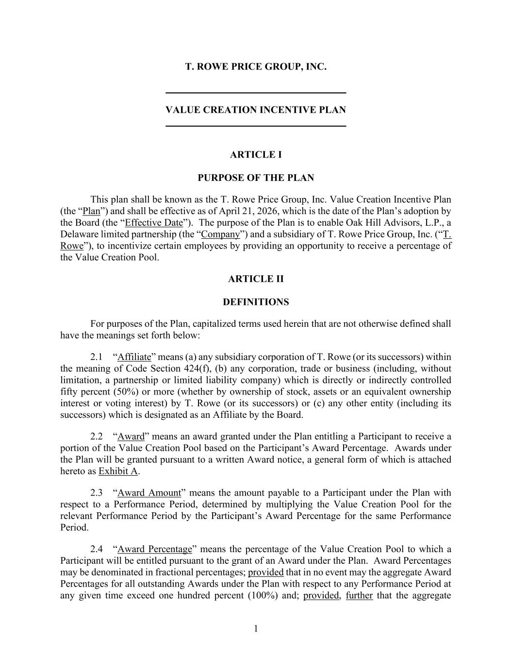
20
Page 46

1 T. ROWE PRICE GROUP, INC. VALUE CREATION INCENTIVE PLAN ARTICLE I PURPOSE OF THE PLAN This plan shall be known as the T. Rowe Price Group, Inc. Value Creation Incentive Plan (the “Plan”) and shall be effective as of April 21, 2026, which is the date of the Plan’s adoption by the Board (the “Effective Date”). The purpose of the Plan is to enable Oak Hill Advisors, L.P., a Delaware limited partnership (the “Company”) and a subsidiary of T. Rowe Price Group, Inc. (“T. Rowe”), to incentivize certain employees by providing an opportunity to receive a percentage of the Value Creation Pool. ARTICLE II DEFINITIONS For purposes of the Plan, capitalized terms used herein that are not otherwise defined shall have the meanings set forth below: 2.1 “Affiliate” means (a) any subsidiary corporation of T. Rowe (or its successors) within the meaning of Code Section 424(f), (b) any corporation, trade or business (including, without limitation, a partnership or limited liability company) which is directly or indirectly controlled fifty percent (50%) or more (whether by ownership of stock, assets or an equivalent ownership interest or voting interest) by T. Rowe (or its successors) or (c) any other entity (including its successors) which is designated as an Affiliate by the Board. 2.2 “Award” means an award granted under the Plan entitling a Participant to receive a portion of the Value Creation Pool based on the Participant’s Award Percentage. Awards under the Plan will be granted pursuant to a written Award notice, a general form of which is attached hereto as Exhibit A. 2.3 “Award Amount” means the amount payable to a Participant under the Plan with respect to a Performance Period, determined by multiplying the Value Creation Pool for the relevant Performance Period by the Participant’s Award Percentage for the same Performance Period. 2.4 “Award Percentage” means the percentage of the Value Creation Pool to which a Participant will be entitled pursuant to the grant of an Award under the Plan. Award Percentages may be denominated in fractional percentages; provided that in no event may the aggregate Award Percentages for all outstanding Awards under the Plan with respect to any Performance Period at any given time exceed one hundred percent (100%) and; provided, further that the aggregate

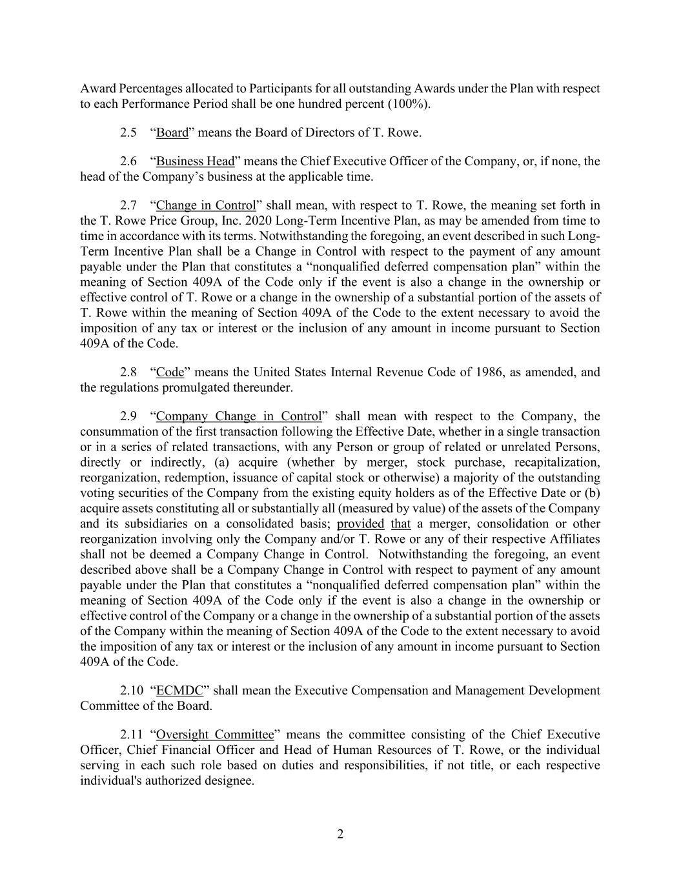
2 Award Percentages allocated to Participants for all outstanding Awards under the Plan with respect to each Performance Period shall be one hundred percent (100%). 2.5 “Board” means the Board of Directors of T. Rowe. 2.6 “Business Head” means the Chief Executive Officer of the Company, or, if none, the head of the Company’s business at the applicable time. 2.7 “Change in Control” shall mean, with respect to T. Rowe, the meaning set forth in the T. Rowe Price Group, Inc. 2020 Long-Term Incentive Plan, as may be amended from time to time in accordance with its terms. Notwithstanding the foregoing, an event described in such Long- Term Incentive Plan shall be a Change in Control with respect to the payment of any amount payable under the Plan that constitutes a “nonqualified deferred compensation plan” within the meaning of Section 409A of the Code only if the event is also a change in the ownership or effective control of T. Rowe or a change in the ownership of a substantial portion of the assets of T. Rowe within the meaning of Section 409A of the Code to the extent necessary to avoid the imposition of any tax or interest or the inclusion of any amount in income pursuant to Section 409A of the Code. 2.8 “Code” means the United States Internal Revenue Code of 1986, as amended, and the regulations promulgated thereunder. 2.9 “Company Change in Control” shall mean with respect to the Company, the consummation of the first transaction following the Effective Date, whether in a single transaction or in a series of related transactions, with any Person or group of related or unrelated Persons, directly or indirectly, (a) acquire (whether by merger, stock purchase, recapitalization, reorganization, redemption, issuance of capital stock or otherwise) a majority of the outstanding voting securities of the Company from the existing equity holders as of the Effective Date or (b) acquire assets constituting all or substantially all (measured by value) of the assets of the Company and its subsidiaries on a consolidated basis; provided that a merger, consolidation or other reorganization involving only the Company and/or T. Rowe or any of their respective Affiliates shall not be deemed a Company Change in Control. Notwithstanding the foregoing, an event described above shall be a Company Change in Control with respect to payment of any amount payable under the Plan that constitutes a “nonqualified deferred compensation plan” within the meaning of Section 409A of the Code only if the event is also a change in the ownership or effective control of the Company or a change in the ownership of a substantial portion of the assets of the Company within the meaning of Section 409A of the Code to the extent necessary to avoid the imposition of any tax or interest or the inclusion of any amount in income pursuant to Section 409A of the Code. 2.10 “ECMDC” shall mean the Executive Compensation and Management Development Committee of the Board. 2.11 “Oversight Committee” means the committee consisting of the Chief Executive Officer, Chief Financial Officer and Head of Human Resources of T. Rowe, or the individual serving in each such role based on duties and responsibilities, if not title, or each respective individual's authorized designee.

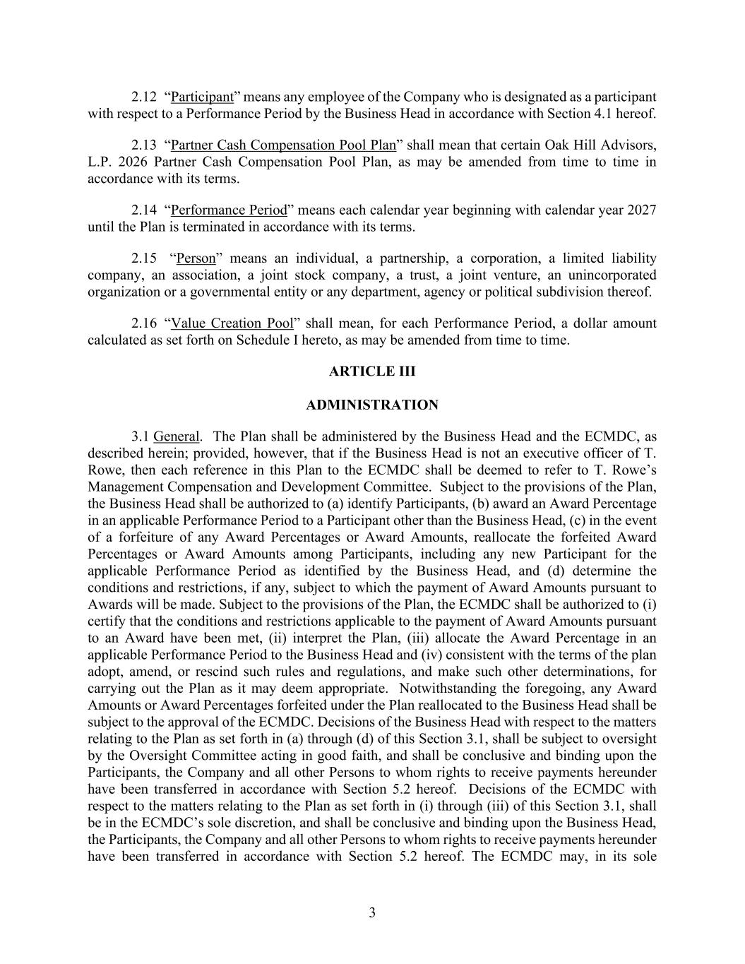
3 2.12 “Participant” means any employee of the Company who is designated as a participant with respect to a Performance Period by the Business Head in accordance with Section 4.1 hereof. 2.13 “Partner Cash Compensation Pool Plan” shall mean that certain Oak Hill Advisors, L.P. 2026 Partner Cash Compensation Pool Plan, as may be amended from time to time in accordance with its terms. 2.14 “Performance Period” means each calendar year beginning with calendar year 2027 until the Plan is terminated in accordance with its terms. 2.15 “Person” means an individual, a partnership, a corporation, a limited liability company, an association, a joint stock company, a trust, a joint venture, an unincorporated organization or a governmental entity or any department, agency or political subdivision thereof. 2.16 “Value Creation Pool” shall mean, for each Performance Period, a dollar amount calculated as set forth on Schedule I hereto, as may be amended from time to time. ARTICLE III ADMINISTRATION 3.1 General. The Plan shall be administered by the Business Head and the ECMDC, as described herein; provided, however, that if the Business Head is not an executive officer of T. Rowe, then each reference in this Plan to the ECMDC shall be deemed to refer to T. Rowe’s Management Compensation and Development Committee. Subject to the provisions of the Plan, the Business Head shall be authorized to (a) identify Participants, (b) award an Award Percentage in an applicable Performance Period to a Participant other than the Business Head, (c) in the event of a forfeiture of any Award Percentages or Award Amounts, reallocate the forfeited Award Percentages or Award Amounts among Participants, including any new Participant for the applicable Performance Period as identified by the Business Head, and (d) determine the conditions and restrictions, if any, subject to which the payment of Award Amounts pursuant to Awards will be made. Subject to the provisions of the Plan, the ECMDC shall be authorized to (i) certify that the conditions and restrictions applicable to the payment of Award Amounts pursuant to an Award have been met, (ii) interpret the Plan, (iii) allocate the Award Percentage in an applicable Performance Period to the Business Head and (iv) consistent with the terms of the plan adopt, amend, or rescind such rules and regulations, and make such other determinations, for carrying out the Plan as it may deem appropriate. Notwithstanding the foregoing, any Award Amounts or Award Percentages forfeited under the Plan reallocated to the Business Head shall be subject to the approval of the ECMDC. Decisions of the Business Head with respect to the matters relating to the Plan as set forth in (a) through (d) of this Section 3.1, shall be subject to oversight by the Oversight Committee acting in good faith, and shall be conclusive and binding upon the Participants, the Company and all other Persons to whom rights to receive payments hereunder have been transferred in accordance with Section 5.2 hereof. Decisions of the ECMDC with respect to the matters relating to the Plan as set forth in (i) through (iii) of this Section 3.1, shall be in the ECMDC’s sole discretion, and shall be conclusive and binding upon the Business Head, the Participants, the Company and all other Persons to whom rights to receive payments hereunder have been transferred in accordance with Section 5.2 hereof. The ECMDC may, in its sole

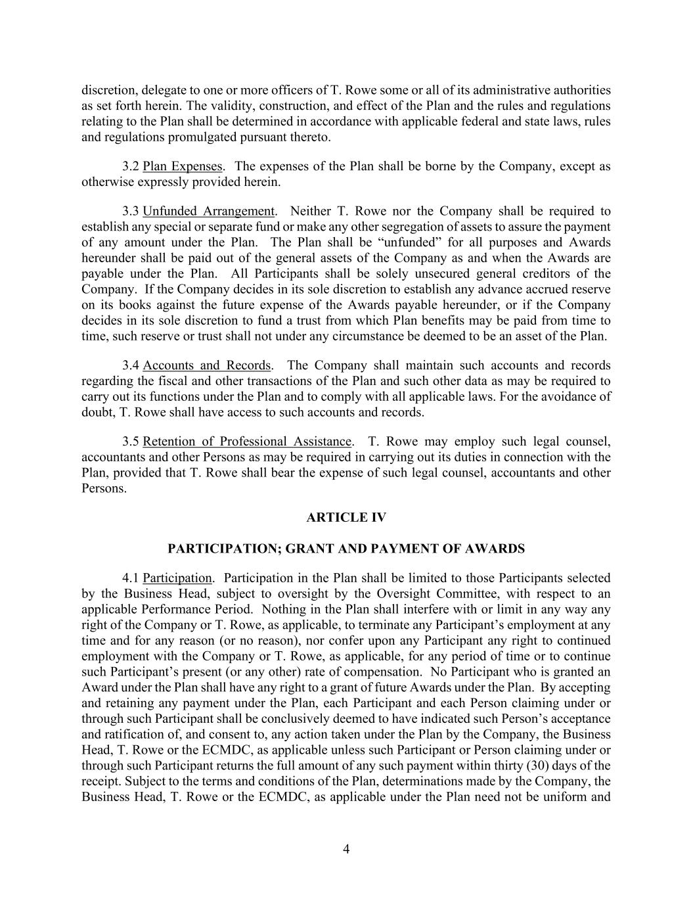
4 discretion, delegate to one or more officers of T. Rowe some or all of its administrative authorities as set forth herein. The validity, construction, and effect of the Plan and the rules and regulations relating to the Plan shall be determined in accordance with applicable federal and state laws, rules and regulations promulgated pursuant thereto. 3.2 Plan Expenses. The expenses of the Plan shall be borne by the Company, except as otherwise expressly provided herein. 3.3 Unfunded Arrangement. Neither T. Rowe nor the Company shall be required to establish any special or separate fund or make any other segregation of assets to assure the payment of any amount under the Plan. The Plan shall be “unfunded” for all purposes and Awards hereunder shall be paid out of the general assets of the Company as and when the Awards are payable under the Plan. All Participants shall be solely unsecured general creditors of the Company. If the Company decides in its sole discretion to establish any advance accrued reserve on its books against the future expense of the Awards payable hereunder, or if the Company decides in its sole discretion to fund a trust from which Plan benefits may be paid from time to time, such reserve or trust shall not under any circumstance be deemed to be an asset of the Plan. 3.4 Accounts and Records. The Company shall maintain such accounts and records regarding the fiscal and other transactions of the Plan and such other data as may be required to carry out its functions under the Plan and to comply with all applicable laws. For the avoidance of doubt, T. Rowe shall have access to such accounts and records. 3.5 Retention of Professional Assistance. T. Rowe may employ such legal counsel, accountants and other Persons as may be required in carrying out its duties in connection with the Plan, provided that T. Rowe shall bear the expense of such legal counsel, accountants and other Persons. ARTICLE IV PARTICIPATION; GRANT AND PAYMENT OF AWARDS 4.1 Participation. Participation in the Plan shall be limited to those Participants selected by the Business Head, subject to oversight by the Oversight Committee, with respect to an applicable Performance Period. Nothing in the Plan shall interfere with or limit in any way any right of the Company or T. Rowe, as applicable, to terminate any Participant’s employment at any time and for any reason (or no reason), nor confer upon any Participant any right to continued employment with the Company or T. Rowe, as applicable, for any period of time or to continue such Participant’s present (or any other) rate of compensation. No Participant who is granted an Award under the Plan shall have any right to a grant of future Awards under the Plan. By accepting and retaining any payment under the Plan, each Participant and each Person claiming under or through such Participant shall be conclusively deemed to have indicated such Person’s acceptance and ratification of, and consent to, any action taken under the Plan by the Company, the Business Head, T. Rowe or the ECMDC, as applicable unless such Participant or Person claiming under or through such Participant returns the full amount of any such payment within thirty (30) days of the receipt. Subject to the terms and conditions of the Plan, determinations made by the Company, the Business Head, T. Rowe or the ECMDC, as applicable under the Plan need not be uniform and

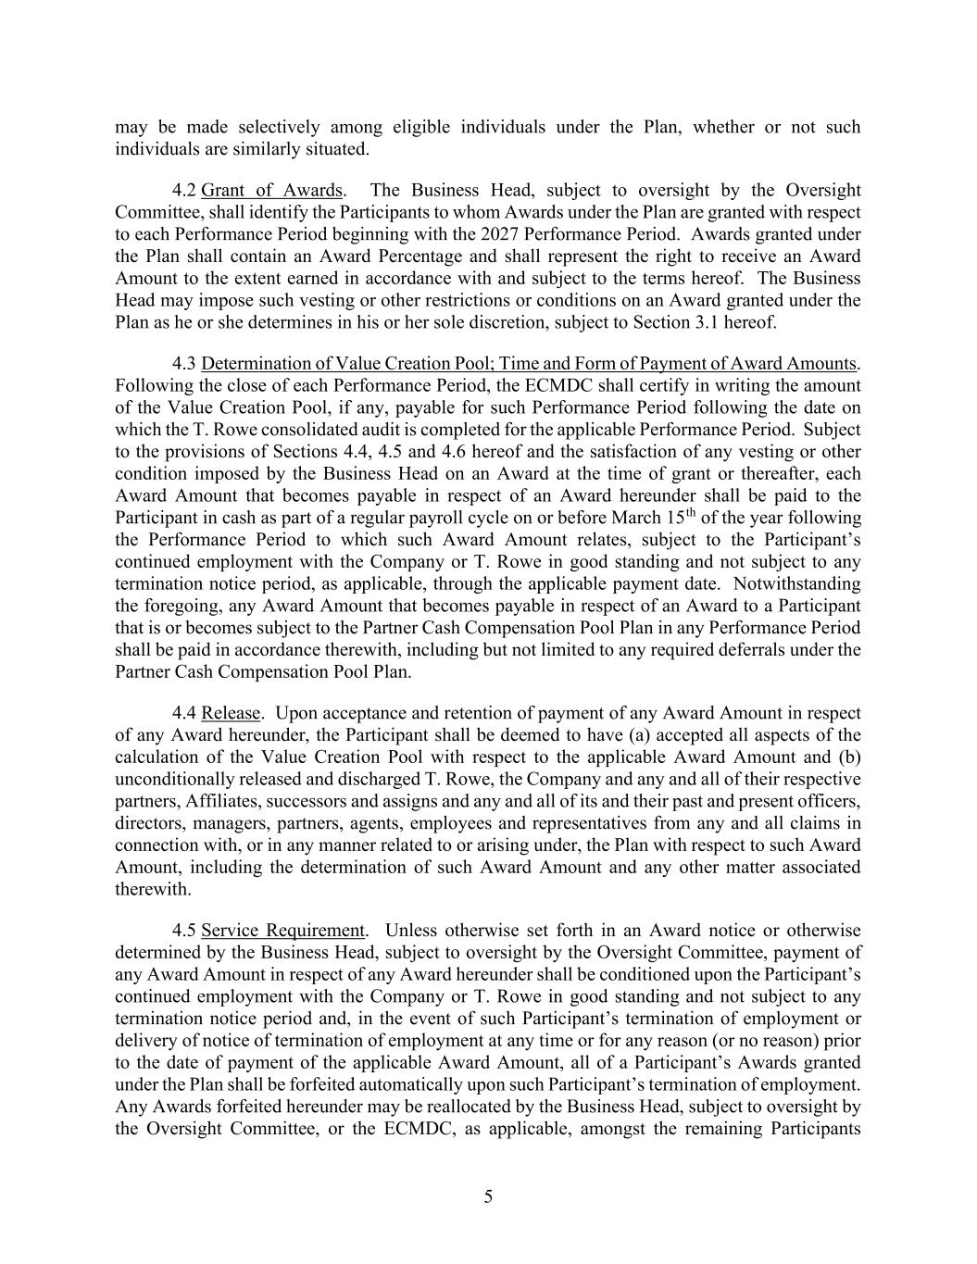
5 may be made selectively among eligible individuals under the Plan, whether or not such individuals are similarly situated. 4.2 Grant of Awards. The Business Head, subject to oversight by the Oversight Committee, shall identify the Participants to whom Awards under the Plan are granted with respect to each Performance Period beginning with the 2027 Performance Period. Awards granted under the Plan shall contain an Award Percentage and shall represent the right to receive an Award Amount to the extent earned in accordance with and subject to the terms hereof. The Business Head may impose such vesting or other restrictions or conditions on an Award granted under the Plan as he or she determines in his or her sole discretion, subject to Section 3.1 hereof. 4.3 Determination of Value Creation Pool; Time and Form of Payment of Award Amounts. Following the close of each Performance Period, the ECMDC shall certify in writing the amount of the Value Creation Pool, if any, payable for such Performance Period following the date on which the T. Rowe consolidated audit is completed for the applicable Performance Period. Subject to the provisions of Sections 4.4, 4.5 and 4.6 hereof and the satisfaction of any vesting or other condition imposed by the Business Head on an Award at the time of grant or thereafter, each Award Amount that becomes payable in respect of an Award hereunder shall be paid to the Participant in cash as part of a regular payroll cycle on or before March 15th of the year following the Performance Period to which such Award Amount relates, subject to the Participant’s continued employment with the Company or T. Rowe in good standing and not subject to any termination notice period, as applicable, through the applicable payment date. Notwithstanding the foregoing, any Award Amount that becomes payable in respect of an Award to a Participant that is or becomes subject to the Partner Cash Compensation Pool Plan in any Performance Period shall be paid in accordance therewith, including but not limited to any required deferrals under the Partner Cash Compensation Pool Plan. 4.4 Release. Upon acceptance and retention of payment of any Award Amount in respect of any Award hereunder, the Participant shall be deemed to have (a) accepted all aspects of the calculation of the Value Creation Pool with respect to the applicable Award Amount and (b) unconditionally released and discharged T. Rowe, the Company and any and all of their respective partners, Affiliates, successors and assigns and any and all of its and their past and present officers, directors, managers, partners, agents, employees and representatives from any and all claims in connection with, or in any manner related to or arising under, the Plan with respect to such Award Amount, including the determination of such Award Amount and any other matter associated therewith. 4.5 Service Requirement. Unless otherwise set forth in an Award notice or otherwise determined by the Business Head, subject to oversight by the Oversight Committee, payment of any Award Amount in respect of any Award hereunder shall be conditioned upon the Participant’s continued employment with the Company or T. Rowe in good standing and not subject to any termination notice period and, in the event of such Participant’s termination of employment or delivery of notice of termination of employment at any time or for any reason (or no reason) prior to the date of payment of the applicable Award Amount, all of a Participant’s Awards granted under the Plan shall be forfeited automatically upon such Participant’s termination of employment. Any Awards forfeited hereunder may be reallocated by the Business Head, subject to oversight by the Oversight Committee, or the ECMDC, as applicable, amongst the remaining Participants

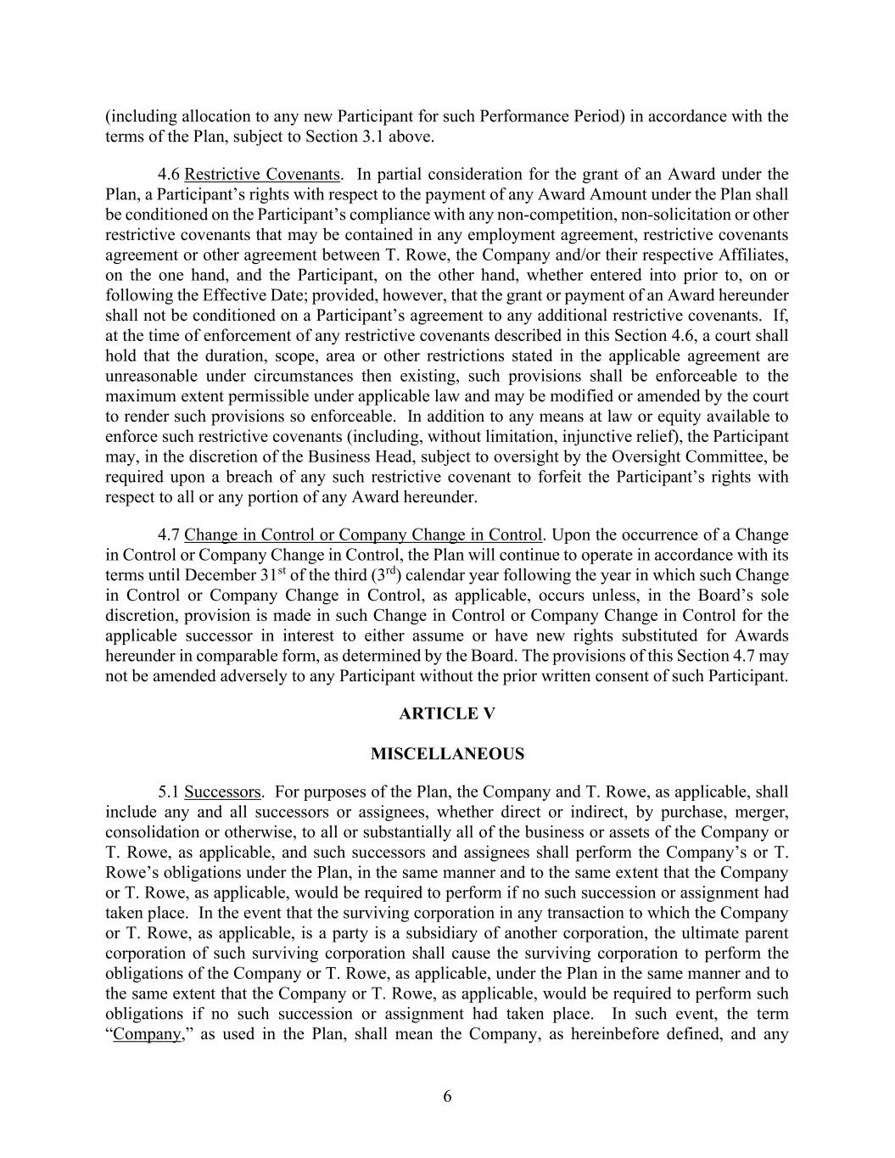
6 (including allocation to any new Participant for such Performance Period) in accordance with the terms of the Plan, subject to Section 3.1 above. 4.6 Restrictive Covenants. In partial consideration for the grant of an Award under the Plan, a Participant’s rights with respect to the payment of any Award Amount under the Plan shall be conditioned on the Participant’s compliance with any non-competition, non-solicitation or other restrictive covenants that may be contained in any employment agreement, restrictive covenants agreement or other agreement between T. Rowe, the Company and/or their respective Affiliates, on the one hand, and the Participant, on the other hand, whether entered into prior to, on or following the Effective Date; provided, however, that the grant or payment of an Award hereunder shall not be conditioned on a Participant’s agreement to any additional restrictive covenants. If, at the time of enforcement of any restrictive covenants described in this Section 4.6, a court shall hold that the duration, scope, area or other restrictions stated in the applicable agreement are unreasonable under circumstances then existing, such provisions shall be enforceable to the maximum extent permissible under applicable law and may be modified or amended by the court to render such provisions so enforceable. In addition to any means at law or equity available to enforce such restrictive covenants (including, without limitation, injunctive relief), the Participant may, in the discretion of the Business Head, subject to oversight by the Oversight Committee, be required upon a breach of any such restrictive covenant to forfeit the Participant’s rights with respect to all or any portion of any Award hereunder. 4.7 Change in Control or Company Change in Control. Upon the occurrence of a Change in Control or Company Change in Control, the Plan will continue to operate in accordance with its terms until December 31st of the third (3rd) calendar year following the year in which such Change in Control or Company Change in Control, as applicable, occurs unless, in the Board’s sole discretion, provision is made in such Change in Control or Company Change in Control for the applicable successor in interest to either assume or have new rights substituted for Awards hereunder in comparable form, as determined by the Board. The provisions of this Section 4.7 may not be amended adversely to any Participant without the prior written consent of such Participant. ARTICLE V MISCELLANEOUS 5.1 Successors. For purposes of the Plan, the Company and T. Rowe, as applicable, shall include any and all successors or assignees, whether direct or indirect, by purchase, merger, consolidation or otherwise, to all or substantially all of the business or assets of the Company or T. Rowe, as applicable, and such successors and assignees shall perform the Company’s or T. Rowe’s obligations under the Plan, in the same manner and to the same extent that the Company or T. Rowe, as applicable, would be required to perform if no such succession or assignment had taken place. In the event that the surviving corporation in any transaction to which the Company or T. Rowe, as applicable, is a party is a subsidiary of another corporation, the ultimate parent corporation of such surviving corporation shall cause the surviving corporation to perform the obligations of the Company or T. Rowe, as applicable, under the Plan in the same manner and to the same extent that the Company or T. Rowe, as applicable, would be required to perform such obligations if no such succession or assignment had taken place. In such event, the term “Company,” as used in the Plan, shall mean the Company, as hereinbefore defined, and any

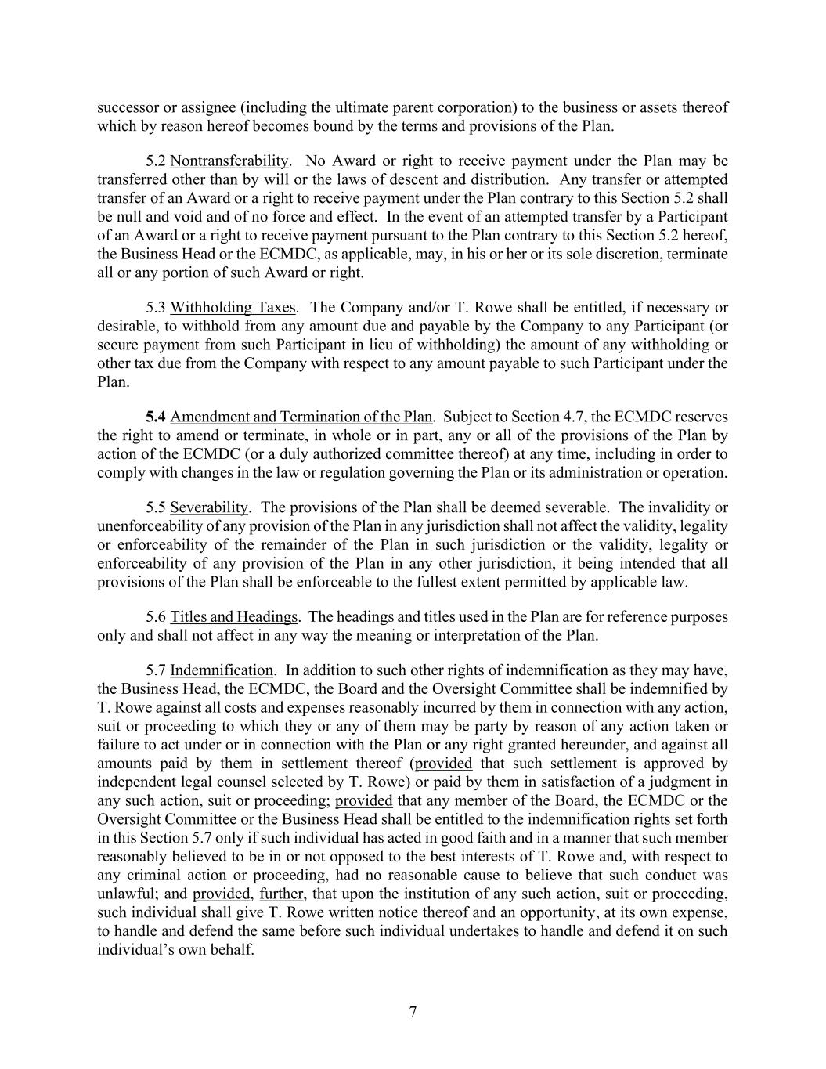
7 successor or assignee (including the ultimate parent corporation) to the business or assets thereof which by reason hereof becomes bound by the terms and provisions of the Plan. 5.2 Nontransferability. No Award or right to receive payment under the Plan may be transferred other than by will or the laws of descent and distribution. Any transfer or attempted transfer of an Award or a right to receive payment under the Plan contrary to this Section 5.2 shall be null and void and of no force and effect. In the event of an attempted transfer by a Participant of an Award or a right to receive payment pursuant to the Plan contrary to this Section 5.2 hereof, the Business Head or the ECMDC, as applicable, may, in his or her or its sole discretion, terminate all or any portion of such Award or right. 5.3 Withholding Taxes. The Company and/or T. Rowe shall be entitled, if necessary or desirable, to withhold from any amount due and payable by the Company to any Participant (or secure payment from such Participant in lieu of withholding) the amount of any withholding or other tax due from the Company with respect to any amount payable to such Participant under the Plan. 5.4 Amendment and Termination of the Plan. Subject to Section 4.7, the ECMDC reserves the right to amend or terminate, in whole or in part, any or all of the provisions of the Plan by action of the ECMDC (or a duly authorized committee thereof) at any time, including in order to comply with changes in the law or regulation governing the Plan or its administration or operation. 5.5 Severability. The provisions of the Plan shall be deemed severable. The invalidity or unenforceability of any provision of the Plan in any jurisdiction shall not affect the validity, legality or enforceability of the remainder of the Plan in such jurisdiction or the validity, legality or enforceability of any provision of the Plan in any other jurisdiction, it being intended that all provisions of the Plan shall be enforceable to the fullest extent permitted by applicable law. 5.6 Titles and Headings. The headings and titles used in the Plan are for reference purposes only and shall not affect in any way the meaning or interpretation of the Plan. 5.7 Indemnification. In addition to such other rights of indemnification as they may have, the Business Head, the ECMDC, the Board and the Oversight Committee shall be indemnified by T. Rowe against all costs and expenses reasonably incurred by them in connection with any action, suit or proceeding to which they or any of them may be party by reason of any action taken or failure to act under or in connection with the Plan or any right granted hereunder, and against all amounts paid by them in settlement thereof (provided that such settlement is approved by independent legal counsel selected by T. Rowe) or paid by them in satisfaction of a judgment in any such action, suit or proceeding; provided that any member of the Board, the ECMDC or the Oversight Committee or the Business Head shall be entitled to the indemnification rights set forth in this Section 5.7 only if such individual has acted in good faith and in a manner that such member reasonably believed to be in or not opposed to the best interests of T. Rowe and, with respect to any criminal action or proceeding, had no reasonable cause to believe that such conduct was unlawful; and provided, further, that upon the institution of any such action, suit or proceeding, such individual shall give T. Rowe written notice thereof and an opportunity, at its own expense, to handle and defend the same before such individual undertakes to handle and defend it on such individual’s own behalf.

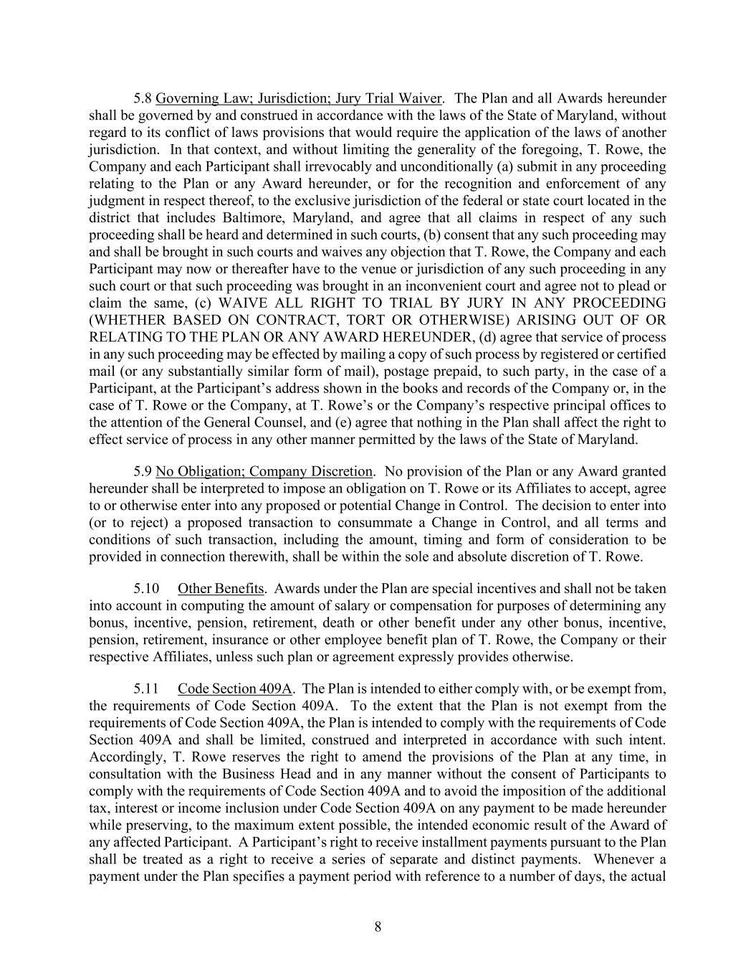
8 5.8 Governing Law; Jurisdiction; Jury Trial Waiver. The Plan and all Awards hereunder shall be governed by and construed in accordance with the laws of the State of Maryland, without regard to its conflict of laws provisions that would require the application of the laws of another jurisdiction. In that context, and without limiting the generality of the foregoing, T. Rowe, the Company and each Participant shall irrevocably and unconditionally (a) submit in any proceeding relating to the Plan or any Award hereunder, or for the recognition and enforcement of any judgment in respect thereof, to the exclusive jurisdiction of the federal or state court located in the district that includes Baltimore, Maryland, and agree that all claims in respect of any such proceeding shall be heard and determined in such courts, (b) consent that any such proceeding may and shall be brought in such courts and waives any objection that T. Rowe, the Company and each Participant may now or thereafter have to the venue or jurisdiction of any such proceeding in any such court or that such proceeding was brought in an inconvenient court and agree not to plead or claim the same, (c) WAIVE ALL RIGHT TO TRIAL BY JURY IN ANY PROCEEDING (WHETHER BASED ON CONTRACT, TORT OR OTHERWISE) ARISING OUT OF OR RELATING TO THE PLAN OR ANY AWARD HEREUNDER, (d) agree that service of process in any such proceeding may be effected by mailing a copy of such process by registered or certified mail (or any substantially similar form of mail), postage prepaid, to such party, in the case of a Participant, at the Participant’s address shown in the books and records of the Company or, in the case of T. Rowe or the Company, at T. Rowe’s or the Company’s respective principal offices to the attention of the General Counsel, and (e) agree that nothing in the Plan shall affect the right to effect service of process in any other manner permitted by the laws of the State of Maryland. 5.9 No Obligation; Company Discretion. No provision of the Plan or any Award granted hereunder shall be interpreted to impose an obligation on T. Rowe or its Affiliates to accept, agree to or otherwise enter into any proposed or potential Change in Control. The decision to enter into (or to reject) a proposed transaction to consummate a Change in Control, and all terms and conditions of such transaction, including the amount, timing and form of consideration to be provided in connection therewith, shall be within the sole and absolute discretion of T. Rowe. 5.10 Other Benefits. Awards under the Plan are special incentives and shall not be taken into account in computing the amount of salary or compensation for purposes of determining any bonus, incentive, pension, retirement, death or other benefit under any other bonus, incentive, pension, retirement, insurance or other employee benefit plan of T. Rowe, the Company or their respective Affiliates, unless such plan or agreement expressly provides otherwise. 5.11 Code Section 409A. The Plan is intended to either comply with, or be exempt from, the requirements of Code Section 409A. To the extent that the Plan is not exempt from the requirements of Code Section 409A, the Plan is intended to comply with the requirements of Code Section 409A and shall be limited, construed and interpreted in accordance with such intent. Accordingly, T. Rowe reserves the right to amend the provisions of the Plan at any time, in consultation with the Business Head and in any manner without the consent of Participants to comply with the requirements of Code Section 409A and to avoid the imposition of the additional tax, interest or income inclusion under Code Section 409A on any payment to be made hereunder while preserving, to the maximum extent possible, the intended economic result of the Award of any affected Participant. A Participant’s right to receive installment payments pursuant to the Plan shall be treated as a right to receive a series of separate and distinct payments. Whenever a payment under the Plan specifies a payment period with reference to a number of days, the actual


9 date of payment within the specified period shall be within the sole discretion of T. Rowe. Notwithstanding the foregoing, in no event whatsoever shall T. Rowe be liable for any additional tax, interest, income inclusion or other penalty that may be imposed on a Participant by Code Section 409A or for damages for failing to comply with Code Section 409A. T. ROWE PRICE GROUP, INC.

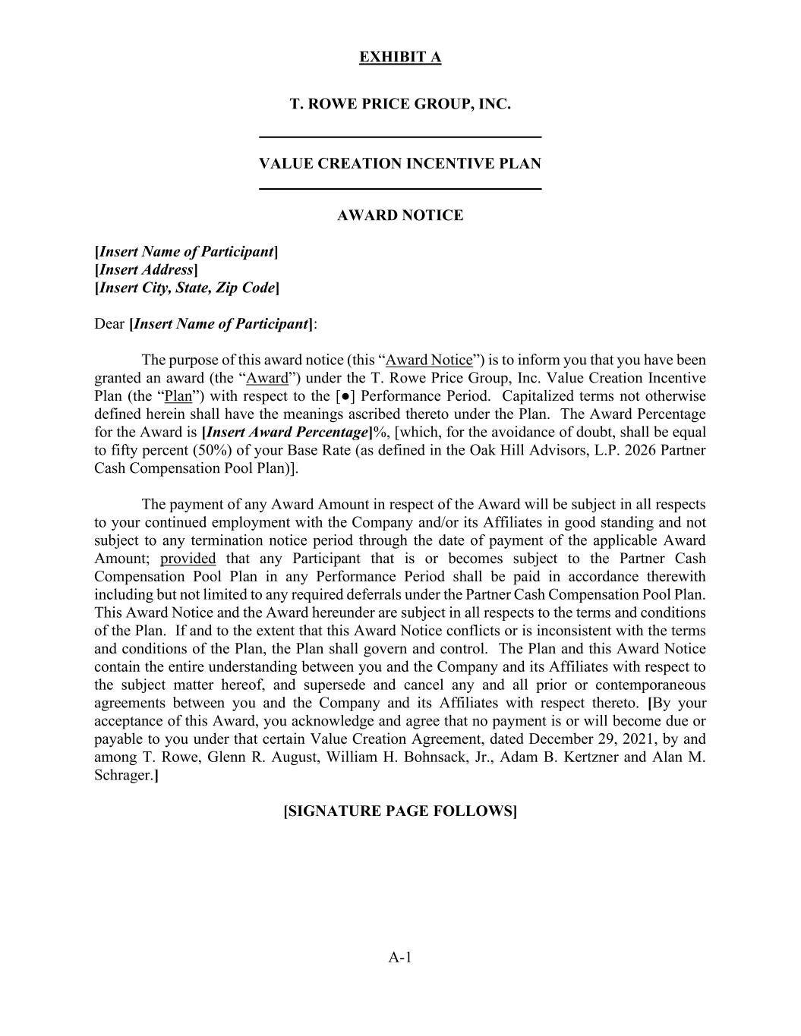
EXHIBIT A A-1 T. ROWE PRICE GROUP, INC. VALUE CREATION INCENTIVE PLAN AWARD NOTICE [Insert Name of Participant] [Insert Address] [Insert City, State, Zip Code] Dear [Insert Name of Participant]: The purpose of this award notice (this “Award Notice”) is to inform you that you have been granted an award (the “Award”) under the T. Rowe Price Group, Inc. Value Creation Incentive Plan (the “Plan”) with respect to the [●] Performance Period. Capitalized terms not otherwise defined herein shall have the meanings ascribed thereto under the Plan. The Award Percentage for the Award is [Insert Award Percentage]%, [which, for the avoidance of doubt, shall be equal to fifty percent (50%) of your Base Rate (as defined in the Oak Hill Advisors, L.P. 2026 Partner Cash Compensation Pool Plan)]. The payment of any Award Amount in respect of the Award will be subject in all respects to your continued employment with the Company and/or its Affiliates in good standing and not subject to any termination notice period through the date of payment of the applicable Award Amount; provided that any Participant that is or becomes subject to the Partner Cash Compensation Pool Plan in any Performance Period shall be paid in accordance therewith including but not limited to any required deferrals under the Partner Cash Compensation Pool Plan. This Award Notice and the Award hereunder are subject in all respects to the terms and conditions of the Plan. If and to the extent that this Award Notice conflicts or is inconsistent with the terms and conditions of the Plan, the Plan shall govern and control. The Plan and this Award Notice contain the entire understanding between you and the Company and its Affiliates with respect to the subject matter hereof, and supersede and cancel any and all prior or contemporaneous agreements between you and the Company and its Affiliates with respect thereto. [By your acceptance of this Award, you acknowledge and agree that no payment is or will become due or payable to you under that certain Value Creation Agreement, dated December 29, 2021, by and among T. Rowe, Glenn R. August, William H. Bohnsack, Jr., Adam B. Kertzner and Alan M. Schrager.] [SIGNATURE PAGE FOLLOWS]


SIGNATURE PAGE TO AWARD NOTICE T. ROWE PRICE GROUP, INC. By: Name: Title: ACKNOWLEDGEMENT I hereby acknowledge that (i) I have received and reviewed a copy of the Plan, and (ii) this Award Notice, the Award and my participation in the Plan are subject in all respects to the terms and conditions of the Plan. Dated: , 20 Participant’s Signature

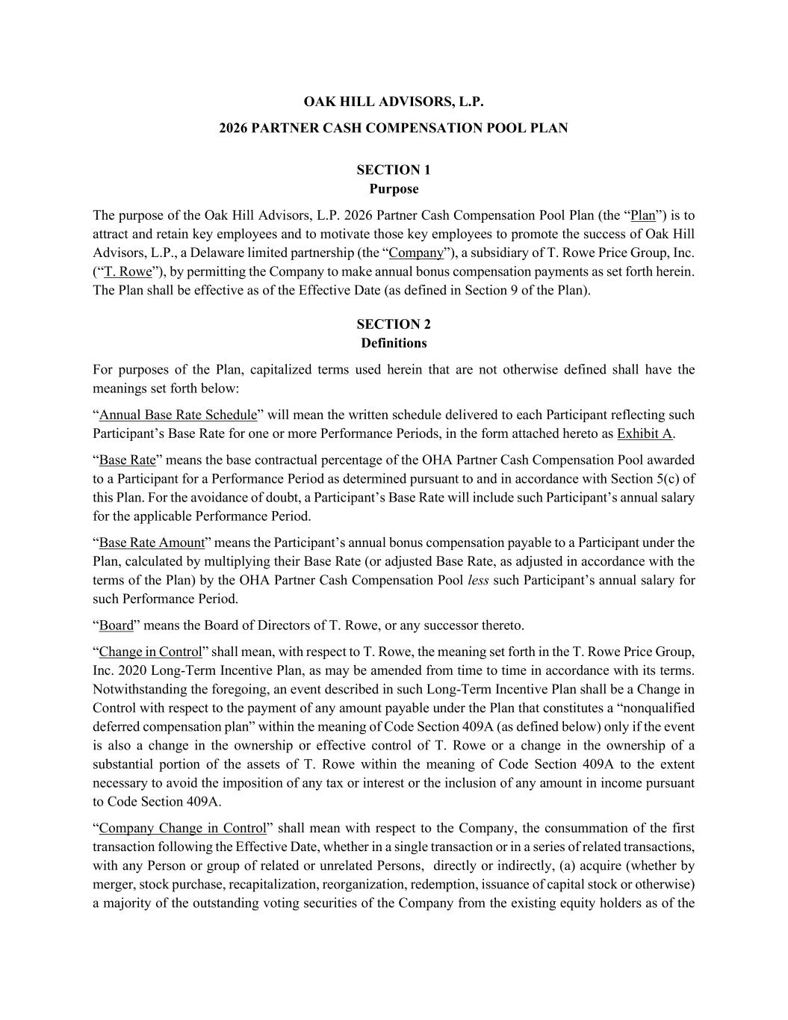
OAK HILL ADVISORS, L.P. 2026 PARTNER CASH COMPENSATION POOL PLAN SECTION 1 Purpose The purpose of the Oak Hill Advisors, L.P. 2026 Partner Cash Compensation Pool Plan (the “Plan”) is to attract and retain key employees and to motivate those key employees to promote the success of Oak Hill Advisors, L.P., a Delaware limited partnership (the “Company”), a subsidiary of T. Rowe Price Group, Inc. (“T. Rowe”), by permitting the Company to make annual bonus compensation payments as set forth herein. The Plan shall be effective as of the Effective Date (as defined in Section 9 of the Plan). SECTION 2 Definitions For purposes of the Plan, capitalized terms used herein that are not otherwise defined shall have the meanings set forth below: “Annual Base Rate Schedule” will mean the written schedule delivered to each Participant reflecting such Participant’s Base Rate for one or more Performance Periods, in the form attached hereto as Exhibit A. “Base Rate” means the base contractual percentage of the OHA Partner Cash Compensation Pool awarded to a Participant for a Performance Period as determined pursuant to and in accordance with Section 5(c) of this Plan. For the avoidance of doubt, a Participant’s Base Rate will include such Participant’s annual salary for the applicable Performance Period. “Base Rate Amount” means the Participant’s annual bonus compensation payable to a Participant under the Plan, calculated by multiplying their Base Rate (or adjusted Base Rate, as adjusted in accordance with the terms of the Plan) by the OHA Partner Cash Compensation Pool less such Participant’s annual salary for such Performance Period. “Board” means the Board of Directors of T. Rowe, or any successor thereto. “Change in Control” shall mean, with respect to T. Rowe, the meaning set forth in the T. Rowe Price Group, Inc. 2020 Long-Term Incentive Plan, as may be amended from time to time in accordance with its terms. Notwithstanding the foregoing, an event described in such Long-Term Incentive Plan shall be a Change in Control with respect to the payment of any amount payable under the Plan that constitutes a “nonqualified deferred compensation plan” within the meaning of Code Section 409A (as defined below) only if the event is also a change in the ownership or effective control of T. Rowe or a change in the ownership of a substantial portion of the assets of T. Rowe within the meaning of Code Section 409A to the extent necessary to avoid the imposition of any tax or interest or the inclusion of any amount in income pursuant to Code Section 409A. “Company Change in Control” shall mean with respect to the Company, the consummation of the first transaction following the Effective Date, whether in a single transaction or in a series of related transactions, with any Person or group of related or unrelated Persons, directly or indirectly, (a) acquire (whether by merger, stock purchase, recapitalization, reorganization, redemption, issuance of capital stock or otherwise) a majority of the outstanding voting securities of the Company from the existing equity holders as of the

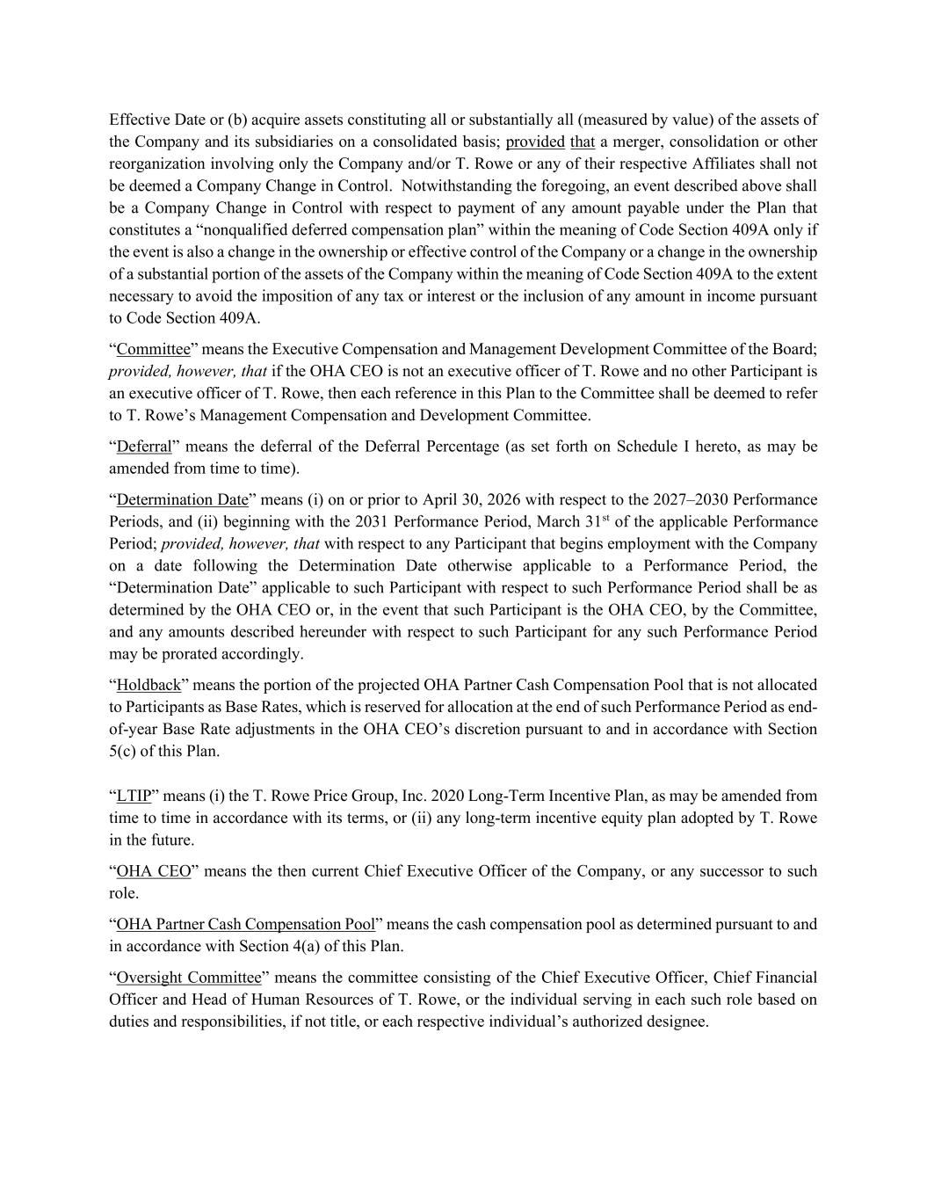
Effective Date or (b) acquire assets constituting all or substantially all (measured by value) of the assets of the Company and its subsidiaries on a consolidated basis; provided that a merger, consolidation or other reorganization involving only the Company and/or T. Rowe or any of their respective Affiliates shall not be deemed a Company Change in Control. Notwithstanding the foregoing, an event described above shall be a Company Change in Control with respect to payment of any amount payable under the Plan that constitutes a “nonqualified deferred compensation plan” within the meaning of Code Section 409A only if the event is also a change in the ownership or effective control of the Company or a change in the ownership of a substantial portion of the assets of the Company within the meaning of Code Section 409A to the extent necessary to avoid the imposition of any tax or interest or the inclusion of any amount in income pursuant to Code Section 409A. “Committee” means the Executive Compensation and Management Development Committee of the Board; provided, however, that if the OHA CEO is not an executive officer of T. Rowe and no other Participant is an executive officer of T. Rowe, then each reference in this Plan to the Committee shall be deemed to refer to T. Rowe’s Management Compensation and Development Committee. “Deferral” means the deferral of the Deferral Percentage (as set forth on Schedule I hereto, as may be amended from time to time). “Determination Date” means (i) on or prior to April 30, 2026 with respect to the 2027–2030 Performance Periods, and (ii) beginning with the 2031 Performance Period, March 31st of the applicable Performance Period; provided, however, that with respect to any Participant that begins employment with the Company on a date following the Determination Date otherwise applicable to a Performance Period, the “Determination Date” applicable to such Participant with respect to such Performance Period shall be as determined by the OHA CEO or, in the event that such Participant is the OHA CEO, by the Committee, and any amounts described hereunder with respect to such Participant for any such Performance Period may be prorated accordingly. “Holdback” means the portion of the projected OHA Partner Cash Compensation Pool that is not allocated to Participants as Base Rates, which is reserved for allocation at the end of such Performance Period as end- of-year Base Rate adjustments in the OHA CEO’s discretion pursuant to and in accordance with Section 5(c) of this Plan. “LTIP” means (i) the T. Rowe Price Group, Inc. 2020 Long-Term Incentive Plan, as may be amended from time to time in accordance with its terms, or (ii) any long-term incentive equity plan adopted by T. Rowe in the future. “OHA CEO” means the then current Chief Executive Officer of the Company, or any successor to such role. “OHA Partner Cash Compensation Pool” means the cash compensation pool as determined pursuant to and in accordance with Section 4(a) of this Plan. “Oversight Committee” means the committee consisting of the Chief Executive Officer, Chief Financial Officer and Head of Human Resources of T. Rowe, or the individual serving in each such role based on duties and responsibilities, if not title, or each respective individual’s authorized designee.

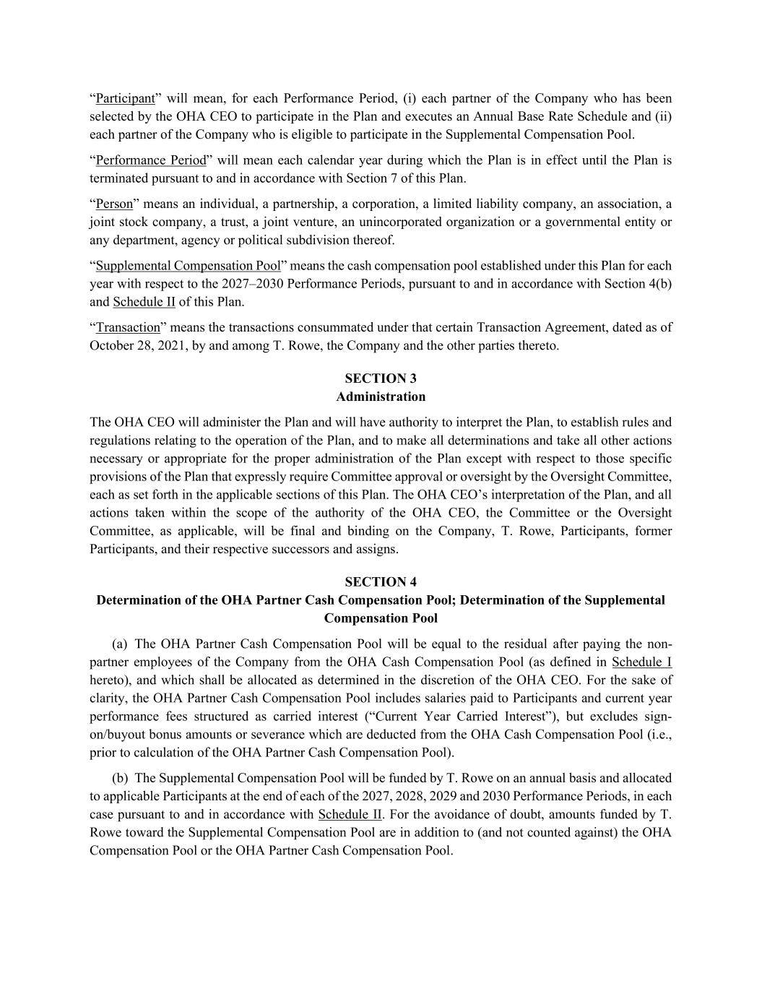
“Participant” will mean, for each Performance Period, (i) each partner of the Company who has been selected by the OHA CEO to participate in the Plan and executes an Annual Base Rate Schedule and (ii) each partner of the Company who is eligible to participate in the Supplemental Compensation Pool. “Performance Period” will mean each calendar year during which the Plan is in effect until the Plan is terminated pursuant to and in accordance with Section 7 of this Plan. “Person” means an individual, a partnership, a corporation, a limited liability company, an association, a joint stock company, a trust, a joint venture, an unincorporated organization or a governmental entity or any department, agency or political subdivision thereof. “Supplemental Compensation Pool” means the cash compensation pool established under this Plan for each year with respect to the 2027–2030 Performance Periods, pursuant to and in accordance with Section 4(b) and Schedule II of this Plan. “Transaction” means the transactions consummated under that certain Transaction Agreement, dated as of October 28, 2021, by and among T. Rowe, the Company and the other parties thereto. SECTION 3 Administration The OHA CEO will administer the Plan and will have authority to interpret the Plan, to establish rules and regulations relating to the operation of the Plan, and to make all determinations and take all other actions necessary or appropriate for the proper administration of the Plan except with respect to those specific provisions of the Plan that expressly require Committee approval or oversight by the Oversight Committee, each as set forth in the applicable sections of this Plan. The OHA CEO’s interpretation of the Plan, and all actions taken within the scope of the authority of the OHA CEO, the Committee or the Oversight Committee, as applicable, will be final and binding on the Company, T. Rowe, Participants, former Participants, and their respective successors and assigns. SECTION 4 Determination of the OHA Partner Cash Compensation Pool; Determination of the Supplemental Compensation Pool (a) The OHA Partner Cash Compensation Pool will be equal to the residual after paying the non- partner employees of the Company from the OHA Cash Compensation Pool (as defined in Schedule I hereto), and which shall be allocated as determined in the discretion of the OHA CEO. For the sake of clarity, the OHA Partner Cash Compensation Pool includes salaries paid to Participants and current year performance fees structured as carried interest (“Current Year Carried Interest”), but excludes sign- on/buyout bonus amounts or severance which are deducted from the OHA Cash Compensation Pool (i.e., prior to calculation of the OHA Partner Cash Compensation Pool). (b) The Supplemental Compensation Pool will be funded by T. Rowe on an annual basis and allocated to applicable Participants at the end of each of the 2027, 2028, 2029 and 2030 Performance Periods, in each case pursuant to and in accordance with Schedule II. For the avoidance of doubt, amounts funded by T. Rowe toward the Supplemental Compensation Pool are in addition to (and not counted against) the OHA Compensation Pool or the OHA Partner Cash Compensation Pool.

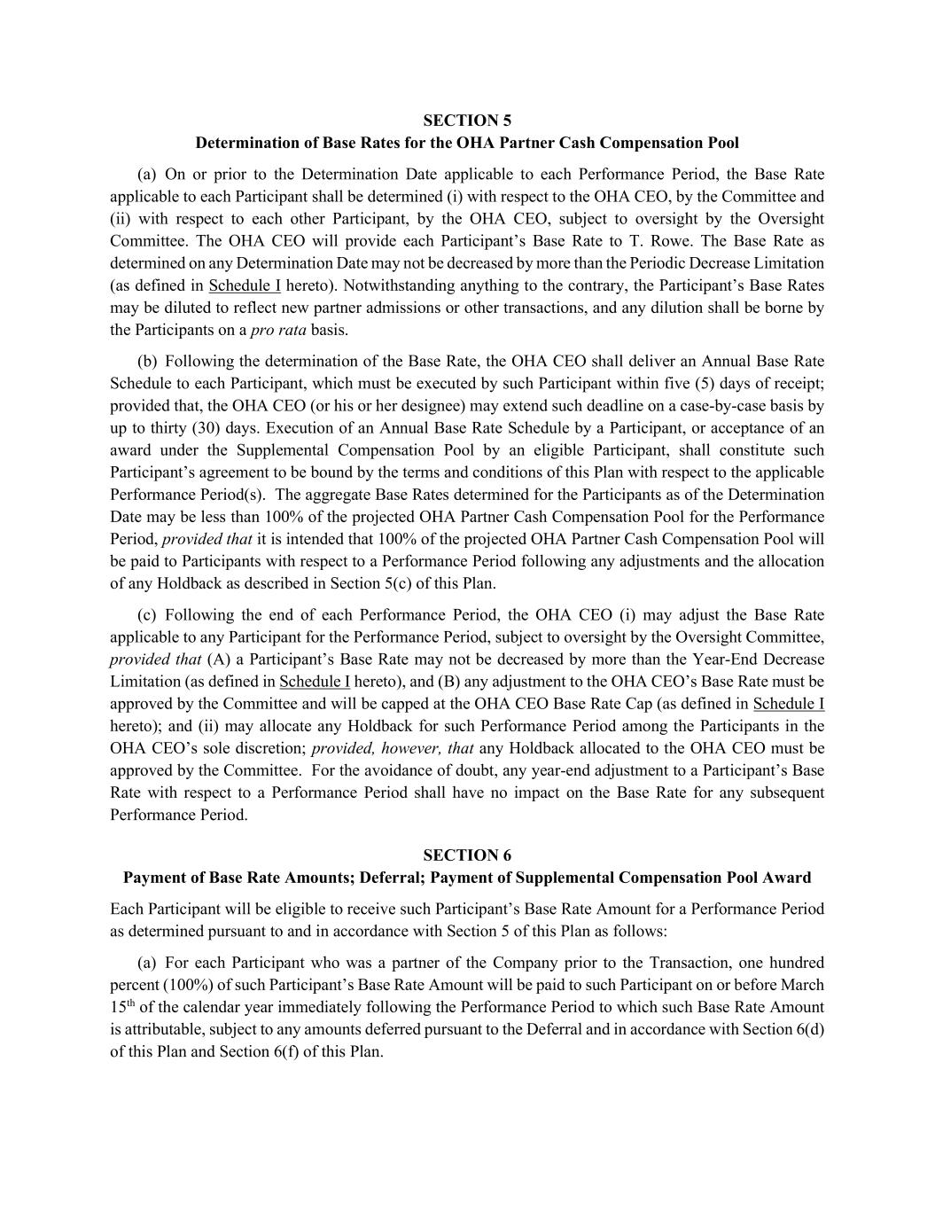
SECTION 5 Determination of Base Rates for the OHA Partner Cash Compensation Pool (a) On or prior to the Determination Date applicable to each Performance Period, the Base Rate applicable to each Participant shall be determined (i) with respect to the OHA CEO, by the Committee and (ii) with respect to each other Participant, by the OHA CEO, subject to oversight by the Oversight Committee. The OHA CEO will provide each Participant’s Base Rate to T. Rowe. The Base Rate as determined on any Determination Date may not be decreased by more than the Periodic Decrease Limitation (as defined in Schedule I hereto). Notwithstanding anything to the contrary, the Participant’s Base Rates may be diluted to reflect new partner admissions or other transactions, and any dilution shall be borne by the Participants on a pro rata basis. (b) Following the determination of the Base Rate, the OHA CEO shall deliver an Annual Base Rate Schedule to each Participant, which must be executed by such Participant within five (5) days of receipt; provided that, the OHA CEO (or his or her designee) may extend such deadline on a case-by-case basis by up to thirty (30) days. Execution of an Annual Base Rate Schedule by a Participant, or acceptance of an award under the Supplemental Compensation Pool by an eligible Participant, shall constitute such Participant’s agreement to be bound by the terms and conditions of this Plan with respect to the applicable Performance Period(s). The aggregate Base Rates determined for the Participants as of the Determination Date may be less than 100% of the projected OHA Partner Cash Compensation Pool for the Performance Period, provided that it is intended that 100% of the projected OHA Partner Cash Compensation Pool will be paid to Participants with respect to a Performance Period following any adjustments and the allocation of any Holdback as described in Section 5(c) of this Plan. (c) Following the end of each Performance Period, the OHA CEO (i) may adjust the Base Rate applicable to any Participant for the Performance Period, subject to oversight by the Oversight Committee, provided that (A) a Participant’s Base Rate may not be decreased by more than the Year-End Decrease Limitation (as defined in Schedule I hereto), and (B) any adjustment to the OHA CEO’s Base Rate must be approved by the Committee and will be capped at the OHA CEO Base Rate Cap (as defined in Schedule I hereto); and (ii) may allocate any Holdback for such Performance Period among the Participants in the OHA CEO’s sole discretion; provided, however, that any Holdback allocated to the OHA CEO must be approved by the Committee. For the avoidance of doubt, any year-end adjustment to a Participant’s Base Rate with respect to a Performance Period shall have no impact on the Base Rate for any subsequent Performance Period. SECTION 6 Payment of Base Rate Amounts; Deferral; Payment of Supplemental Compensation Pool Award Each Participant will be eligible to receive such Participant’s Base Rate Amount for a Performance Period as determined pursuant to and in accordance with Section 5 of this Plan as follows: (a) For each Participant who was a partner of the Company prior to the Transaction, one hundred percent (100%) of such Participant’s Base Rate Amount will be paid to such Participant on or before March 15th of the calendar year immediately following the Performance Period to which such Base Rate Amount is attributable, subject to any amounts deferred pursuant to the Deferral and in accordance with Section 6(d) of this Plan and Section 6(f) of this Plan.

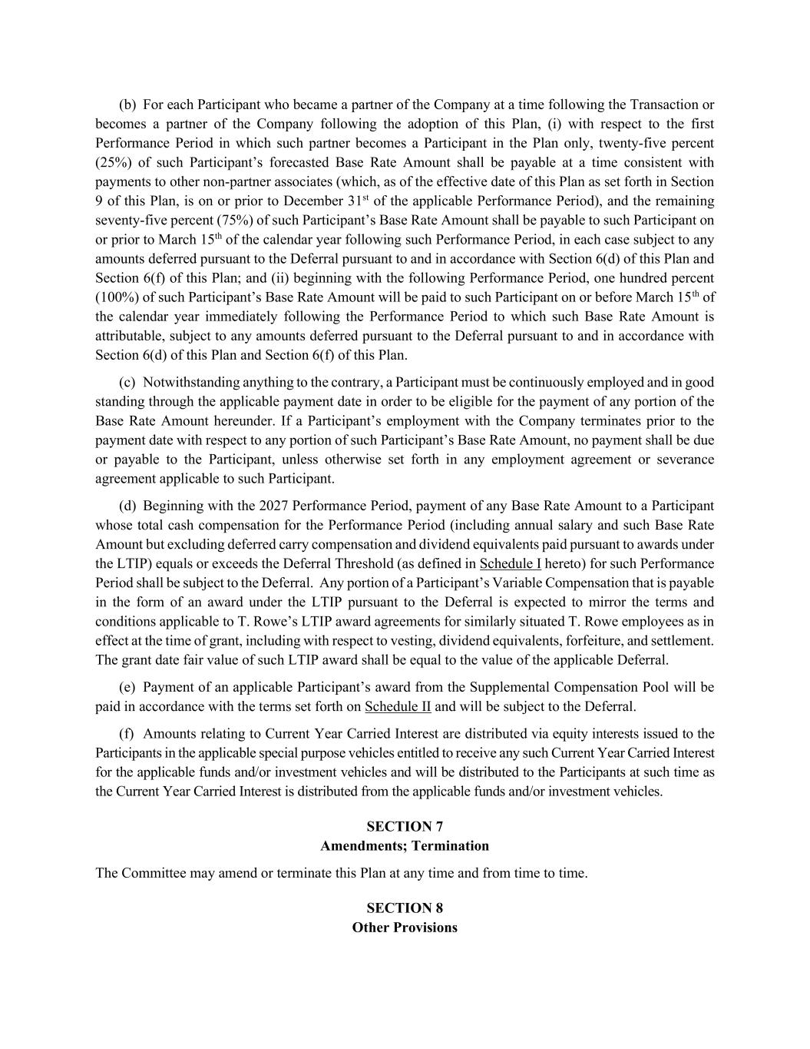
(b) For each Participant who became a partner of the Company at a time following the Transaction or becomes a partner of the Company following the adoption of this Plan, (i) with respect to the first Performance Period in which such partner becomes a Participant in the Plan only, twenty-five percent (25%) of such Participant’s forecasted Base Rate Amount shall be payable at a time consistent with payments to other non-partner associates (which, as of the effective date of this Plan as set forth in Section 9 of this Plan, is on or prior to December 31st of the applicable Performance Period), and the remaining seventy-five percent (75%) of such Participant’s Base Rate Amount shall be payable to such Participant on or prior to March 15th of the calendar year following such Performance Period, in each case subject to any amounts deferred pursuant to the Deferral pursuant to and in accordance with Section 6(d) of this Plan and Section 6(f) of this Plan; and (ii) beginning with the following Performance Period, one hundred percent (100%) of such Participant’s Base Rate Amount will be paid to such Participant on or before March 15th of the calendar year immediately following the Performance Period to which such Base Rate Amount is attributable, subject to any amounts deferred pursuant to the Deferral pursuant to and in accordance with Section 6(d) of this Plan and Section 6(f) of this Plan. (c) Notwithstanding anything to the contrary, a Participant must be continuously employed and in good standing through the applicable payment date in order to be eligible for the payment of any portion of the Base Rate Amount hereunder. If a Participant’s employment with the Company terminates prior to the payment date with respect to any portion of such Participant’s Base Rate Amount, no payment shall be due or payable to the Participant, unless otherwise set forth in any employment agreement or severance agreement applicable to such Participant. (d) Beginning with the 2027 Performance Period, payment of any Base Rate Amount to a Participant whose total cash compensation for the Performance Period (including annual salary and such Base Rate Amount but excluding deferred carry compensation and dividend equivalents paid pursuant to awards under the LTIP) equals or exceeds the Deferral Threshold (as defined in Schedule I hereto) for such Performance Period shall be subject to the Deferral. Any portion of a Participant’s Variable Compensation that is payable in the form of an award under the LTIP pursuant to the Deferral is expected to mirror the terms and conditions applicable to T. Rowe’s LTIP award agreements for similarly situated T. Rowe employees as in effect at the time of grant, including with respect to vesting, dividend equivalents, forfeiture, and settlement. The grant date fair value of such LTIP award shall be equal to the value of the applicable Deferral. (e) Payment of an applicable Participant’s award from the Supplemental Compensation Pool will be paid in accordance with the terms set forth on Schedule II and will be subject to the Deferral. (f) Amounts relating to Current Year Carried Interest are distributed via equity interests issued to the Participants in the applicable special purpose vehicles entitled to receive any such Current Year Carried Interest for the applicable funds and/or investment vehicles and will be distributed to the Participants at such time as the Current Year Carried Interest is distributed from the applicable funds and/or investment vehicles. SECTION 7 Amendments; Termination The Committee may amend or terminate this Plan at any time and from time to time. SECTION 8 Other Provisions

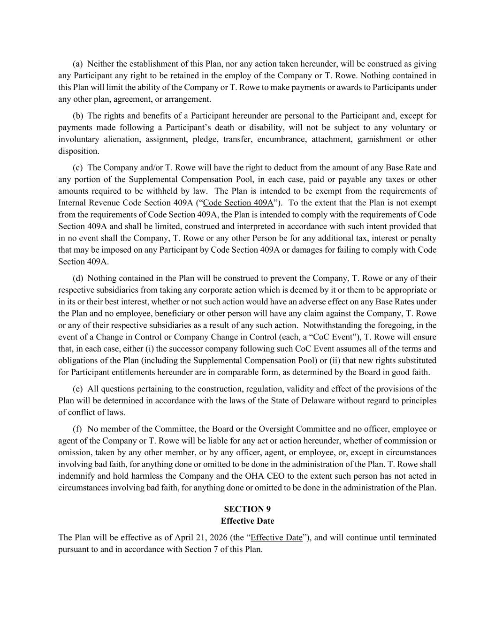
(a) Neither the establishment of this Plan, nor any action taken hereunder, will be construed as giving any Participant any right to be retained in the employ of the Company or T. Rowe. Nothing contained in this Plan will limit the ability of the Company or T. Rowe to make payments or awards to Participants under any other plan, agreement, or arrangement. (b) The rights and benefits of a Participant hereunder are personal to the Participant and, except for payments made following a Participant’s death or disability, will not be subject to any voluntary or involuntary alienation, assignment, pledge, transfer, encumbrance, attachment, garnishment or other disposition. (c) The Company and/or T. Rowe will have the right to deduct from the amount of any Base Rate and any portion of the Supplemental Compensation Pool, in each case, paid or payable any taxes or other amounts required to be withheld by law. The Plan is intended to be exempt from the requirements of Internal Revenue Code Section 409A (“Code Section 409A”). To the extent that the Plan is not exempt from the requirements of Code Section 409A, the Plan is intended to comply with the requirements of Code Section 409A and shall be limited, construed and interpreted in accordance with such intent provided that in no event shall the Company, T. Rowe or any other Person be for any additional tax, interest or penalty that may be imposed on any Participant by Code Section 409A or damages for failing to comply with Code Section 409A. (d) Nothing contained in the Plan will be construed to prevent the Company, T. Rowe or any of their respective subsidiaries from taking any corporate action which is deemed by it or them to be appropriate or in its or their best interest, whether or not such action would have an adverse effect on any Base Rates under the Plan and no employee, beneficiary or other person will have any claim against the Company, T. Rowe or any of their respective subsidiaries as a result of any such action. Notwithstanding the foregoing, in the event of a Change in Control or Company Change in Control (each, a “CoC Event”), T. Rowe will ensure that, in each case, either (i) the successor company following such CoC Event assumes all of the terms and obligations of the Plan (including the Supplemental Compensation Pool) or (ii) that new rights substituted for Participant entitlements hereunder are in comparable form, as determined by the Board in good faith. (e) All questions pertaining to the construction, regulation, validity and effect of the provisions of the Plan will be determined in accordance with the laws of the State of Delaware without regard to principles of conflict of laws. (f) No member of the Committee, the Board or the Oversight Committee and no officer, employee or agent of the Company or T. Rowe will be liable for any act or action hereunder, whether of commission or omission, taken by any other member, or by any officer, agent, or employee, or, except in circumstances involving bad faith, for anything done or omitted to be done in the administration of the Plan. T. Rowe shall indemnify and hold harmless the Company and the OHA CEO to the extent such person has not acted in circumstances involving bad faith, for anything done or omitted to be done in the administration of the Plan. SECTION 9 Effective Date The Plan will be effective as of April 21, 2026 (the “Effective Date”), and will continue until terminated pursuant to and in accordance with Section 7 of this Plan.

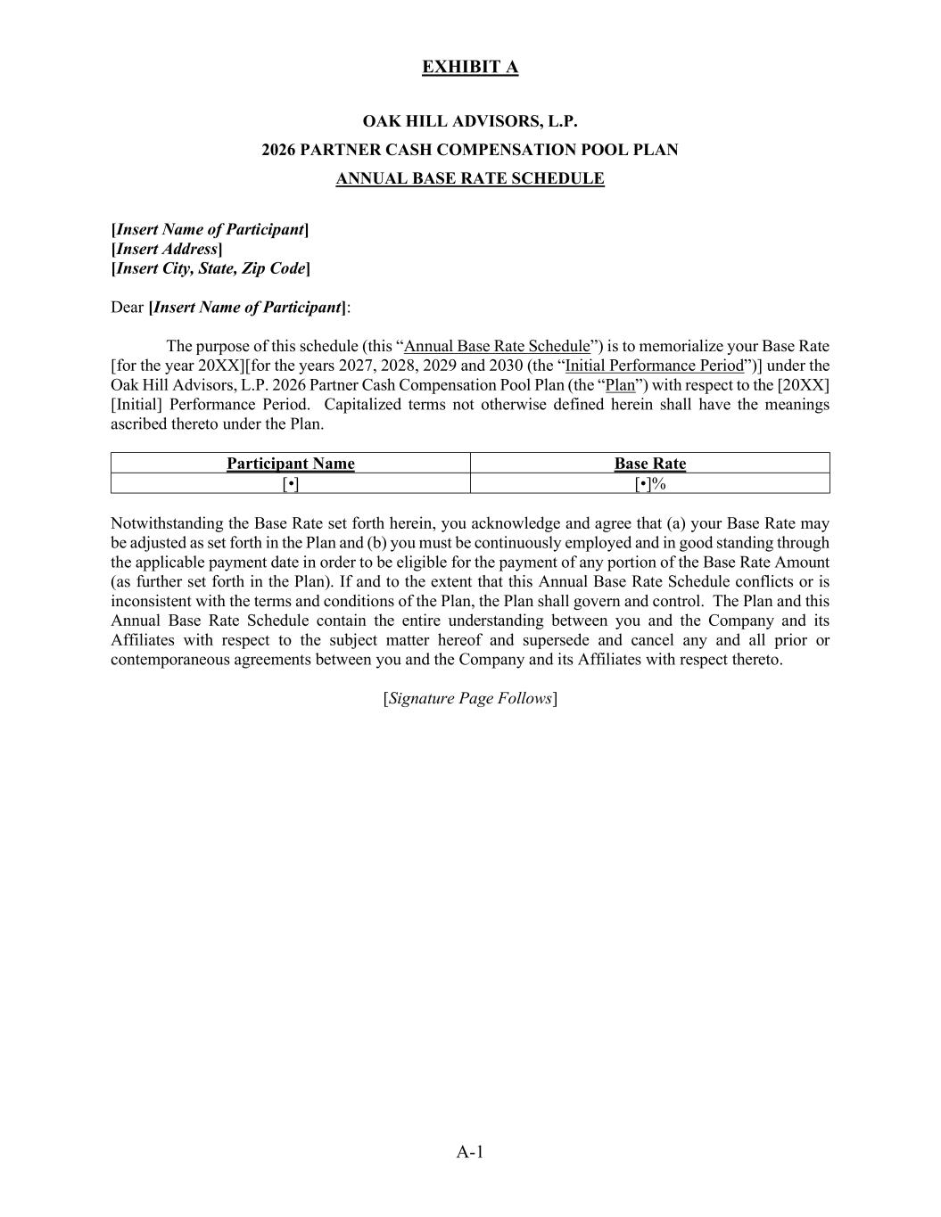
EXHIBIT A A-1 OAK HILL ADVISORS, L.P. 2026 PARTNER CASH COMPENSATION POOL PLAN ANNUAL BASE RATE SCHEDULE [Insert Name of Participant] [Insert Address] [Insert City, State, Zip Code] Dear [Insert Name of Participant]: The purpose of this schedule (this “Annual Base Rate Schedule”) is to memorialize your Base Rate [for the year 20XX][for the years 2027, 2028, 2029 and 2030 (the “Initial Performance Period”)] under the Oak Hill Advisors, L.P. 2026 Partner Cash Compensation Pool Plan (the “Plan”) with respect to the [20XX] [Initial] Performance Period. Capitalized terms not otherwise defined herein shall have the meanings ascribed thereto under the Plan. Participant Name Base Rate [•] [•]% Notwithstanding the Base Rate set forth herein, you acknowledge and agree that (a) your Base Rate may be adjusted as set forth in the Plan and (b) you must be continuously employed and in good standing through the applicable payment date in order to be eligible for the payment of any portion of the Base Rate Amount (as further set forth in the Plan). If and to the extent that this Annual Base Rate Schedule conflicts or is inconsistent with the terms and conditions of the Plan, the Plan shall govern and control. The Plan and this Annual Base Rate Schedule contain the entire understanding between you and the Company and its Affiliates with respect to the subject matter hereof and supersede and cancel any and all prior or contemporaneous agreements between you and the Company and its Affiliates with respect thereto. [Signature Page Follows]


A-1 SIGNATURE PAGE TO ANNUAL BASE RATE SCHEDULE OAK HILL ADVISORS, L.P. By: Name: Title: ACKNOWLEDGEMENT I hereby acknowledge that (i) I have received and reviewed a copy of the Plan, and (ii) this Annual Base Rate Schedule and my participation in the Plan are subject in all respects to the terms and conditions of the Plan. Dated: , 20 Participant’s Signature

EXHIBIT 15

Letter from KPMG LLP, independent registered public accounting firm, re unaudited interim financial information

July 31, 2026

T. Rowe Price Group, Inc.
Baltimore, Maryland

Re: Registration Statements No. 033-7012, No. 333-59714, No. 333-120882, No. 333-120883, No. 333-142092, No. 333-167317, No. 333-180904, No. 333-199560, No. 333-212705, No. 333-217483, No. 333-238319, and No. 333-273601

With respect to the subject registration statements, we acknowledge our awareness of the use therein of our report dated July 31, 2026 related to our review of interim financial information.

Pursuant to Rule 436 under the Securities Act of 1933 (the Act), such report is not considered part of a registration statement prepared or certified by an independent registered public accounting firm, or a report prepared or certified by an independent registered public accounting firm within the meaning of Sections 7 and 11 of the Act.

/s/ KPMG LLP

Philadelphia, Pennsylvania

EXHIBIT 31(i).1 Rule 13a-14(a) Certification of Principal Executive Officer

I, Robert W. Sharps, certify that:
1.I have reviewed this Form 10-Q Quarterly Report for the quarterly period ended June 30, 2026 of T. Rowe Price Group, Inc.;
2.Based on my knowledge, this report does not contain any untrue statement of a material fact or omit to state a material fact necessary to make the statements made, in light of the circumstances under which such statements were made, not misleading with respect to the period covered by this report;
3.Based on my knowledge, the financial statements, and other financial information included in this report, fairly present in all material respects the financial condition, results of operations and cash flows of the registrant as of, and for, the periods presented in this report;
4.The registrant’s other certifying officer and I are responsible for establishing and maintaining disclosure controls and procedures (as defined in Exchange Act Rules 13a-15(e) and 15d-15(e)) and internal control over financial reporting (as defined in Exchange Act Rules 13a-15(f) and 15d-15(f)) for the registrant and have:
(a) Designed such disclosure controls and procedures, or caused such disclosure controls and procedures to be designed under our supervision, to ensure that material information relating to the registrant, including its consolidated subsidiaries, is made known to us by others within those entities, particularly during the period in which this report is being prepared;
(b) Designed such internal control over financial reporting, or caused such internal control over financial reporting to be designed under our supervision, to provide reasonable assurance regarding the reliability of financial reporting and the preparation of financial statements for external purposes in accordance with generally accepted accounting principles;
(c) Evaluated the effectiveness of the registrant’s disclosure controls and procedures and presented in this report our conclusions about the effectiveness of the disclosure controls and procedures, as of the end of the period covered by this report based on such evaluation; and
(d) Disclosed in this report any change in the registrant’s internal control over financial reporting that occurred during the registrant’s most recent fiscal quarter (the registrant’s fourth fiscal quarter in the case of an annual report) that has materially affected, or is reasonably likely to materially affect, the registrant’s internal control over financial reporting; and
5.The registrant’s other certifying officer and I have disclosed, based on our most recent evaluation of internal control over financial reporting, to the registrant’s auditors and the audit committee of the registrant’s board of directors (or persons performing the equivalent functions):
(a) All significant deficiencies and material weaknesses in the design or operation of internal control over financial reporting which are reasonably likely to adversely affect the registrant’s ability to record, process, summarize and report financial information; and
(b) Any fraud, whether or not material, that involves management or other employees who have a significant role in the registrant’s internal control over financial reporting.

July 31, 2026
/s/ Robert W. Sharps
Chair and Chief Executive Officer

EXHIBIT 31(i).2 Rule 13a-14(a) Certification of Principal Financial Officer

I, Jennifer B. Dardis, certify that:
1.I have reviewed this Form 10-Q Quarterly Report for the quarterly period ended June 30, 2026 of T. Rowe Price Group, Inc.;
2.Based on my knowledge, this report does not contain any untrue statement of a material fact or omit to state a material fact necessary to make the statements made, in light of the circumstances under which such statements were made, not misleading with respect to the period covered by this report;
3.Based on my knowledge, the financial statements, and other financial information included in this report, fairly present in all material respects the financial condition, results of operations and cash flows of the registrant as of, and for, the periods presented in this report;
4.The registrant’s other certifying officer and I are responsible for establishing and maintaining disclosure controls and procedures (as defined in Exchange Act Rules 13a-15(e) and 15d-15(e)) and internal control over financial reporting (as defined in Exchange Act Rules 13a-15(f) and 15d-15(f)) for the registrant and have:
(a) Designed such disclosure controls and procedures, or caused such disclosure controls and procedures to be designed under our supervision, to ensure that material information relating to the registrant, including its consolidated subsidiaries, is made known to us by others within those entities, particularly during the period in which this report is being prepared;
(b) Designed such internal control over financial reporting, or caused such internal control over financial reporting to be designed under our supervision, to provide reasonable assurance regarding the reliability of financial reporting and the preparation of financial statements for external purposes in accordance with generally accepted accounting principles;
(c) Evaluated the effectiveness of the registrant’s disclosure controls and procedures and presented in this report our conclusions about the effectiveness of the disclosure controls and procedures, as of the end of the period covered by this report based on such evaluation; and
(d) Disclosed in this report any change in the registrant’s internal control over financial reporting that occurred during the registrant’s most recent fiscal quarter (the registrant’s fourth fiscal quarter in the case of an annual report) that has materially affected, or is reasonably likely to materially affect, the registrant’s internal control over financial reporting; and
5.The registrant’s other certifying officer and I have disclosed, based on our most recent evaluation of internal control over financial reporting, to the registrant’s auditors and the audit committee of the registrant’s board of directors (or persons performing the equivalent functions):
(a) All significant deficiencies and material weaknesses in the design or operation of internal control over financial reporting which are reasonably likely to adversely affect the registrant’s ability to record, process, summarize and report financial information; and
(b) Any fraud, whether or not material, that involves management or other employees who have a significant role in the registrant’s internal control over financial reporting.

July 31, 2026
/s/ Jennifer B. Dardis
Vice President, Chief Financial Officer and Treasurer

EXHIBIT 32 Section 1350 Certifications

We certify, to the best of our knowledge, based upon a review of the Form 10-Q Quarterly Report for the quarterly period ended June 30, 2026, of T. Rowe Price Group, Inc., that:
(1) The Form 10-Q Quarterly Report fully complies with the requirements of Section 13(a) of the Securities Exchange Act of 1934, as amended; and
(2) The information contained in the Form 10-Q Quarterly Report fairly presents, in all material respects, the financial condition and results of operations of T. Rowe Price Group, Inc.

July 31, 2026

/s/ Robert W. Sharps
Chair and Chief Executive Officer

/s/ Jennifer B. Dardis
Vice President, Chief Financial Officer and Treasurer

