UNITED STATES

SECURITIES AND EXCHANGE COMMISSION

Washington, D.C. 20549

______________________________________

FORM 10-Q

______________________________________

QUARTERLY REPORT PURSUANT TO SECTION 13 OF THE SECURITIES EXCHANGE ACT OF 1934

For the quarterly period ended June 30, 2018

Commission File Number: 000-32191

______________________________________

T. ROWE PRICE GROUP, INC.

(Exact name of registrant as specified in its charter)

Maryland

52-2264646

(State of incorporation)

(I.R.S. Employer Identification No.)

100 East Pratt Street, Baltimore, Maryland 21202

(Address, including Zip Code, of principal executive offices)

(410) 345-2000

(Registrant’s telephone number, including area code)

______________________________________

Indicate by check mark whether the registrant (1) has filed all reports required to be filed by Section 13 of the Securities Exchange Act of 1934 during the preceding 12 months, and (2) has been subject to such filing requirements for the past 90 days. x Yes ☐ No

Indicate by check mark whether the registrant has submitted electronically and posted on its corporate Web site, if any, every Interactive Data File required to be submitted and posted pursuant to Rule 405 of Regulation S-T during the preceding 12 months. x Yes ☐ No

Indicate by check mark whether the registrant is a large accelerated filer, an accelerated filer, a non-accelerated filer, smaller reporting company, or an emerging growth company. See the definitions of “large accelerated filer,” “accelerated filer” “smaller reporting company” and “emerging growth company” in Rule 12b-2 of the Exchange Act.

Large accelerated filer x

Accelerated filer ☐

Smaller reporting company ☐

Non-accelerated filer ☐ (do not check if smaller reporting company)

Emerging growth company ☐

If an emerging growth company, indicate by check mark if the registrant has elected not to use the extended transition period for complying with any new or revised financial accounting standards provided pursuant to Section 13(a) of the Exchange Act.☐

Indicate by check mark whether the registrant is a shell company (as defined in Rule 12b-2 of the Exchange Act). ☐ Yes x No

The number of shares outstanding of the issuer’s common stock ($.20 par value), as of the latest practicable date, July 23, 2018, is 243,190,703.

The exhibit index is at Item 6 on page 46.

PART I – FINANCIAL INFORMATION

Item 1. Financial Statements.

UNAUDITED CONDENSED CONSOLIDATED BALANCE SHEETS

(in millions, except share data)

 |  | 12/31/2017 |  |  | 6/30/2018
ASSETS
Cash and cash equivalents | $ | 1,902.7 |  | $ | 1,484.4
Accounts receivable and accrued revenue |  | 565.3 |  |  | 564.4
Investments |  | 1,477.3 |  |  | 2,459.5
Assets of consolidated T. Rowe Price investment products ($1,839.6 million at December 31,
2017 and $1,467.0 million at June 30, 2018, related to variable interest entities) |  | 2,048.4 |  |  | 1,857.0
Property and equipment, net |  | 652.0 |  |  | 655.2
Goodwill |  | 665.7 |  |  | 665.7
Other assets |  | 224.0 |  |  | 196.0
Total assets | $ | 7,535.4 |  | $ | 7,882.2
LIABILITIES
Accounts payable and accrued expenses | $ | 216.2 |  | $ | 220.0
Liabilities of consolidated T. Rowe Price investment products ($39.5 million at December 31,
2017, and $51.6 million at June 30, 2018, related to variable interest entities) |  | 55.9 |  |  | 114.6
Accrued compensation and related costs |  | 108.5 |  |  | 349.6
Supplemental savings plan liability |  | 269.3 |  |  | 287.8
Income taxes payable |  | 68.3 |  |  | 56.4
Total liabilities |  | 718.2 |  |  | 1,028.4
Commitments and contingent liabilities
Redeemable non-controlling interests |  | 992.8 |  |  | 739.2
STOCKHOLDERS’ EQUITY
Preferred stock, undesignated, $.20 par value – authorized and unissued 20,000,000 shares |  | — |  |  | —
Common stock, $.20 par value—authorized 750,000,000; issued 245,111,000 shares at
December 31, 2017, and 243,180,000 at June 30, 2018 |  | 49.0 |  |  | 48.6
Additional capital in excess of par value |  | 846.1 |  |  | 654.6
Retained earnings |  | 4,932.9 |  |  | 5,435.1
Accumulated other comprehensive loss |  | (3.6) |  |  | (23.7)
Total permanent stockholders’ equity |  | 5,824.4 |  |  | 6,114.6
Total liabilities, redeemable non-controlling interests, and permanent stockholders’ equity | $ | 7,535.4 |  | $ | 7,882.2

The accompanying notes are an integral part of these statements.

Page 2

UNAUDITED CONDENSED CONSOLIDATED STATEMENTS OF INCOME (in millions, except per-share amounts)

 |  |  | Three months ended |  |  |  |  |  | Six months ended
 |  |  | 6/30/2017 |  |  | 6/30/2018 |  |  | 6/30/2017 |  |  | 6/30/2018
Revenues
Investment advisory fees | $ |  | 1,046.0 |  | $ | 1,214.4 |  | $ | 2,038.7 |  | $ | 2,403.6
Administrative, distribution, and servicing fees |  |  | 140.0 |  |  | 130.6 |  |  | 279.9 |  |  | 269.4
Net revenues |  |  | 1,186.0 |  |  | 1,345.0 |  |  | 2,318.6 |  |  | 2,673.0
Operating expenses
Compensation and related costs |  |  | 403.8 |  |  | 456.0 |  |  | 801.2 |  |  | 897.4
Distribution and servicing |  |  | 64.8 |  |  | 71.6 |  |  | 124.6 |  |  | 141.9
Advertising and promotion |  |  | 18.7 |  |  | 19.0 |  |  | 44.4 |  |  | 43.6
Product-related costs |  |  | 34.4 |  |  | 37.1 |  |  | 73.0 |  |  | 79.2
Technology, occupancy, and facility costs |  |  | 85.6 |  |  | 93.2 |  |  | 168.4 |  |  | 187.3
General, administrative, and other |  |  | 71.1 |  |  | 73.4 |  |  | 127.7 |  |  | 145.1
Nonrecurring insurance recoveries related to Dell appraisal rights
matter |  |  | — |  |  | — |  |  | (50.0) |  |  | —
Total operating expenses |  |  | 678.4 |  |  | 750.3 |  |  | 1,289.3 |  |  | 1,494.5
Net operating income |  |  | 507.6 |  |  | 594.7 |  |  | 1,029.3 |  |  | 1,178.5
Non-operating income
Net gains on investments |  |  | 71.4 |  |  | 17.4 |  |  | 136.2 |  |  | 31.8
Net gains on consolidated investment products |  |  | 39.4 |  |  | 19.1 |  |  | 88.3 |  |  | 19.9
Other income (loss) |  |  | 1.2 |  |  | (2.4) |  |  | 2.5 |  |  | (1.5)
Total non-operating income |  |  | 112.0 |  |  | 34.1 |  |  | 227.0 |  |  | 50.2
Income before income taxes |  |  | 619.6 |  |  | 628.8 |  |  | 1,256.3 |  |  | 1,228.7
Provision for income taxes |  |  | 229.6 |  |  | 169.2 |  |  | 465.9 |  |  | 313.6
Net income |  |  | 390.0 |  |  | 459.6 |  |  | 790.4 |  |  | 915.1
Less: net income attributable to redeemable non-controlling
interests |  |  | 16.1 |  |  | 10.7 |  |  | 30.6 |  |  | 12.5
Net income attributable to T. Rowe Price Group | $ |  | 373.9 |  | $ | 448.9 |  | $ | 759.8 |  | $ | 902.6
Earnings per share on common stock of T. Rowe Price Group
Basic |  | $ | 1.52 |  | $ | 1.81 |  | $ | 3.08 |  | $ | 3.62
Diluted | $ |  | 1.50 |  | $ | 1.77 |  | $ | 3.04 |  | $ | 3.55
Dividends declared per share |  | $ | .57 |  | $ | .70 |  | $ | 1.14 |  | $ | 1.40
The accompanying notes are an integral part of these statements.
 | Page 3

UNAUDITED CONDENSED CONSOLIDATED STATEMENTS OF COMPREHENSIVE INCOME (in millions)

 |  | Three months ended |  |  |  |  |  | Six months ended
 |  | 6/30/2017 |  |  | 6/30/2018 |  |  | 6/30/2017 |  |  | 6/30/2018
Net income | $ | 390.0 |  | $ | 459.6 |  | $ | 790.4 |  | $ | 915.1
Other comprehensive income (loss)
Net unrealized holding gains on available-for-sale investments |  | 13.9 |  |  | — |  |  | 32.2 |  |  | —
Reclassification gains (losses) recognized in non-operating income
upon dispositions, determined using average cost |  | (30.3) |  |  | — |  |  | (77.9) |  |  | —
Net unrealized gains (losses) recognized upon the transfer to
trading investments |  | (23.6) |  |  | — |  |  | (23.6) |  |  | —
Total net unrealized holding gains (losses) recognized in other
comprehensive income |  | (40.0) |  |  | — |  |  | (69.3) |  |  | —
Currency translation adjustments
Consolidated T. Rowe Price investment products - variable
interest entities |  | 30.0 |  |  | (40.0) |  |  | 37.0 |  |  | (23.8)
Reclassification gains (losses) recognized in non-operating
income upon deconsolidation of certain T. Rowe Price investment
products |  | — |  |  | (.5) |  |  | — |  |  | (3.6)
Consolidated T. Rowe Price investment products - variable interest
entities, net |  | 30.0 |  |  | (40.5) |  |  | 37.0 |  |  | (27.4)
Equity method investments |  | 6.7 |  |  | (3.3) |  |  | 3.5 |  |  | .5
Total currency translation adjustments |  | 36.7 |  |  | (43.8) |  |  | 40.5 |  |  | (26.9)
Other comprehensive income (loss) before income taxes |  | (3.3) |  |  | (43.8) |  |  | (28.8) |  |  | (26.9)
Net deferred tax benefits (income taxes) |  | 4.6 |  |  | 6.0 |  |  | 15.3 |  |  | 3.5
Total other comprehensive income (loss) |  | 1.3 |  |  | (37.8) |  |  | (13.5) |  |  | (23.4)
Total comprehensive income |  | 391.3 |  |  | 421.8 |  |  | 776.9 |  |  | 891.7
Less: comprehensive income attributable to redeemable non-
controlling interests |  | 23.6 |  |  | (9.8) |  |  | 40.2 |  |  | (1.0)
Comprehensive income attributable to T. Rowe Price Group | $ | 367.7 |  | $ | 431.6 |  | $ | 736.7 |  | $ | 892.7

The accompanying notes are an integral part of these statements.

Page 4

UNAUDITED CONDENSED CONSOLIDATED STATEMENTS OF CASH FLOWS⁽¹⁾
(in millions)

 |  | Six months ended
 |  | 6/30/2017 |  |  | 6/30/2018
Cash flows from operating activities
Net income | $ | 790.4 |  | $ | 915.1
Adjustments to reconcile net income to net cash provided by (used in) operating activities
Depreciation and amortization of property and equipment |  | 71.9 |  |  | 74.7
Stock-based compensation expense |  | 74.2 |  |  | 90.8
Realized gains on dispositions of available-for-sale T. Rowe Price investment products |  | (77.9) |  |  | —
Gains recognized upon transfer of an investment in a T. Rowe Price mutual fund from available-for-
sale to held as trading |  | (23.6) |  |  | —
Net gains recognized on other investments |  | (23.9) |  |  | (5.4)
Net investments in T. Rowe Price investment products to economically hedge supplemental savings
plan liability |  | (129.0) |  |  | (13.7)
Net change in securities held by consolidated T. Rowe Price investment products |  | (802.0) |  |  | (407.1)
Other changes in assets and liabilities |  | 259.1 |  |  | 274.9
Net cash provided by (used in) operating activities |  | 139.2 |  |  | 929.3
Cash flows from investing activities
Purchases of T. Rowe Price investment products |  | (23.4) |  |  | (1,110.2)
Dispositions T. Rowe Price investment products |  | 294.7 |  |  | 259.3
Net cash of T. Rowe Price investment products on consolidation (deconsolidation) |  | (45.9) |  |  | (21.7)
Additions to property and equipment |  | (82.6) |  |  | (78.6)
Other investing activity |  | (5.2) |  |  | 7.2
Net cash provided by (used in) investing activities |  | 137.6 |  |  | (944.0)
Cash flows from financing activities
Repurchases of common stock |  | (446.9) |  |  | (450.3)
Common share issuances under stock-based compensation plans |  | 74.4 |  |  | 92.8
Dividends paid to common stockholders of T. Rowe Price Group |  | (280.4) |  |  | (348.7)
Net subscriptions received from redeemable non-controlling interest holders |  | 717.7 |  |  | 318.0
Net cash provided by (used in) financing activities |  | 64.8 |  |  | (388.2)
Effect of exchange rate changes on cash and cash equivalents of consolidated
T. Rowe Price investment products |  | 3.8 |  |  | (6.6)
Net change in cash and cash equivalents during period |  | 345.4 |  |  | (409.5)
Cash and cash equivalents at beginning of year |  | 1,270.5 |  |  | 2,005.8
Cash and cash equivalents at end of period, including $73.7 million at June 30, 2017, and $111.9 million | $ | 1,615.9 |  | $ | 1,596.3
at June 30, 2018, held by consolidated T. Rowe Price investment products) | $ | 1,615.9 |  | $ | 1,596.3

- See note 12 for supplementary consolidating cash flow statements.

The accompanying notes are an integral part of these statements.

Page 5

UNAUDITED CONDENSED CONSOLIDATED STATEMENT OF STOCKHOLDERS’ EQUITY (shares in thousands; dollars in millions)

 |  |  |  |  |  |  | Additional |  |  |  | Accumulated |  |  |  |  |  | Redeemable
 | Common |  |  |  |  |  | capital in |  |  |  |  | other |  |  | Total |  |  | non-
 | shares |  | Common |  |  |  | excess of |  | Retained |  | comprehensive |  |  | stockholders’ |  |  |  | controlling
 | outstanding |  |  | stock |  |  | par value |  | earnings |  | income (loss) |  |  |  | equity |  |  | interests
Balances at December 31, 2017 | 245,111 |  | $ | 49.0 |  | $ | 846.1 |  | $4,932.9 |  | $ | (3.6) |  | $ | 5,824.4 |  | $ | 992.8
Cumulative effect adjustment upon adoption of
new financial instruments and accumulated
other comprehensive income guidance on
January 1, 2018⁽¹⁾ | — |  |  | — |  |  | — |  | 22.4 |  |  | (7.9) |  |  | 14.5 |  |  | —
Reclassification adjustment of stranded tax
benefits on currency translation adjustments
upon adoption of new accumulated other
comprehensive income guidance on January 1,
2018 | — |  |  | — |  |  | — |  | 2.3 |  |  | (2.3) |  |  | — |  |  | —
Balances at January 1, 2018 | 245,111 |  |  | 49.0 |  |  | 846.1 |  | 4,957.6 |  |  | (13.8) |  |  | 5,838.9 |  |  | 992.8
Net income | — |  |  | — |  |  | — |  | 902.6 |  |  | — |  |  | 902.6 |  |  | 12.5
Other comprehensive income (loss), net of tax | — |  |  | — |  |  | — |  | — |  |  | (9.9) |  |  | (9.9) |  |  | (13.5)
Dividends declared | — |  |  | — |  |  | — |  | (348.8) |  |  | — |  |  | (348.8) |  |  | —
Common stock-based compensation plans
activity
Shares issued upon option exercises | 2,241 |  |  | .4 |  |  | 91.7 |  | — |  |  | — |  |  | 92.1 |  |  | —
Restricted shares issued, net of shares
withheld for taxes | 8 |  |  | — |  |  | (.1) |  | — |  |  | — |  |  | (.1) |  |  | —
Shares issued upon vesting of restricted stock
units, net of shares withheld for taxes | 56 |  |  | — |  |  | (.7) |  | — |  |  | — |  |  | (.7) |  |  | —
Forfeiture of restricted awards | (6) |  |  | — |  |  | — |  | — |  |  | — |  |  | — |  |  | —
Stock-based compensation expense | — |  |  | — |  |  | 90.8 |  | — |  |  | — |  |  | 90.8 |  |  | —
Restricted stock units issued as dividend
equivalents | — |  |  | — |  |  | .1 |  | (.1) |  |  | — |  |  | — |  |  | —
Common shares repurchased | (4,230) |  |  | (.8) |  |  | (373.3) |  | (76.2) |  |  | — |  |  | (450.3) |  |  | —
Net subscriptions into T. Rowe Price investment
products | — |  |  | — |  |  | — |  | — |  |  | — |  |  | — |  |  | 322.6
Net deconsolidations of T. Rowe Price
investment products | — |  |  | — |  |  | — |  | — |  |  | — |  |  | — |  |  | (575.2)
Balances at June 30, 2018 | 243,180 |  | $ | 48.6 |  | $ | 654.6 |  | $5,435.1 |  | $ | (23.7) |  | $ | 6,114.6 |  | $ | 739.2

- Includes the reclassification of $1.7 million of stranded income taxes on available-for-sale investments resulting from U.S. tax law changes enacted on December 22, 2017, from accumulated other comprehensive income to retained earnings.

The accompanying notes are an integral part of these statements.

Page 6

NOTES TO UNAUDITED CONDENSED CONSOLIDATED FINANCIAL STATEMENTS

NOTE 1 – THE COMPANY AND BASIS OF PREPARATION.

T. Rowe Price Group (Price Group) derives its consolidated revenues and net income primarily from investment advisory services that its subsidiaries provide to individual and institutional investors in the T. Rowe Price U.S. mutual funds (U.S. mutual funds) and other investment products, including separately managed accounts, subadvised funds, and other T. Rowe Price investment products. We also provide certain investment advisory clients with related administrative services, including distribution, mutual fund transfer agent, accounting, and shareholder services; participant recordkeeping and transfer agent services for defined contribution retirement plans; brokerage; and trust services.

Investment advisory revenues depend largely on the total value and composition of assets under our management. Accordingly, fluctuations in financial markets and in the composition of assets under management impact our revenues and results of operations.

These unaudited condensed consolidated financial statements are prepared in accordance with accounting principles generally accepted in the United States, which require the use of estimates and reflect all adjustments that are, in the opinion of management, necessary to a fair statement of our results for the interim periods presented. All such adjustments are of a normal recurring nature. Actual results may vary from our estimates.

In order to increase transparency of operating expenses and better align expenses that have similar cost drivers, we have changed, as of January 1, 2018, the presentation of certain line items of our income statement. In doing so, we have reclassified certain prior year amounts to conform to the 2018 presentation. These reclassifications are shown along with the impact of the new revenue recognition accounting standard adopted on January 1, 2018, in the New Accounting Guidance section below.

The unaudited interim financial information contained in these condensed consolidated financial statements should be read in conjunction with the consolidated financial statements contained in our 2017 Annual Report.

NEW ACCOUNTING GUIDANCE.

We adopted Accounting Standards Codification Topic 606: Revenue from Contracts with Customers (ASC 606), on January 1, 2018, using the retrospective method which required adjustments to be reflected as of January 1, 2016. In connection with the adoption of this guidance, we reevaluated all of our revenue contracts and determined that the new guidance does not change the timing of when we recognize revenue. However, we did conclude that certain fees earned from the U.S. mutual funds associated with our mutual fund transfer agent, accounting, shareholder servicing, and participant recordkeeping activities could no longer be reported net of the expenses paid to third parties that perform such services as we are deemed, under the guidance, to have control over the services before they are transferred to the U.S. mutual funds. No transition-related practical expedients were applied. Certain immaterial balance sheet reclassifications were made to conform to the 2018 presentation and all related note disclosures have been recast. Updates to our revenue recognition disclosures are included in Note 2 - Information about Receivables, Revenues, and Services and our updated revenue recognition accounting policy is included in the Summary of Significant Accounting Policies section below.

Page 7

The impact of ASC 606 and other income statement reclassifications, as described above, on the condensed consolidated statements of income for each quarter of 2017 follows:

 |  | Three months ended 3/31/2017 |  |  |  |  |  |  |  |  |  |  |  |  | Three months ended 6/30/2017
 |  | As |  |  |  |  | Impact |  |  |  |  |  |  | As |  |  |  |  |  |  |  |  |  | As
 | previously |  |  | Change in |  |  | of ASC |  |  |  |  |  | previously |  |  |  | Change in |  |  | Impact of |  |  | reported
(in millions) | reported |  |  | Presentation |  |  |  | 606 |  |  | Recast |  | reported |  |  |  | Presentation |  |  | ASC 606 |  |  |  | herein
Revenues
Investment advisory fees | $ | 991.1 |  | $ | — |  | $ | 1.6 |  | $ | 992.7 |  | $1,043.9 |  | $ |  |  | — |  | $ | 2.1 |  | $ | 1,046.0
Administrative, distribution, and servicing fees⁽¹⁾ |  | 122.5 |  |  | — |  |  | 17.4 |  |  | 139.9 |  |  | 127.7 |  |  |  | — |  |  | 12.3 |  |  | 140.0
Net revenues |  | 1,113.6 |  |  | — |  |  | 19.0 |  |  | 1,132.6 |  |  | 1,171.6 |  |  |  | — |  |  | 14.4 |  |  | 1,186.0
Operating expenses
Compensation and related costs |  | 397.4 |  |  | — |  |  | — |  |  | 397.4 |  |  | 403.8 |  |  |  | — |  |  | — |  |  | 403.8
Distribution and servicing |  | 35.2 |  |  | 22.9 |  |  | 1.7 |  |  | 59.8 |  |  | 36.4 |  |  |  | 26.4 |  |  | 2.0 |  |  | 64.8
Advertising and promotion |  | 25.6 |  |  | — |  |  | .1 |  |  | 25.7 |  |  | 18.6 |  |  |  | — |  |  | .1 |  |  | 18.7
Product-related costs |  | — |  |  | 21.4 |  |  | 17.2 |  |  | 38.6 |  |  | — |  |  |  | 22.4 |  |  | 12.0 |  |  | 34.4
Technology, occupancy, and facility costs⁽²⁾ |  | 81.0 |  |  | 1.8 |  |  | — |  |  | 82.8 |  |  | 83.1 |  |  |  | 2.5 |  |  | — |  |  | 85.6
General, administrative, and other |  | 102.7 |  |  | (46.1) |  |  | — |  |  | 56.6 |  |  | 122.1 |  |  |  | (51.3) |  |  | .3 |  |  | 71.1
Nonrecurring insurance recoveries related to Dell
appraisal rights matter |  | (50.0) |  |  | — |  |  | — |  |  | (50.0) |  |  | — |  |  |  | — |  |  | — |  |  | —
Total operating expenses |  | 591.9 |  |  | — |  |  | 19.0 |  |  | 610.9 |  |  | 664.0 |  |  |  | — |  |  | 14.4 |  |  | 678.4
Net operating income | $ | 521.7 |  | $ | — |  | $ | — |  | $ | 521.7 |  | $ | 507.6 |  |  | $ | — |  | $ | — |  | $ | 507.6
 |  | Three months ended 9/30/2017 |  |  |  |  |  |  |  |  |  |  |  | Three months ended 12/31/2017
 |  | As |  |  |  |  | Impact |  |  |  |  |  |  | As
 | previously |  |  | Change in |  |  | of ASC |  |  |  |  |  | previously |  |  |  | Change in |  |  | Impact of
(in millions) | reported |  |  | Presentation |  |  |  | 606 |  |  | Recast |  | reported |  |  |  | Presentation |  |  | ASC 606 |  |  |  | Recast
Revenues
Investment advisory fees | $1,096.7 |  |  | $ | — |  | $ | 2.2 |  | $ | 1,098.9 |  | $1,156.0 |  | $ |  |  | — |  | $ | 2.2 |  | $ | 1,158.2
Administrative, distribution, and servicing fees⁽¹⁾ |  | 125.0 |  |  | — |  |  | 14.8 |  |  | 139.8 |  |  | 130.1 |  |  |  | — |  |  | 9.3 |  |  | 139.4
Net revenues |  | 1,221.7 |  |  | — |  |  | 17.0 |  |  | 1,238.7 |  |  | 1,286.1 |  |  |  | — |  |  | 11.5 |  |  | 1,297.6
Operating expenses
Compensation and related costs |  | 417.4 |  |  | — |  |  | — |  |  | 417.4 |  |  | 446.3 |  |  |  | — |  |  | — |  |  | 446.3
Distribution and servicing |  | 37.4 |  |  | 27.9 |  |  | 2.1 |  |  | 67.4 |  |  | 38.0 |  |  |  | 30.2 |  |  | 2.4 |  |  | 70.6
Advertising and promotion |  | 14.0 |  |  | — |  |  | — |  |  | 14.0 |  |  | 33.8 |  |  |  | — |  |  | .2 |  |  | 34.0
Product-related costs |  | — |  |  | 23.4 |  |  | 14.5 |  |  | 37.9 |  |  | — |  |  |  | 26.0 |  |  | 9.1 |  |  | 35.1
Technology, occupancy, and facility costs⁽²⁾ |  | 84.0 |  |  | 2.2 |  |  | .1 |  |  | 86.3 |  |  | 90.4 |  |  |  | 5.5 |  |  | (.1) |  |  | 95.8
General, administrative, and other |  | 120.4 |  |  | (53.5) |  |  | .3 |  |  | 67.2 |  |  | 146.6 |  |  |  | (61.7) |  |  | (.1) |  |  | 84.8
Total operating expenses |  | 673.2 |  |  | — |  |  | 17.0 |  |  | 690.2 |  |  | 755.1 |  |  |  | — |  |  | 11.5 |  |  | 766.6
Net operating income | $ | 548.5 |  | $ | — |  | $ | — |  | $ | 548.5 |  | $ | 531.0 | $ |  |  | — |  | $ | — |  | $ | 531.0

- The previously reported column aggregates the administrative fees and distribution and servicing fees lines presented in the income statement in prior year.
- The previously reported column aggregates the depreciation and amortization of property and equipment and occupancy and facility costs lines presented in the income statement in prior year.

Page 8

We adopted Accounting Standards Update No. 2016-01 — Financial Instruments — Overall (Subtopic 825-10): Recognition and Measurement

of Financial Assets and Financial Liabilities on January 1, 2018. This standard update addresses certain aspects of recognition, measurement,

presentation, and disclosure of financial instruments. After January 1, 2018, the guidance requires substantially all equity investments in non-

consolidated entities to be measured at fair value with changes recognized in earnings, except for those accounted for using the equity method

of accounting. As such, the guidance eliminated the available-for-sale investment category for equity securities, which required unrealized

holding gains to be recognized in accumulated other comprehensive income. Upon adoption, we reclassified net unrealized holding gain of

$7.9 million, net of taxes, related to our $597.1 million available-for-sale investment portfolio from accumulated other comprehensive income to

retained earnings. Additionally, certain investments that do not have readily available market prices or quotations will be measured at fair value,

under the new guidance, as we elected to use their calculated and reported net asset value (NAV) per share as a practical expedient for

measuring their fair value in accordance with ASC 946. As such, we recognized a cumulative adjustment to retained earnings of $14.5 million

to adjust investments previously accounted for as cost method investments to fair value on January 1, 2018. The corresponding increase in the

investments’ carrying value and related deferred taxes was $19.5 million and $5.0 million, respectively. Our updated investments policy is

included in the Summary of Significant Accounting Policies section below.

We adopted Accounting Standards Update No. 2018-02 — Reclassification of certain tax effects from accumulated other comprehensive income on January 1, 2018. This guidance permits tax effects stranded in accumulated other comprehensive income primarily resulting from the enactment of U.S. tax reform bill originally known as the Tax Cuts and Jobs Act of 2017 to be reclassified to retained earnings either on January 1, 2018, or retrospectively. We elected to adopt the guidance on January 1, 2018, and reclassified $2.3 million of stranded tax benefits related to currency translation adjustments to retained earnings. The stranded income taxes related to our available-for-sale investment portfolio at December 31, 2017, were reclassified to retained earnings with the adoption of Accounting Standards Update No. 2016-01 on January 1, 2018. Our updated comprehensive income policy is included in the Summary of Significant Accounting Policies section below.

NEWLY ISSUED BUT NOT YET ADOPTED ACCOUNTING GUIDANCE.

In February 2016, the FASB issued Accounting Standards Update No. 2016-02 — Leases (Topic 842). The standard update seeks to increase transparency and comparability among organizations by recognizing lease assets and lease liabilities on the balance sheet and disclosing key information about leasing arrangements. The standards update is effective for fiscal years beginning after December 15, 2018, including interim periods within those fiscal years. Early adoption is permitted, and certain practical expedients are available. While we continue evaluating the full impact this standard will have on our financial position and results of operations, we currently expect the most significant impact will be the recognition of a right of use asset and lease liability on our consolidated balance sheets for each real-estate operating lease. We plan to adopt the standard on its effective date, January 1, 2019.

We have considered all other newly issued accounting guidance that is applicable to our operations and the preparation of our condensed consolidated statements, including those we have not yet adopted. We do not believe that any such guidance has or will have a material effect on our financial position or results of operations.

U.S. TAX REFORM AND NEWLY ENACTED MARYLAND TAX LEGISLATION.

The income tax provision for the second quarter of 2018 includes an additional nonrecurring charge of $20.8 million related to the enactment of U.S. tax reform as the firm adjusted its deferred tax asset and liability re-measurement estimates recorded at December 31, 2017. We also recognized in the second quarter of 2018 a nonrecurring charge of $ 7.9 million for the re-measurement of our deferred tax assets and liabilities to reflect the effect of Maryland state tax legislation enacted on April 24, 2018. This new state tax legislation, effective in 2018, adopted a five-year phase-in of the single sales factor method of apportionment for calculating income tax for multi -state companies doing business in Maryland and is expected to result in a net benefit over time. We continue to evaluate the impact of U.S. tax reform and the Maryland state tax legislation on our estimates and expectations due to changes in our interpretations of the law, assumptions used in applying the law, and additional guidance concerning the law that may be issued.

Page 9

SUMMARY OF SIGNIFICANT ACCOUNTING POLICIES.

Revenue recognition.

Our revenue is earned from investment advisory, administrative, and distribution services we provide to our clients. Each distinct service we promise in our agreements is considered a performance obligation and is the basis for determining when we recognize revenue. The fees are allocated to each distinct performance obligation and we recognize revenue when, or as, we satisfy our promises. The consideration for our services is generally variable and included in net revenues, when it is improbable that a significant reversal could occur in the future. For certain client agreements, we have the discretion to hire a third party to provide services to our clients. In these circumstances, we are generally deemed to control the services before transferring them to our clients, and accordingly present the revenues gross of the related third-party costs. The timing of when we bill our clients and related payment terms vary in accordance with agreed-upon contractual terms. For the majority of our agreements, billing occurs after we have recognized revenue which results in accounts receivable and accrued revenue. For an insignificant portion of our contracts, billing occurs in advance of providing services which results in deferred revenue within the accounts payable and accrued expenses line of our condensed consolidated balance sheets.

Taxes billed to our clients based on our fees for services rendered are not included in revenues.

Investment advisory fees.

The majority of our investment advisory agreements, including those with the U.S. mutual funds, have a single performance obligation as the promised services are not separately identifiable from other promises in the agreements and, therefore, are not distinct. Substantially all performance obligations for providing advisory services are satisfied over time and revenue is recognized as time passes.

Investment advisory agreements with T. Rowe Price investment products regulated outside the U.S. generally have two performance obligations; one for investment management and one for distribution. For these agreements, we allocate the management fee to each performance obligation using our best estimate of the standalone fee of each of these services. The performance obligation for providing investment management services, like our other advisory contracts, is satisfied over time and revenue is recognized as time passes. The performance obligation for distribution is satisfied at the point in time when an investor makes an investment into the product. Accordingly, a portion of the investment advisory fees earned from these products relate to distribution performance obligations that were satisfied during prior periods. These distribution fees are reported within the investment advisory fees line of our condensed consolidated statements of income.

The management fee for our investment advisory agreements are based on our assets under management, which change based on fluctuations in financial markets, and represent variable consideration. Therefore, investment advisory fees are generally constrained, and excluded from revenue, until the asset values on which our client is billed are no longer subject to financial market volatility. Investment advisory fees for investment products are presented net of fees waived pursuant to the contractual expense limitations of the product. Our assets under management are valued in accordance with valuation and pricing processes for each major type of investment. Fair values used in our processes are primarily determined from quoted market prices; prices furnished by dealers who make markets in such securities; or from data provided by an independent pricing service that considers yield or price of investments of comparable quality, coupon, maturity, and type. Investments for which market prices are not readily available are not a material portion of our total assets under management.

We provide all services to the U.S. mutual funds under contracts that are subject to periodic review and approval by the funds’ Boards.

Regulations require that the funds’ shareholders also approve material changes to investment advisory contracts.

Administrative, distribution, and servicing fees.

Administrative fees.

The administrative services we provide include distribution, mutual fund transfer agent, accounting and shareholder services; participant recordkeeping and transfer agent services for defined contribution retirement plans; brokerage, and trust services.

The administrative service agreements with the U.S. mutual funds for accounting oversight, transfer agency, and recordkeeping services generally have one performance obligation as the promised services in each agreement are

Page 10

not separately identifiable from other promises in the agreement and, therefore, are not distinct. The fees for performing these services are generally equal to the costs incurred and represent variable consideration. The fees are generally constrained, and are recognized as revenue when costs are incurred to perform the services. These fees are generally offset by the costs incurred to provide such services.

Other administrative service agreements for participant recordkeeping and transfer agent services for defined contribution retirement plans; brokerage services, and trust services generally have one performance obligation as the promised services in each agreement are not separately identifiable from other performance obligations in the contract and, therefore, are not distinct. Our performance obligation in each agreement is satisfied over time and revenue is recognized as time passes. The fees for these services vary by contract and are both fixed and variable.

Distribution and servicing fees.

The agreements for distribution and servicing fees earned from 12b-1 plans of the Advisor Class, R Class, and Variable Annuity II Class shares of the U.S. mutual funds have one performance obligation, as distribution services are not separately identifiable from shareholder servicing promises in the agreements and, therefore, are not distinct. Our performance obligation is satisfied at the point in time when an investor makes an investment into these share classes of the U.S. mutual funds. The fees for these distribution and servicing agreements are based on the assets under management in these shares classes, which change based on fluctuations in financial markets, and represent variable consideration. These fees are generally constrained, and excluded from revenue, until the asset values on which our client is billed are not subject to financial market volatility. Accordingly, the majority of the distribution and servicing revenue disclosed in Note 2 - information about receivables, revenues and services relates to distribution and servicing obligations that were satisfied during prior periods. These fees are offset entirely by the distribution and servicing costs paid to third-party financial intermediaries that source the assets of these share classes.

Investments.

Investments held at fair value

Investments in T. Rowe Price investment products have been made for both general corporate investment purposes and to provide seed capital for newly formed products. Those investments that we do not consolidate are carried at fair value using the quoted closing NAV per share of each fund as of the balance sheet date. The underlying investments held by our consolidated T. Rowe Price investment products retain investment company specialized accounting in consolidation, are considered trading securities for cash flow reporting purposes, and are valued in accordance with the valuation and pricing policy used to value our assets under management which is further described in the Revenue Recognition policy above.

We elected to value our interest in investment partnerships for which market prices or quotations are not readily available, at fair value using the NAV per share as practical expedient for measuring fair value.

Changes in the fair values of all these investments are reflected in non-operating income in our condensed consolidated statements of income.

Equity method investments

Equity method investments consist of investments in entities, including T. Rowe Price investment products, for which we have the ability to exercise significant influence over the operating and financial policies of the investee. The carrying values of these investments are adjusted to reflect our proportionate share of the investee's net income or loss, any unrealized gain or loss resulting from the translation of foreign-denominated financial statements into U.S. dollars, and dividends received. Our proportionate share of income or loss is included in non-operating income in our consolidated statements of income. As permitted under existing accounting guidance, we adopted a policy by which we recognize our share of UTI Asset Management Company Limited’s (UTI) earnings on a quarter lag as current financial information is not available in a timely manner. The basis difference between our carrying value and our proportionate share of UTI’s book value is primarily related to consideration paid in excess of the stepped-up basis of assets and liabilities on the date of purchase.

Comprehensive income.

The components of comprehensive income are presented in a separate statement following our consolidated statements of income and include net income, the change in our currency translation adjustments, and prior to 2018, the change in net unrealized security holding gains (losses) on investments classified as available-for-sale.

Page 11

The currency translation adjustments result from translating our proportionate share of the financial statements of UTI, our equity method investment, and certain consolidated T. Rowe Price investment products into U.S. dollars. Assets and liabilities are translated into U.S. dollars using year-end exchange rates, and revenues and expenses are translated using weighted-average exchange rates for the period.

The changes in accumulated balances of each component of other comprehensive income, the deferred tax impacts of each component, and information about significant items reclassified out of accumulated other comprehensive income are presented in the notes to the financial statements. The notes also indicate the line item of our consolidated statements of income to which the significant reclassifications were recognized.

We reclassify income tax effects relating to currency translation adjustments to tax expense when there is a reduction in our ownership interest in the related investment. The amount of the reclassification depends on the investment’s accounting treatment before and after the change in ownership percentage. Prior to 2018, tax effects relating to each available-for-sale investment’s unrealized holding gain or loss, were reclassified upon the sale of the investment.

NOTE 2 – INFORMATION ABOUT RECEIVABLES, REVENUES, AND SERVICES.

Revenues earned during the second quarter of 2017 and 2018 under agreements with clients include:

 |  |  |  |  | Three months ended 6/30/2017 |  |  |  |  |  |  |  |  |  |  |  | Three months ended 6/30/2018
 |  |  |  |  | Administrative, distribution, and |  |  |  |  |  |  |  |  |  |  |  | Administrative, distribution, and
 |  |  |  |  | servicing fees |  |  |  |  |  |  |  |  |  |  |  | servicing fees
 |  |  |  |  |  |  |  | Distribution |  |  |  |  |  |  |  |  |  |  |  | Distribution
 |  | Investment |  |  | Administrative |  | and servicing |  |  |  |  |  |  | Investment |  |  | Administrative |  | and servicing
(in millions) |  | advisory fees |  |  | fees |  |  | fees |  | Net revenues |  |  | advisory fees |  |  |  | fees |  |  | fees |  | Net revenues
U.S. mutual funds | $ | 756.4 |  | $ | 83.6 |  | $ | 36.4 |  | $ | 876.4 |  | $ | 846.9 |  | $ | 74.4 |  | $ | 35.5 |  | $ | 956.8
Subadvised and separate
accounts and other
investment products |  | 289.6 |  |  | — |  |  | — |  |  | 289.6 |  |  | 367.5 |  |  | — |  |  | — |  |  | 367.5
Other |  | — |  |  | 20.0 |  |  | — |  |  | 20.0 |  |  | — |  |  | 20.7 |  |  | — |  |  | 20.7
 | $ | 1,046.0 |  | $ | 103.6 |  | $ | 36.4 |  | $ | 1,186.0 |  | $ | 1,214.4 |  | $ | 95.1 |  | $ | 35.5 |  | $ | 1,345.0
 |  |  |  |  | Six months ended 6/30/2017 |  |  |  |  |  |  |  |  |  |  |  | Six months ended 6/30/2018
 |  |  |  |  | Administrative, distribution, and |  |  |  |  |  |  |  |  |  |  |  | Administrative, distribution, and
 |  |  |  |  | servicing fees |  |  |  |  |  |  |  |  |  |  |  | servicing fees
 |  |  |  |  |  |  |  | Distribution |  |  |  |  |  |  |  |  |  |  |  | Distribution
 |  | Investment |  |  | Administrative |  | and servicing |  |  |  |  |  |  | Investment |  |  | Administrative |  | and servicing
(in millions) |  | advisory fees |  |  | fees |  |  | fees |  | Net revenues |  |  | advisory fees |  |  |  | fees |  |  | fees |  | Net revenues
U.S. mutual funds | $ | 1,473.8 |  | $ | 169.9 |  | $ | 71.6 |  | $ | 1,715.3 |  | $ | 1,679.8 |  | $ | 156.2 |  | $ | 72.1 |  | $ | 1,908.1
Subadvised and separate
accounts and other
investment products |  | 564.9 |  |  | — |  |  | — |  |  | 564.9 |  |  | 723.8 |  |  | — |  |  | — |  |  | 723.8
Other |  | — |  |  | 38.4 |  |  | — |  |  | 38.4 |  |  | — |  |  | 41.1 |  |  | — |  |  | 41.1
 | $ | 2,038.7 |  | $ | 208.3 |  | $ | 71.6 |  | $ | 2,318.6 |  | $ | 2,403.6 |  | $ | 197.3 |  | $ | 72.1 |  | $ | 2,673.0

Page 12

The following table details the investment advisory fees earned from clients by their underlying asset class.

 |  | Three months ended |  |  |  |  |  | Six months ended
(in millions) |  | 6/30/2017 |  |  | 6/30/2018 |  |  | 6/30/2017 |  |  | 6/30/2018
U.S. mutual funds
Equity and blended assets | $ | 628.9 |  | $ | 718.0 |  | $ | 1,223.1 |  | $ | 1,423.5
Fixed income, including money market |  | 127.5 |  |  | 128.9 |  |  | 250.7 |  |  | 256.3
 |  | 756.4 |  |  | 846.9 |  |  | 1,473.8 |  |  | 1,679.8
Subadvised and separate accounts and other investment products
Equity and blended assets |  | 240.3 |  |  | 308.0 |  |  | 468.2 |  |  | 605.0
Fixed income, including money market |  | 49.3 |  |  | 59.5 |  |  | 96.7 |  |  | 118.8
 |  | 289.6 |  |  | 367.5 |  |  | 564.9 |  |  | 723.8
Total | $ | 1,046.0 |  | $ | 1,214.4 |  | $ | 2,038.7 |  | $ | 2,403.6

The following table summarizes the investment portfolios and assets under management on which we earn investment advisory fees.

 |  | Average during |  |  |  |  |  | Average during
 |  | Three months ended |  |  |  |  |  | Six months ended |  |  |  |  |  | As of
(in billions) |  | 6/30/2017 |  |  | 6/30/2018 |  |  | 6/30/2017 |  |  | 6/30/2018 |  |  | 12/31/2017 |  |  | 6/30/2018
U.S. mutual funds
Equity and blended assets | $ | 440.1 |  | $ | 496.1 |  | $ | 430.6 |  | $ | 495.4 |  | $ | 480.5 |  | $ | 497.5
Fixed income, including money market |  | 120.1 |  |  | 128.5 |  |  | 117.8 |  |  | 127.9 |  |  | 125.8 |  |  | 128.6
 |  | 560.2 |  |  | 624.6 |  |  | 548.4 |  |  | 623.3 |  |  | 606.3 |  |  | 626.1
Subadvised and separate accounts and other investment
products
Equity and blended assets |  | 244.7 |  |  | 314.9 |  |  | 238.0 |  |  | 311.6 |  |  | 291.9 |  |  | 320.1
Fixed income, including money market |  | 81.0 |  |  | 97.0 |  |  | 79.2 |  |  | 96.1 |  |  | 92.9 |  |  | 97.9
 |  | 325.7 |  |  | 411.9 |  |  | 317.2 |  |  | 407.7 |  |  | 384.8 |  |  | 418.0
Total | $ | 885.9 |  | $ | 1,036.5 |  | $ | 865.6 |  | $ | 1,031.0 |  | $ | 991.1 |  | $ | 1,044.1

Investors that we serve are primarily domiciled in the U.S.; investment advisory clients outside the U.S. account for 5.8% and 6.1% of our assets under management at December 31, 2017, and June 30, 2018, respectively.

Total net revenues earned from T. Rowe Price investment products aggregate $985.0 million and $1,114.8 for the second quarter of 2017 and 2018, respectively. Fees earned during the six months ended June 30, 2017 and 2018 total $1,930.0 million and $2,215.4 million respectively. Accounts receivable from these products aggregates $371.9 million at December 31, 2017, and $376.6 million at June 30, 2018.

Page 13

NOTE 3 – INVESTMENTS.

The carrying values of investments we do not consolidate are as follows:

(in millions) |  | 12/31/2017 |  |  | 6/30/2018
Investments held at fair value
T. Rowe Price investment products ⁽¹⁾ | $ | 692.1 |  | $ | 1,398.2
T. Rowe Price investment products designated as an economic hedge of supplemental savings plan
liability |  | 268.2 |  |  | 288.3
Investment partnerships and other investments⁽²⁾ |  | 78.0 |  |  | 93.9
Equity method investments
T. Rowe Price investment products |  | 277.4 |  |  | 508.8
26% interest in UTI Asset Management Company Limited (India) |  | 155.8 |  |  | 164.6
Investment partnerships and other investments |  | 4.8 |  |  | 4.7
U.S. Treasury note |  | 1.0 |  |  | 1.0
Total | $ | 1,477.3 |  | $ | 2,459.5

- Includes $597.1 million of investments at December 31, 2017, that were previously reported as available-for sale investments prior to the adoption of the new financial instruments guidance on January 1, 2018. Refer to Note 1 for more information.
- These investments at December 31, 2017, were carried at cost. Upon adoption of new financial guidance on January 1, 2018, these investments are carried at fair value using NAV per share as a practical expedient. Refer to Note 1 for more information.

The investment partnerships are carried at fair value using NAV per share as a practical expedient. Our interests in these partnerships are generally not redeemable and are subject to significant restrictions on transferability. The underlying investments of these partnerships have contractual terms through 2029, though we may receive distributions of liquidating assets over a longer term. The investment strategies of these partnerships include growth equity, buyout, venture capital, and real estate.

Net gains on investments during the second quarter and first six months of 2018 includes $8.0 million and $6.1 million, respectively, of net unrealized gains recognized on investments held at fair value that were still held at June 30, 2018. For the second quarter and first six months of 2017, the majority of unrealized gains or losses on investments held at fair value are included and presented with other comprehensive income.

During the first six months of 2017 and 2018, certain T. Rowe Price investment products in which we provided initial seed capital at the time of formation were deconsolidated, as we no longer had a controlling interest. Depending on our ownership interest, we are now reporting our residual interests in these T. Rowe Price investment products as either an equity method investment or an investment held at fair value. Additionally, during the first six months of 2017 and 2018 certain T. Rowe Price investment products that were being accounted for as equity method investments were consolidated, as we regained a controlling interest. The net impact of these changes on our condensed consolidated balance sheets and income statements as of the dates the portfolios were deconsolidated or reconsolidated is detailed below.

 |  | Three months ended |  |  |  |  |  | Six months ended
(in millions) |  | 6/30/2017 |  |  | 6/30/2018 |  |  | 6/30/2017 |  |  | 6/30/2018
Net increase (decrease) in assets of consolidated T. Rowe Price
investment products | $ | (38.1) |  | $ | 97.1 |  | $ | (1,074.0) |  | $ | (660.4)
Net increase (decrease) in liabilities of consolidated T. Rowe Price
investment products | $ | (.4) |  | $ | 23.7 |  | $ | (133.6) |  | $ | 18.5
Net increase (decrease) in redeemable non-controlling interests | $ | (19.5) |  | $ | 57.7 |  | $ | (787.2) |  | $ | (575.2)
Gains (losses) recognized upon deconsolidation | $ | — |  | $ | .5 |  | $ | — |  | $ | 3.6

The gains or losses recognized upon deconsolidation were the result of reclassifying currency translation adjustments accumulated on certain T. Rowe Price investment products with non-USD functional currencies from accumulated other comprehensive income to non-operating income.

On July 9, 2018, we signed a letter of intent to sell our 10% holding in Daiwa SB Investments Ltd. We expect the sale to close in the third-quarter of 2018 and will recognize the realized gain as part of non-operating income.

Page 14

VARIABLE INTEREST ENTITIES.

Our investments at December 31, 2017 and June 30, 2018, include interests in variable interest entities that we do not consolidate as we are not deemed the primary beneficiary. Our maximum risk of loss related to our involvement with these entities is as follows:

(in millions) |  | 12/31/2017 |  |  | 6/30/2018
Investment carrying values | $ | 129.2 |  | $ | 175.9
Unfunded capital commitments |  | 38.8 |  |  | 35.0
Uncollected investment advisory and administrative fees |  | 7.7 |  |  | 10.8
 | $ | 175.7 |  | $ | 221.7

The unfunded capital commitments totaling $38.8 million and $35.0 million at December 31, 2017 and June 30, 2018, respectively, relate primarily to the investment partnerships in which we have an existing investment. In addition to such amounts, a percentage of prior distributions may be called under certain circumstances.

NOTE 4 – FAIR VALUE MEASUREMENTS.

We determine the fair value of our cash equivalents and certain investments using the following broad levels of inputs as defined by related accounting standards:

Level 1 – quoted prices in active markets for identical securities.

Level 2 – observable inputs other than Level 1 quoted prices including, but not limited to, quoted prices for similar securities, interest rates, prepayment speeds, and credit risk. These inputs are based on market data

obtained from independent sources.

Level 3 – unobservable inputs reflecting our own assumptions based on the best information available. We do not value any investments using Level 3 inputs.

These levels are not necessarily an indication of the risk or liquidity associated with our investments. There have been no transfers between the levels. The following table summarizes our investments that are recognized in our condensed consolidated balance sheets using fair value measurements determined based on the differing levels of inputs. This table excludes investments held by consolidated T. Rowe Price investment products which are presented separately on our condensed consolidated balance sheets and are detailed in Note 5.

 |  | 12/31/17 |  |  |  |  |  | 6/30/18
(in millions) |  | Level 1 |  |  | Level 2 |  |  | Level 1 |  |  | Level 2
Cash equivalents held in T. Rowe Price money market funds | $ | 1,726.4 |  | $ | — |  | $ | 1,195.0 |  | $ | —
T. Rowe Price investment products⁽¹⁾ |  | 942.9 |  |  | 17.4 |  |  | 1,668.9 |  |  | 17.6
Total | $ | 2,669.3 |  | $ | 17.4 |  | $ | 2,863.9 |  | $ | 17.6

- Includes $597.1 million of investments at December 31, 2017 that were previously reported as available-for sale investments prior to the adoption of new financial instruments guidance on January 1, 2018. Refer to Note 1 for more information.

At June 30, 2018, the reported investments held at fair value in Note 3 include $ 93.9 million of investments that are carried at fair value using the NAV per share as a practical expedient. These investments are not required to be included in the fair value hierarchy levels above.

NOTE 5 – CONSOLIDATED T. ROWE PRICE INVESTMENT PRODUCTS.

The T. Rowe Price investment products that we consolidate in our condensed consolidated financial statements are generally those products we provided initial seed capital at the time of their formation and have a controlling interest. Our U.S. mutual funds are considered voting interest entities, while those regulated outside the U.S. are considered variable interest entities.

Page 15

The following table details the net assets of the consolidated T. Rowe Price investment products:

 |  |  |  |  | 12/31/2017 |  |  |  |  |  |  |  |  | 6/30/2018
 |  | Voting |  |  | Variable |  |  |  |  |  | Voting |  |  | Variable
 |  | interest |  |  | interest |  |  |  |  |  | interest |  |  | interest
(in millions) |  | entities |  |  | entities |  |  | Total |  |  | entities |  |  | entities |  |  | Total
Cash and cash equivalents⁽¹⁾ | $ | 7.1 |  | $ | 96.0 |  | $ | 103.1 |  | $ | 26.1 |  | $ | 85.8 |  | $ | 111.9
Investments⁽²⁾ |  | 188.8 |  |  | 1,725.7 |  |  | 1,914.5 |  |  | 313.1 |  |  | 1,347.5 |  |  | 1,660.6
Other assets |  | 12.9 |  |  | 17.9 |  |  | 30.8 |  |  | 50.8 |  |  | 33.7 |  |  | 84.5
Total assets |  | 208.8 |  |  | 1,839.6 |  |  | 2,048.4 |  |  | 390.0 |  |  | 1,467.0 |  |  | 1,857.0
Liabilities |  | 16.4 |  |  | 39.5 |  |  | 55.9 |  |  | 63.0 |  |  | 51.6 |  |  | 114.6
Net assets | $ | 192.4 |  | $ | 1,800.1 |  | $ | 1,992.5 |  | $ | 327.0 |  | $ | 1,415.4 |  | $ | 1,742.4
Attributable to T. Rowe Price Group | $ | 131.6 |  | $ | 868.1 |  | $ | 999.7 |  | $ | 219.6 |  | $ | 783.6 |  | $ | 1,003.2
Attributable to redeemable non-controlling interests |  | 60.8 |  |  | 932.0 |  |  | 992.8 |  |  | 107.4 |  |  | 631.8 |  |  | 739.2
 | $ | 192.4 |  | $ | 1,800.1 |  | $ | 1,992.5 |  | $ | 327.0 |  | $ | 1,415.4 |  | $ | 1,742.4

- Cash and cash equivalents includes $6.2 million and $24.3 million at December 31, 2017 and June 30, 2018, respectively, of investments in T. Rowe Price money market mutual funds.
- Investments include $15.0 million and $46.2 million at December 31, 2017 and June 30, 2018, respectively, of T. Rowe Price investment products.

Although we can redeem our net interest in these T. Rowe Price investment products at any time, we cannot directly access or sell the assets held by these products to obtain cash for general operations. Additionally, the assets of these investment products are not available to our general creditors.

Since third party investors in these investment products have no recourse to our credit, our overall risk related to the net assets of consolidated T. Rowe Price investment products is limited to valuation changes associated with our net interest. We, however, are required to recognize the valuation changes associated with all underlying investments held by these products in our condensed consolidated statements of income, and disclose the portion attributable to third party investors as net income attributable to redeemable non-controlling interests.

The operating results of the consolidated T. Rowe Price investment products for the three- and six- months ended June 30, 2017 and 2018 are reflected in our condensed consolidated statements of income as follows:

Three months ended

 |  |  |  |  | 6/30/2017 |  |  |  |  |  |  |  |  | 6/30/2018
 |  | Voting |  |  | Variable |  |  |  |  |  | Voting |  |  | Variable
 |  | interest |  |  | interest |  |  |  |  |  | interest |  |  | interest
 |  | entities |  |  | entities |  |  | Total |  |  | entities |  |  | entities |  |  | Total
Operating expenses reflected in net operating income | $ | (.2) |  | $ | (2.5) |  | $ | (2.7) |  | $ | (.4) |  | $ | (2.7) |  | $ | (3.1)
Net investment income reflected in non-operating income |  | 4.8 |  |  | 34.6 |  |  | 39.4 |  |  | .2 |  |  | 18.9 |  |  | 19.1
Impact on income before taxes | $ | 4.6 |  | $ | 32.1 |  | $ | 36.7 |  | $ | (0.2) |  | $ | 16.2 |  | $ | 16.0
Net income attributable to T. Rowe Price Group | $ | 3.4 |  | $ | 17.2 |  | $ | 20.6 |  | $ | (.6) |  | $ | 5.9 |  | $ | 5.3
Net income attributable to redeemable non-controlling
interests |  | 1.2 |  |  | 14.9 |  |  | 16.1 |  |  | .4 |  |  | 10.3 |  |  | 10.7
 | $ | 4.6 |  | $ | 32.1 |  | $ | 36.7 |  | $ | (.2) |  | $ | 16.2 |  | $ | 16.0

Page 16

Six months ended

 |  |  |  |  | 6/30/2017 |  |  |  |  |  |  |  |  | 6/30/2018
 |  | Voting |  |  | Variable |  |  |  |  |  | Voting |  |  | Variable
 |  | interest |  |  | interest |  |  |  |  |  | interest |  |  | interest
(in millions) |  | entities |  |  | entities |  |  | Total |  |  | entities |  |  | entities |  |  | Total
Operating expenses reflected in net operating income | $ | (.5) |  | $ | (4.8) |  | $ | (5.3) |  | $ | (.7) |  | $ | (4.9) |  | $ | (5.6)
Net investment income reflected in non-operating income |  | 10.1 |  |  | 78.2 |  |  | 88.3 |  |  | (.6) |  |  | 20.5 |  |  | 19.9
Impact on income before taxes | $ | 9.6 |  | $ | 73.4 |  | $ | 83.0 |  | $ | (1.3) |  | $ | 15.6 |  | $ | 14.3
Net income attributable to T. Rowe Price Group | $ | 7.3 |  | $ | 45.1 |  | $ | 52.4 |  | $ | (1.3) |  | $ | 3.1 |  | $ | 1.8
Net income attributable to redeemable non-controlling
interests |  | 2.3 |  |  | 28.3 |  |  | 30.6 |  |  | — |  |  | 12.5 |  |  | 12.5
 | $ | 9.6 |  | $ | 73.4 |  | $ | 83.0 |  | $ | (1.3) |  | $ | 15.6 |  | $ | 14.3

The operating expenses of these consolidated products are reflected in other operating expenses. In preparing our condensed consolidated financial statements, we eliminated operating expenses of $1.0 million and $ 1.4 million for the three months ended June 30, 2017 and 2018, respectively, against the investment advisory and administrative fees earned from these portfolios. Operating expenses eliminated for the six months ended June 30, 2017 and 2018, were $1.8 million and $3.1 million, respectively. The net investment income reflected in non-operating income includes dividend and interest income and realized and unrealized gains and losses on the underlying securities held by the consolidated T. Rowe Price investment products.

The table below details the impact of these consolidated investment products on the individual lines of our condensed consolidated statements of cash flows for the six months ended June 30, 2017 and 2018.

Six months ended

 |  |  |  |  | 6/30/2017 |  |  |  |  |  |  |  |  | 6/30/2018
 |  | Voting |  |  | Variable |  |  |  |  |  | Voting |  |  | Variable
 |  | interest |  |  | interest |  |  |  |  |  | interest |  |  | interest
(in millions) |  | entities |  |  | entities |  |  | Total |  |  | entities |  |  | entities |  |  | Total
Net cash provided by (used in) operating activities | $ | (6.4) |  | $ | (727.8) |  | $ | (734.2) |  | $ | (38.1) |  | $ | (358.4) |  | $ | (396.5)
Net cash provided by (used in) investing activities |  | (6.2) |  |  | (39.7) |  |  | (45.9) |  |  | — |  |  | (21.7) |  |  | (21.7)
Net cash provided by (used in) financing activities |  | 8.9 |  |  | 775.5 |  |  | 784.4 |  |  | 57.1 |  |  | 376.5 |  |  | 433.6
Effect of exchange rate changes on cash and cash
equivalents of consolidated
T. Rowe Price investment products |  | — |  |  | 3.8 |  |  | 3.8 |  |  | — |  |  | (6.6) |  |  | (6.6)
Net change in cash and cash equivalents during period |  | (3.7) |  |  | 11.8 |  |  | 8.1 |  |  | 19.0 |  |  | (10.2) |  |  | 8.8
Cash and cash equivalents at beginning of year |  | 10.3 |  |  | 55.3 |  |  | 65.6 |  |  | 7.1 |  |  | 96.0 |  |  | 103.1
Cash and cash equivalents at end of period | $ | 6.6 |  | $ | 67.1 |  | $ | 73.7 |  | $ | 26.1 |  | $ | 85.8 |  | $ | 111.9

The net cash provided by financing activities during the first half of 2017 and 2018 includes $66.7 million and $115.6 million, respectively, of net subscriptions we made into the consolidated T. Rowe Price investment products, net of dividends received. These cash flows were eliminated in consolidation.

FAIR VALUE MEASUREMENTS.

We determine the fair value of investments held by consolidated T. Rowe Price investment products using the following broad levels of inputs as defined by related accounting standards:

Level 1 – quoted prices in active markets for identical securities.

Page 17

Level 2 – observable inputs other than Level 1 quoted prices including, but not limited to, quoted prices for similar securities, interest rates, prepayment speeds, and credit risk. These inputs are based on market data obtained from independent sources.

Level 3 – unobservable inputs reflecting our own assumptions based on the best information available. The value of investments using Level 3 inputs is insignificant.

These levels are not necessarily an indication of the risk or liquidity associated with these investment holdings. There have been no material transfers between the levels. The following table summarizes the investment holdings held by our consolidated T. Rowe Price investment products using fair value measurements determined based on the differing levels of inputs.

 |  | 12/31/17 |  |  |  |  |  | 6/30/18
(in millions) |  | Level 1 |  |  | Level 2 |  |  | Level 1 |  |  | Level 2
Assets
Cash equivalents | $ | 6.2 |  | $ | .7 |  | $ | 24.3 |  | $ | .9
Equity securities |  | 536.0 |  |  | 667.5 |  |  | 207.8 |  |  | 571.3
Fixed income securities |  | — |  |  | 687.4 |  |  | — |  |  | 852.6
Other investments |  | 1.3 |  |  | 22.3 |  |  | 1.2 |  |  | 27.7
 | $ | 543.5 |  | $ | 1,377.9 |  | $ | 233.3 |  | $ | 1,452.5
Liabilities | $ | (.1) |  | $ | (13.7) |  | $ | (.6) |  | $ | (14.6)
NOTE 6 – STOCKHOLDERS’ EQUITY.

Regular cash dividends declared per share during the first six months of 2017 and 2018 were $1.14 and $1.40, respectively.

NOTE 7 – STOCK-BASED COMPENSATION.

STOCK OPTIONS.

The following table summarizes the status of, and changes in, our stock options during the first half of 2018.

 |  |  |  | Weighted-
 |  |  |  | average
 |  |  |  | exercise
 | Options |  |  | price
Outstanding at December 31, 2017 | 15,221,123 | $ |  | 66.98
Exercised | (3,013,552) | $ |  | 60.46
Forfeited | (36,455) | $ |  | 75.74
Expired | (14,364) | $ |  | 71.15
Outstanding at June 30, 2018 | 12,156,752 | $ |  | 68.57
Exercisable at June 30, 2018 | 8,118,130 | $ |  | 65.02

Page 18

RESTRICTED SHARES AND STOCK UNITS.

The following table summarizes the status of, and changes in, our nonvested restricted shares and restricted stock units during the first half of 2018.

 |  |  | Restricted |  |  | Weighted-
 | Restricted |  | stock |  |  | average
 | shares |  | units |  |  | fair value
Nonvested at December 31, 2017 | 473,115 |  | 5,556,911 | $ |  | 82.37
Time-based grants | 8,775 |  | 21,376 | $ |  | 111.46
Vested | (20,280) |  | (30,300) | $ |  | 71.97
Forfeited | (5,916) |  | (65,513) | $ |  | 78.94
Nonvested at June 30, 2018 | 455,694 |  | 5,482,474 | $ |  | 82.64

Nonvested at June 30, 2018, includes 7,200 performance-based restricted shares and 406,412 performance-based restricted stock units. These performance-based restricted shares and units include 7,200 restricted shares and 291,958 restricted stock units for which the performance period has lapsed, and the performance threshold has been met.

FUTURE STOCK-BASED COMPENSATION EXPENSE.

The following table presents the compensation expense (in millions) to be recognized over the remaining vesting periods of the stock-based awards outstanding at June 30, 2018. Estimated future compensation expense will change to reflect future grants of restricted stock awards and units, future option grants, changes in the probability of performance thresholds being met, and adjustments for actual forfeitures.

Third quarter 2018 | $ | 46.1
Fourth quarter 2018 |  | 40.5
2019 |  | 96.4
2020 through 2023 |  | 79.6
Total | $ | 262.6

NOTE 8 – EARNINGS PER SHARE CALCULATIONS.

The following table presents the reconciliation of net income attributable to T. Rowe Price Group to net income allocated to our common stockholders and the weighted-average shares that are used in calculating the basic and diluted earnings per share on our common stock. Weighted-average common shares outstanding assuming dilution reflects the potential dilution, determined using the treasury stock method, that could occur if outstanding stock options were exercised and non-participating stock awards vested.

 |  | Three months ended |  |  |  |  |  | Six months ended
(in millions) |  | 6/30/2017 |  |  | 6/30/2018 |  |  | 6/30/2017 |  |  | 6/30/2018
Net income attributable to T. Rowe Price Group | $ | 373.9 |  | $ | 448.9 |  | $ | 759.8 |  | $ | 902.6
Less: net income allocated to outstanding restricted stock and stock unit
holders |  | 8.5 |  |  | 10.5 |  |  | 17.2 |  |  | 21.1
Net income allocated to common stockholders | $ | 365.4 |  | $ | 438.4 |  | $ | 742.6 |  | $ | 881.5
Weighted-average common shares
Outstanding |  | 239.8 |  |  | 242.2 |  |  | 240.9 |  |  | 243.2
Outstanding assuming dilution |  | 243.0 |  |  | 247.4 |  |  | 244.2 |  |  | 248.6

Page 19

The following table shows the weighted-average outstanding stock options that are excluded from the calculation of diluted earnings per common share as the inclusion of such shares would be anti-dilutive.

 | Three months ended |  |  |  |  | Six months ended
(in millions) | 6/30/2017 |  | 6/30/2018 |  |  | 6/30/2017 |  | 6/30/2018
Weighted-average outstanding stock options excluded | 8.5 |  |  | — |  | 9.0 |  | —

NOTE 9 – OTHER COMPREHENSIVE INCOME AND ACCUMULATED OTHER COMPREHENSIVE INCOME.

The following table presents the impact of the components of other comprehensive income or loss on deferred tax benefits (income taxes).

 |  | Three months ended |  |  |  |  |  | Six months ended
(in millions) |  | 6/30/2017 |  |  | 6/30/2018 |  |  | 6/30/2017 |  |  | 6/30/2018
Net deferred tax benefits (income taxes) on:
Net unrealized holding gains or losses | $ | (5.4) |  | $ | — |  | $ | (12.5) |  | $ | —
Reclassification adjustments recognized in the provision for income
taxes:
Net gains realized on dispositions |  | 11.9 |  |  | — |  |  | 30.5 |  |  | —
Net gains recognized upon transfer to trading
investments |  | 9.2 |  |  | — |  |  | 9.2 |  |  | —
Net deferred tax benefits (income taxes) on net unrealized holding gains or
losses |  | 15.7 |  |  | — |  |  | 27.2 |  |  | —
Currency translation adjustments |  | (11.1) |  |  | 5.9 |  |  | (11.9) |  |  | 2.6
Reclassification adjustment recognized in the provision for income taxes
upon deconsolidation of T. Rowe Price investment product |  | — |  |  | .1 |  |  | — |  |  | .9
Total deferred tax benefits (income taxes) on currency translation
adjustments |  | (11.1) |  |  | 6.0 |  |  | (11.9) |  |  | 3.5
Total net deferred tax benefits (income taxes) | $ | 4.6 |  | $ | 6.0 |  | $ | 15.3 |  | $ | 3.5

Page 20

The changes in each component of accumulated other comprehensive income (loss), including reclassification adjustments for the first half of 2018 are presented in the table below.

Currency translation adjustments

 |  |  |  |  |  |  | Consolidated T.
 |  |  |  |  |  |  |  | Rowe Price
 |  |  |  |  |  |  |  | investment
 |  |  |  |  |  |  |  | products - |  |  | Total currency
 |  | Net unrealized |  |  | Equity method |  | variable interest |  |  |  | translation
(in millions) |  | holding gains |  |  | investments |  |  | entities |  |  | adjustments |  |  | Total
Balances at December 31, 2017 | $ | 7.9 |  | $ | (30.6) |  | $ | 19.1 |  | $ | (11.5) |  | $ | (3.6)
Reclassification of unrealized holding gains to retained
earnings upon adoption of new financial instruments
guidance⁽¹⁾ |  | (7.9) |  |  | — |  |  | — |  |  | — |  |  | (7.9)
Reclassification adjustment of stranded tax benefits on
currency translation adjustments upon adoption of new
accumulated other comprehensive income guidance |  | — |  |  | (6.4) |  |  | 4.1 |  |  | (2.3) |  |  | (2.3)
Balance at January 1, 2018 |  | — |  |  | (37.0) |  |  | 23.2 |  |  | (13.8) |  |  | (13.8)
Other comprehensive income before reclassifications
and income taxes |  | — |  |  | .5 |  |  | (10.3) |  |  | (9.8) |  |  | (9.8)
Reclassification adjustments recognized in non-operating
income |  | — |  |  | — |  |  | (3.6) |  |  | (3.6) |  |  | (3.6)
 |  | — |  |  | .5 |  |  | (13.9) |  |  | (13.4) |  |  | (13.4)
Net deferred tax income taxes |  | — |  |  | (.1) |  |  | 3.6 |  |  | 3.5 |  |  | 3.5
Other comprehensive income (loss) |  | — |  |  | .4 |  |  | (10.3) |  |  | (9.9) |  |  | (9.9)
Balances at June 30, 2018 | $ | — |  | $ | (36.6) |  | $ | 12.9 |  | $ | (23.7) |  | $ | (23.7)

- Includes the reclassification of $1.7 million of stranded income taxes on available-for-sale investments resulting from U.S. tax law changes enacted on December 22, 2017, from accumulated other comprehensive income to retained earnings.

NOTE 10 – DELL APPRAISAL RIGHTS MATTER.

In 2016, we paid $166.2 million to compensate certain U.S. mutual funds, trusts, separately managed accounts, and subadvised clients (collectively, Clients) for the denial of their appraisal rights by the Delaware Chancery Court (Court) in connection with the 2013 leveraged buyout of Dell, Inc. (Dell).

On December 30, 2016, we entered into a settlement agreement for $100.0 million with our insurance carrier for insurance proceeds related to this matter. We recognized the proceeds as a reduction to the $166.2 million nonrecurring charge that we recognized earlier in 2016 and received the proceeds in January 2017. We received an additional $50 million in insurance proceeds from other insurance carriers in early 2017 and recognized a related reduction in operating expenses.

In accordance with the compensation payment, the Clients agreed that in the event the findings made by the Court regarding the fair value of Dell or the amount of interest to be applied were modified by a final, non-appealable judgment, T. Rowe Price and the Clients would make an appropriate adjustment between themselves, calculated in a manner that is consistent with the methodology used to compensate Clients. In December 2016, several parties, including Dell and the successful appraisal petitioners, filed appeals to the Delaware Supreme Court to challenge the Court’s valuation ruling. On December 14, 2017, the Delaware Supreme Court reversed the judgment and remanded the case for further proceedings, with language suggesting that the deal price of $13.75 may be the ultimate outcome. One party has settled with Dell for $13.75, and we expect all remaining parties to settle with Dell and submit to the court a stipulation and proposed order approving settlement and dismissal.

Once the Court enters a final, non-appealable order dismissing the case with prejudice, Clients will be expected to repay any overpayment using the methodology used to calculate the original payment. We estimate that the first $15.2 million reclaimed from our Clients would be paid back to T. Rowe Price Group. We would then be required to repay any additional reclaimed funds to our insurers in a specific order.

Page 21

NOTE 11 – COMMITMENTS AND CONTINGENCIES.

On February 14, 2017, T. Rowe Price Group, Inc., T. Rowe Price Associates, Inc., T. Rowe Price Trust Company, current and former members of the management committee, and trustees of the T. Rowe Price U.S. Retirement Program were named as defendants in a lawsuit filed in the United States District Court for the District of Maryland. The lawsuit alleges breaches of ERISA’s fiduciary duty and prohibited transaction provisions on behalf of a class of all participants and beneficiaries of the T. Rowe Price 401(k) Plan from February 14, 2011, to the time of judgment. The plaintiffs are seeking certification of the complaint as a class action. T. Rowe Price believes the claims are without merit and is vigorously defending the action. This matter is in the early stages of litigation and we cannot predict the eventual outcome or whether it will have a material negative impact on our financial results, or estimate the possible loss or range of loss that may arise from any negative outcome.

On April 27, 2016, certain shareholders in the T. Rowe Price Blue Chip Growth Fund, T. Rowe Price Capital Appreciation Fund, T. Rowe Price Equity Income Fund, T. Rowe Price Growth Stock Fund, T. Rowe Price International Stock Fund, T. Rowe Price High Yield Fund, T. Rowe Price New Income Fund and T. Rowe Price Small Cap Stock Fund (the “Funds”) filed a Section 36(b) complaint under the caption Zoidis v. T. Rowe Price Assoc., Inc., against T. Rowe Price Associates, Inc. (“T. Rowe Price”) in the United States District Court for the Northern District of California. The complaint alleges that the management fees for the identified funds are excessive because T. Rowe Price charges lower advisory fees to subadvised clients with funds in the same strategy. The complaint seeks to recover the allegedly excessive advisory fees received by T. Rowe Price in the year preceding the start of the lawsuit, along with investments’ returns and profits. In the alternative, the complaint seeks the rescission of each fund’s investment management agreement and restitution of any allegedly excessive management fees. T. Rowe Price believes the claims are without merit and is vigorously defending the action. This matter is in the early stages of litigation and we cannot predict the eventual outcome or whether it will have a material negative impact on our financial results, or estimate the possible loss or range of loss that may arise from any negative outcome.

In addition to the matters discussed above, various claims against us arise in the ordinary course of business, including employment-related claims. In the opinion of management, after consultation with counsel, the likelihood of an adverse determination in one or more of these pending ordinary course of business claims that would have a material adverse effect on our financial position or results of operations is remote.

Page 22

NOTE 12 – SUPPLEMENTARY CONSOLIDATING CASH FLOW STATEMENT.

The following table summarizes the cash flows for the six months ended June 30, 2017 and 2018, that are attributable to T. Rowe Price Group, our consolidated T. Rowe Price investment products and the related eliminations (elims) required in preparing the statements.

Six months ended

 |  |  |  |  | 6/30/2017 |  |  |  |  |  |  |  |  |  |  |  | 6/30/2018
 |  |  |  |  | Cash flow |  |  |  |  |  |  |  |  |  |  |  | Cash flow
 |  |  |  | attributable to |  |  |  |  |  |  |  |  |  |  |  | attributable to
 | Cash flow |  |  | consolidated |  |  |  |  |  |  |  |  | Cash flow |  |  | consolidated
 | attributable |  |  | T. Rowe Price |  |  |  |  |  |  |  |  | attributable |  |  | T. Rowe Price
 | to T. Rowe |  |  |  | investment |  |  |  |  |  | As |  | to T. Rowe |  |  |  | investment |  |  |  |  |  | As
(in millions) | Price Group |  |  |  | products |  |  | Elims |  |  | reported |  | Price Group |  |  |  | products |  |  | Elims |  |  | reported
Cash flows from operating activities
Net income | $ | 759.8 |  | $ | 83.0 |  | $ | (52.4) |  | $ | 790.4 |  | $ | 902.6 |  | $ | 14.3 |  | $ | (1.8) |  | $ | 915.1
Adjustments to reconcile net income to
net cash provided by (used in) operating
activities
Depreciation and amortization of
property and equipment |  | 71.9 |  |  | — |  |  | — |  |  | 71.9 |  |  | 74.7 |  |  | — |  |  | — |  |  | 74.7
Stock-based compensation expense |  | 74.2 |  |  | — |  |  | — |  |  | 74.2 |  |  | 90.8 |  |  | — |  |  | — |  |  | 90.8
Realized gains on dispositions of
available-for-sale T. Rowe Price
investment products |  | (77.9) |  |  | — |  |  | — |  |  | (77.9) |  |  | — |  |  | — |  |  | — |  |  | —
Gains recognized upon transfer of an
investment in a T. Rowe Price mutual
fund from available-for-sale to held as
trading |  | (23.6) |  |  | — |  |  | — |  |  | (23.6) |  |  | — |  |  | — |  |  | — |  |  | —
Net gains recognized on investments |  | (76.3) |  |  | — |  |  | 52.4 |  |  | (23.9) |  |  | (7.2) |  |  | — |  |  | 1.8 |  |  | (5.4)
Net investments in T. Rowe Price
investment products to economically
hedge supplemental savings plan
liability |  | (129.0) |  |  | — |  |  | — |  |  | (129.0) |  |  | (13.7) |  |  | — |  |  | — |  |  | (13.7)
Net change in trading securities held by
consolidated T. Rowe Price investment
products |  | — |  |  | (802.0) |  |  | — |  |  | (802.0) |  |  | — |  |  | (407.1) |  |  | — |  |  | (407.1)
Other changes in assets and liabilities |  | 277.0 |  |  | (15.2) |  |  | (2.7) |  |  | 259.1 |  |  | 281.4 |  |  | (3.7) |  |  | (2.8) |  |  | 274.9
Net cash provided by (used in) operating
activities |  | 876.1 |  |  | (734.2) |  |  | (2.7) |  |  | 139.2 |  |  | 1,328.6 |  |  | (396.5) |  |  | (2.8) |  |  | 929.3
Net cash provided by (used in) investing
activities |  | 114.1 |  |  | (45.9) |  |  | 69.4 |  |  | 137.6 |  |  | (1,040.7) |  |  | (21.7) |  |  | 118.4 |  |  | (944.0)
Net cash provided by (used in) financing
activities |  | (652.9) |  |  | 784.4 |  |  | (66.7) |  |  | 64.8 |  |  | (706.2) |  |  | 433.6 |  |  | (115.6) |  |  | (388.2)
Effect of exchange rate changes on cash
and cash equivalents of consolidated T.
Rowe Price investment products |  | — |  |  | 3.8 |  |  | — |  |  | 3.8 |  |  | — |  |  | (6.6) |  |  | — |  |  | (6.6)
Net change in cash and cash equivalents
during period |  | 337.3 |  |  | 8.1 |  |  | — |  |  | 345.4 |  |  | (418.3) |  |  | 8.8 |  |  | — |  |  | (409.5)
Cash and cash equivalents at beginning
of year |  | 1,204.9 |  |  | 65.6 |  |  | — |  |  | 1,270.5 |  |  | 1,902.7 |  |  | 103.1 |  |  | — |  |  | 2,005.8
Cash and cash equivalents at end of | $ | 1,542.2 |  | $ | 73.7 |  | $ | — |  | $ | 1,615.9 |  | $ | 1,484.4 |  | $ | 111.9 |  | $ | — |  | $ | 1,596.3
period | $ | 1,542.2 |  | $ | 73.7 |  |  |  |  |  |  |  | $ | 1,484.4 |  | $ | 111.9

Page 23

REPORT OF INDEPENDENT REGISTERED PUBLIC ACCOUNTING FIRM

The Board of Directors and Stockholders

T. Rowe Price Group, Inc.:

Results of Review of Interim Financial Information

We have reviewed the condensed consolidated balance sheet of T. Rowe Price Group, Inc. and subsidiaries ("the Company") as of June 30, 2018, the related condensed consolidated statements of income and comprehensive income for the three-month and six-month periods ended June 30, 2018 and 2017, the related condensed consolidated statements of cash flows for the six-month periods ended June 30, 2018 and 2017, the related condensed consolidated statement of stockholders' equity for the six-month period ended June 30, 2018, and the related notes (collectively, the consolidated interim financial information). Based on our reviews, we are not aware of any material modifications that should be made to the consolidated interim financial information for it to be in conformity with U.S. generally accepted accounting principles.

We have previously audited, in accordance with the standards of the Public Company Accounting Oversight Board (United States) (PCAOB), the consolidated balance sheet of the Company as of December 31, 2017, and the related consolidated statements of income, comprehensive income, changes in stockholders’ equity, and cash flows for the year then ended (not presented herein); and in our report dated February 16, 2018, we expressed an unqualified opinion on those consolidated financial statements. In our opinion, the information set forth in the accompanying condensed consolidated balance sheet as of December 31, 2017, is fairly stated, in all material respects, in relation to the consolidated balance sheet from which it has been derived.

Basis for Review Results

This consolidated interim financial information is the responsibility of the Company’s management. We are a public accounting firm registered with the PCAOB and are required to be independent with respect to the Company in accordance with the U.S. federal securities laws and the applicable rules and regulations of the Securities and Exchange Commission and the PCAOB.

We conducted our reviews in accordance with the standards of the PCAOB. A review of consolidated interim financial information consists principally of applying analytical procedures and making inquiries of persons responsible for financial and accounting matters. It is substantially less in scope than an audit conducted in accordance with the standards of the PCAOB, the objective of which is the expression of an opinion regarding the financial statements taken as a whole. Accordingly, we do not express such an opinion.

/s/ KPMG LLP

Baltimore, Maryland

July 25, 2018

Page 24

Item 2. Management’s Discussion and Analysis of Financial Condition and Results of Operations.

GENERAL.

Our revenues and net income are derived primarily from investment advisory services provided to individual and institutional investors in U.S. mutual funds and other investment products. The other investment products include: separately managed accounts, subadvised funds, and other T. Rowe Price products including collective investment trusts, target-date retirement trusts, open-ended investment products offered to investors outside the U.S., and products offered through variable annuity life insurance plans in the U.S. Investment advisory clients domiciled outside the U.S. account for 6% of our assets under management at June 30, 2018.

We manage a broad range of U.S., international and global stock, bond, and money market mutual funds and other investment products, which meet the varied needs and objectives of individual and institutional investors. Investment advisory revenues depend largely on the total value and composition of assets under our management. Accordingly, fluctuations in financial markets and in the composition of assets under management affect our revenues and results of operations. We incur significant expenditures to develop new products and services, and improve and expand our capabilities and distribution channels in order to attract new investment advisory clients and additional investments from our existing clients. These efforts often involve costs that precede any future revenues that we may recognize from an increase to our assets under management.

We remain debt-free with ample liquidity and resources that allow us to take advantage of attractive growth opportunities; invest in key capabilities, including investment professionals, technologies, and new product offerings; and, most importantly, provide our clients with strong investment management expertise and service both now and in the future. We expect to continue our investment in long-term initiatives to sustain and deepen our investment talent, add investment capabilities both in terms of new strategies and new investment vehicles, expand capabilities through enhanced technology, and broaden our distribution reach globally. We currently expect our 2018 non-GAAP operating expenses to grow in the range of 8% to 11%. This expense growth range factors in a number cost optimization efforts and any contemplated uses of our expected U.S. tax reform benefits.

BACKGROUND.

Led by small -caps, U.S. stocks rose in the second quarter of 2018, supported by favorable earnings and economic data. Domestic equities were volatile amid political upheaval in some European countries, rising oil prices and interest rates, and trade tensions between the U.S. and its major trading partners.

Stocks in developed non-U.S. markets underperformed U.S. shares, as weaker currencies versus the U.S. dollar reduced returns in dollar terms. Developed Asian markets were mixed in dollar terms; Japanese stocks declined about 3%. European markets were also mixed in dollar terms, as the euro and British pound both fell more than 5% versus the dollar. On the plus side, shares in the UK and oil producer Norway rose about 3%. In contrast, Italian stocks fell almost 7% and Spanish shares slipped 4%, as new governments came to power in both countries.

Emerging equity markets significantly underperformed stocks in developed markets, as broad currency weakness reduced returns in dollar terms, and as trade tensions threatened to hurt global growth. Emerging Asian markets fell broadly. In emerging Europe, Turkish shares tumbled nearly 26% amid elevated inflation, rising interest rates, and President Erdogan’s intentions to have a greater role in determining monetary policy. In Latin America, Brazilian shares fell more than 26% as a truckers’ strike crippled commerce. Currency weakness and uncertainty about October elections also weighed on the market.

Page 25

Returns of several major equity market indexes for the three- and six-month periods ended June 30, 2018, are as follows:

 |  | Three months ended |  | Six months ended
Index |  | 6/30/2018 |  | 6/30/2018
S&P 500 Index |  | 3.4% |  | 2.7%
NASDAQ Composite Index⁽¹⁾ |  | 6.3% |  | 8.8%
Russell 2000 Index |  | 7.8% |  | 7.7%
MSCI EAFE (Europe, Australasia, and Far East) Index |  | (1.0)% |  | (2.4)%
MSCI Emerging Markets Index |  | (7.9)% |  | (6.5)%
- Returns exclude dividends

Global bond returns were mixed in the second quarter of 2018. In the U.S. Treasury market, short- and intermediate-term yields increased as the Federal Reserve raised its overnight federal funds target rate range in June. Longer-term yields rose to a lesser extent. The 10-year Treasury note yield, which reached a seven-year high above 3.1% in May, rose from 2.74% to 2.85% during the quarter. Investment-grade corporate bonds declined amid heavy supply. Mortgage-backed securities edged higher. High yield bonds, which have less interest rate sensitivity, outpaced investment-grade issues. Tax-free municipal securities outperformed taxable bonds, helped by limited issuance and strong demand.

Bonds in developed non-U.S. markets produced negative returns in dollar terms due to weaker currencies versus the dollar. In the eurozone, Italian bond yields surged as the formation of a populist government in late May raised fears about increased government spending. In the UK, weak growth and easing inflation pressures led to reduced expectations for central bank interest rate increases. However, a rate increase is still possible in the months ahead. In Japan, the central bank kept its benchmark short-term interest rate at (.1)% and continued targeting a yield of around 0% for the 10-year government bond.

Emerging markets bonds fared poorly in dollar terms due to general currency weakness and rising long-term interest rates in several countries.

Bonds denominated in local currencies performed worse than dollar-denominated debt.

Returns for several major bond market indexes for the three- and six-month periods ended June 30, 2018, are as follows:

 |  | Three months ended |  | Six months ended
Index |  | 6/30/2018 |  | 6/30/2018
Bloomberg Barclays U.S. Aggregate Bond Index |  | (.2)% |  | (1.6)%
JPMorgan Global High Yield Index |  | .2% |  | (.5)%
Bloomberg Barclays Municipal Bond Index |  | .9% |  | (.3)%
Bloomberg Barclays Global Aggregate Ex-U.S. Dollar Bond Index |  | (4.8)% |  | (1.3)%
JPMorgan Emerging Markets Bond Index Plus |  | (4.1)% |  | (6.1)%

Page 26

ASSETS UNDER MANAGEMENT.

Assets under management ended the second quarter of 2018 at $1,044.1 billion, an increase of $ 29.9 billion from March 31, 2018 and $53.0 billion from the end of 2017. We had net cash inflows of $7.6 billion in the second quarter of 2018 and $18.9 billion for the first half of 2018. The following table details changes in our assets under management, by vehicle and asset class during the three- and six-month periods ended June 30, 2018:

 |  |  |  |  | Three months ended 6/30/2018 |  |  |  |  |  |  |  |  |  |  |  | Six months ended 6/30/2018
 |  | U.S. |  | Subadvised and |  |  |  | Other |  |  |  |  |  | U.S. |  | Subadvised and |  |  |  | Other
 |  | mutual |  |  | separate |  |  | investment |  |  |  |  |  | mutual |  |  | separate |  |  | investment
(in billions) |  | funds |  |  | accounts |  |  | products |  |  | Total |  |  | funds |  |  | accounts |  |  | products |  |  | Total
Assets under management at
beginning of period |  | 612.9 |  |  | 260.4 |  |  | 140.9 |  |  | 1,014.2 |  |  | 606.3 |  |  | 255.2 |  |  | 129.6 |  |  | 991.1
Net cash flows before client
transfers |  | 4.0 |  |  | 1.5 |  |  | 2.1 |  |  | 7.6 |  |  | 12.1 |  |  | .5 |  |  | 6.3 |  |  | 18.9
Client transfers |  | (4.7) |  |  | — |  |  | 4.7 |  |  | — |  |  | (13.6) |  |  | 2.6 |  |  | 11.0 |  |  | —
Net cash flows after client
transfers |  | (.7) |  |  | 1.5 |  |  | 6.8 |  |  | 7.6 |  |  | (1.5) |  |  | 3.1 |  |  | 17.3 |  |  | 18.9
Net market appreciation and
income |  | 14.5 |  |  | 6.9 |  |  | 1.5 |  |  | 22.9 |  |  | 22.0 |  |  | 10.5 |  |  | 2.3 |  |  | 34.8
Distributions not reinvested |  | (.6) |  |  | — |  |  | — |  |  | (.6) |  |  | (.7) |  |  | — |  |  | — |  |  | (.7)
Change during the period |  | 13.2 |  |  | 8.4 |  |  | 8.3 |  |  | 29.9 |  |  | 19.8 |  |  | 13.6 |  |  | 19.6 |  |  | 53.0
Assets under management at | $ | 626.1 |  | $ | 268.8 |  | $ | 149.2 |  | $ | 1,044.1 |  | $ | 626.1 |  | $ | 268.8 |  | $ | 149.2 |  | $ | 1,044.1
June 30, 2018 | $ | 626.1 |  | $ | 268.8 |  | $ | 149.2 |  | $ | 1,044.1 |  | $ | 626.1 |  | $ | 268.8 |  | $ | 149.2 |  | $ | 1,044.1
 |  |  |  |  | Three months ended 6/30/2018 |  |  |  |  |  |  |  |  |  |  |  | Six months ended 6/30/2018
 |  |  |  |  | Fixed income, |  |  |  |  |  |  |  |  |  |  |  | Fixed income,
 |  |  |  | including money |  |  |  |  |  |  |  |  |  |  |  | including money
(in billions) |  | Equity |  |  | market |  |  | Multi-asset⁽¹⁾ |  |  | Total |  |  | Equity |  |  | market |  |  | Multi-asset⁽¹⁾ |  |  | Total
Assets under management at
beginning of period | $ | 579.3 |  | $ | 135.8 |  | $ | 299.1 |  | $ | 1,014.2 |  | $ | 564.1 |  | $ | 134.4 |  | $ | 292.6 |  | $ | 991.1
Net cash flows |  | 3.8 |  |  | 1.2 |  |  | 2.6 |  |  | 7.6 |  |  | 6.6 |  |  | 3.3 |  |  | 9.0 |  |  | 18.9
Net market appreciation and
income⁽²⁾ |  | 20.5 |  |  | (.6) |  |  | 2.4 |  |  | 22.3 |  |  | 32.9 |  |  | (1.3) |  |  | 2.5 |  |  | 34.1
Change during the period |  | 24.3 |  |  | .6 |  |  | 5.0 |  |  | 29.9 |  |  | 39.5 |  |  | 2.0 |  |  | 11.5 |  |  | 53.0
Assets under management at | $ | 603.6 |  | $ | 136.4 |  | $ | 304.1 |  | $ | 1,044.1 |  | $ | 603.6 |  | $ | 136.4 |  | $ | 304.1 |  | $ | 1,044.1
June 30, 2018 | $ | 603.6 |  | $ | 136.4 |  | $ | 304.1 |  | $ | 1,044.1 |  | $ | 603.6 |  | $ | 136.4 |  | $ | 304.1 |  | $ | 1,044.1
- The underlying assets under management of the multi-asset portfolios have been aggregated and presented in this category and not reported in the equity and fixed income columns.
- Reported net of distributions not reinvested.

Our target date retirement products, which are included in the multi-asset totals shown above, continue to be a significant part of our assets under management. Net cash inflows into our target date retirement products were $2.5 billion in the second quarter of 2018 and $8.5 billion in the first six months of 2018. Assets under management in these portfolios are as follows:

 |  |  |  |  | As of
(in billions) |  | 12/31/17 |  |  | 3/31/18 |  |  | 6/30/18
Target date retirement U.S. mutual funds | $ | 168.4 |  | $ | 162.6 |  | $ | 161.4
Target date separately managed retirement accounts |  | 1.7 |  |  | 4.9 |  |  | 5.2
Target date retirement trusts |  | 63.7 |  |  | 72.4 |  |  | 77.6
 | $ | 233.8 |  | $ | 239.9 |  | $ | 244.2

Page 27

RESULTS OF OPERATIONS.

The 2017 net revenues and operating expenses presented with these results of operations have been recast to reflect the impact of adopting, on January 1, 2018, new accounting guidance related to revenue recognition. We elected to adopt the new guidance on a retrospective basis, which requires 2017 results to be recast to reflect the impact. The new guidance requires certain revenue related expenses that are incurred in servicing our U.S. mutual funds to be recognized in operating expenses versus being presented net against the related revenues. As such, net revenues and operating expenses, primarily product-related, were recast to reflect an increase of $ 14.4 million and $33.4 million for the three-and six-months ended June 30, 2017. Additionally, we modified our income statement presentation to increase operating expense transparency and to align expenses with similar drivers. Prior year amounts have been reclassified to conform to the new 2018 presentation. For more information and the impact on the remaining quarters of 2017 of these two changes, see Note 1, The Company and Basis of Preparation, in the condensed consolidated financial statements contained in Part I, Item 1 of this filing.

Second quarter of 2017 versus Second quarter of 2018.

The table below presents financial results on a U.S. GAAP basis as well as a non-GAAP basis that adjusts for the impact of our consolidated T. Rowe Price investment products, the supplemental savings plan, non-operating income on certain investments, and, in 2018, nonrecurring tax charges of $20.8 million ($.08 in diluted earnings per share) related to the enactment of U.S. tax reform and $7.9 million ($.03 in diluted earnings per share) related to the enactment of new Maryland state tax legislation in the second quarter. Beginning in the second quarter of 2018, our non-GAAP adjustments no longer include non-operating income related to our cash and discretionary investments. We believe the non-GAAP financial measures below provide relevant and meaningful information to investors about our core operating results.

 |  |  |  |  |  | Three months ended
 |  |  |  |  |  |  |  |  |  |  |  | Dollar |  | Percentage
(in millions, except per-share data) |  |  |  |  |  | 6/30/2017 |  |  | 6/30/2018 |  |  | change |  | change
U.S. GAAP basis
Investment advisory fees |  |  |  |  | $ | 1,046.0 |  | $ | 1,214.4 |  | $ | 168.4 |  | 16.1%
Net revenues |  |  |  |  | $ | 1,186.0 |  | $ | 1,345.0 |  | $ | 159.0 |  | 13.4%
Operating expenses |  |  |  |  | $ | 678.4 |  | $ | 750.3 |  | $ | 71.9 |  | 10.6%
Net operating income |  |  |  |  | $ | 507.6 |  | $ | 594.7 |  | $ | 87.1 |  | 17.2%
Non-operating income⁽²⁾ |  |  |  |  | $ | 112.0 |  | $ | 34.1 |  | $ | (77.9) |  | n/m
Net income attributable to T. Rowe Price Group |  |  |  |  | $ | 373.9 |  | $ | 448.9 |  | $ | 75.0 |  | 20.1%
Diluted earnings per common share |  |  |  |  | $ | 1.50 |  | $ | 1.77 |  | $ | .27 |  | 18.0%
Weighted average common shares outstanding assuming dilution |  |  |  |  |  | 243.0 |  |  | 247.4 |  |  | 4.4 |  | 1.8%
Adjusted non-GAAP basis⁽²⁾
Operating expenses |  |  |  |  | $ | 676.7 |  | $ | 745.3 |  | $ | 68.6 |  | 10.1%
Net income attributable to T. Rowe Price Group |  |  |  |  | $ | 317.9 |  | $ | 472.8 |  | $ | 154.9 |  | 48.7%
Diluted earnings per common share |  |  |  |  | $ | 1.28 |  | $ | 1.87 |  | $ | .59 |  | 46.1%
Assets under management (in billions)
Average assets under management |  |  |  |  | $ | 885.9 |  | $ | 1,036.5 |  | $ | 150.6 |  | 17.0%
Ending assets under management |  |  |  |  | $ | 903.6 |  | $ | 1,044.1 |  | $ | 140.5 |  | 15.5%
- The percentage change in non-operating income is not meaningful (n/m).
- See the reconciliation to the comparable U.S. GAAP measures at the end of the results of operations sections of this management discussion and analysis.

Investment advisory fees earned in the second quarter of 2018 increased over the comparable 2017 quarter as average assets under our management increased $150.6 billion, or 17.0%, to $ 1,036.5 billion. The average annualized effective fee rate earned on our assets under management during the second quarter of 2018 was 47.0 basis points, compared with 47.4 basis points earned during the second quarter of 2017. Our effective fee rate has

Page 28

declined in part due to fee reductions we made to certain mutual funds and other products since the end of the second quarter 2017 and client transfers within the complex to lower fee vehicles or share classes. This reduction was offset in part as a greater percentage of our assets under management are in higher fee equity strategies. We regularly assess the competitiveness of our investment advisory fees and will continue to make adjustments as deemed appropriate.

Operating expenses were $ 750.3 million in the second quarter of 2018 compared with $ 678.4 million in the second quarter of 2017, and $744.2 million in the first quarter of 2018. On a non-GAAP basis, our operating expenses in the second quarter of 2018 increased 10.1% to $745.3 million compared to the 2017 quarter, and were in line with the $741.0 million recognized in the first quarter of 2018. The 10.1% increase from the second quarter of 2017 is primarily due to higher market driven expenses and continued strategic investments.

Our operating margin in the second quarter of 2018 was 44.2%, compared to 42.8% earned in the 2017 quarter, as a 17% increase in our average assets under management since the end of June 2017 has led to growth in 2018 net revenues that has outpaced our growth in operating expenses.

Net revenues

 |  | Three months ended |  |  |  |  |  | Q2 2018 vs. Q2 2017
(in millions) |  | 6/30/2017 |  |  | 6/30/2018 |  |  | Dollar change |  | Percentage change
Investment advisory fees
U.S. mutual funds | $ | 756.4 |  | $ | 846.9 |  | $ | 90.5 |  | 12.0 %
Subadvised and separate accounts and other investment
products |  | 289.6 |  |  | 367.5 |  |  | 77.9 |  | 26.9 %
 |  | 1,046.0 |  |  | 1,214.4 |  |  | 168.4 |  | 16.1 %
Administrative, distribution, and servicing fees
Administrative fees |  | 103.6 |  |  | 95.1 |  |  | (8.5) |  | (8.2)%
Distribution and servicing fees |  | 36.4 |  |  | 35.5 |  |  | (.9) |  | (2.5)%
 |  | 140.0 |  |  | 130.6 |  |  | (9.4) |  | (6.7)%
Net revenues | $ | 1,186.0 |  | $ | 1,345.0 |  | $ | 159.0 |  | 13.4 %

Investment advisory revenues earned in the second quarter of 2018 from the U.S. mutual funds were $846.9 million, an increase of $90.5 million, or 12.0%, from the comparable 2017 quarter. Average mutual fund assets under management in the second quarter of 2018 were $624.6 billion, an increase of 11.5% from the average in the second quarter of 2017.

Investment advisory revenues earned in the second quarter of 2018 from the other investment products were $367.5 million, an increase of $77.9 million, or 26.9%, from the comparable 2017 quarter. Average assets under management for these products in the second quarter of 2018 were $411.9 billion, an increase of 26.5% from the average in the second quarter of 2017.

Administrative, distribution, and servicing fees in the second quarter of 2018 were $130.6 million, a decrease of $9.4 million from the comparable 2017 quarter. In this line, we recognize fees earned from providing administrative and distribution services to our investment advisory clients, primarily our U.S. mutual funds and their investors. The decrease is primarily attributable to lower servicing revenue due to client transfers into other vehicles. The distribution and servicing fees we earn are related to 12b-1 plans of certain shares classes of our U.S. mutual funds and are entirely offset by the costs paid to third-party intermediaries who source these assets. These costs are reported in the distribution and servicing cost line in the consolidated income statements.

Our second quarter net revenues reflect the elimination of $1.0 million in 2017 and $1.4 million in 2018, earned from our consolidated T. Rowe Price investment products. The corresponding expenses recognized by these products, and also consolidated in our financial statements, were eliminated from operating expenses.

Page 29

Operating expenses

Three months ended

(in millions) |  | 6/30/2017 |  |  | 6/30/2018 |  |  | Dollar change |  | Percentage change
Compensation and related costs | $ | 403.8 |  | $ | 456.0 |  | $ | 52.2 |  | 12.9%
Distribution and servicing |  | 64.8 |  |  | 71.6 |  |  | 6.8 |  | 10.5%
Advertising and promotion |  | 18.7 |  |  | 19.0 |  |  | 0.3 |  | 1.6%
Product-related costs |  | 34.4 |  |  | 37.1 |  |  | 2.7 |  | 7.8%
Technology, occupancy, and facility costs |  | 85.6 |  |  | 93.2 |  |  | 7.6 |  | 8.9%
General, administrative, and other |  | 71.1 |  |  | 73.4 |  |  | 2.3 |  | 3.2%
Total operating expenses | $ | 678.4 |  | $ | 750.3 |  | $ | 71.9 |  | 10.6%

Compensation and related costs were $456.0 million in the second quarter of 2018, an increase of $52.2 million, or 12.9%, compared to the second quarter of 2017. Our base salaries, benefits and related employee costs have increased $22.2 million from the second quarter of 2017 primarily as a result of a 6.2% increase in our average staff size and modest increases in base salaries at the beginning of 2018. The second quarter of 2018 also includes $9.0 million in one-time bonuses paid to certain associates that was funded by the benefits expected to be realized from U.S. tax reform. Our interim accrual for annual variable compensation increased $21.3 million from the 2017 quarter. We recognize the interim accrual ratably over the year using the ratio of recognized quarterly net revenues to forecasted annual net revenues. Our non-cash stock-based compensation expense has increased 7.8 million over the prior quarter, as we shifted our annual grant in 2017 from twice a year to a single grant in December. We employed 6,936 associates at June 30, 2018, compared with 6,881 associates at the end of 2017.

The increases in compensation and related costs were offset in part by lower market-related expense from our supplemental savings plan of

$2.4 million. We began economically hedging the exposure to these market movements at the end of the second quarter of 2017 and show the effectiveness of these hedges in our non-GAAP measures’ reconciliation at the end of the management discussion and analysis. Higher labor capitalization related to internally developed software of $6.0 million also reduced the increase in compensation and related costs from the 2017 quarter.

Distribution and servicing includes those costs incurred to distribute the T. Rowe Price products as well as client and shareholder servicing, recordkeeping, and administrative services. These costs were $71.6 million for the second quarter of 2018, an increase of 10.5% over the $64.8 million recognized in the second quarter of 2017. The increase is primarily driven by strong markets and net cash flows over the last twelve months. These costs include those distribution and servicing costs paid to third-party intermediaries that source the assets of certain share classes of our U.S. mutual funds and is offset entirely by the 12b-1 revenue we earn and report in administrative, distribution, and servicing fees.

Product-related costs is a new financial statement line item that consists of non-advisory related costs that we incur to service certain T. Rowe Price products. These costs were $37.1 million in the second quarter of 2018, an increase of $2.7 million, or 7.8%, compared to the second quarter of 2017. The increase is primarily due to higher operating costs of our collective investment trusts as the number of trusts and their net assets have increased since the end of the second quarter of 2017.

Technology, occupancy, and facility costs is a new financial statement line item that consists of depreciation expense, technology equipment and maintenance, software, and costs related to our facilities. These costs were $93.2 million in the second quarter of 2018, an increase of $7.6 million, or 8.9%, compared to the $85.6 million recognized in the second quarter of 2017. The increase is due primarily to incremental investment in our technology capabilities, including related depreciation and maintenance programs.

General, administrative, and other consists of costs associated with the overall management of the firm, including information services, professional services, travel and entertainment, research costs, and other general operating expenses. These costs were $73.4 million in the current quarter, an increase of $2.3 million, or 3.2%, compared to the $71.1 million recognized in the second quarter of 2017. The increase reflects growing operational and regulatory business demands.

Page 30

Non-operating income

Non-operating income in the second quarter of 2018 was $34.1 million, a decrease of $77.9 million from the 2017 quarter. The following table details the components of non-operating income during the second quarter of 2017 and 2018 and the related dollar change.

 |  | Three months ended
(in millions) |  | 6/30/2017 |  |  | 6/30/2018 |  | Dollar change
Net gains from non-consolidated T. Rowe Price investment products
Net realized gains on dispositions of available-for-sale investments | $ | 30.3 |  | $ | — |  | $ | (30.3)
Ordinary and capital gain dividend distributions |  | 3.5 |  |  | 11.4 |  |  | 7.9
Market gains (losses) on equity method and other investments at fair value |  | 8.4 |  |  | (10.7) |  |  | (19.1)
Gains reclassified from accumulated other comprehensive income upon transfer of an
available-for-sale sponsored investment portfolio to sponsored investment portfolios held as
trading |  | 23.6 |  |  | — |  |  | (23.6)
Net gain recognized upon deconsolidation |  | — |  |  | .5 |  |  | .5
Dividends and market gains on investment products used to hedge the supplemental savings
plan liability |  | — |  |  | 5.0 |  |  | 5.0
Total net gains from non-consolidated T. Rowe Price investment products |  | 65.8 |  |  | 6.2 |  |  | (59.6)
Other investment income |  | 5.6 |  |  | 11.2 |  |  | 5.6
Total earned on investments |  | 71.4 |  |  | 17.4 |  |  | (54.0)
Net gains (losses) on consolidated sponsored investment portfolios |  | 39.4 |  |  | 19.1 |  |  | (20.3)
Other income, including foreign currency gains and losses |  | 1.2 |  |  | (2.4) |  |  | (3.6)
Non-operating income | $ | 112.0 |  | $ | 34.1 |  | $ | (77.9)

On January 1, 2018, we implemented new accounting guidance that eliminated the available-for-sale investment category for equity securities, which recognized unrealized holding gains in accumulated other comprehensive income until the investment was sold and the related gain was reclassified to the income statement. Under the new guidance, substantially all equity investments are measured at fair value with changes recognized in earnings, except for those accounted for using the equity method of accounting. For more information on the impact of this new accounting guidance, see Note 1, The Company and Basis of Preparation, in the condensed consolidated financial statements contained in Part I, Item 1 of this filing.

During the second quarter of 2017, non-operating income included $30.8 million in gains realized from the disposition of certain available-for-sale investments and $23.6 million in unrealized gains recognized on sponsored trading investments that were reclassified from accumulated other comprehensive income. Given the implementation of the new accounting guidance discussed above, similar episodic realized gains on investments held at fair value will no longer occur.

Page 31

The $ 20.3 million decrease from the 2017 quarter in net investment income of consolidated T. Rowe Price investment products is primarily a result of larger unrealized losses recognized during 2018 compared with 2017 and the deconsolidation of investments in the 2018 quarter. The impact of consolidating certain T. Rowe Price investment products on the individual lines of our condensed consolidated statements of income is as follows:

Three months ended

(in millions) |  | 6/30/2017 |  |  | 6/30/2018
Operating expenses reflected in net operating income | $ | (2.7) |  | $ | (3.1)
Net investment income reflected in non-operating income |  | 39.4 |  |  | 19.1
Impact on income before taxes | $ | 36.7 |  | $ | 16.0
Net income attributable to our interest in the consolidated T. Rowe Price investment products | $ | 20.6 |  | $ | 5.3
Net income attributable to redeemable non-controlling interests (unrelated third-party investors) |  | 16.1 |  |  | 10.7
 | $ | 36.7 |  | $ | 16.0

Provision for income taxes

Our effective tax rate for the second quarter of 2018 was 26.9%, compared with 37.1% in the 2017 quarter, as U.S. tax reform reduced the U.S. federal corporate tax rate from 35% to 21% on January 1, 2018. The income tax provision for the second quarter of 2018 includes an additional nonrecurring charge of $ 20.8 million related to the enactment of U.S. tax reform as we adjusted our deferred tax asset and liability re-measurement estimates recorded at December 31, 2017. We also recognized in the second quarter of 2018 a nonrecurring charge of $7.9 million for the re-measurement of our deferred tax assets and liabilities to reflect the effect of Maryland state tax legislation enacted on April 24, 2018. This new state tax legislation, effective in 2018, adopted a five-year phase-in of the single sales factor method of apportionment for calculating income tax for multi-state companies doing business in Maryland and is expected to result in a net benefit over time.

The second quarter rate of 26.9% contributes to an effective tax rate for the first half of 2018 of 25.5%. The following table reconciles the statutory federal income tax rate to our effective tax rate for the first half of 2018:

Statutory U.S. federal income tax rate

Impact of nonrecurring charge related to U.S. tax reform

Impact of nonrecurring charge related to new Maryland state tax legislation

State income taxes for current year, net of federal income tax benefits⁽¹⁾

Net income attributable to redeemable non-controlling interests

Net excess tax benefits from stock-based compensation plans activity

Other items

Effective income tax rate

21.0 %

1.7 %

.7 %

4.4 %

(.2)%

(2.4)%

.3 %

25.5 %

- State income tax benefits are reflected in the total benefits for net income attributable to redeemable non-controlling interests and stock-based compensation plans activity.

We currently estimate our effective tax rate for the full-year 2018 will be in the range of 24% to 27%. The benefit expected to be realized in 2018 from new Maryland state tax legislation will offset the nonrecurring re-measurement charge relating to this legislation and recognized in the second quarter of 2018 income tax provision. Based on information currently available, we expect that the Maryland state tax legislation will reduce our effective state tax rate over the five-year phase-in period to less than 2.5%.

Our effective tax rate will continue to experience volatility in future periods as the tax benefits recognized from stock-based compensation are impacted by market fluctuations in our stock price and timing of option exercises. The rate will also be impacted by changes in our consolidated investment products that are driven by market fluctuations and changes in the proportion of their net income that is attributable to non-controlling interests.

Page 32

We continue to evaluate the impact of U.S. tax reform and the Maryland state tax legislation on our estimates and expectations due to changes in our interpretations of the law, assumptions used in applying the law, and additional guidance concerning the law that may be issued.

First half of 2017 versus first half of 2018.

The table below presents financial results on a U.S. GAAP basis as well as a non-GAAP basis that adjusts for the impact of the Dell appraisal rights matter, our consolidated T. Rowe Price investment products, the supplemental savings plan, non-operating income on certain investments, and, in 2018, nonrecurring tax charges of $20.8 million ($.08 in diluted earnings per share) related to the enactment of U.S. tax reform and $ 7.9 million ($.03 in diluted earnings per share) related to the enactment of new Maryland state tax legislation in the second quarter. Beginning in the second quarter of 2018, our non-GAAP adjustments no longer include non-operating income related to our cash and discretionary investments. We believe the non-GAAP financial measures below provide relevant and meaningful information to investors about our core operating results.

 |  |  |  |  |  | Six months ended
 |  |  |  |  |  |  |  |  |  |  |  | Dollar |  | Percentage
(in millions, except per-share data) |  |  |  |  |  | 6/30/2017 |  |  | 6/30/2018 |  |  | change |  | change
U.S. GAAP basis
Investment advisory fees |  |  |  |  | $ | 2,038.7 |  | $ | 2,403.6 |  | $ | 364.9 |  | 17.9%
Net revenues |  |  |  |  | $ | 2,318.6 |  | $ | 2,673.0 |  | $ | 354.4 |  | 15.3%
Operating expenses |  |  |  |  | $ | 1,289.3 |  | $ | 1,494.5 |  | $ | 205.2 |  | 15.9%
Net operating income |  |  |  |  | $ | 1,029.3 |  | $ | 1,178.5 |  | $ | 149.2 |  | 14.5%
Non-operating income⁽¹⁾ |  |  |  |  | $ | 227.0 |  | $ | 50.2 |  | $ | (176.8) |  | n/m
Net income attributable to T. Rowe Price Group |  |  |  |  | $ | 759.8 |  | $ | 902.6 |  | $ | 142.8 |  | 18.8%
Diluted earnings per share on common share |  |  |  |  | $ | 3.04 |  | $ | 3.55 |  | $ | .51 |  | 16.8%
Weighted average common shares outstanding assuming dilution |  |  |  |  |  | 244.2 |  |  | 248.6 |  |  | 4.4 |  | 1.8%
Adjusted non-GAAP basis⁽²⁾
Operating expenses |  |  |  |  | $ | 1,335.8 |  | $ | 1,486.3 |  | $ | 150.5 |  | 11.3%
Net income attributable to T. Rowe Price Group |  |  |  |  | $ | 615.1 |  | $ | 918.4 |  | $ | 303.3 |  | 49.3%
Diluted earnings per share on common share |  |  |  |  | $ | 2.46 |  | $ | 3.61 |  |  | 1.15 |  | 46.7%
Assets under management (in billions)
Average assets under management |  |  |  |  | $ | 865.6 |  | $ | 1,031.0 |  | $ | 165.4 |  | 19.1%
Ending assets under management |  |  |  |  | $ | 903.6 |  | $ | 1,044.1 |  | $ | 140.5 |  | 15.5%
- The percentage change in non-operating income is not meaningful (n/m).
- See the reconciliation to the comparable U.S. GAAP measures at the end of the results of operations sections of this management discussion and analysis.

Investment advisory revenues earned in the first half of 2018 increased 17.9% over the comparable 2017 period as average assets under our management increased $165.4 billion, or 19.1%, to $1,031.0 billion. The average annualized fee rate earned on our assets under management was 47.0 basis points in the first half of 2018, compared with 47.4 basis points earned in the first half of 2017. Our effective fee rate has declined in part due to fee reductions we made to certain mutual funds and other products since the end of 2016 and client transfers within the complex to lower fee vehicles or share classes. This reduction was offset in part as a greater percentage of our assets under management are in higher fee equity strategies. We regularly assess the competitiveness of our investment advisory fees and will continue to make adjustments as deemed appropriate.

Operating expenses were $1,494.5 million in the first half of 2018 compared with $1,289.3 million in the 2017 period. On a non-GAAP basis, our operating expenses in the first half of 2018 increased 11.3% to $1,486.3 million

Page 33

compared to the 2017 period as higher market driven expenses and continued strategic investments drove our operating expenses.

Our operating margin in the first half of 2018 was 44.1%, compared to 44.4% in the 2017 period. Our operating income in the first half of 2017 includes $50.0 million of insurance recoveries related to the Dell appraisal rights matter. Excluding these insurance recoveries our operating margin was 42.2% in the first six months of 2017. The 19% increase in our average assets under management since the end of June 2017 has led to growth in 2018 net revenues that has outpaced our growth in operating expenses.

Net revenues

Six months ended

(in millions) |  | 6/30/2017 |  |  | 6/30/2018 |  |  | Dollar change |  | Percentage change
Investment advisory fees
U.S. mutual funds | $ | 1,473.8 |  | $ | 1,679.8 |  | $ | 206.0 |  | 14.0 %
Subadvised and separate accounts and other investment
products |  | 564.9 |  |  | 723.8 |  |  | 158.9 |  | 28.1 %
 |  | 2,038.7 |  |  | 2,403.6 |  |  | 364.9 |  | 17.9 %
Administrative, distribution, and servicing fees
Administrative fees |  | 208.3 |  |  | 197.3 |  |  | (11.0) |  | (5.3)%
Distribution and servicing fees |  | 71.6 |  |  | 72.1 |  |  | .5 |  | .7 %
 |  | 279.9 |  |  | 269.4 |  |  | (10.5) |  | (3.8)%
Net revenues | $ | 2,318.6 |  | $ | 2,673.0 |  | $ | 354.4 |  | 15.3 %

Investment advisory revenues earned from the T. Rowe Price mutual funds distributed in the U.S. increased 14.0%, or $206.0 million, to $ 1.7 billion. Average mutual fund assets in the first half of 2018 were $623.3 billion, an increase of 13.7% from the average for the comparable 2017 period.

Investment advisory revenues earned on the other investment products for the first half of 2018 were $723.8 million, an increase of $158.9 million, or 28.1%, from the $564.9 million earned in the comparable 2017 period. Average assets in these products were $407.7 billion during the first half of 2018, up 28.5% from the comparable 2017 period.

Administrative, distribution, and servicing fees in the first half of 2018 were $269.4 million, a decrease of $10.5 million from the comparable 2017 period. The decrease is primarily attributable to lower servicing revenue due to client transfers into other vehicles.

The results for the first half of 2017 and 2018 include the elimination of $1.8 million in 2017 and $3.1 million in 2018, earned from our consolidated T. Rowe Price investment products. The corresponding expenses recognized by these products, and also consolidated in our financial statements, were eliminated from operating expenses.

Page 34

Operating expenses

Six months ended

(in millions) |  | 6/30/2017 |  |  | 6/30/2018 |  |  | Dollar change |  | Percentage change
Compensation and related costs | $ | 801.2 |  | $ | 897.4 |  | $ | 96.2 |  | 12.0 %
Distribution and servicing |  | 124.6 |  |  | 141.9 |  |  | 17.3 |  | 13.9 %
Advertising and promotion |  | 44.4 |  |  | 43.6 |  |  | (.8) |  | (1.8)%
Product-related costs |  | 73.0 |  |  | 79.2 |  |  | 6.2 |  | 8.5 %
Technology, occupancy, and facility costs |  | 168.4 |  |  | 187.3 |  |  | 18.9 |  | 11.2 %
General, administrative, and other |  | 127.7 |  |  | 145.1 |  |  | 17.4 |  | 13.6 %
Nonrecurring insurance recoveries related to Dell appraisal
rights matter⁽¹⁾ |  | (50.0) |  |  | — |  |  | 50.0 |  | n/m
Total operating expenses | $ | 1,289.3 |  | $ | 1,494.5 |  | $ | 205.2 |  | 15.9 %

- The percentage change in nonrecurring insurance recoveries related to Dell appraisal rights matter is not meaningful (n/m).

Compensation and related costs were $897.4 million in the first half of 2018, an increase of $ 96.2 million, or 12.0%, compared to the 2017 period. The largest part of the increase is attributable to a $48.7 million, or 11.0% increase in base salaries, benefits and related employee costs which resulted from an increase of 7.5% in average headcount from the 2017 period, combined with a modest increase in salaries at the beginning of 2018. The first half of 2018 also includes $9.0 million in one-time bonuses paid to certain associates that was funded by U.S. tax reform benefits. The interim accrual for our annual variable compensation in the 2018 period rose $39.5 million over the interim accrual in the 2017 period. Our non-cash stock-based compensation expense has increased $16.6 million over the prior quarter, as we shifted our annual grant in 2017 from twice a year to a single grant in December. These increases were offset in part by lower market-related expense from our supplemental savings plan of $5.7 million in the first half of 2018 compared with $13.0 million in the comparable 2017 period. Higher labor capitalization related to internally developed software of $9.8 million also impacted the compensation and related costs increase from the 2017 period.

Distribution and servicing costs were $141.9 million for the first half of 2018, an increase of 13.9% over the $124.6 million recognized in the 2017 period. The increase is primarily driven by strong markets and net cash flows over the last twelve months.

Product-related costs were $79.2 million in the first half of 2018, an increase of $6.2 million, or 8.5%, compared to the 2017 period. About half of the increase is due to higher operating costs of our collective investment trusts as the number of trusts and their average net assets have increased over the last twelve months. The servicing costs we incur that are reimbursed by our U.S. mutual funds and recognized in administrative, distribution and servicing fees have also increased over the prior year.

Technology, occupancy, and facility costs were $187.3 million in the first half of 2018, an increase of 11.2% compared to the $168.4 million recognized in the 2017 period. The increase is due primarily to incremental investment in our technology capabilities, including related maintenance programs, as well as expanded office facilities.

General, administrative, and other consists of costs were $145.1 million in the first half of 2018, an increase of 13.6% compared to the $127.7 million recognized in the 2017 period. The increase was a result of our continued investment in our strategic initiatives and other growing operational and regulatory business demands.

Non-operating income

Net non-operating investment activity during the first half of 2018 resulted in income of $50.2 million, a decrease of $176.8 million from the 2017 period. The following table details the components of non-operating income (in millions) during the first half of 2017 and 2018.

Page 35

 |  | Six months ended
(in millions) |  | 6/30/2017 |  |  | 6/30/2018 |  | Dollar change
Net gains from non-consolidated T. Rowe Price investment products
Net realized gains on dispositions of available-for-sale investments | $ | 77.9 |  | $ | — |  | $ | (77.9)
Ordinary and capital gain dividend distributions |  | 5.9 |  |  | 19.3 |  |  | 13.4
Market gains (losses) on equity method and other investments at fair value |  | 18.7 |  |  | (13.6) |  |  | (32.3)
Gains reclassified from accumulated other comprehensive income upon transfer of an
available-for-sale sponsored investment portfolio to sponsored investment portfolios held as
trading |  | 23.6 |  |  | — |  |  | (23.6)
Net gain recognized upon deconsolidation |  | — |  |  | 3.6 |  |  | 3.6
Dividends and market gains on investment products used to hedge the supplemental savings
plan liability |  | — |  |  | 7.9 |  |  | 7.9
Total net gains from non-consolidated T. Rowe Price investment products |  | 126.1 |  |  | 17.2 |  |  | (108.9)
Other investment income |  | 10.1 |  |  | 14.6 |  |  | 4.5
Total earned on investments |  | 136.2 |  |  | 31.8 |  |  | (104.4)
Net gains (losses) on consolidated sponsored investment portfolios |  | 88.3 |  |  | 19.9 |  |  | (68.4)
Other income, including foreign currency gains and losses |  | 2.5 |  |  | (1.5) |  |  | (4.0)
Non-operating income | $ | 227.0 |  | $ | 50.2 |  | $ | (176.8)

The decrease in market gains on equity method and other investments at fair value is driven primarily by realized gains of $77.9 million from the sale of certain available-for-sale investments recognized in the first half of 2017, which as discussed above will no longer occur for this type of investment after the implementation of the new financial instruments accounting guidance.

The $ 68.4 million decrease from the 2017 period in net investment income of consolidated T. Rowe Price investment products is primarily a result of larger unrealized losses recognized during 2018 compared with 2017 and the deconsolidation of an investment in 2018. The impact of consolidating certain T. Rowe Price investment products on the individual lines of our condensed consolidated statements of income for the first half of 2017 and 2018 is as follows:

Six months ended

(in millions) |  | 6/30/2017 |  |  | 6/30/2018
Operating expenses reflected in net operating income | $ | (5.3) |  | $ | (5.6)
Net investment income reflected in non-operating income |  | 88.3 |  |  | 19.9
Impact on income before taxes | $ | 83.0 |  | $ | 14.3
Net income attributable to our interest in the consolidated T. Rowe Price investment products | $ | 52.4 |  | $ | 1.8
Net income attributable to redeemable non-controlling interests (unrelated third-party investors) |  | 30.6 |  |  | 12.5
Impact on income before taxes | $ | 83.0 |  | $ | 14.3

Page 36

Non-GAAP information and reconciliation

We believe the non-GAAP financial measures below provide relevant and meaningful information to investors about our core operating results. These measures have been established in order to increase transparency for the purpose of evaluating our core business, for comparing current results with prior period results, and to enable more appropriate comparison with industry peers. However, non-GAAP financial measures should not be considered a substitute for financial measures calculated in accordance with U.S. GAAP and may be calculated differently by other companies. The following schedule reconciles U.S. GAAP financial measures to non-GAAP financial measures for the three- and six-month periods ended June 30, 2017 and 2018.

 |  | Three months ended |  |  |  |  |  | Six months ended
(in millions, except per-share amounts) |  | 6/30/2017 |  |  | 6/30/2018 |  |  | 6/30/2017 |  |  | 6/30/2018
Operating expenses, GAAP basis | $ | 678.4 |  | $ | 750.3 |  | $ | 1,289.3 |  | $ | 1,494.5
Non-GAAP adjustments:
Expenses of consolidated T. Rowe Price investment products, net of
elimination of its related management and administrative fees⁽¹⁾ |  | (1.7) |  |  | (1.7) |  |  | (3.5) |  |  | (2.5)
Compensation expense related to market valuation changes in the
supplemental savings plan liability⁽²⁾ |  | — |  |  | (3.3) |  |  |  |  |  | (5.7)
Insurance recoveries related to Dell appraisal rights matter⁽⁴⁾ |  | — |  |  | — |  |  | 50.0 |  |  | —
Adjusted operating expenses | $ | 676.7 |  | $ | 745.3 |  | $ | 1,335.8 |  | $ | 1,486.3
Net income attributable to T. Rowe Price Group, GAAP basis | $ | 373.9 |  | $ | 448.9 |  | $ | 759.8 |  | $ | 902.6
Non-GAAP adjustments:
Net income of consolidated T. Rowe Price investment products, net of
redeemable non-controlling interests⁽¹⁾ |  | (20.6) |  |  | (5.3) |  |  | (52.4) |  |  | (1.8)
Non-operating income of investments designated as an economic hedge of the
supplemental savings plan liability less related compensation expense⁽²⁾ |  | — |  |  | (1.7) |  |  | — |  |  | (2.2)
Other non-operating income⁽³⁾ |  | (72.6) |  |  | (2.0) |  |  | (138.7) |  |  | (14.4)
Insurance recoveries related to Dell appraisal rights matter⁽⁴⁾ |  | — |  |  | — |  |  | (50.0) |  |  | —
Income tax impacts of non-GAAP adjustments⁽⁵⁾ |  | 37.2 |  |  | 4.2 |  |  | 96.4 |  |  | 5.5
Nonrecurring charge related to enactment of U.S. tax reform⁽⁶⁾ |  | — |  |  | 20.8 |  |  | — |  |  | 20.8
Nonrecurring charge related to enactment of Maryland state tax legislation⁽⁷⁾ |  | — |  |  | 7.9 |  |  | — |  |  | 7.9
Adjusted net income attributable to T. Rowe Price Group | $ | 317.9 |  | $ | 472.8 |  | $ | 615.1 |  | $ | 918.4
Diluted earnings per common share, GAAP basis | $ | 1.50 |  | $ | 1.77 |  | $ | 3.04 |  | $ | 3.55
Non-GAAP adjustments:
Consolidated T. Rowe Price investment products⁽¹⁾ |  | (.05) |  |  | (.01) |  |  | (.13) |  |  | —
Non-operating income of investments designated as an economic hedge of the
supplemental savings plan liability less related compensation expense⁽²⁾ |  | — |  |  | — |  |  | — |  |  | (.01)
Other non-operating income⁽³⁾ |  | (.17) |  |  | — |  |  | (.33) |  |  | (.04)
Insurance recoveries related to Dell appraisal rights matter⁽⁴⁾ |  | — |  |  | — |  |  | (.12) |  |  | —
Nonrecurring charge related to enactment of U.S. tax reform⁽⁶⁾ |  | — |  |  | .08 |  |  | — |  |  | .08
Nonrecurring charge related to enactment of Maryland state tax legislation⁽⁷⁾ |  | — |  |  | .03 |  |  | — |  |  | .03
Adjusted diluted earnings per common share⁽⁸⁾ | $ | 1.28 |  | $ | 1.87 |  | $ | 2.46 |  | $ | 3.61

Page 37

- The non-GAAP adjustments add back the management and administrative fees that we earn from the consolidated T. Rowe Price investment products and subtract the investment income and operating expenses of these products that have been included in our U.S. GAAP consolidated statements of income. We believe the consolidated T. Rowe Price investment products may impact the reader's ability to understand our core operating results. The following table details the calculation of operating expenses of consolidated T. Rowe Price investment products, net of elimination of its related management and administrative fees.

 |  | Three months ended |  |  |  |  |  | Six months ended
 |  | 6/30/2017 |  |  | 6/30/2018 |  |  | 6/30/2017 |  |  | 6/30/2018
Operating expenses before eliminations | $ | 2.7 |  | $ | 3.1 |  | $ | 5.3 |  | $ | 5.6
Operating expenses eliminated in consolidation |  | (1.0) |  |  | (1.4) |  |  | (1.8) |  |  | (3.1)
Total operating expenses, net of eliminations | $ | 1.7 |  | $ | 1.7 |  | $ | 3.5 |  | $ | 2.5

The following table details the calculation of net income of consolidated T. Rowe Price investment products, net of redeemable non-controlling interests:

 |  | Three months ended |  |  |  |  |  |  | Six months ended
 |  | 6/30/2017 |  |  | 6/30/2018 |  |  |  | 6/30/2017 |  |  | 6/30/2018
Net gains on investments | $ | 39.4 |  | $ | 19.1 |  |  | $ | 88.3 |  | $ | 19.9
Operating expenses |  | (2.7) |  |  | (3.1) |  |  |  | (5.3) |  |  | (5.6)
Net income |  | 36.7 |  |  | 16.0 |  |  |  | 83.0 |  |  | 14.3
Less: net income attributable to redeemable non-controlling interests |  | 16.1 |  |  | 10.7 |  |  |  | 30.6 |  |  | 12.5
T. Rowe Price Group's portion of net income | $ | 20.6 |  | $ | 5.3 |  |  | $ | 52.4 |  | $ | 1.8

- This non-GAAP adjustment removes the impact of market movements on the supplemental savings plan liability and related investments designated as economic hedges of the liability beginning July 1, 2017. Amounts deferred under the supplemental savings plan are adjusted for appreciation (depreciation) of hypothetical investments chosen by the employees. Since we economically hedge the exposure to these market movements, we believe it is useful to offset the non-operating investment income earned on the hedges against the related compensation expense to increase comparability period to period. The following table details the supplemental savings plan related items:

 |  | Three months ended |  |  |  |  |  | Six months ended
 |  | 6/30/2017 |  |  | 6/30/2018 |  |  | 6/30/2017 |  |  | 6/30/2018
Non-operating income of investments designated as an economic hedge of
supplemental savings plan liability | $ | — |  | $ | 5.0 |  | $ | — |  | $ | 7.9
Compensation expense from market valuation changes in supplemental
savings plan liability |  | — |  |  | (3.3) |  |  | — |  |  | (5.7)
Non-operating income of investments designated as an economic hedge of | $ | — |  | $ | 1.7 |  | $ | — |  | $ | 2.2
supplemental savings plan liability less compensation expense

- This non-GAAP adjustment removes the non-operating income that remains after backing out the portion related to the consolidated T. Rowe Price investment products and the investments designated as an economic hedge of our supplemental savings plan liability. Beginning in the second quarter of 2018, we modified the non-GAAP adjustment and no longer adjust for the investment gains recognized on our cash and discretionary investments as the income earned on these assets are considered part of our core operations. The impact on previously reported non-GAAP measures is immaterial. We believe adjusting for the remaining non-operating income helps the reader's ability to understand our core operating results and increases comparability to prior years. Additionally, we do not emphasize the impact of the portion of non-operating income removed when managing and evaluating our performance.

Page 38

 |  | Three months ended |  |  |  |  |  | Six months ended
 |  | 6/30/2017 |  |  | 6/30/2018 |  |  | 6/30/2017 |  |  | 6/30/2018
Total non-operating income | $ | 112.0 |  | $ | 34.1 |  | $ | 227.0 |  | $ | 50.2
Less: net investment gains of consolidated T. Rowe Price investment
products |  | 39.4 |  |  | 19.1 |  |  | 88.3 |  |  | 19.9
Less: non-operating income from investments designated as an economic
hedge of supplemental savings plan liability |  | — |  |  | 5.0 |  |  | — |  |  | 7.9
Less: investment gains earned on cash and discretionary investments |  | — |  |  | 8.0 |  |  | — |  |  | 8.0
Total other non-operating income | $ | 72.6 |  | $ | 2.0 |  | $ | 138.7 |  | $ | 14.4

- In the first quarter of 2017, we recognized insurance recoveries of $50.0 million related to the Dell appraisal rights matter as a reduction in operating expenses. We believe it is useful to readers of our condensed consolidated statements of income to adjust for these insurance recoveries given the nonrecurring nature of the initial charge and related insurance recoveries.

⁽⁵⁾ The income tax impacts were calculated in order to achieve an overall year-to-date non-GAAP effective tax rate of 37.5% for 2017 and 23.3% for 2018. As such, the non-GAAP effective tax rate for the second quarter was 37.7% for 2017 and 22.4% for 2018.

- During the second quarter of 2018, we recognized a nonrecurring charge of $20.8 million for an adjustment made to the charge taken in 2017 related to the enactment of U.S. tax reform. We believe it is useful to readers of our consolidated statements of income to adjust for this nonrecurring charge in arriving at net income attributable to T. Rowe Price Group and diluted earnings per share.

- During the second quarter of 2018, we recognized a nonrecurring charge of $7.9 million for the remeasurement of our deferred tax assets and liabilities to reflect the effect of Maryland state tax legislation enacted on April 24, 2018. We believe it is useful to readers of our consolidated statements of income to adjust for this nonrecurring charge in arriving at net income attributable to T. Rowe Price Group and diluted earnings per share.

- This non-GAAP measure was calculated by applying the two-class method to adjusted net income attributable to T. Rowe Price Group divided by the weighted-average common shares outstanding assuming dilution.

CAPITAL RESOURCES AND LIQUIDITY.

We remain debt-free with ample liquidity, including cash and investments in T. Rowe Price products, as follows:

(in millions) |  | 12/31/2017 |  |  | 6/30/2018
Cash and cash equivalents | $ | 1,902.7 |  | $ | 1,484.4
Discretionary investments |  | 780.3 |  |  | 1,709.1
Total cash and discretionary investments |  | 2,683.0 |  |  | 3,193.5
Redeemable seed capital investments |  | 1,188.9 |  |  | 1,201.1
Investments used to hedge the supplemental savings plan liability |  | 268.2 |  |  | 288.3
Total cash and investments in T. Rowe Price products | $ | 4,140.1 |  | $ | 4,682.9

During the first half of 2018, we rebalanced our cash and discretionary investments portfolio resulting in the reallocation of some cash invested in T. Rowe Price money market funds to certain T. Rowe Price short-term fixed income funds. On July 9, 2018, we signed a letter of intent to sell our 10% holding in Daiwa SB Investments Ltd, which has a carrying value of $0 at June 30, 2018. We expect the sale to close in the third-quarter of 2018 and will recognize the realized gain as part of non-operating income. Like other similar investment gains, this gain will be backed out in our non-GAAP measures.

The cash and discretionary investments in T. Rowe Price products held by our subsidiaries outside the U.S. were $424.5 million at December 31, 2017 and $406.3 million at June 30, 2018.

Page 39

We increased our quarterly recurring dividend per share in March 2018 by 22.8% to $.70 per share. In the first half of 2018, we expended $450.3 million to repurchase 4.2 million shares, or 1.7%, of our outstanding common stock at an average price of $ 106.48 per share. These dividends and repurchases were expended using existing cash balances and cash generated from operations. We will generally repurchase our common stock over time to offset the dilution created by our equity-based compensation plans.

Since the end of 2015, we have returned $3.0 billion to stockholders through stock repurchases and our regular quarterly dividends, as follows:

 |  |  |  |  |  |  |  | Total cash
 |  |  |  |  |  |  |  | returned to
(in millions) | Recurring dividend |  |  | Stock repurchases |  |  |  | stockholders
2016 | $ | 541.2 |  | $ | 676.9 |  | $ | 1,218.1
2017 |  | 562.6 |  |  | 458.1 |  |  | 1,020.7
Six months ended 6/30/2018 |  | 348.8 |  |  | 450.3 |  |  | 799.1
Total | $ | 1,452.6 |  | $ | 1,585.3 |  | $ | 3,037.9

The cash and investment presentation on the condensed consolidated balance sheet is based on how we account for the cash or investment. The following table details how T. Rowe Price Group’s interests in cash and investments relate to where they are presented in the condensed consolidated balance sheet as of June 30, 2018.

 |  |  |  |  |  |  |  | Net assets of
 |  |  |  |  |  |  |  | consolidated T.
 |  |  |  |  |  |  |  | Rowe Price
 |  | Cash and cash |  |  |  |  |  | investment
(in millions) |  | equivalents |  |  | Investments |  |  | products |  |  | 6/30/2018
Cash and discretionary investments | $ | 1,484.4 |  | $ | 1,675.1 |  | $ | 34.0 |  | $ | 3,193.5
Seed capital investments |  | — |  |  | 231.9 |  |  | 969.2 |  |  | 1,201.1
Investment products used to hedge supplemental savings plan |  | — |  |  | 288.3 |  |  | — |  |  | 288.3
Total cash and investments in T. Rowe Price products attributable
to T. Rowe Price Group |  | 1,484.4 |  |  | 2,195.3 |  |  | 1,003.2 |  |  | 4,682.9
Investment in UTI and other investments |  | — |  |  | 264.2 |  |  | — |  |  | 264.2
Total cash and investments attributable to T. Rowe Price Group |  | 1,484.4 |  |  | 2,459.5 |  |  | 1,003.2 |  |  | 4,947.1
Redeemable non-controlling interests |  | — |  |  | — |  |  | 739.2 |  |  | 739.2
As reported on condensed consolidated balance sheet at June 30, | $ | 1,484.4 |  | $ | 2,459.5 |  | $ | 1,742.4 |  | $ | 5,686.3
2018 | $ | 1,484.4 |  | $ | 2,459.5 |  | $ | 1,742.4 |  | $ | 5,686.3

Our condensed consolidated balance sheet reflects the cash and cash equivalents, investments, other assets and liabilities of those T. Rowe Price investment products we consolidate, as well as redeemable non-controlling interests for the portion of these T. Rowe Price investment products that are held by unrelated third-party investors. Although we can redeem our net interest in these T. Rowe Price investment products at any time, we cannot directly access or sell the assets held by the products to obtain cash for general operations. Additionally, the assets of these T. Rowe Price investment products are not available to our general creditors. Our interest in these T. Rowe Price investment products was used as initial seed capital and is recategorized as discretionary when it is determined by management that the seed capital is no longer needed. We assess the discretionary investment products and when we decide to liquidate our interest, we seek to do so in a way as to not impact the product and ultimately, the unrelated third-party investors.

We anticipate property and equipment expenditures for the full-year 2018 to be about $189 million, of which about two-thirds is planned for technology initiatives. Given the availability of our financial resources, we expect to fund our anticipated capital expenditures with operating resources, and do not maintain an available external source of additional liquidity.

Page 40

The following table summarizes the cash flows for the six months ended June 30, 2017 and 2018, that are attributable to T. Rowe Price Group, our consolidated T. Rowe Price investment products, and the related eliminations required in preparing the statement.

Six months ended

 |  |  |  |  | 6/30/2017 |  |  |  |  |  |  |  |  |  |  |  | 6/30/2018
 |  |  |  |  | Cash flow |  |  |  |  |  |  |  |  |  |  |  | Cash flow
 |  |  |  | attributable to |  |  |  |  |  |  |  |  |  |  |  | attributable to
 | Cash flow |  |  | consolidated |  |  |  |  |  |  |  |  | Cash flow |  |  | consolidated
 | attributable |  |  | T. Rowe Price |  |  |  |  |  |  |  |  | attributable |  |  | T. Rowe Price
 | to T. Rowe |  |  |  | investment |  |  |  |  |  | As |  | to T. Rowe |  |  |  | investment |  |  |  |  |  | As
(in millions) | Price Group |  |  |  | products |  |  | Elims |  |  | reported |  | Price Group |  |  |  | products |  |  | Elims |  |  | reported
Cash flows from operating activities
Net income | $ | 759.8 |  | $ | 83.0 |  | $ | (52.4) |  | $ | 790.4 |  | $ | 902.6 |  | $ | 14.3 |  | $ | (1.8) |  | $ | 915.1
Adjustments to reconcile net income to net
cash provided by (used in) operating
activities
Depreciation and amortization of property
and equipment |  | 71.9 |  |  | — |  |  | — |  |  | 71.9 |  |  | 74.7 |  |  | — |  |  | — |  |  | 74.7
Stock-based compensation expense |  | 74.2 |  |  | — |  |  | — |  |  | 74.2 |  |  | 90.8 |  |  | — |  |  | — |  |  | 90.8
Realized gains on dispositions of
available-for-sale T. Rowe Price
investment products |  | (77.9) |  |  | — |  |  | — |  |  | (77.9) |  |  | — |  |  | — |  |  | — |  |  | —
Gains recognized upon transfer of an
investment in a T. Rowe Price mutual fund
from available-for-sale to held as trading |  | (23.6) |  |  | — |  |  | — |  |  | (23.6) |  |  | — |  |  | — |  |  | — |  |  | —
Net gains recognized on investments |  | (76.3) |  |  | — |  |  | 52.4 |  |  | (23.9) |  |  | (7.2) |  |  | — |  |  | 1.8 |  |  | (5.4)
Net investments in T. Rowe Price
investment products to economically
hedge supplemental savings plan liability |  | (129.0) |  |  | — |  |  | — |  |  | (129.0) |  |  | (13.7) |  |  | — |  |  | — |  |  | (13.7)
Net change in trading securities held by
consolidated T. Rowe Price investment
products |  | — |  |  | (802.0) |  |  | — |  |  | (802.0) |  |  | — |  |  | (407.1) |  |  | — |  |  | (407.1)
Other changes in assets and liabilities |  | 277.0 |  |  | (15.2) |  |  | (2.7) |  |  | 259.1 |  |  | 281.4 |  |  | (3.7) |  |  | (2.8) |  |  | 274.9
Net cash provided by (used in) operating
activities |  | 876.1 |  |  | (734.2) |  |  | (2.7) |  |  | 139.2 |  |  | 1,328.6 |  |  | (396.5) |  |  | (2.8) |  |  | 929.3
Net cash provided by (used in) investing
activities |  | 114.1 |  |  | (45.9) |  |  | 69.4 |  |  | 137.6 |  |  | (1,040.7) |  |  | (21.7) |  | 118.4 |  |  |  | (944.0)
Net cash provided by (used in) financing
activities |  | (652.9) |  |  | 784.4 |  |  | (66.7) |  |  | 64.8 |  |  | (706.2) |  |  | 433.6 |  | (115.6) |  |  |  | (388.2)
Effect of exchange rate changes on cash and
cash equivalents of consolidated T. Rowe
Price investment products |  | — |  |  | 3.8 |  |  | — |  |  | 3.8 |  |  | — |  |  | (6.6) |  |  | — |  |  | (6.6)
Net change in cash and cash equivalents
during period |  | 337.3 |  |  | 8.1 |  |  | — |  |  | 345.4 |  |  | (418.3) |  |  | 8.8 |  |  | — |  |  | (409.5)
Cash and cash equivalents at beginning of
year |  | 1,204.9 |  |  | 65.6 |  |  | — |  |  | 1,270.5 |  |  | 1,902.7 |  |  | 103.1 |  |  | — |  |  | 2,005.8
Cash and cash equivalents at end of period | $ | 1,542.2 |  | $ | 73.7 |  | $ | — |  | $ | 1,615.9 |  | $ | 1,484.4 |  | $ | 111.9 |  | $ | — |  | $ | 1,596.3

Page 41

Operating activities attributable to T. Rowe Price Group during the first half of 2018 provided cash flows of $1,328.6 million, an increase of

$452.5 million from the 2017 period, as higher net income, non-cash depreciation expense, and non-cash stock-based compensation expense recognized during the first half of 2018 added cash flows of $ 162.2 million. A decrease of $170.6 million in adjustments for investment gains, including $54.4 million of gains that were recognized in 2017 as part of establishing the economic hedge of the supplemental savings plan liability, also increased cash flows. We invested $129.0 million into certain investment products in 2017 to establish the hedge and invested an additional $13.7 million in 2018 in order to maintain it. Timing differences on the cash settlement of our assets and liabilities, including insurance receivables related to the Dell appraisal rights, increased cash flows by $4.4 million. Our interim operating cash flows do not include the cash impact of variable compensation that is accrued throughout the year before being substantially paid out in December. The remaining change in reported operating cash flows is attributable to the net change in trading securities held in our consolidated investment products’ underlying portfolios.

Net cash used in investing activities that are attributable to T. Rowe Price Group totaled $1,040.7 million in the first half of 2018, compared with $114.1 million of cash provided by investing activities in the 2017 period. During the first half of 2018, we rebalanced our cash and discretionary investments portfolio resulting in the reallocation of cash and cash equivalents of $945.0 million to certain T. Rowe Price fixed income funds.

Excluding these reallocations, we also sold other investments in T. Rowe Price products in 2017 receiving net proceeds of $271.3 million, compared with net proceeds of $94.1 million in 2018. A portion of the net proceeds received in 2017 were used to fund the newly established economic hedge of our supplemental savings liability mentioned above. Seed capital provided in the first half of 2018 increased by $49.0 million. Since we consolidate the seed capital in T. Rowe Price investment products, our seed capital was eliminated in preparing our consolidated condensed statement of cash flows. These investing cash flows were offset by a $4.0 million decrease in property and equipment expenditures and a $24.2 million decrease in net cash removed from our balance sheet from consolidating and deconsolidating investment products during the first half of 2018 compared with the 2017 period.

Net cash used in financing activities attributable to T. Rowe Price Group were $706.2 million in the first half of 2018 compared with $652.9 million in the 2017 period. The increase in cash used in financing activities includes a $68.3 million increase in dividends paid resulting from a nearly 23% increase in our quarterly dividend per share offset by a $3.4 million decrease in cash outflows for common stock repurchases. Additionally, the higher stock price in 2018 led to a larger number of stock option exercises resulting in an $18.4 million increase in related cash proceeds compared with the 2017 period. The remaining change in reported cash flows from financing activities is primarily attributable to a $399.7 million decrease in net subscriptions received from redeemable non-controlling interests holders of our consolidated investment products during the first half of 2018 compared to the 2017 period.

CRITICAL ACCOUNTING POLICIES.

The preparation of financial statements often requires the selection of specific accounting methods and policies from among several acceptable alternatives. Further, significant estimates and judgments may be required in selecting and applying those methods and policies in the recognition of the assets and liabilities in our condensed consolidated balance sheets, the revenues and expenses in our condensed consolidated statements of income, and the information that is contained in our significant accounting policies and notes to condensed consolidated financial statements. Making these estimates and judgments requires the analysis of information concerning events that may not yet be complete and of facts and circumstances that may change over time. Accordingly, actual amounts or future results can differ materially from those estimates that we include currently in our condensed consolidated financial statements, significant accounting policies, and notes.

We adopted Accounting Standards Update No. 2016-01 — Financial Instruments — Overall (Subtopic 825-10): Recognition and Measurement of Financial Assets and Financial Liabilities on January 1, 2018. The guidance eliminated the available-for-sale investment category for equity securities, which required unrealized holding gains to be recognized in accumulated other comprehensive income. As a result, our other-than-temporary impairment policy for available-for-sale investments is no longer considered a critical accounting policy as of January 1, 2018.

There have been no other material changes in the critical accounting policies previously identified in our 2017 Annual Report on Form 10-K.

Page 42

NEW ACCOUNTING STANDARDS.

See The Company and Basis of Preparation note within Item 1. Financial Statements for a discussion of newly issued but not yet adopted accounting guidance.

FORWARD-LOOKING INFORMATION.

From time to time, information or statements provided by or on behalf of T. Rowe Price, including those within this report, may contain certain

forward-looking information, including information or anticipated information relating to: our revenues, net income, and earnings per share on

common stock; changes in the amount and composition of our assets under management; our expense levels; the impact of U.S. tax reform

enacted in December 2017, and tax changes in Maryland in 2018, including on our estimated effective income tax rate; and our expectations

regarding financial markets, future transactions, dividends, investments, capital expenditures, and other conditions. Readers are cautioned that

any forward-looking information provided by or on behalf of T. Rowe Price is not a guarantee of future performance. Actual results may differ

materially from those in forward-looking information because of various factors including, but not limited to, those discussed below and in

Item 1A, Risk Factors, of our Form 10-K Annual Report. Further, forward-looking statements speak only as of the date on which they are made,

and we undertake no obligation to update any forward-looking statement to reflect events or circumstances after the date on which it is made or

to reflect the occurrence of unanticipated events.

Our future revenues and results of operations will fluctuate primarily due to changes in the total value and composition of assets under our management. Such changes result from many factors, including, among other things: cash inflows and outflows in the U.S. mutual funds and other investment products, fluctuations in global financial markets that result in appreciation or depreciation of the assets under our management, our introduction of new mutual funds and investment products, and changes in retirement savings trends relative to participant-directed investments and defined contribution plans. The ability to attract and retain investors’ assets under our management is dependent on investor sentiment and confidence; the relative investment performance of the Price mutual funds and other managed investment products as compared to competing offerings and market indexes; the ability to maintain our investment management and administrative fees at appropriate levels; competitive conditions in the mutual fund, asset management, and broader financial services sectors; and our level of success in implementing our strategy to expand our business. Our revenues are substantially dependent on fees earned under contracts with the Price funds and could be adversely affected if the independent directors of one or more of the Price funds terminated or significantly altered the terms of the investment management or related administrative services agreements. Non-operating investment income will also fluctuate primarily due to the size of our investments, changes in their market valuations, or, in the case of our equity method investments, our proportionate share of the investees' net income.

Our future results are also dependent upon the level of our expenses, which are subject to fluctuation for the following or other reasons: changes in the level of our advertising and promotion expenses in response to market conditions, including our efforts to expand our investment advisory business to investors outside the U.S. and to further penetrate our distribution channels within the U.S.; the pace and level of spending to support key strategic priorities; variations in the level of total compensation expense due to, among other things, bonuses, restricted stock units and other equity grants, other incentive awards, changes in our employee count and mix, and competitive factors; any goodwill or other asset impairment that may arise; fluctuation in foreign currency exchange rates applicable to the costs of our international operations; expenses and capital costs, such as technology assets, depreciation, amortization, and research and development, incurred to maintain and enhance our administrative and operating services infrastructure; unanticipated costs that may be incurred to protect investor accounts and the goodwill of our clients; and disruptions of services, including those provided by third parties, such as fund and product recordkeeping, facilities, communications, power, and the mutual fund transfer agent and accounting systems.

Our business is also subject to substantial governmental regulation, and changes in legal, regulatory, accounting, tax, and compliance requirements may have a substantial effect on our operations and results, including, but not limited to, effects on costs that we incur and effects on investor interest in our investment products and investing in general or in particular classes of mutual funds or other investments.

Page 43

Item 3. Quantitative and Qualitative Disclosures About Market Risk.

Our investments in T. Rowe Price investment products expose us to market risk as they are measured at fair value each reporting period based the products’ net asset value per share. Investments in these products generally moderate market risk as they are diversified and invest in a number of different financial instruments. T. Rowe Price further manages its exposure to market risk by diversifying its investments among many domestic and international products as well as diversification among equity and fixed income portfolios. In addition, investment holdings may be altered from time to time in response to changes in market risks and other factors, as management deems appropriate.

In order to quantify the sensitivity of our T. Rowe Price investment products to changes in market valuations, we have chosen to use a variant of each product's net asset value to quantify the equity price risk, as we believe the volatility in each product's net asset value best reflects the underlying risk potential as well as the market trends surrounding each of its investment objectives. The potential future loss of value, before any income tax benefits, of these investments at each reporting period is determined by using the lower of each product’s lowest net asset value per share during the period or its net asset value per share at the end of the reporting period, reduced by 10%. In considering this presentation, it is important to note that: not all products experienced their lowest net asset value per share on the same day; it is likely that the composition of the investment portfolio would be changed if adverse market conditions persisted; and we could experience future losses in excess of those presented.

Our market risk sensitivity analysis on our investments in T. Rowe Price investment products at June 30, 2018, indicates that the total potential loss in value on these investments is materially the same as what we reported in our Form 10-K Annual Report for 2017. However, the implementation of the new financial instrument guidance would result in the total potential loss in value to be recognized in our condensed consolidated statements of income rather than a portion being recognized within accumulated other comprehensive income in our condensed consolidated balance sheets as discussed in the Form 10-K. Other than these changes there has been no other material change in the information provided in Item 7A of the Form 10-K Annual Report for 2017.

Item 4. Controls and Procedures.

Our management, including our principal executive and principal financial officers, has evaluated the effectiveness of our disclosure controls and procedures as of June 30, 2018. Based on that evaluation, our principal executive and principal financial officers have concluded that our disclosure controls and procedures as of June 30, 2018, are effective at the reasonable assurance level to ensure that the information required to be disclosed by us in the reports that we file or submit under the Securities Exchange Act of 1934, including this Form 10-Q quarterly report, is recorded, processed, summarized, and reported, within the time periods specified in the Securities and Exchange Commission’s rules and forms, and to ensure that information required to be disclosed by us in the reports that we file or submit under the Exchange Act is accumulated and communicated to our management, including our principal executive and principal financial officers, or persons performing similar functions, as appropriate to allow timely decisions regarding required disclosure.

Our management, including our principal executive and principal financial officers, has evaluated any change in our internal control over financial reporting that occurred during the second quarter of 2018, and has concluded that there was no change during the second quarter of 2018 that has materially affected, or is reasonably likely to materially affect, our internal control over financial reporting.

PART II – OTHER INFORMATION

Item 1. Legal Proceedings.

On February 14, 2017, T. Rowe Price Group, Inc., T. Rowe Price Associates, Inc., T. Rowe Price Trust Company, current and former members of the management committee, and trustees of the T. Rowe Price U.S. Retirement Program were named as defendants in a lawsuit filed in the United States District Court for the District of Maryland. The lawsuit alleges breaches of ERISA’s fiduciary duty and prohibited transaction provisions on behalf of a class of all participants and beneficiaries of the T. Rowe Price 401(k) Plan from February 14, 2011, to the time of judgment. The plaintiffs are seeking certification of the complaint as a class action. T. Rowe Price believes the claims are without merit and is vigorously defending the action. This matter is in the early stages of litigation and we cannot predict the eventual outcome or whether it will have a material negative impact on our financial results, or estimate the possible loss or range of loss that may arise from any negative outcome.

Page 44

On April 27, 2016, certain shareholders in the T. Rowe Price Blue Chip Growth Fund, T. Rowe Price Capital Appreciation Fund, T. Rowe Price Equity Income Fund, T. Rowe Price Growth Stock Fund, T. Rowe Price International Stock Fund, T. Rowe Price High Yield Fund, T. Rowe Price New Income Fund and T. Rowe Price Small Cap Stock Fund (the “Funds”) filed a Section 36(b) complaint under the caption Zoidis v. T. Rowe Price Assoc., Inc., against T. Rowe Price Associates, Inc. (“T. Rowe Price”) in the United States District Court for the Northern District of California. The complaint alleges that the management fees for the identified funds are excessive because T. Rowe Price charges lower advisory fees to subadvised clients with funds in the same strategy. The complaint seeks to recover the allegedly excessive advisory fees received by T. Rowe Price in the year preceding the start of the lawsuit, along with investments’ returns and profits. In the alternative, the complaint seeks the rescission of each fund’s investment management agreement and restitution of any allegedly excessive management fees. T. Rowe Price believes the claims are without merit and is vigorously defending the action. This matter is in the early stages of litigation and we cannot predict the eventual outcome or whether it will have a material negative impact on our financial results, or estimate the possible loss or range of loss that may arise from any negative outcome.

In addition to the matters discussed above, various claims against us arise in the ordinary course of business, including employment-related claims. In the opinion of management, after consultation with counsel, the likelihood of an adverse determination in one or more of these pending ordinary course of business claims that would have a material adverse effect on our financial position or results of operations is remote.

Item 1A. Risk Factors.

Other than the update below, there have been no material changes in the information provided in Item 1A of our Form 10-K Annual Report for 2017.

There has been substantial regulatory and legislative activity at federal and state levels regarding standards of care for financial services firms, related to both retirement and taxable accounts. This includes the U.S. Department of Labor’s (DOL) adoption of a fiduciary rule that was ultimately struck down by the Fifth Circuit Court of Appeals and the SEC’s proposal of a package of related rules and interpretations. The ultimate action taken by the DOL, SEC or other applicable regulatory or legislative body may impact our business activities and increase our costs.

Item 2. Unregistered Sales of Equity Securities and Use of Proceeds.

(c) Repurchase activity during the second quarter of 2018 is as follows:

 |  |  |  |  |  |  | Total Number of |  | Maximum Number of
 |  |  |  |  |  |  | Shares Purchased as |  | Shares that May Yet Be
 |  | Total Number of |  |  | Average Price |  | Part of Publicly |  | Purchased Under the
Month |  | Shares Purchased |  |  | Paid per Share |  | Announced Program |  | Program
April |  | 1,338,212 |  | $ | 105.83 |  | 1,295,239 | 20,954,201
May |  | 153,638 |  | $ | 119.99 |  | — | 20,954,201
June |  | 81,435 |  | $ | 124.89 |  | — | 20,954,201
Total |  | 1,573,285 |  | $ | 108.20 |  | 1,295,239

Shares repurchased by us in a quarter may include repurchases conducted pursuant to publicly announced board authorization, outstanding shares surrendered to the company to pay the exercise price in connection with swap exercises of employee stock options, and shares withheld to cover the minimum tax withholding obligation associated with the vesting of restricted stock awards. Of the total number of shares purchased during the second quarter of 2018, 277,423 were related to shares surrendered in connection with employee stock option exercises and 623 were related to shares withheld to cover tax withholdings associated with the vesting of restricted stock awards.

The 1,295,239 shares of our common stock were repurchased pursuant to the Board of Directors’ December 10, 2015, publicly announced authorization. The maximum number of shares that may yet be purchased as of June 30, 2018, under the Board of Directors’ December 10, 2015, December 6, 2016, and April 26, 2018, publicly announced authorizations is 20,954,201.

Page 45

Item 4. Mine Safety Disclosures.

Not applicable.

Item 5. Other Information.

On July 25, 2018, we issued an earnings release reporting our results of operations for the second quarter of 2018 and first six months of 2018. A copy of that earnings release is furnished herewith as Exhibit 99. This information shall not be deemed filed for purposes of Section 18 of the Securities Exchange Act of 1934, nor shall it be deemed incorporated by reference in any filing under the Securities Act of 1933.

SEC FILINGS.

We make available free of charge through our website our annual report on Form 10-K, quarterly reports on Form 10-Q, current reports on Form 8-K, and any amendments to those reports filed or furnished pursuant to Section 13(a) of the Exchange Act as soon as reasonably practicable after we electronically file them with, or furnish them to, the SEC. To obtain any of this information, access our website at troweprice.com. We use our website as a channel of distribution for material company information, including our monthly disclosure of preliminary assets under management.

Item 6. Exhibits.

The following exhibits required by Item 601 of Regulation S-K are furnished herewith.

3(i) | Charter of T. Rowe Price Group, Inc., as reflected by Articles of Restatement dated June 20, 2018.
3(ii) | Amended and Restated By-Laws of T. Rowe Price Group, Inc. as of December 10, 2015. (Incorporated by reference from
 | Form 8-K Current Report filed on December 10, 2015.)
10.03 | Transfer Agency and Service Agreement as of January 1, 2018, between T. Rowe Price Services, Inc. and the T. Rowe
 | Price Funds. (Incorporated by reference from Form 485BPOS filed on April 26, 2018.)
10.04 | Agreement as of January 1, 2018, between T. Rowe Price Retirement Plan Services, Inc. and certain of the T. Rowe
 | Price Funds. (Incorporated by reference from Form 485BPOS filed on April 26, 2018.)
10.05 | Fund Accounting Services Agreement as of August 1, 2015 between T. Rowe Price Associates, Inc. and the T. Rowe
 | Price Funds. (Incorporated by reference from Form 485BPOS filed on April 26, 2018.)
10.16.1 | T. Rowe Price Group, Inc. 2018 Annual Incentive Compensation Pool for Executive Officers. (Incorporated by reference
 | from Form 8-K Current Report filed on February 16, 2018).
15 | Letter from KPMG LLP, independent registered public accounting firm, re unaudited interim financial information.
31(i).1 | Rule 13a-14(a) Certification of Principal Executive Officer.
31(i).2 | Rule 13a-14(a) Certification of Principal Financial Officer.
32 | Section 1350 Certifications.
99.1 | Earnings release issued July 25, 2018, reporting our results of operations for the second quarter and first half of 2018.
101 | The following series of unaudited XBRL-formatted documents are collectively included herewith as Exhibit 101. The
 | financial information is extracted from T. Rowe Price Group’s unaudited condensed consolidated interim financial
 | statements and notes that are included in this Form 10-Q Report.

101.INS XBRL Instance Document (File name: trow-20180630.xml).

101.SCH XBRL Taxonomy Extension Schema Document (File name: trow-20180630.xsd).

Page 46

101.CAL XBRL Taxonomy Calculation Linkbase Document (File name: trow-20180630_cal.xml).

101.LAB XBRL Taxonomy Label Linkbase Document (File name: trow-20180630_lab.xml).

101.PRE XBRL Taxonomy Presentation Linkbase Document (File name: trow-20180630_pre.xml).

101.DEF XBRL Taxonomy Definition Linkbase Document (File name: trow-20180630_def.xml).

Page 47

SIGNATURES

Pursuant to the requirements of the Securities Exchange Act of 1934, the registrant has duly caused this report to be signed on its behalf by the undersigned thereunto duly authorized on July 25, 2018.

T. Rowe Price Group, Inc.

By: /s/ Céline S. Dufétel

Vice President, Chief Financial Officer and Treasurer

Page 48

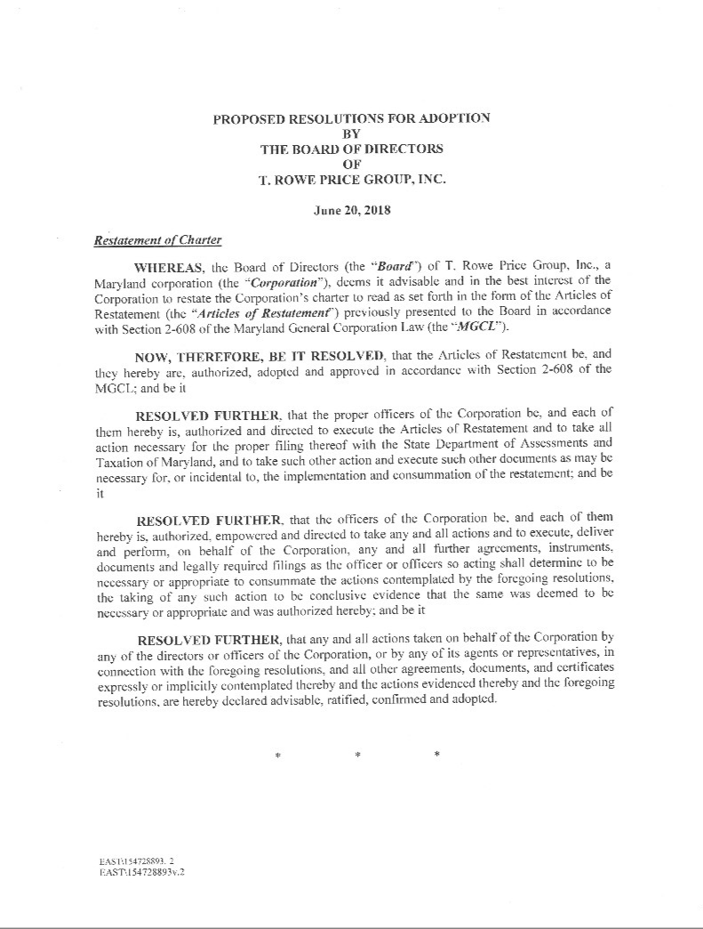

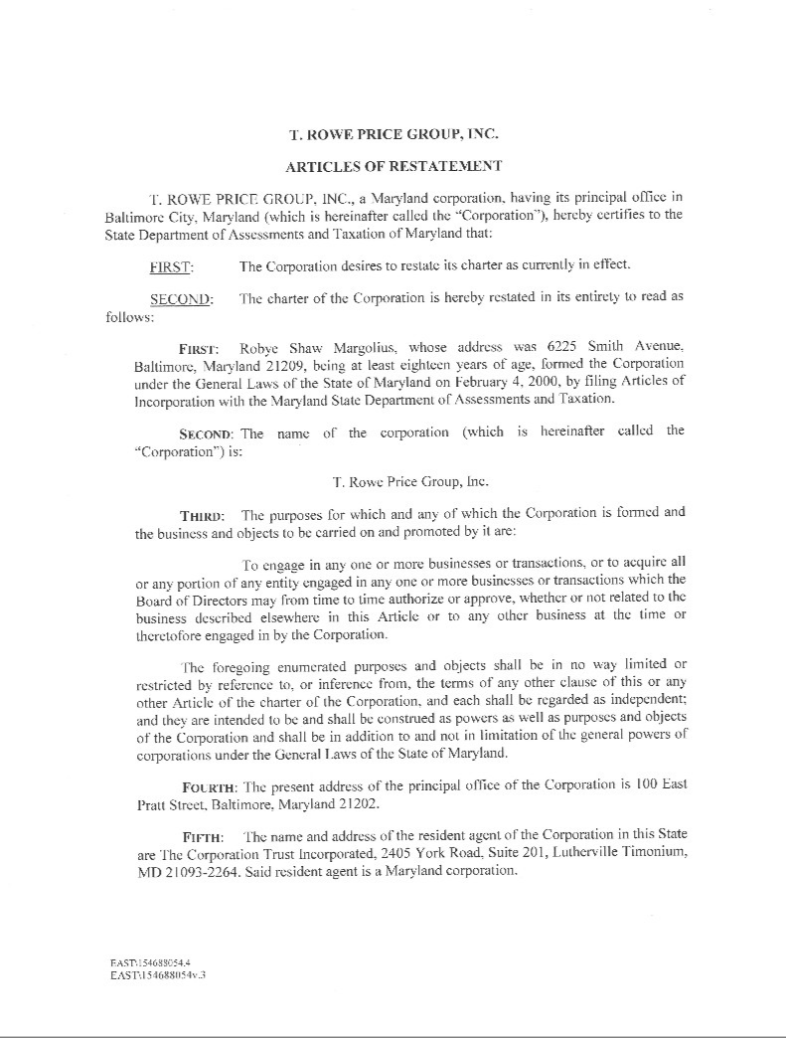

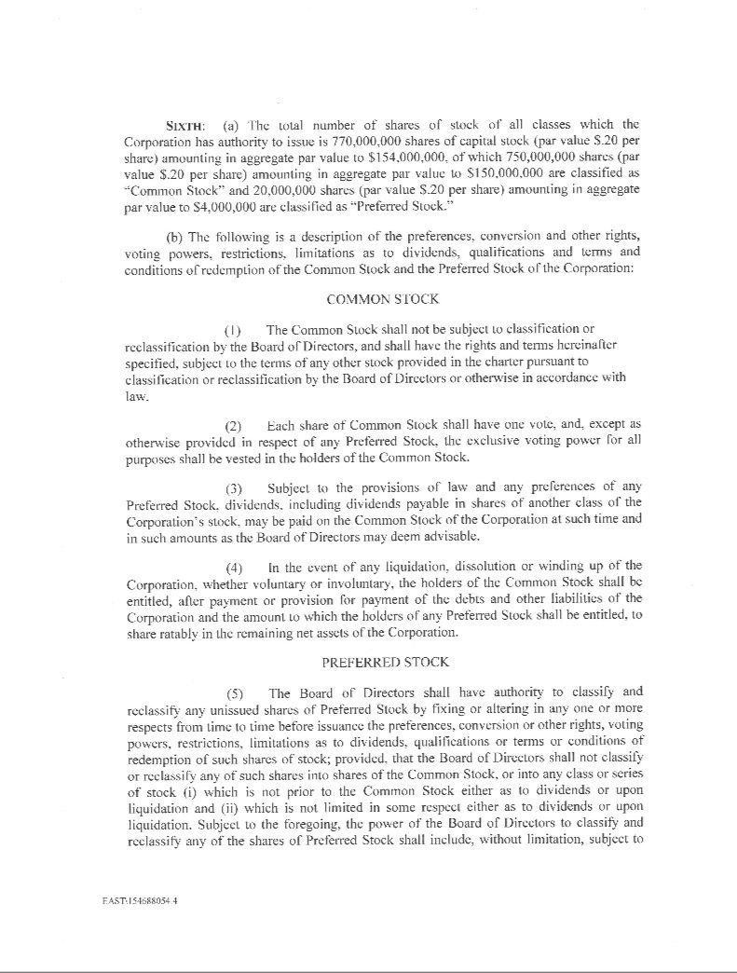

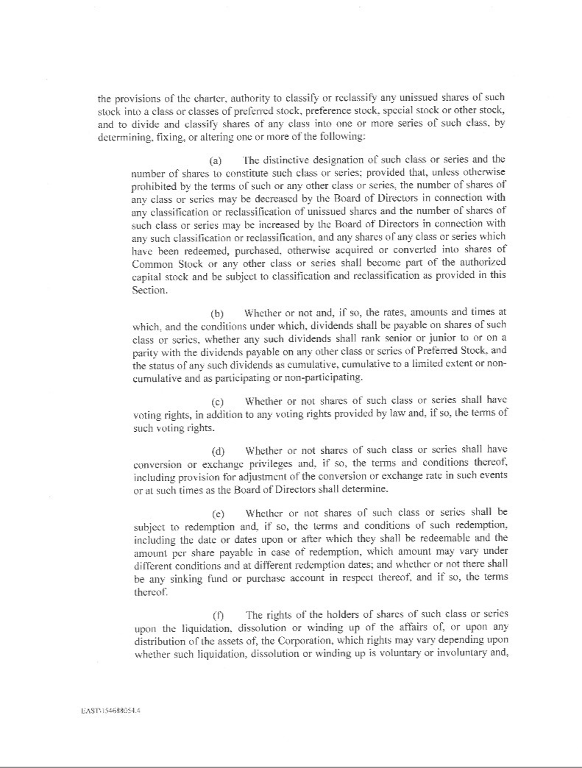

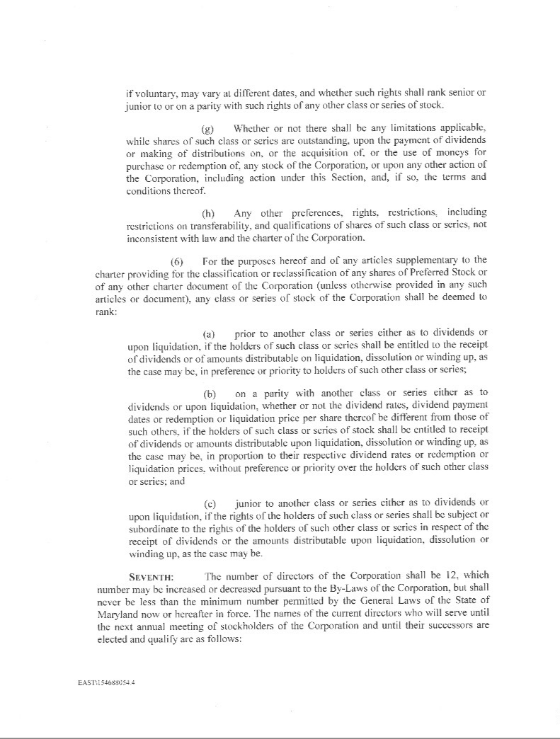

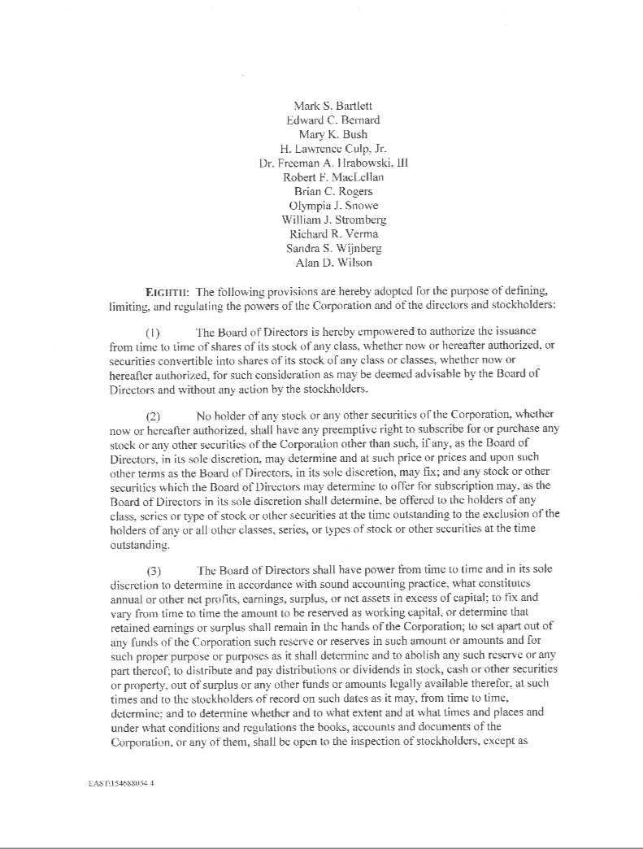

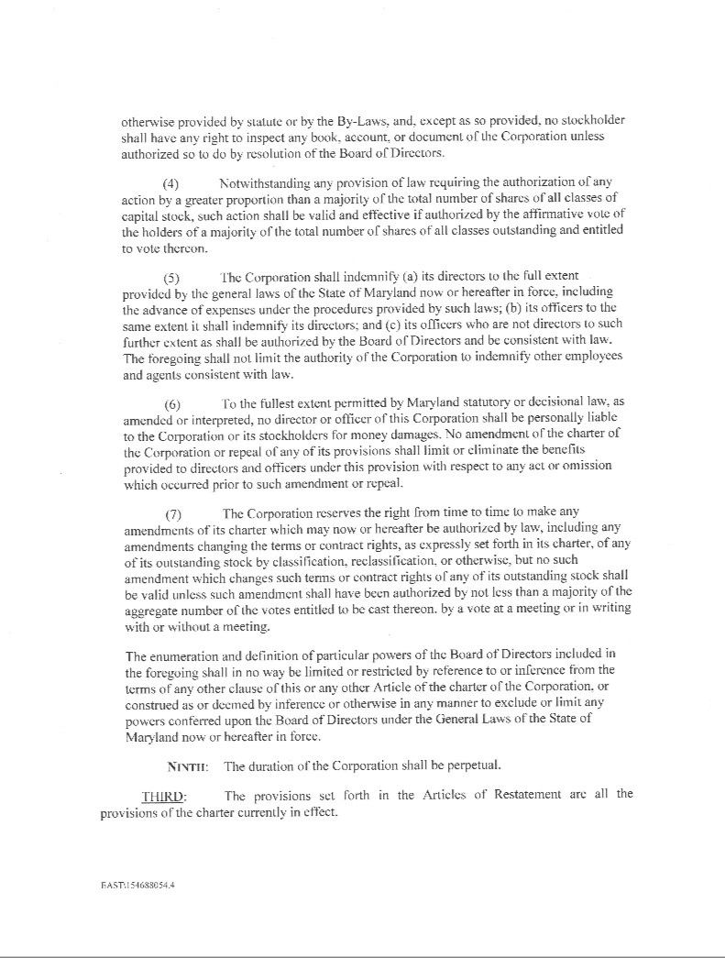

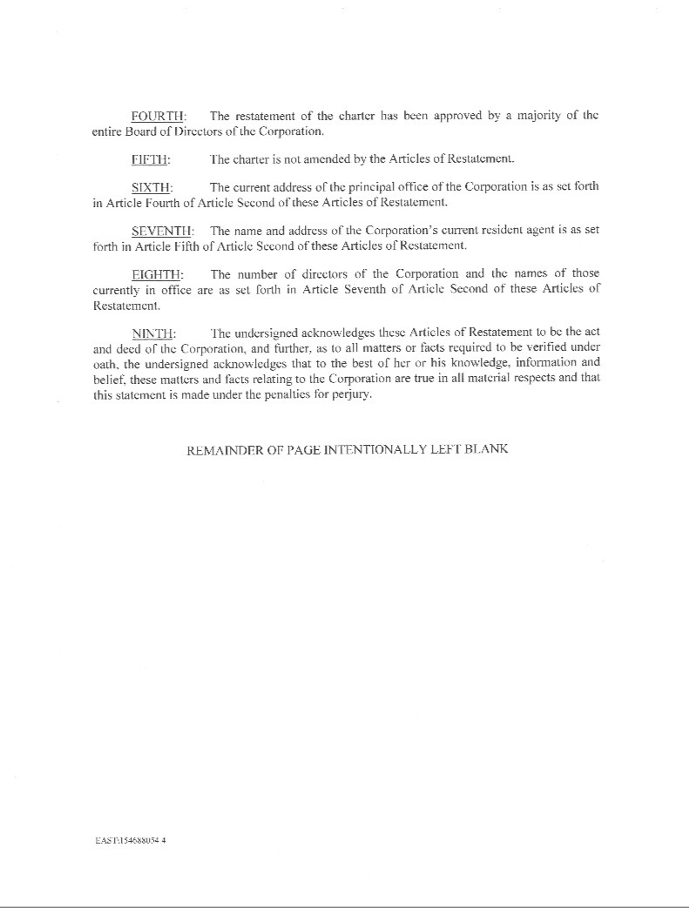

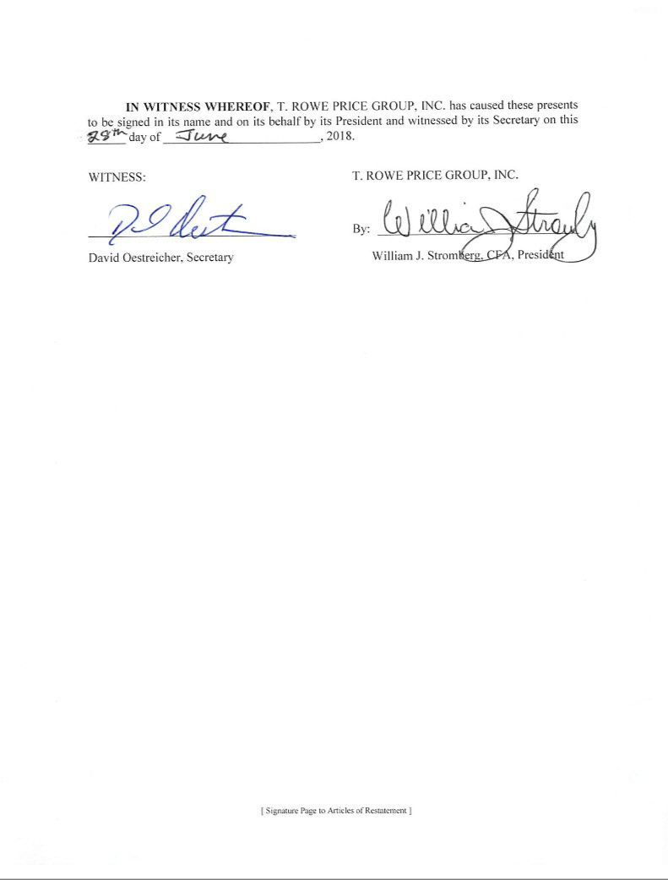

EXHIBIT 15

Letter from KPMG LLP, independent registered public accounting firm, re unaudited interim financial information

T. Rowe Price Group, Inc.

100 East Pratt Street

Baltimore, Maryland 21202

Re: Registration Statements on Form S-8: No. 33-7012, No. 333-59714, No. 333-120882, No. 333-120883, No. 333-142092, No. 333-167317, No. 333-180904, No. 333-199560, No. 333-212705 , and 333-217483.

With respect to the subject registration statements, we acknowledge our awareness of the use therein of our report dated July 25, 2018 related to our review of interim financial information.

Pursuant to Rule 436 under the Securities Act of 1933 (the Act), such report is not considered part of a registration statement prepared or certified by an independent registered public accounting firm, or a report prepared or certified by an independent registered public accounting firm within the meaning of Sections 7 and 11 of the Act.

/s/ KPMG LLP

Baltimore, Maryland

July 25, 2018

EXHIBIT 31(i).1 Rule 13a-14(a) Certification of Principal Executive Officer

I, William J. Stromberg, certify that:

- I have reviewed this Form 10-Q Quarterly Report for the quarterly period ended June 30, 2018 of T. Rowe Price Group, Inc.;

- Based on my knowledge, this report does not contain any untrue statement of a material fact or omit to state a material fact necessary to make the statements made, in light of the circumstances under which such statements were made, not misleading with respect to the period covered by this report;

- Based on my knowledge, the financial statements, and other financial information included in this report, fairly present in all material respects the financial condition, results of operations and cash flows of the registrant as of, and for, the periods presented in this report;

- The registrant’s other certifying officer and I are responsible for establishing and maintaining disclosure controls and procedures (as defined in Exchange Act Rules 13a-15(e) and 15d-15(e)) and internal control over financial reporting (as defined in Exchange Act Rules 13a-15(f) and 15d-15(f)) for the registrant and have:

  - Designed such disclosure controls and procedures, or caused such disclosure controls and procedures to be designed under our supervision, to ensure that material information relating to the registrant, including its consolidated subsidiaries, is made known to us by others within those entities, particularly during the period in which this report is being prepared;

  - Designed such internal control over financial reporting, or caused such internal control over financial reporting to be designed under our supervision, to provide reasonable assurance regarding the reliability of financial reporting and the preparation of financial statements for external purposes in accordance with generally accepted accounting principles;

  - Evaluated the effectiveness of the registrant’s disclosure controls and procedures and presented in this report our conclusions about the effectiveness of the disclosure controls and procedures, as of the end of the period covered by this report based on such evaluation; and

  - Disclosed in this report any change in the registrant’s internal control over financial reporting that occurred during the registrant’s most recent fiscal quarter (the registrant’s fourth fiscal quarter in the case of an annual report) that has materially affected, or is reasonably likely to materially affect, the registrant’s internal control over financial reporting; and

- The registrant’s other certifying officer and I have disclosed, based on our most recent evaluation of internal control over financial reporting, to the registrant’s auditors and the audit committee of the registrant’s board of directors (or persons performing the equivalent functions):

  - All significant deficiencies and material weaknesses in the design or operation of internal control over financial reporting which are reasonably likely to adversely affect the registrant’s ability to record, process, summarize and report financial information; and

  - Any fraud, whether or not material, that involves management or other employees who have a significant role in the registrant’s internal control over financial reporting.

July 25, 2018

/s/ William J. Stromberg

President and Chief Executive Officer

EXHIBIT 31(i).2 Rule 13a-14(a) Certification of Principal Financial Officer

I, Céline S. Dufétel, certify that:

- I have reviewed this Form 10-Q Quarterly Report for the quarterly period ended June 30, 2018 of T. Rowe Price Group, Inc.;

- Based on my knowledge, this report does not contain any untrue statement of a material fact or omit to state a material fact necessary to make the statements made, in light of the circumstances under which such statements were made, not misleading with respect to the period covered by this report;

- Based on my knowledge, the financial statements, and other financial information included in this report, fairly present in all material respects the financial condition, results of operations and cash flows of the registrant as of, and for, the periods presented in this report;

- The registrant’s other certifying officer and I are responsible for establishing and maintaining disclosure controls and procedures (as defined in Exchange Act Rules 13a-15(e) and 15d-15(e)) and internal control over financial reporting (as defined in Exchange Act Rules 13a-15(f) and 15d-15(f)) for the registrant and have:

  - Designed such disclosure controls and procedures, or caused such disclosure controls and procedures to be designed under our supervision, to ensure that material information relating to the registrant, including its consolidated subsidiaries, is made known to us by others within those entities, particularly during the period in which this report is being prepared;

  - Designed such internal control over financial reporting, or caused such internal control over financial reporting to be designed under our supervision, to provide reasonable assurance regarding the reliability of financial reporting and the preparation of financial statements for external purposes in accordance with generally accepted accounting principles;

  - Evaluated the effectiveness of the registrant’s disclosure controls and procedures and presented in this report our conclusions about the effectiveness of the disclosure controls and procedures, as of the end of the period covered by this report based on such evaluation; and

  - Disclosed in this report any change in the registrant’s internal control over financial reporting that occurred during the registrant’s most recent fiscal quarter (the registrant’s fourth fiscal quarter in the case of an annual report) that has materially affected, or is reasonably likely to materially affect, the registrant’s internal control over financial reporting; and

- The registrant’s other certifying officer and I have disclosed, based on our most recent evaluation of internal control over financial reporting, to the registrant’s auditors and the audit committee of the registrant’s board of directors (or persons performing the equivalent functions):

  - All significant deficiencies and material weaknesses in the design or operation of internal control over financial reporting which are reasonably likely to adversely affect the registrant’s ability to record, process, summarize and report financial information; and

  - Any fraud, whether or not material, that involves management or other employees who have a significant role in the registrant’s internal control over financial reporting.

July 25, 2018

/s/ Céline S. Dufétel

Vice President, Chief Financial Officer and Treasurer

EXHIBIT 32 Section 1350 Certifications

We certify, to the best of our knowledge, based upon a review of the Form 10-Q Quarterly Report for the quarterly period ended June 30, 2018, of T. Rowe Price Group, Inc., that:

- The Form 10-Q Quarterly Report fully complies with the requirements of Section 13(a) of the Securities Exchange Act of 1934, as amended; and

- The information contained in the Form 10-Q Quarterly Report fairly presents, in all material respects, the financial condition and results of operations of T. Rowe Price Group, Inc.

July 25, 2018

/s/ William J. Stromberg

President and Chief Executive Officer

/s/ Céline S. Dufétel

Vice President, Chief Financial Officer and Treasurer

A signed original of this written statement has been provided to T. Rowe Price Group, Inc. and will be retained by T. Rowe Price Group, Inc. and furnished to the Securities and Exchange Commission or its staff upon request.





